Swinburne University of Technology

Programming Concepts OnCampus Sem1 2019

Doubtfire Submission

**Task 9.9C**

*Submitted By:*

Sanduni Amanda Galhenage *Tutor:*

101337547 Somkiat Kitjongthawonkul

2019/05/21 11:11

May 21, 2019



Produced by Doubtfire

Programming Concepts

Week 9 CreditSubmission Tasks Template

Student ID: _101337547____________________

Student Name: __Sanduni Amanda ____________________________

Credit Task 9HTML code page

Paste the HTML code of the web page here.

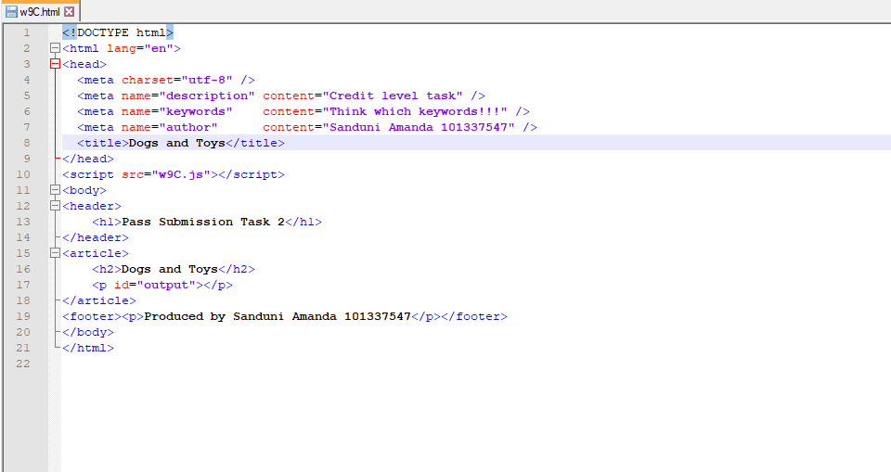

Credit Task 9 JavaScript code

Paste the JavaScript code of the same page here.

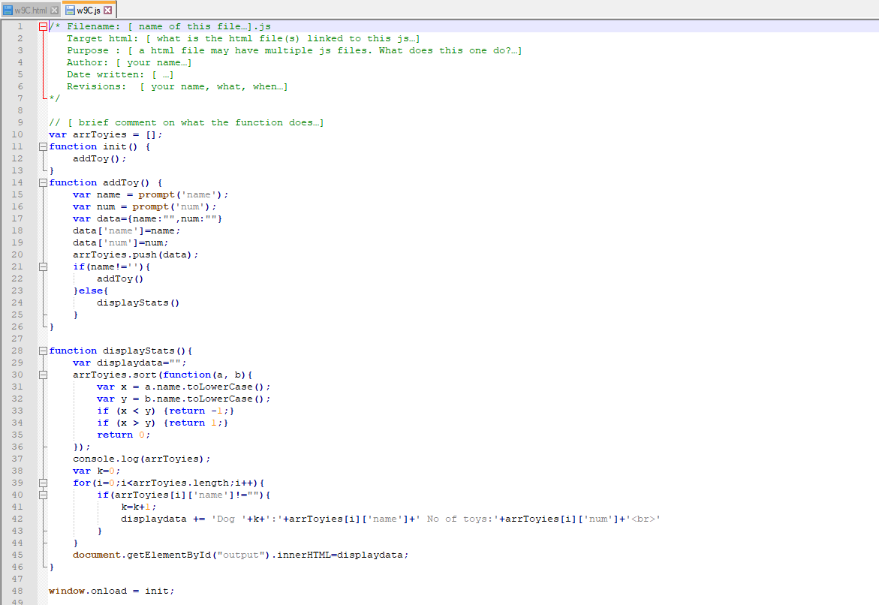

Credit Task 9 web page testing

Paste the screen captures of your testing web page here.

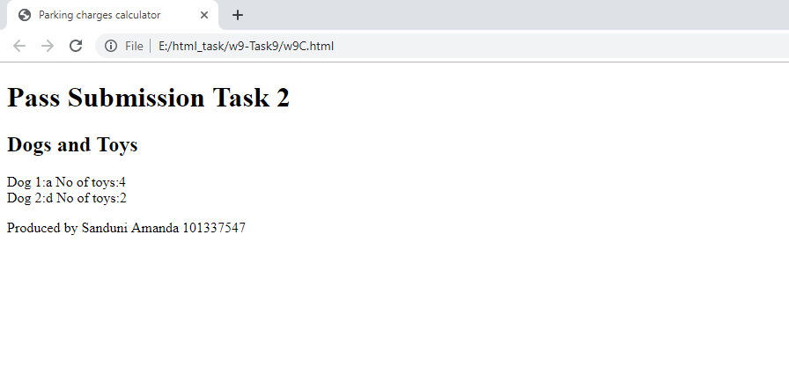

Content W9C.html

<!DOCTYPE html>

<html lang="en">

<head>

<meta charset="utf-8" />

<meta name="description" content="Credit level task" />

<meta name="keywords" content="Think which keywords!!!" />

<meta name="author" content="Sanduni Amanda 101337547" />

<title>Dogs and Toys</title>

</head>

<script src="w9C.js"></script>

<body>

<header>

<h1>Pass Submission Task 2</h1>

</header>

<article>

<h2>Dogs and Toys</h2>

<p id="output"></p>

</article>

<footer><p>Produced by Sanduni Amanda 101337547</p></footer>

</body>

</html>

Content w9C.js

/* Filename: [ name of this file…].js

Target html: [ what is the html file(s) linked to this js…]

Purpose : [ a html file may have multiple js files. What does this one do?…]

Author: [ your name…]

Date written: [ …]

Revisions: [ your name, what, when…]

*/

// [ brief comment on what the function does…]

var arrToyies = [];

function init() {

addToy();

}

function addToy() {

var name = prompt('name');

var num = prompt('num');

var data={name:"",num:""}

data['name']=name;

data['num']=num;

arrToyies.push(data);

if(name!=''){

addToy()

}else{

displayStats()

}

}

function displayStats(){

var displaydata="";

arrToyies.sort(function(a, b){

var x = a.name.toLowerCase();

var y = b.name.toLowerCase();

if (x < y) {return -1;}

if (x > y) {return 1;}

return 0;

});

console.log(arrToyies);

var k=0;

for(i=0;i<arrToyies.length;i++){

if(arrToyies[i]['name']!=""){

k=k+1;

displaydata += 'Dog '+k+':'+arrToyies[i]['name']+' No of toys:'+arrToyies[i]['num']+'<br>'

}

}

document.getElementById("output").innerHTML=displaydata;

}

window.onload = init;