Task 13

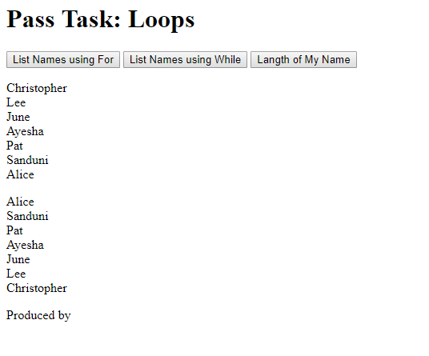

W6p1.js

var arrPeople = ["Alice", "Sanduni", "Pat", "Ayesha", "June", "Lee", "Christopher"];

function listValuesForLoop() {

var vOutput = "";

for (var i = arrPeople.length-1; i >= 0; i--) {

vOutput += arrPeople[i] + "<br>";

}

document.getElementById("msg1").innerHTML = vOutput;

}

function listValuesWhileLoop() {

var vOutput = "",i=0;

while (i < arrPeople.length) {

vOutput += arrPeople[i] + "<br>";

i++;

}

document.getElementById("msg2").innerHTML = vOutput;

}

function determineNameLength() {

var vOutput = "";

document.getElementById("msg2").innerHTML = arrPeople[1] + " : " + arrPeople[1].length;

}

function init() {

document.getElementById("msg3").onclick = start;

}

function start() {

var vOutput = "";

vOutput += "List of all names in the array: <br>";

for (var i = 0; i < arrPeople.length; i++) {

vOutput += arrPeople[i] + "<br>";

}

document.getElementById("msg").innerHTML = vOutput;

}

window.onload = init;

w6p1.html

<!DOCTYPE html>

<html>

<head>

<title>w6a.html</title>

<meta charset="utf-8" />

<meta name="description" content="Provide description" />

<meta name="keywords" content="Think which keywords!!!" />

<meta name="author" content="Tanya Linden" />

<script src="w6p1.js"></script>

</head>

<body>

<header>

<h1>Pass Task: Loops</h1>

<button type="button" id="forbtn" onclick="javascript:listValuesForLoop();">List Names using For</button>

<button type="button" id="whilebtn" onclick="javascript:listValuesWhileLoop();">List Names using While</button>

<button type="button" id="namelength" onclick="javascript:determineNameLength();">Langth of My Name</button>

</header>

<article>

<form>

<p id="msg1"></p>

<p id="msg2"></p>

<p id="msg3"></p>

</form>

</article>

<footer><p>Produced by <your name and student id></p></footer>

</body>

</html>

Task14

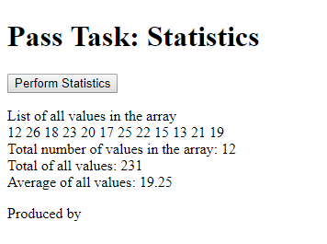

function init() {

document.getElementById("stats").click();

}

function start() {

var nums = [12, 26, 18, 23, 20, 17, 25, 22, 15, 13, 21, 19];

var vOutput = "";

var sum=0;

vOutput += "List of all values in the array <br>";

for (var i = 0; i < nums.length; i++) {

vOutput += nums[i] + " ";

}

vOutput += "<br> Total number of values in the array: "+nums.length+"<br>";

for (var i = 0; i < nums.length; i++) {

sum+=nums[i];

}

vOutput += "Total of all values: "+sum+"<br>";

vOutput += "Average of all values: "+sum/(nums.length)+"<br>";

document.getElementById("msg").innerHTML=vOutput;

}

window.onload = init;

----------

function init() {

document.getElementById("stats").click();

}

function start() {

var nums = [12, 26, 18, 23, 20, 17, 25, 22, 15, 13, 21, 19];

var vOutput = "";

var sum=0;

vOutput += "List of all values in the array <br>";

for (var i = 0; i < nums.length; i++) {

vOutput += nums[i] + " ";

}

vOutput += "<br> Total number of values in the array: "+nums.length+"<br>";

for (var i = 0; i < nums.length; i++) {

sum+=nums[i];

}

vOutput += "Total of all values: "+sum+"<br>";

vOutput += "Average of all values: "+sum/(nums.length)+"<br>";

document.getElementById("msg").innerHTML=vOutput;

}

window.onload = init;

task15

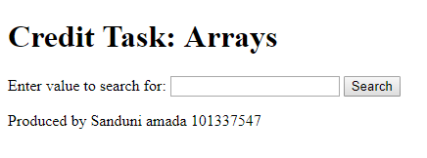

<!DOCTYPE html>

<html>

<head>

<title>w6a.html</title>

<meta charset="utf-8" />

<meta name="description" content="Provide description" />

<meta name="keywords" content="Think which keywords!!!" />

<meta name="author" content="Sanduni amada" />

<script src="w6c1.js"></script>

</head>

<body>

<header>

<h1>Credit Task: Arrays</h1>

</header>

<article>

<label>Enter value to search for:</label>

<input type="text" id="numVal">

<button onclick="javascript:start();">Search</button>

<p id="msg"></p>

</article>

<footer><p>Produced by Sanduni amada 101337547</p></footer>

</body>

</html>

function start() {

var numVal = 0, index = -1;

var nums = [18, 23, 20, 17, 21, 18, 22, 19, 18, 20];

var vOutput = "";

numVal = document.getElementById("numVal").value;

if(numVal==""){

return;

}

for (var i = 0; i < nums.length; i++) {

if (numVal == nums[i]) {

index = i;

}

}

vOutput += "<br> The values in the array are: " + nums.toString() + ".<br>";

if (index == -1) {

vOutput += "The number "+numVal+" does not exist in the array.<br>";

vOutput += "The values in this example do not match the values you must use.<br>";

}else{

vOutput += "The number "+numVal+" exists in the array<br>";

}

document.getElementById("msg").innerHTML = vOutput;

}

Task16

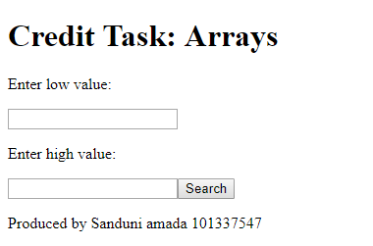

<!DOCTYPE html>

<html>

<head>

<title>w6a.html</title>

<meta charset="utf-8" />

<meta name="description" content="Provide description" />

<meta name="keywords" content="Think which keywords!!!" />

<meta name="author" content="Sanduni amada" />

<script src="w6c2.js"></script>

</head>

<body>

<header>

<h1>Credit Task: Arrays</h1>

</header>

<article>

<label>Enter low value:</label>

<p><input type="text" id="low"></p>

<label>Enter high value:</label>

<p><input type="text" id="high"><button onclick="javascript:start();">Search</button></p>

<p id="msg"></p>

</article>

<footer><p>Produced by Sanduni amada 101337547</p></footer>

</body>

</html>

-----function start() {

var low = 0, high = 0, count = 0, highest = -1;

var nums = [18, 23, 20, 17, 21, 18, 22, 19, 18, 25];

var vOutput = "";

vOutput += "The values in the array are: " + nums.toString() + ".<br>";

low = document.getElementById("low").value;

high = document.getElementById("high").value;

if (Number(low) == "NaN" || Number(high) == "NaN" || low == "" || high == "") {

vOutput += "At least one of the values (low or high or both) is not numeric.<br>";

document.getElementById("msg").innerHTML = vOutput;

return;

}

for (var i = 0; i < nums.length; i++) {

if (nums[i] >= low && nums[i] <= high) {

count++;

}

if (highest < nums[i]) {

highest = nums[i];

}

}

if (low > highest) {

vOutput += "Error when low value is NOT less than high value<br>";

document.getElementById("msg").innerHTML = vOutput;

return;

}

if (count == 0) {

vOutput += "0 values that exist in the range.<br>";

}

if (count == 1) {

vOutput += "1 value that exist in the range.<br>";

}

if (count > 1) {

vOutput += "More than 1 value that exist in the array.<br>";

}

document.getElementById("msg").innerHTML = vOutput;

}