Task5

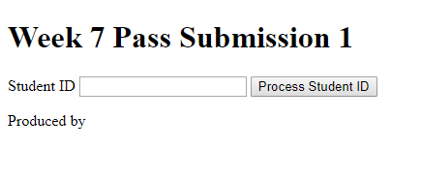

<!DOCTYPE html>

<html>

<head>

<title>w6a.html</title>

<meta charset="utf-8" />

<meta name="description" content="Provide description" />

<meta name="keywords" content="Think which keywords!!!" />

<meta name="author" content="Tanya Linden" />

<script src="w7p1.js"></script>

</head>

<body>

<header>

<h1>Week 7 Pass Submission 1</h1>

</header>

<article>

<p>

<label>Student ID</label>

<input type="text" id="studentid">

<button id="process" onclick="javascript: process();">Process Student ID</button>

</p>

<p id="result"></p>

</article>

<footer><p>Produced by <your name and student id></p></footer>

</body>

</html>

function process(){

var studentid="",msg="";

studentid=document.getElementById("studentid").value;

msg="Total of all digits is "+processStudentID(studentid);

document.getElementById("result").innerHTML=msg;

}

function processStudentID(pID){

var total=0;

for(var i=0;i<pID.length;i++){

total+=Number(pID.charAt(i));

}

return total;

}

Task8

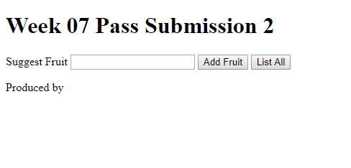

<!DOCTYPE html>

<html>

<head>

<title>w6a.html</title>

<meta charset="utf-8" />

<meta name="description" content="Provide description" />

<meta name="keywords" content="Think which keywords!!!" />

<meta name="author" content="Sanduni amada 101337547" />

<script src="w7p2.js"></script>

</head>

<body>

<header>

<h1>Week 07 Pass Submission 2</h1>

</header>

<article>

<p>

<label>Suggest Fruit</label>

<input type="text" id="fruit">

<button id="add" onclick="javascript:addFruit()">Add Fruit</button>

<button id="list" onclick="displayArray()">List All</button>

</p>

<p id="output"></p>

</article>

<footer><p>Produced by <your name and student id></p></footer>

</body>

</html>

var arrFruitList=[];

function addFruit(){

var fruit=document.getElementById("fruit").value;

arrFruitList.push(fruit);

document.getElementById("fruit").value="";

}

function displayArray(){

var output="";

for(var i=0;i<arrFruitList.length;i++){

output+=arrFruitList[i]+"<br>";

}

document.getElementById("output").innerHTML=output;

}

Task9

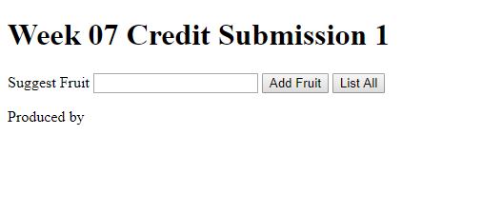

var arrFruitList = [];

function addFruit() {

var fruit = document.getElementById("fruit").value;

var result = findFruit(fruit);

if (result) {

arrFruitList.push(fruit);

document.getElementById("fruit").value = "";

}else{

document.getElementById("output").innerHTML = "Cannot add fruit "+fruit+": this fruit is already on the list<br>";

}

}

function findFruit(fruit){

var i=0;

while(i<arrFruitList.length){

if(fruit==arrFruitList[i]){

return false;

}

i++;

}

return true;

}

function displayArray() {

var output = "";

for (var i = 0; i < arrFruitList.length; i++) {

output += arrFruitList[i] + "<br>";

}

document.getElementById("output").innerHTML = output;

}

<!DOCTYPE html>

<html>

<head>

<title>w6a.html</title>

<meta charset="utf-8" />

<meta name="description" content="Provide description" />

<meta name="keywords" content="Think which keywords!!!" />

<meta name="author" content="Tanya Linden" />

<script src="w7c1.js"></script>

</head>

<body>

<header>

<h1>Week 07 Credit Submission 1</h1>

</header>

<article>

<p>

<label>Suggest Fruit</label>

<input type="text" id="fruit">

<button id="add" onclick="javascript:addFruit()">Add Fruit</button>

<button id="list" onclick="displayArray()">List All</button>

</p>

<p id="output"></p>

</article>

<footer><p>Produced by <your name and student id></p></footer>

</body>

</html>

Task10

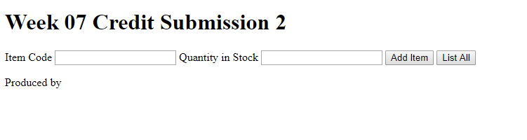

<!DOCTYPE html>

<html>

<head>

<title>w6a.html</title>

<meta charset="utf-8" />

<meta name="description" content="Provide description" />

<meta name="keywords" content="Think which keywords!!!" />

<meta name="author" content="Tanya Linden" />

<script src="w7c2.js"></script>

</head>

<body>

<header>

<h1>Week 07 Credit Submission 2</h1>

</header>

<article>

<p>

<label>Item Code</label>

<input type="text" id="itemcode">

<label>Quantity in Stock</label>

<input type="text" id="stock">

<button id="add" onclick="javascript:addItem()">Add Item</button>

<button id="list" onclick="javascript:listItems()">List All</button>

</p>

<p id="output"></p>

</article>

<footer><p>Produced by <your name and student id></p></footer>

</body>

</html>

var arrItemCodes = [], arrStockQty = [];

function addItem() {

var stock = document.getElementById("stock").value;

if (stock == "") {

alert("Input stock!");

return;

}

var vQty = stock;

var validQty = validateItemQty(stock);

var outmsg = "", vCode = "", validCode = false;

vCode = document.getElementById("itemcode").value;

if (vCode == "") {

alert("Input item code!");

return;

}

vCode = vCode.toUpperCase();

validCode = validateItemCode(vCode);

if(!validCode){

outmsg = "Invalid item code <br/>";

}

if (validCode && validQty) {

arrItemCodes.push(vCode);

arrStockQty.push(vQty);

outmsg = "Item details recorded";

document.getElementById("stock").value="";

document.getElementById("itemcode").value="";

}

document.getElementById("output").innerHTML = outmsg;

}

function listItems() {

var outmsg = "";

if (arrItemCodes.length == 0) {

outmsg = "There are no items in stock";

} else {

for (var i = 0; i < arrItemCodes.length; i++) {

outmsg += arrItemCodes[i] + " " + arrStockQty[i] + "<br>";

}

}

document.getElementById("output").innerHTML = outmsg;

}

function validateItemQty(item) {

var num = Number(item);

if (num == "NaN" || num < 0) {

return false;

}

return true;

}

function validateItemCode(pCode) {

var valid = true, firstChar, leftover, num = 0;

firstChar = pCode.substring(0, 1);

leftover = pCode.substring(1);

if (leftover.length != 4) {

valid = false;

}

num = Number(leftover);

if(isNaN(num)){

valid=false;

}

firstChar = pCode.charAt(0);

if (!(firstChar >= "A" && firstChar <= "Z")) {

valid = false;

}

return valid;

}