**Think Bridge: (Inventory (Shop Bridge) Form)**

* 1. **PURPOSE**

The purpose of the Software Design Document is to provide a description of the design of a system fully enough to allow for software development to proceed with an understanding of what is to be built and how it is expected to built. The Software Design Document provides information necessary to provide description of the details for the software and system to be built.

## FUNCTIONAL AND DATABASE

1.form been developed by **ASP.MVC (.NET FRAMEWORK 4.5)** with the concept of ADO.NET and I use the PLSQL for backend and I have attached the script file (DBSCRIPT.txt) which contain both the table create script and the function for the actions.

**1.2 Application Module Design:**

## VIEW SCREEN

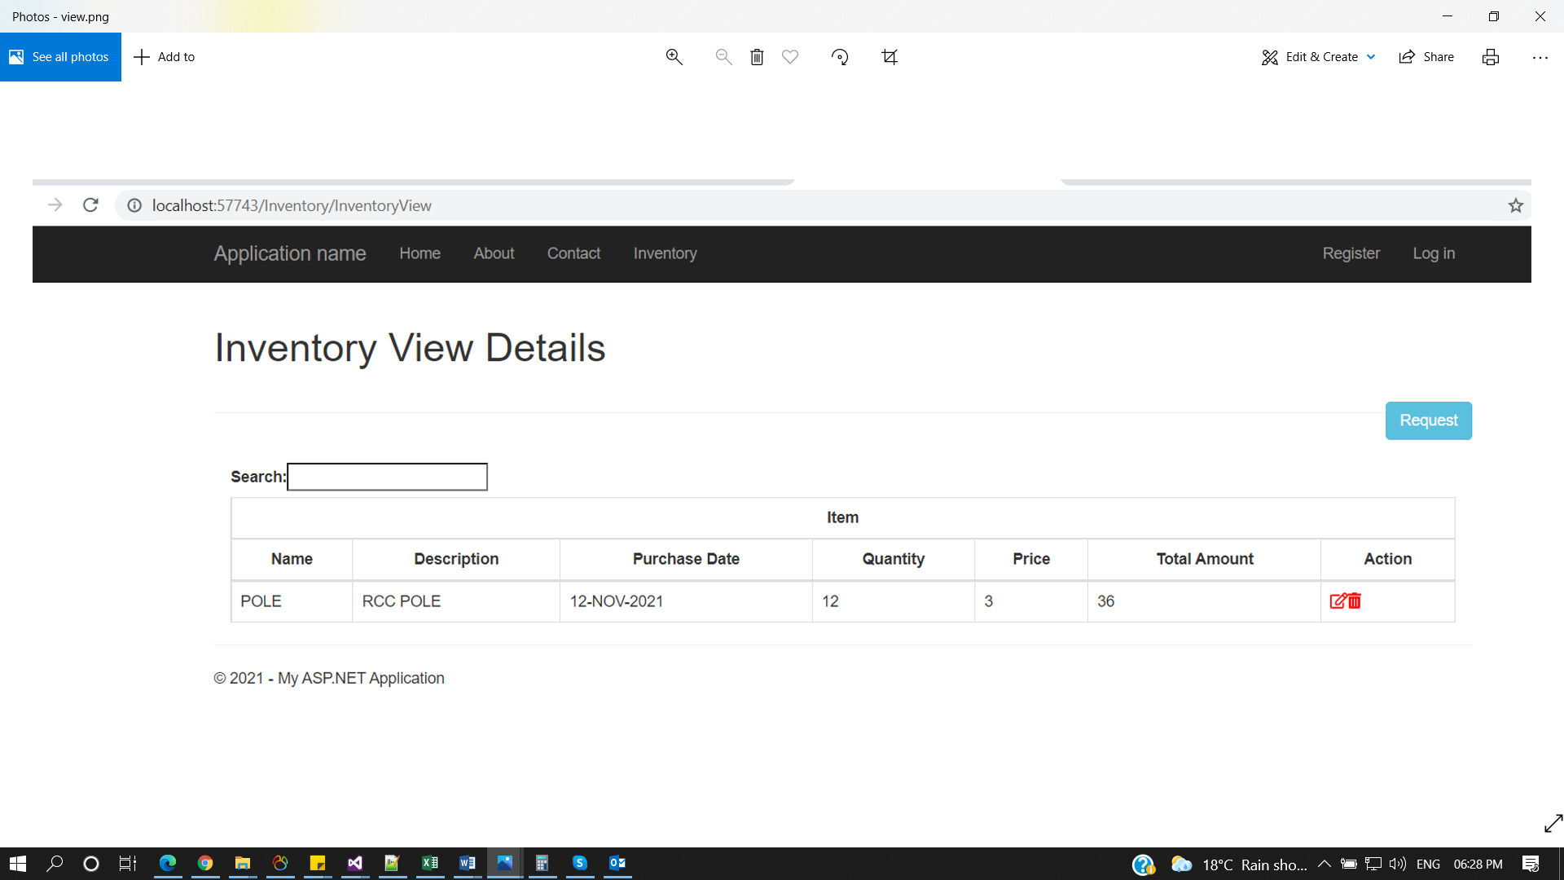

* This form can be used for view the save inventory records (list of items in inventory) in the grid format and also, we can search he items by search box.
* Forms includes request button which will redirect to create screen on the right side of the page.
* It includes edit and remove action in the grid (edit for modify the item in inventory and delete for removing the item inventory).

## 2.CREATE SCREEN

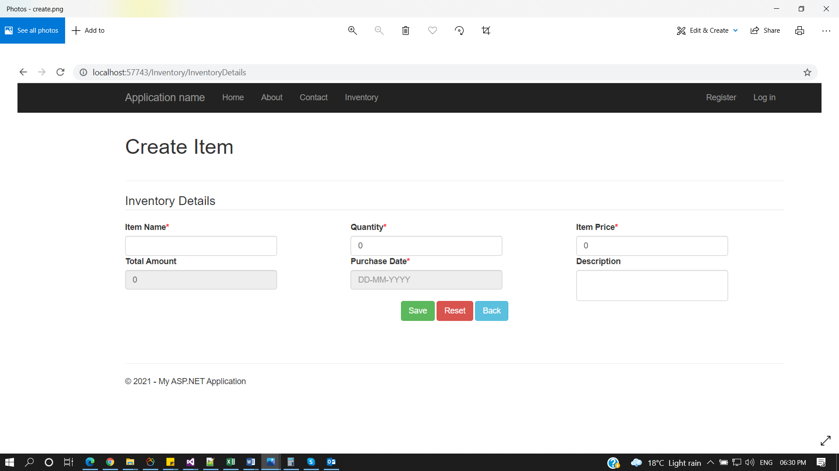

* This form can be used for Creating item inventory.
* Form includes 6 capturing fields and the 3-action button below.
* Form includes item name field which accept a character and special symbol, quantity field accept numeric, Item price field accept numeric, total amount field read-only (calculated on change of price or quantity) (quantity*price), and a date picker for selection purchase date, and description for item description.
* Form with save for saving the captured record to database and reset button for refreshing page and back used for redirecting to view page.