Food Category distribution in neighbourhoods of Bangalore

# Introduction

To understand the distribution of food category venues for different neighborhood in Bangalore. This can help entrepreneurs to identify the opportunity for newer restaurants and specific cuisines.

This report summarizes the similarity of neighbourhood calculated on basis of venue within food category but approach can be extended for any available venue category, which can help identify best location for newer entrepreneurial ventures.

# Data Acquisition

The various neighbourhoods of Bangalore are defined as per postal code. The latitude and longitude information of each postal code is obtained from Indian government website (<https://data.gov.in/resources/all-india-pincode-directory-contact-details-along-latitude-and-longitude>) . This latitude and longitude information will be used with Foursquare API to explore food category venues within 50 m of respective longitude and latitude.

The postal codes with either or both latitude and longitude missing are dropped from analysis.

During data preprocessing it was observed that few food categories within dataset had very few occurrences whereas other categories have significant presence. By analysis of the frequency of each food category, top 9 food categories were selected to obtain the basic data for this study.

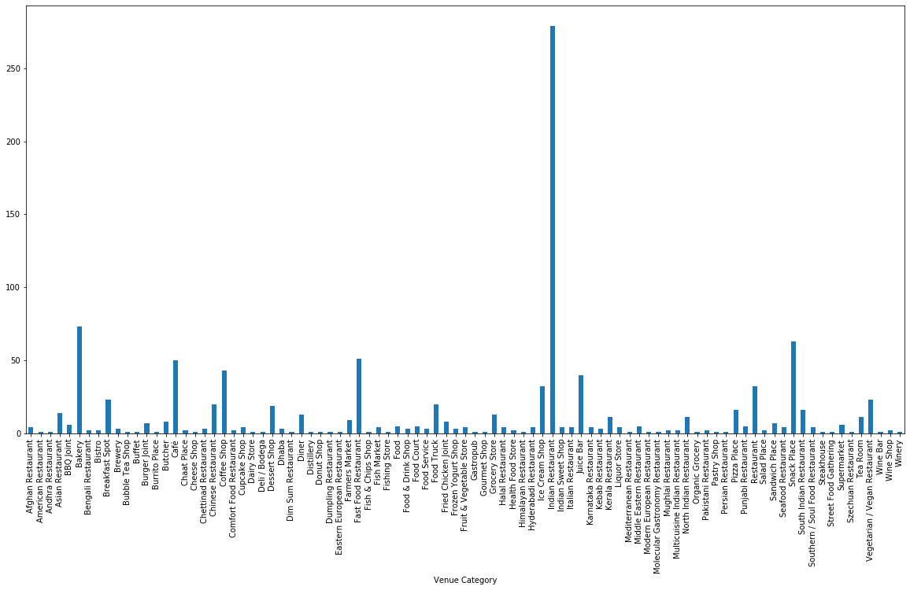

Distribution of food categories across all neighbourhoods

# Data Analysis

To analyze the data, a dataframe with “Neighbourhood” and “Venue Category” is created. The “Venue Category” contains only top 9 food categories identified earlier.

Subsequently, category information is converted using dummies command. All postal codes are displayed row-wise. Each row depicting one neighbourhood with their corresponding dummy (0/1) against the listed top 9 categories column-wise. Dummy “1” represents the presence and dummy “0” represents the absence of a category at a given postal code.

Within each neighbourhood, local mean of each category is calculated. This new dataframe represents weight distribution matrix of each category against respective postal code. This formulates the feature dataset for further segregation to various clusters depending on their similarities.

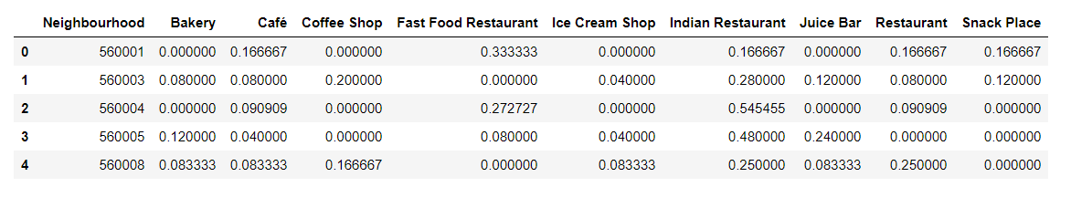

Feature dataset of each neigbourhood with top 9 food categories

# Clustering of data

With the feature set of each postal code, k-means clustering is performed to determine the similarity across neighbourhoods. To identify best homogeneity within clusters, the number of clusters are varied between 4 to 8. The cluster label identified is added to dataframe with postal code and latitude and longitude details. With this dataframe, multiple rows represent same cluster label. To have best representation of each cluster, local mean of each category against cluster is performed.

# Discussions

The dataframe with cluster labels and features (food category) depicts the frequency distribution of top 9 food categories within each cluster. With reference to cluster labels, similar neighbourhoods are identified. Also, feature set of each cluster indicates the presence of various food category venues in those neighbourhoods. For example, neighbourhoods in Cluster 1 has “Indian Restaurant” (38%) along with “Bakery” (13%) whereas Cluster 3 has “Indian Restaurant” (50%) with “Fast food Restaurant” (16%).

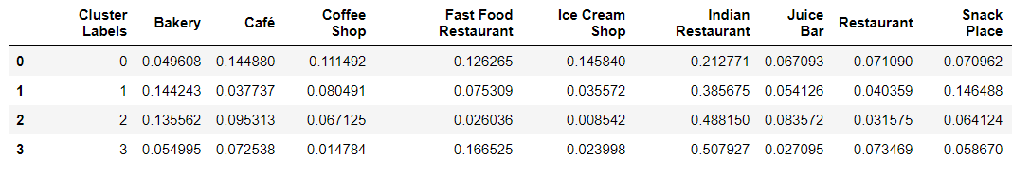

Cluster labels with average feature set

For quick insight of neighbourhood similarity, each cluster is assigned a unique color. This color is used to create markers for neigbourhood on a map.

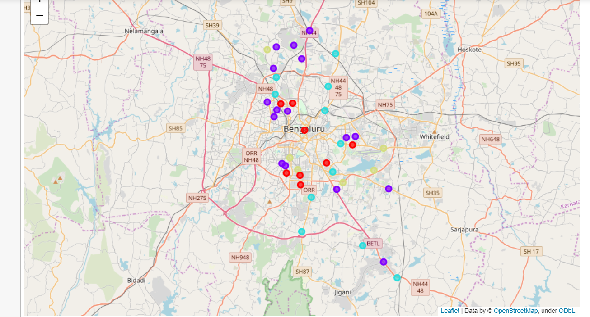

Neighbourhood similarity basis K-means clustering