Contents

[1.0 AWS Application 2](#_Toc398292888)

[2.0 Application Walk through 2](#_Toc398292889)

[3.0 Reference 13](#_Toc398292890)

# 1.0 AWS Application

This application is used in replacement for AWS management console. This application provides basic functionalities like:

1. Creating an instance

2. Starting an instance

3. Stopping an instance

4. Rebooting an instance

5. Terminating an instance

6. Creating an AMI

**Limitations**

Due to the scope and time, the first version of the application has few restrictions.

* This application can only create instance using Amazon's public AMI "ami-a02015e5" (Microsoft Windows Server 2012 Base, Microsoft Windows 2012 RTM Standard edition with 64-bit architecture).
* The application is restricted to a command line interface.
* Application can only create the instance in **US West (Northern California) Region**.
* If user wishes to create a instance in some other region, User needs to comment uncomment setEndpoints in lines 75 to 80 and specify AMI id in line 59 with respect to the region.

# 2.0 Application Walk through

Prerequisites:

1. Install Eclipse(Kepler Edition) with AWS Plugin
2. Configure AWS and Java SDK.
3. Create AWS java project.(File->New Project->AWS Java Project)
4. Create a package structure "**com.cmpe281.testPackage**".
5. Place the files "**MyFirstCloudClass.java**", "**AwsConsoleApp.java**" and "**AwsCredentials.properties**" under the package.
6. Ensure that your **AwsCredentials.properties** contains the right AWS key pair.
7. Run **MyFirstCloudClass.java** as an Java Application.
8. Respond to the application via console. (Use numeric inputs for optimal operations)

Startup screen for the application. 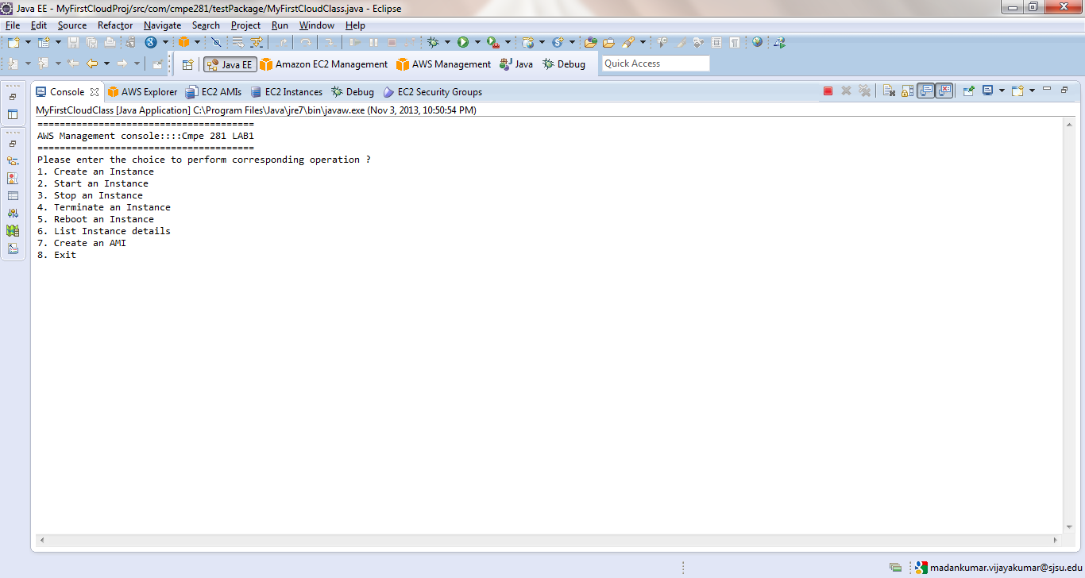

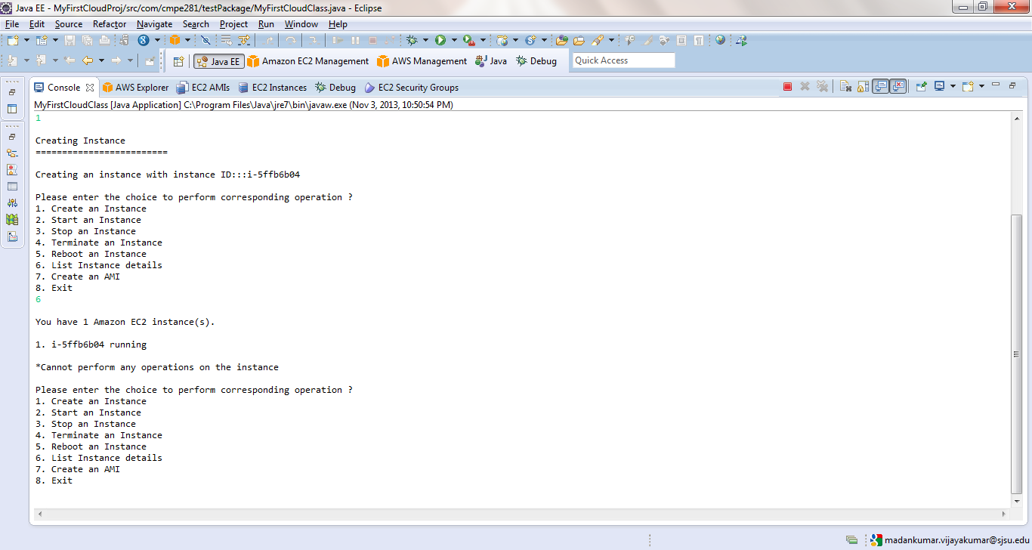Entered choice 1 to create an instance with AMID: ami-a02015e5

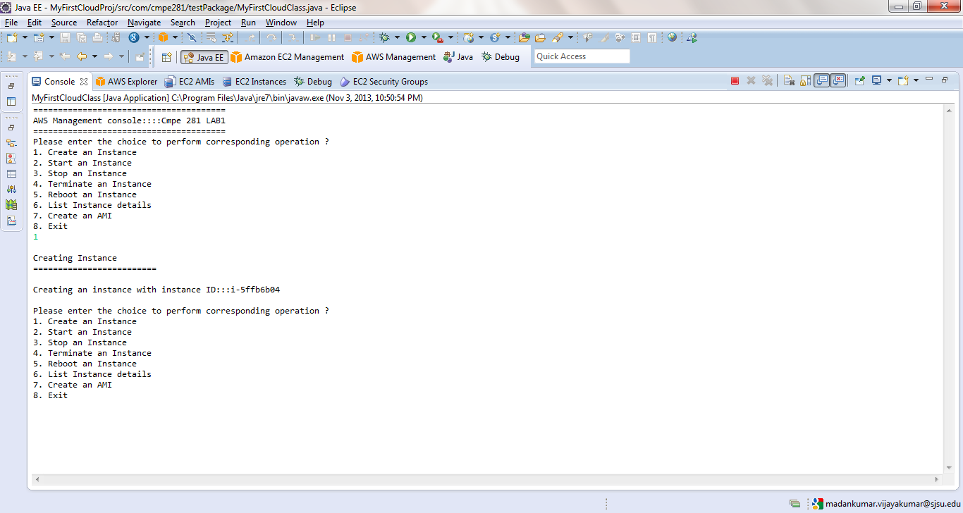

Created an instance and instance id is displayed

Entered choice 6 and it shows that an instance has been created and it is in running state.

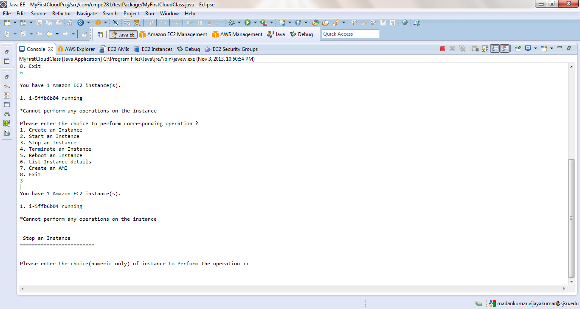Enter choice 3 to stop the instance. Application displays the current instances on which operation can be performed.

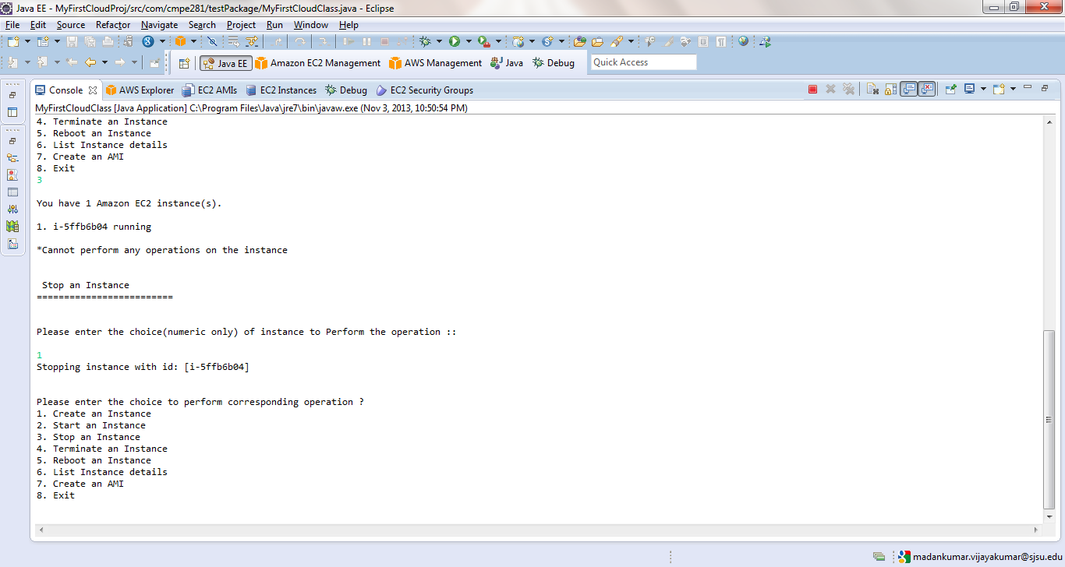Entered choice 1 corresponding to the instance to stop it.

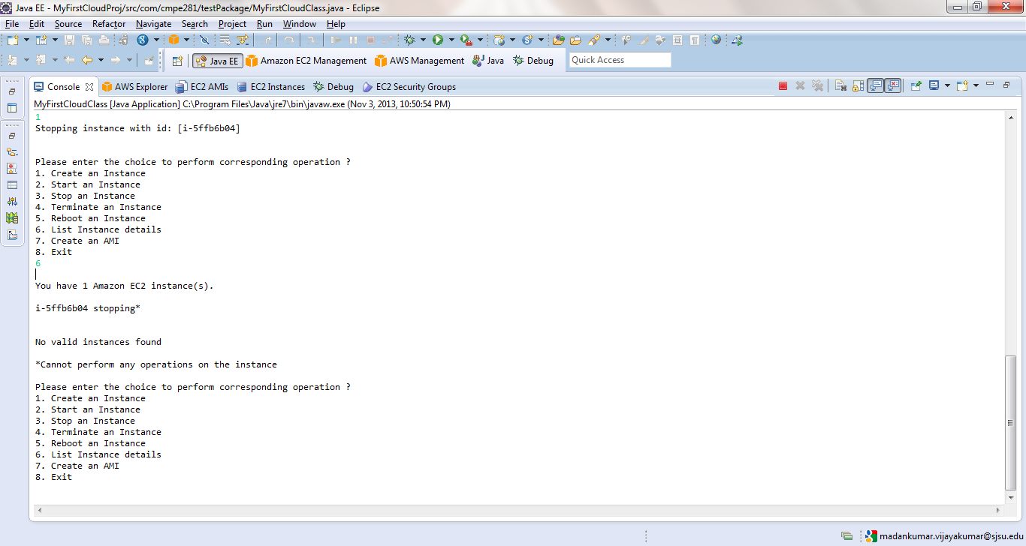Entered choice 6 to print the details of the instance and application shows that instance is in "stopping" state. The asterisks(\*) mark is shown beside the instance to show user cannot perform any operation on that particular instance.

**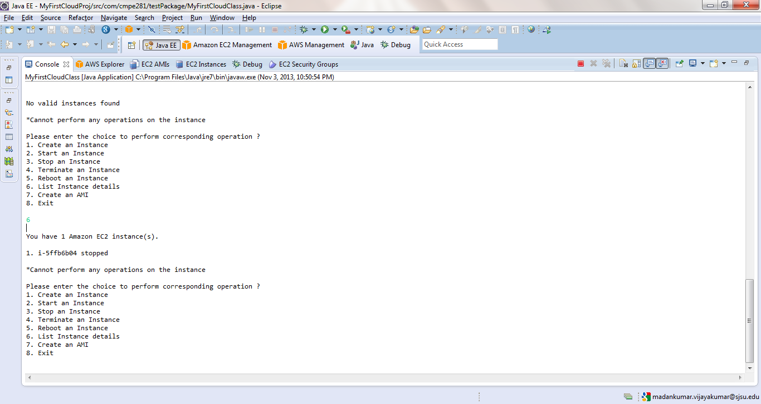**After the instance is stopped, choice 6 was entered and application shows the instance in stopped state.

Created another instance using choice 1. **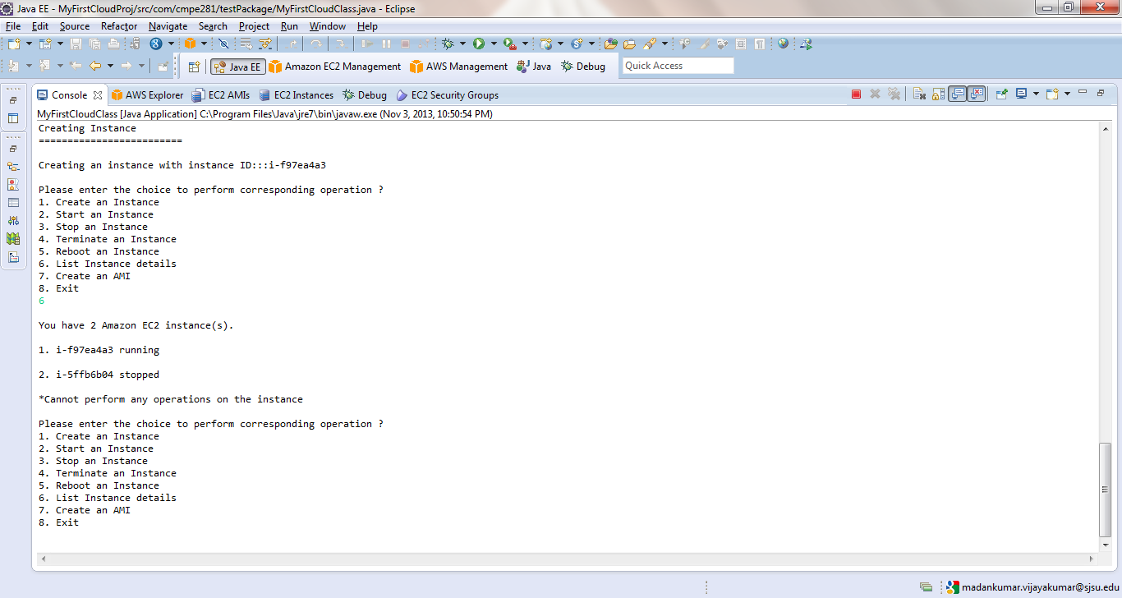**

Entered choice 2 for starting an instance. The application lists all the instance and asks user an option to choose which instance to start.

**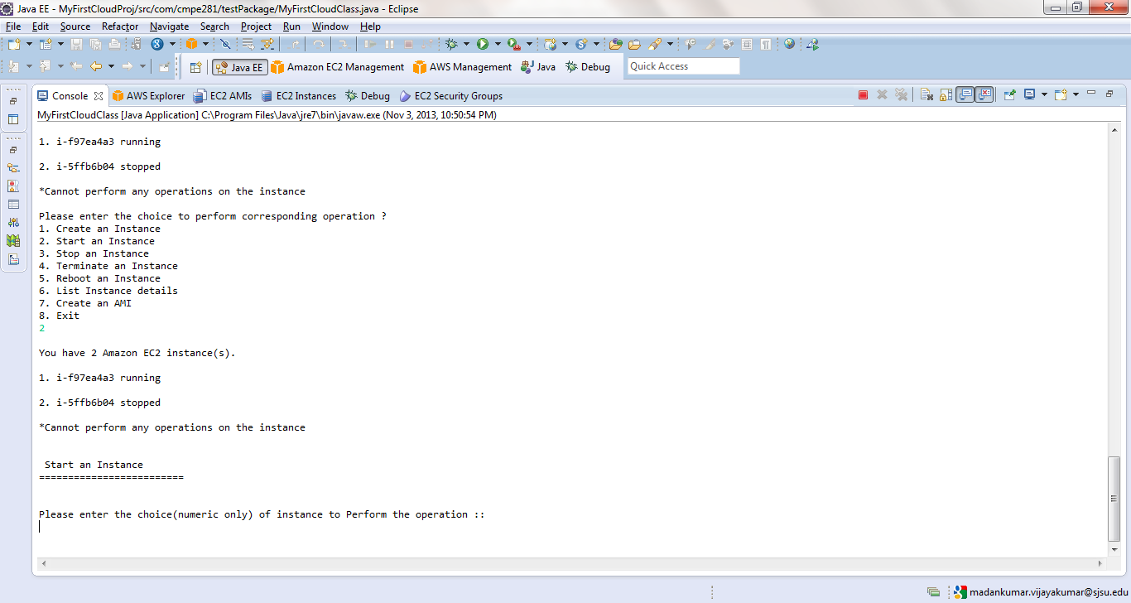**

Choice 2 was entered and second (stopped) instance was selected.

**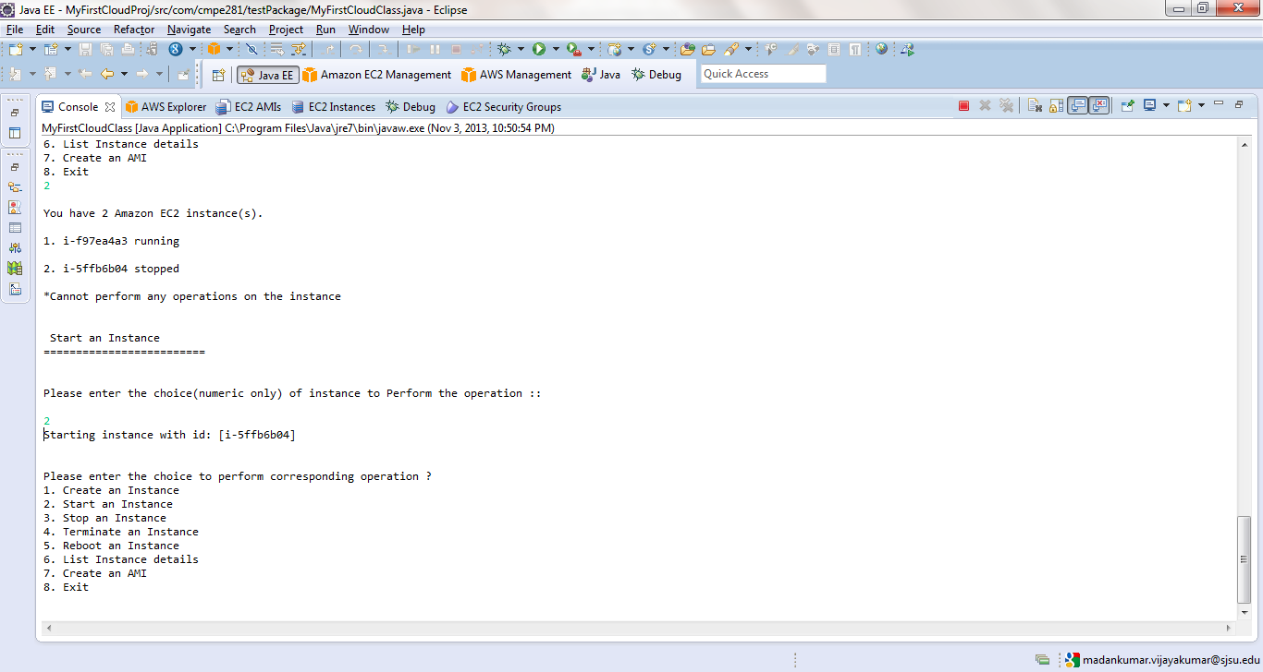**

Choice 6 was entered to verify the instance was started and running.

**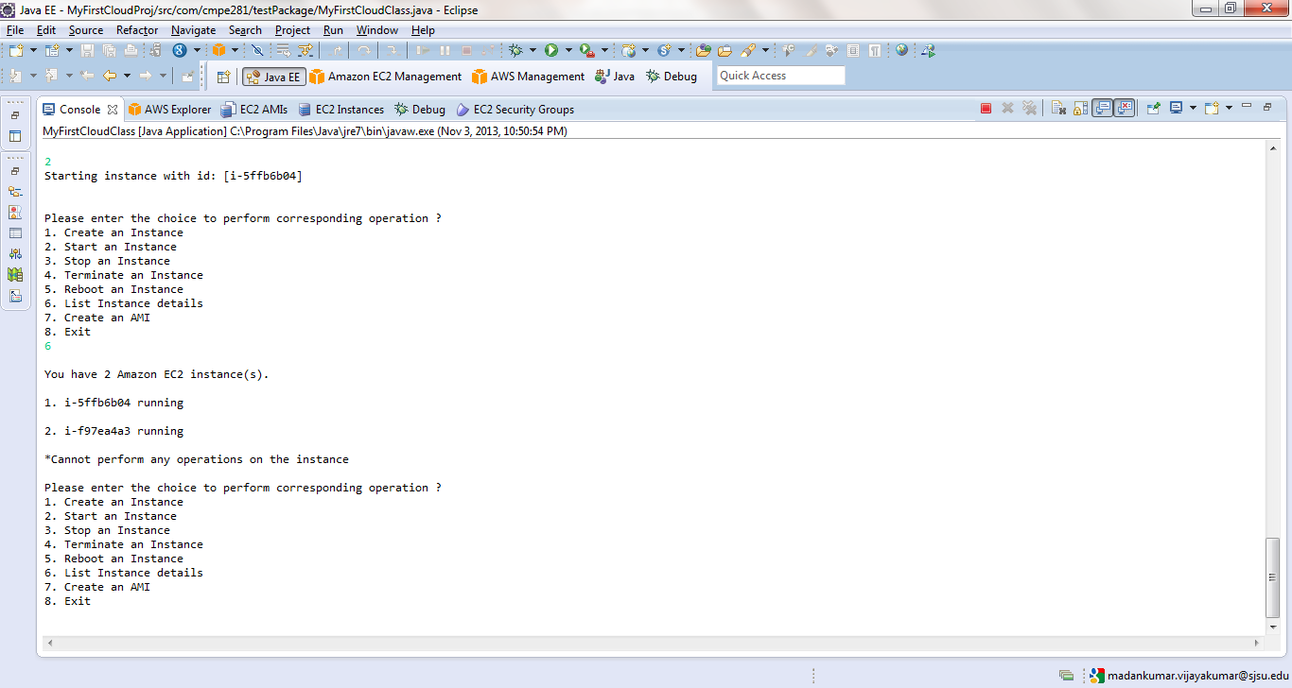**

Both the instances are stopped . User cannot perform operation when the instance are in stopping state. **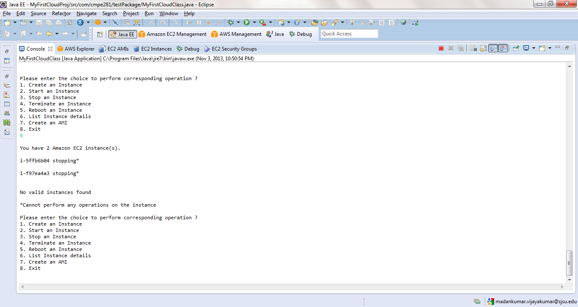**

A new instance was created using Choice 1. Choice 6 prints all the instances.

**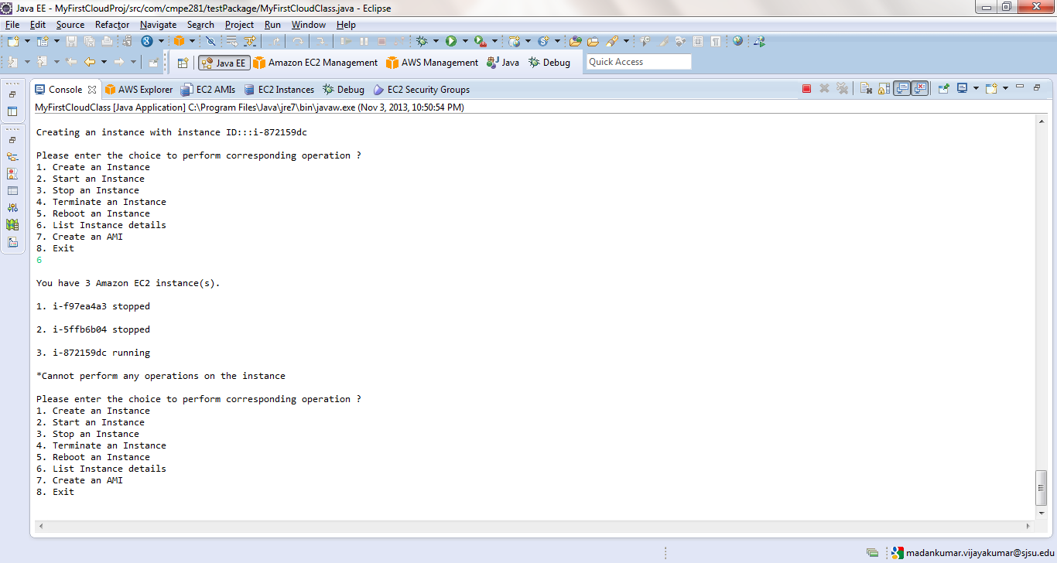**

Choice 5 was entered to reboot the instances. Application lists all the available instances for reboot. User cannot reboot stopped instance.(shown with asterisk)

**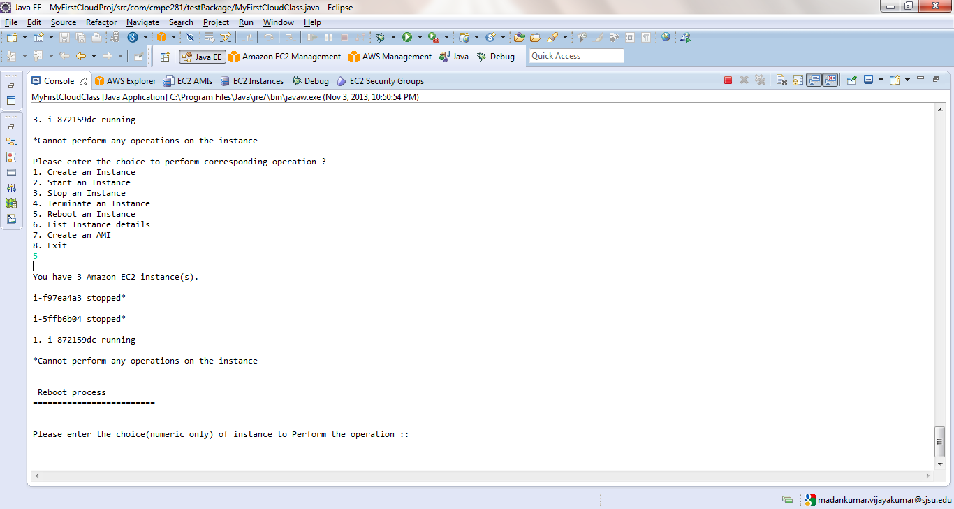**

Choice of instance was entered to reboot.

**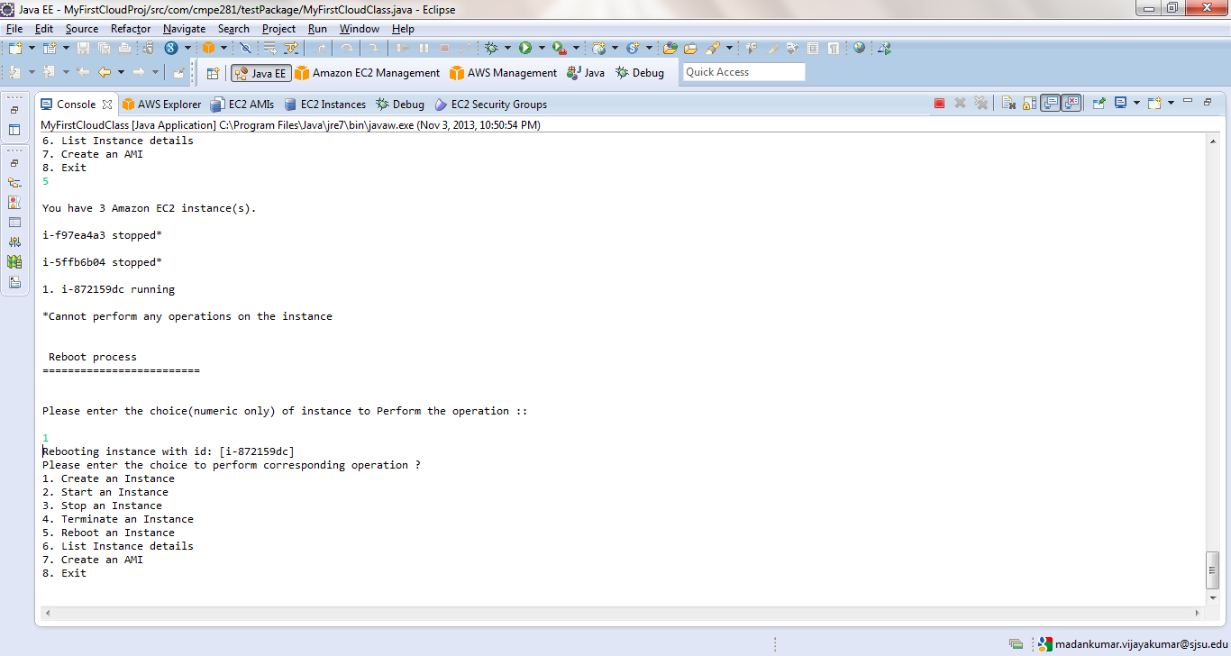**

Choice 7 was entered to create an AMI from a instance. Application displays all the available instances for creating an image.

**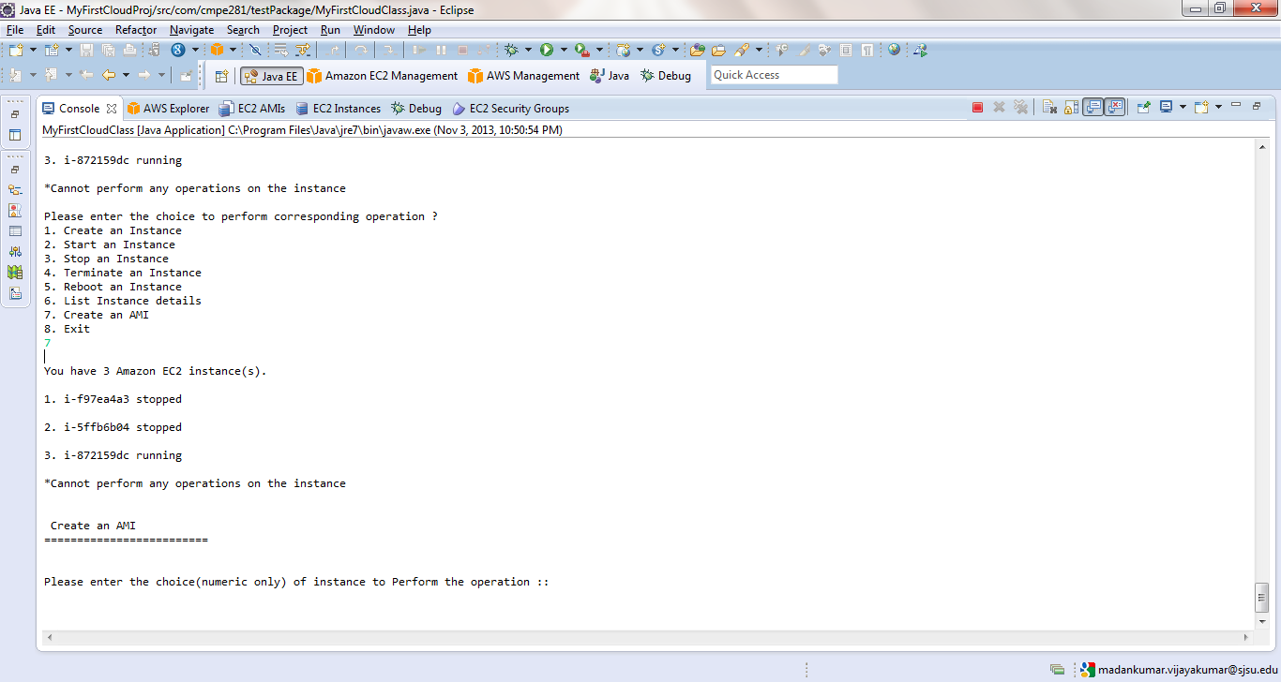**

Choice was entered and machine image was created.

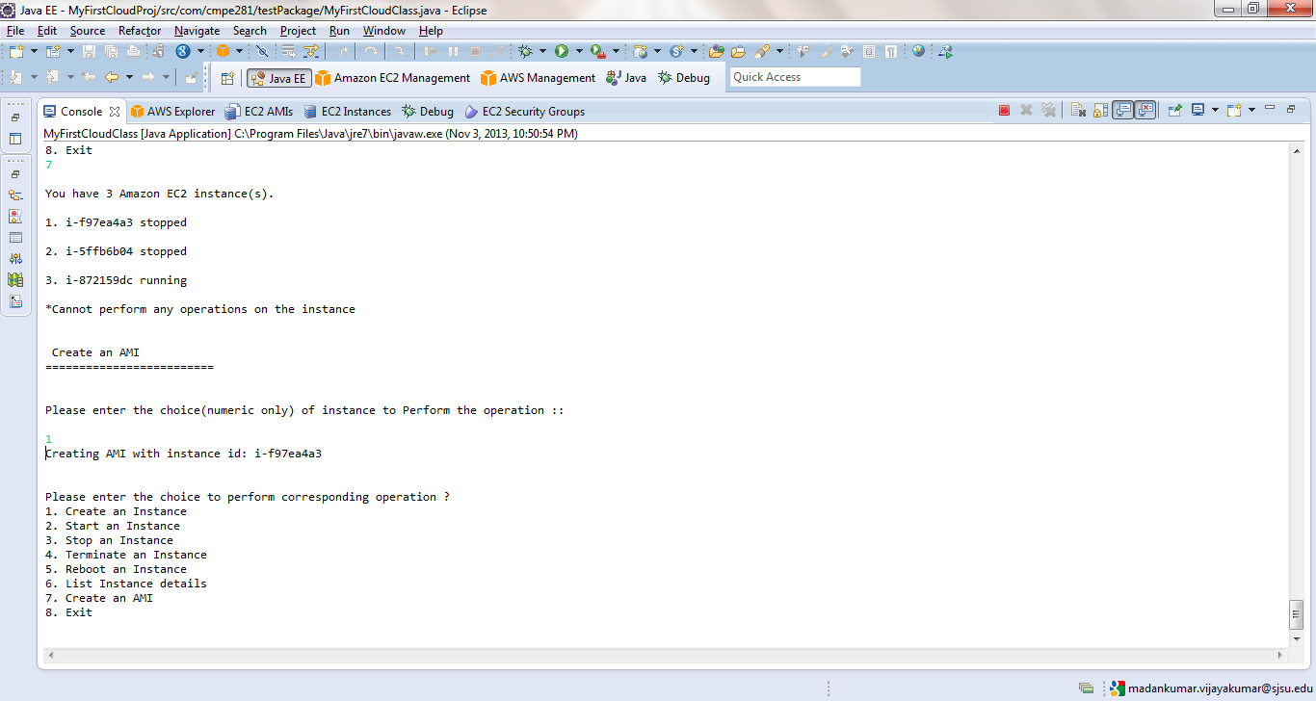

AWS console shows the machine image that was created and stored in EBS volume.

**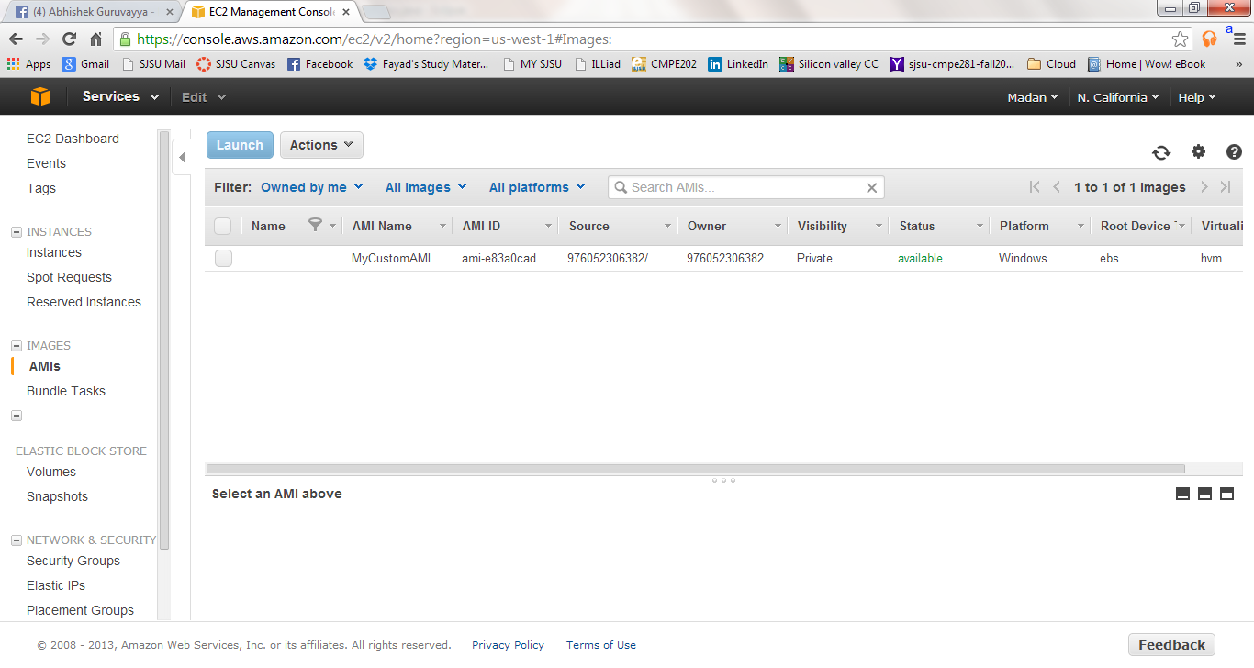**

Listing the instances using choice 6. A instance was created and kept in running state.

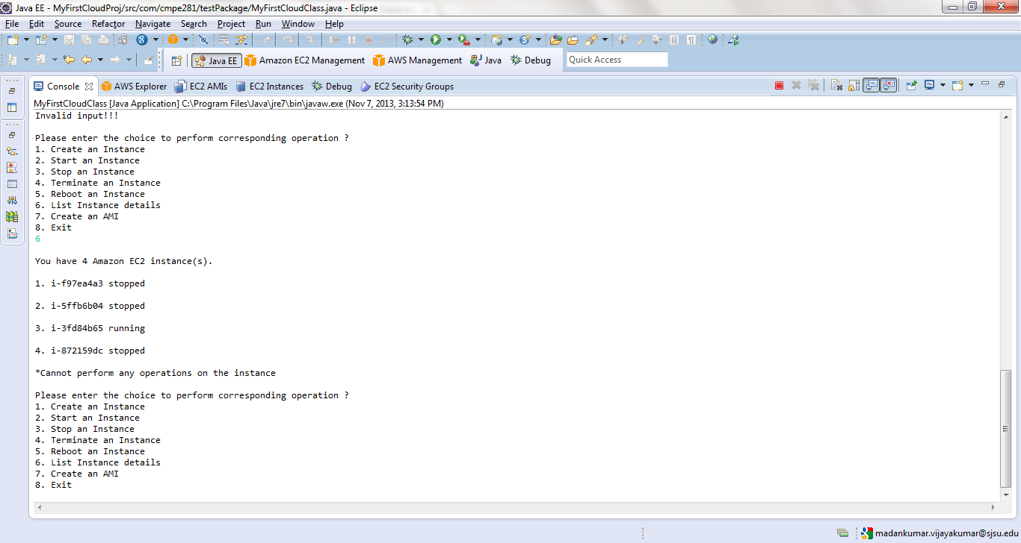

Entered a choice to terminate a instance. Application listed down the available instance on which operation can be performed. Note that Running instance cannot be terminated.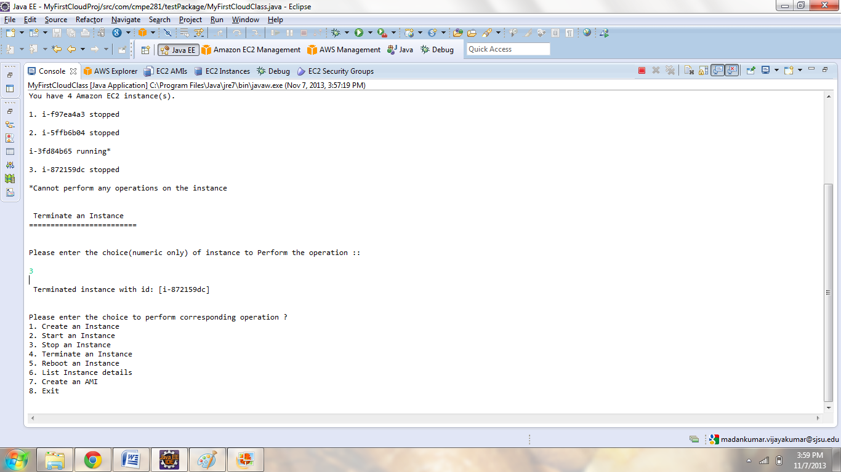

Enter the choice to select the instance to terminate.

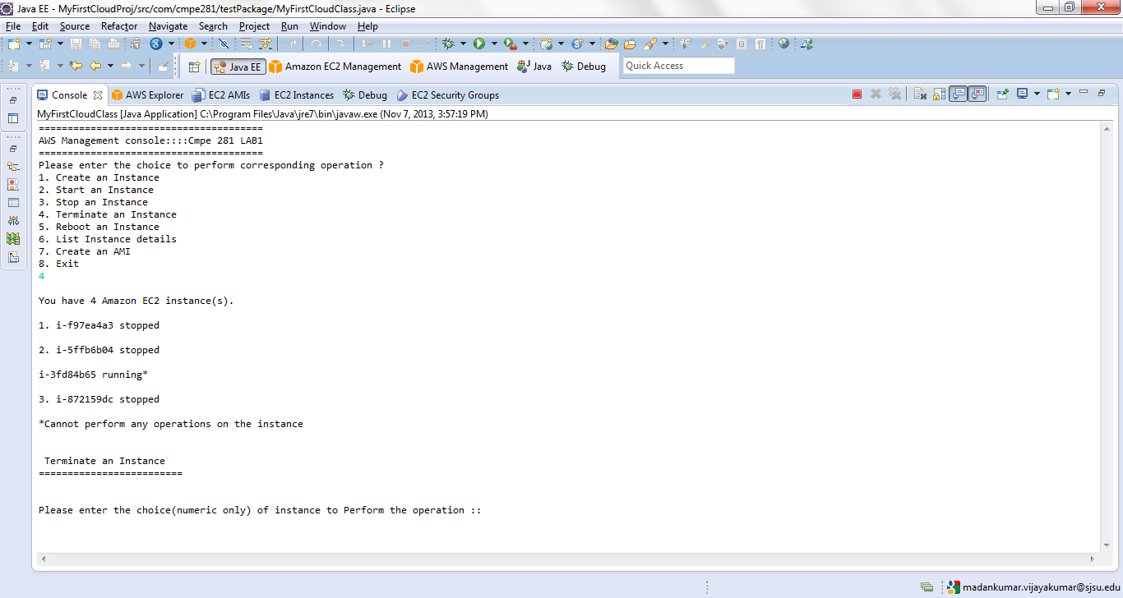

Application was terminated using choice 8.

# D:\Madan\SJSU\CloudTech_CMPE_281\Lab1\Screen-grab\image19.png

# 3.0 Reference

http://docs.aws.amazon.com/AWSJavaSDK/latest/javadoc/index.html

http://aws.amazon.com/articles/5496117154196801

http://docs.aws.amazon.com/general/latest/gr/rande.html#ec2\_region