CMPE 277: Routing Application Assignment

1. The application will display maps using bing maps.
2. This utilises Bing maps and its Geolocation, Routing services.
3. The Find location will draw a new push pin which will remember the place that the user has visited.
4. Get address will return the address of the current location.
5. Route will draw a path between 2 points in the map.

Screen grabs below:

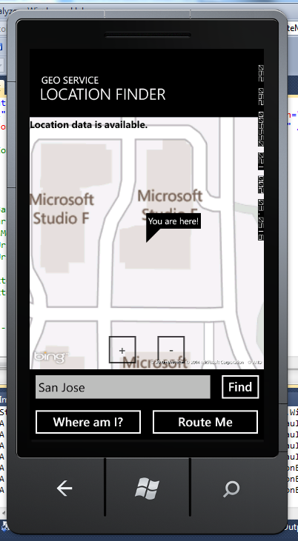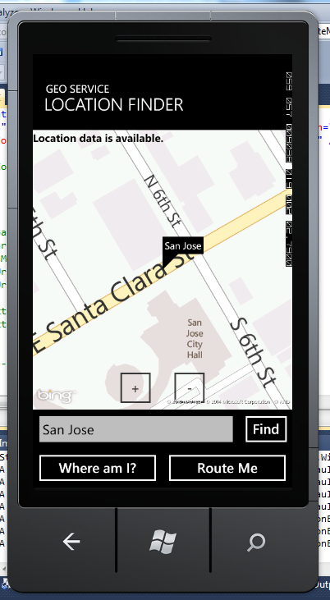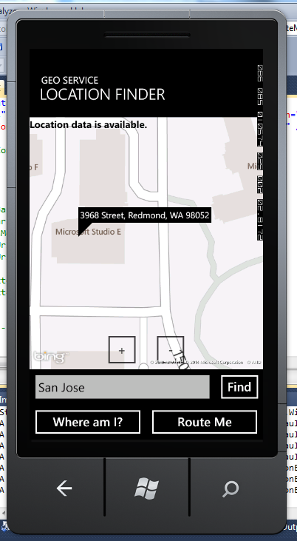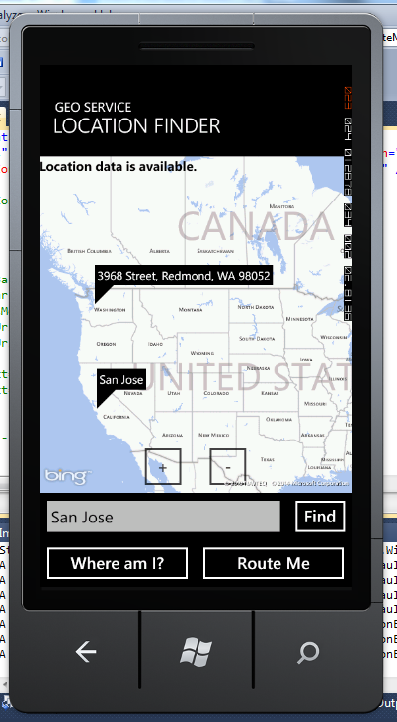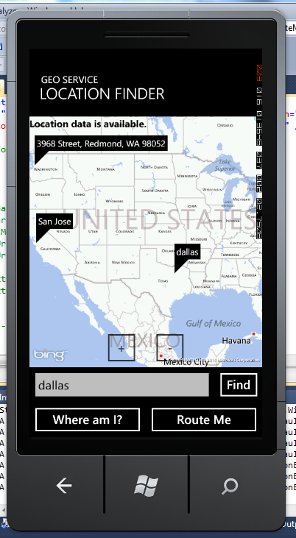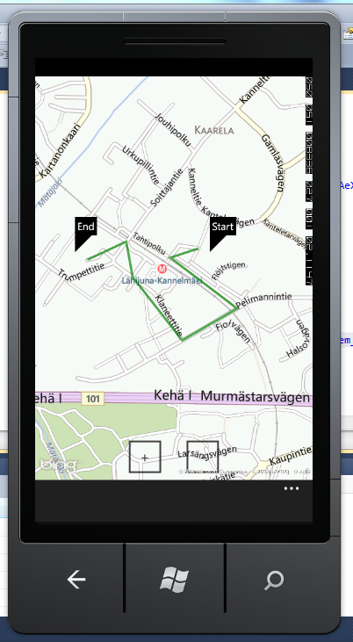

References:

* MSDN
* Microsoft developer blogs