MALLA REDDY UNIVERSITY
B.Sc Computer Science – Semester I
MR24-1BSCC17 : Stack Development Frameworks

UNIT I – Introduction to Full Stack Development

Topics covered: Web Development Concepts · Full Stack Architecture · Client-Server Model · HTTP Methods · Frontend & Backend Overview · Stack Frameworks · Node.js · MongoDB

1. Web Development – An Overview
The World Wide Web has transformed the way people communicate, share information, and conduct business. Web development is the process of building and maintaining websites and web applications that run in a browser or on a server. It encompasses everything from simple static pages to complex, dynamic applications that serve millions of users.
Web development is broadly divided into two areas:
- Frontend Development – Everything a user sees and interacts with in the browser.
- Backend Development – The server-side logic, databases, and APIs that power the application behind the scenes.

1.1 Static vs. Dynamic Web Pages
A static web page contains fixed content that looks the same every time it is loaded. It is written in plain HTML and CSS and does not change unless the developer manually updates the file. A simple company brochure page is a typical example.
A dynamic web page, on the other hand, generates content in real time based on user interactions, database queries, or server-side processing. Social media feeds, e-commerce product pages, and online banking portals are all dynamic. The server receives a request, processes it (often fetching data from a database), and returns a personalised response to each user.
Key Distinction: Static pages are fast and easy to host, but inflexible. Dynamic pages are powerful and personalised, but require a backend server and a database.

1.2 What is Web Technology?
Web technology refers to the collection of tools, languages, protocols, and standards used to build and run web applications. The core technologies are:
- HTML (HyperText Markup Language) – Defines the structure and content of a web page using elements such as headings, paragraphs, lists, images, and forms.
- CSS (Cascading Style Sheets) – Controls the visual presentation: colours, fonts, layout, and responsiveness across screen sizes.
- JavaScript – A programming language that runs in the browser and makes web pages interactive. It can also run on the server (Node.js).
- HTTP/HTTPS – The protocol through which browsers and servers communicate. HTTPS adds encryption for security.

2. Full Stack Development
Full stack development refers to the practice of working across all layers of a web application – from the user interface in the browser, through the server-side logic, down to the database. A developer who is proficient in all these layers is called a full stack developer.
The term "stack" refers to the combination of technologies used together to build an application. A typical web application stack has three layers:

2.1 The Three Layers of a Full Stack Application
Layer 1 – Frontend (Presentation Layer)
The frontend is the part of the application that runs in the user's browser. It is responsible for displaying information, capturing user input, and providing a smooth user experience. Frontend developers work with HTML, CSS, and JavaScript. Modern frontend development heavily relies on frameworks such as React, Angular, and Vue.js, which make it easier to build complex, reactive user interfaces.
Layer 2 – Backend (Application / Logic Layer)
The backend is the server-side of the application. It receives requests from the frontend, applies business logic, communicates with the database, and returns the appropriate response. Backend developers use languages and frameworks such as Node.js with Express, Python with Django or Flask, PHP with Laravel, Ruby on Rails, or Java with Spring Boot. The backend enforces rules such as authentication, data validation, and access control.
Layer 3 – Database (Data Layer)
The database stores all persistent data – user records, product catalogues, orders, and so on. Databases fall into two major categories: relational (SQL) databases such as MySQL, PostgreSQL, and SQLite, and non-relational (NoSQL) databases such as MongoDB and Redis. The backend queries the database, processes the results, and sends them to the frontend.

In Summary: A user types a URL → the browser (frontend) sends a request → the server (backend) processes it → the database returns data → the server sends a response → the browser renders the page.

2.2 Why Full Stack Development?
Full stack development has become increasingly important because:
- Startups and small teams need developers who can work across the entire product without having to hand off tasks to specialists at every stage.
- Understanding the complete system helps developers make better architectural decisions. A frontend developer who understands the database schema can write more efficient API calls.
- Full stack developers can prototype and ship features end-to-end, accelerating the development cycle.
- It provides career flexibility – a full stack developer can contribute to any part of the project and move between roles as needed.

3. Client–Server Architecture
Client–server architecture is a computing model that divides the workload between two types of entities: clients, which request services, and servers, which provide them. Almost every web application in use today is built on this model.
A client is typically a browser (Chrome, Firefox, Safari) running on a user's device. The server is a remote computer that is always on and connected to the internet, waiting to handle incoming requests. The two communicate using the HTTP (or HTTPS) protocol over the internet.

3.1 Types of Architecture
1-Tier Architecture (Single-Tier or Monolithic Model)
In a single-tier model, the entire application – the interface, logic, and data storage – resides on the same machine. Desktop applications that store their data locally are a common example. While simple to deploy, they are not suitable for multi-user or internet-facing applications.
Example Use Cases:
- Microsoft Excel
- Personal finance tools that store and compute everything locally
Pros:
- Simple to build and deploy
- No network communication overhead
Cons:
- Not scalable
- No separation of concerns
- Unsuitable for multi-user environments
Best suited for small, standalone, offline applications.

2-Tier Architecture (Client–Server)
Here the client (interface) and the server (data/logic) are separated onto two distinct machines. The client sends requests directly to the database server. This is faster than a single-tier setup but becomes problematic as user numbers scale, since the database server must handle both application logic and data storage.
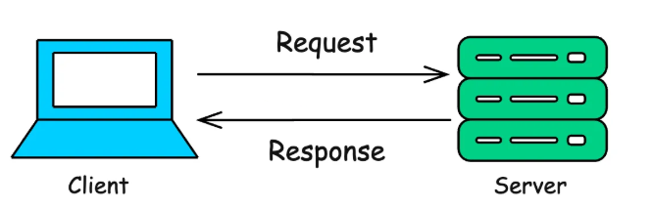

Example Use Case:
- A desktop application that connects directly to a central database to retrieve and display data.
Pros:
- Simple and fast for a small number of users
- Easy to implement
Cons:
- Poor scalability as more clients are added
- Performance bottlenecks on the server
- Difficult to update logic across different clients
Suitable for internal tools or apps with a small user base and limited traffic.

3-Tier Architecture (Recommended for Web Applications)
Three-tier architecture is the standard model for modern web applications. It separates concerns into:
- Presentation Tier – The browser or mobile app that the end user interacts with.
- Application Tier – The web server running the backend logic (e.g., a Node.js or Django server).
- Data Tier – The database server (e.g., MySQL or MongoDB) that stores and retrieves data.
This separation means each tier can be scaled, updated, and secured independently. If the application tier is under heavy load, more server instances can be added without touching the database or the frontend code.
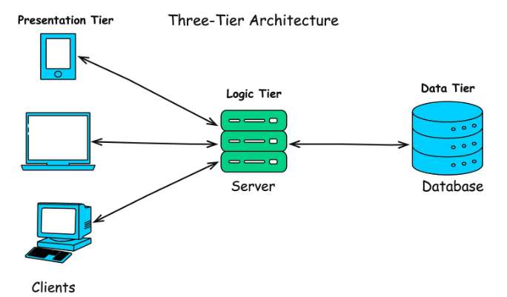

Example: A web application where the client (browser) interacts with a web server (application server) that then queries a database server to retrieve data.
Pros:
- Better scalability and maintainability
- Logic is centralized, so clients are lightweight
- Improved security and abstraction
Cons:
- More complex than 1- or 2-tier setups
- Slightly increased latency if layers aren't optimized
Ideal for web apps, SaaS products, and large internal tools.

Advantage of 3-Tier: Separation of concerns makes the system more maintainable, scalable, and secure. Each tier can be deployed on separate machines or cloud services.

3.2 The Request–Response Cycle
The HTTP request–response cycle is the fundamental mechanism by which a browser communicates with a server. In another words, The request–response cycle is the process where a client sends a request to a server, the server processes it (possibly using a database), and then sends a response back to the client. It works as follows:
- The user types a URL into the browser or clicks a link.
- The browser resolves the domain name to an IP address using DNS (Domain Name System).
- The browser opens a TCP connection to the server on port 80 (HTTP) or 443 (HTTPS).
- The browser sends an HTTP request containing the method (GET, POST, etc.), the path, headers, and optionally a body.
- The server receives the request, processes it (runs backend code, queries the database if needed), and prepares a response.
- The server sends an HTTP response containing a status code, headers, and a body (HTML, JSON, or other data).
- The browser receives the response, parses the HTML/CSS/JS, and renders the page for the user.

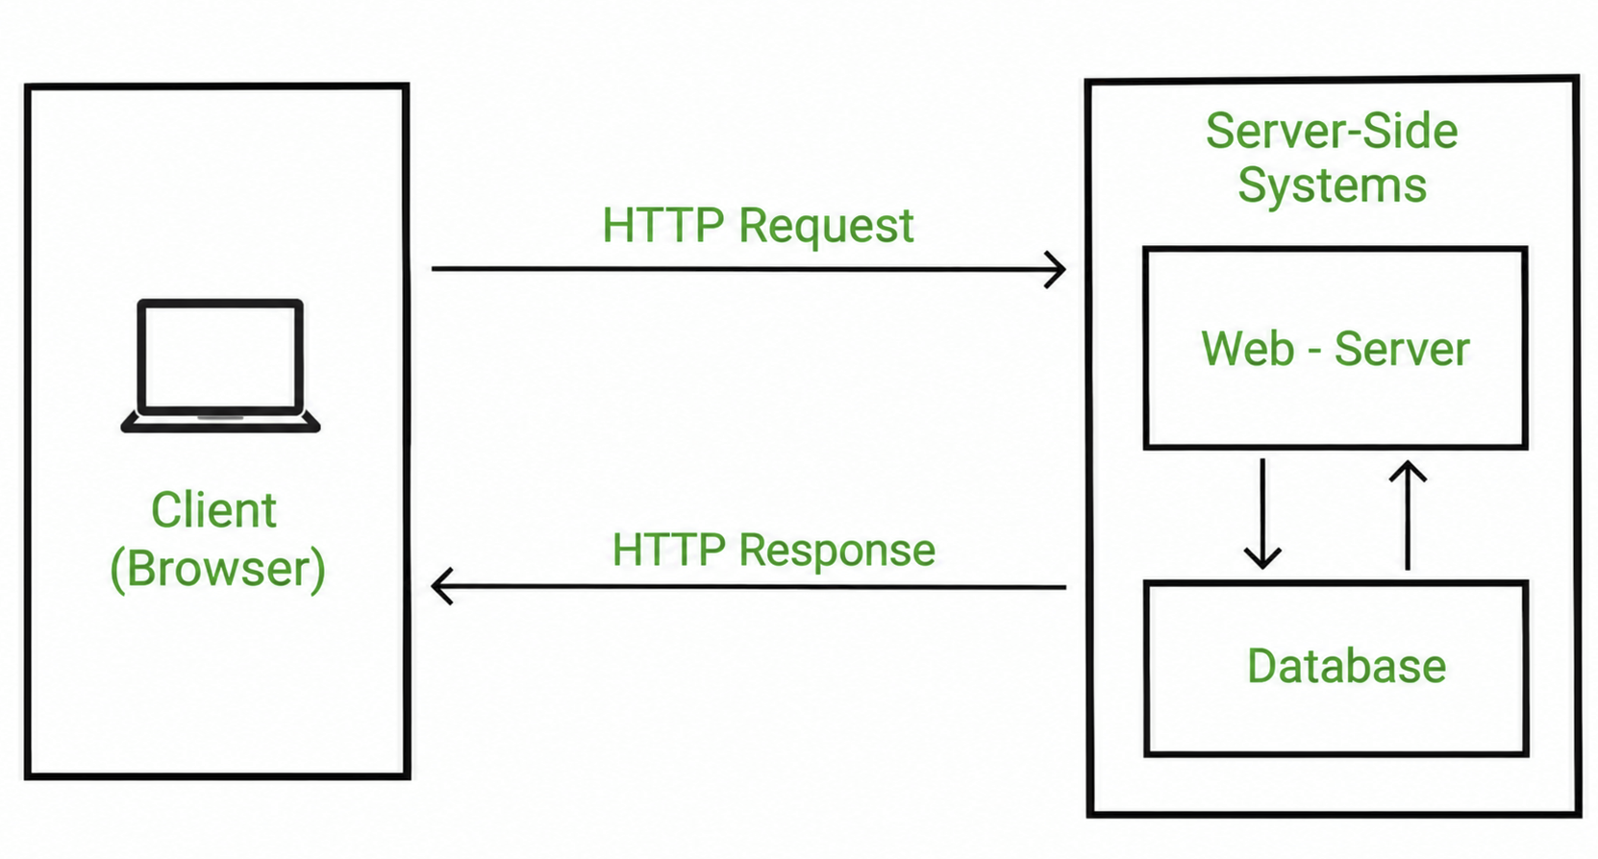

Request-Response Flow

Step | Actor | Action
1 | Browser (Client) | Sends HTTP GET /index.html to server
2 | Network | Request travels through internet / DNS resolution
3 | Web Server | Receives request, runs application logic
4 | Database | Server queries database if data is needed
5 | Web Server | Builds HTTP response (status 200, HTML body)
6 | Browser (Client) | Receives response, renders the page

4. HTTP Methods
HTTP (HyperText Transfer Protocol) defines a set of request methods that indicate the action to be performed on a given resource. These methods correspond to the four basic operations of data management, commonly abbreviated as CRUD – Create, Read, Update, Delete.

HTTP Method | CRUD Operation | Purpose | Example
GET | Read | Retrieve a resource from the server. Data is sent in the URL (query string). | GET /students?id=101
POST | Create | Submit data to the server to create a new resource. Data is in the request body. | POST /students (with JSON body)
PUT | Update | Replace an existing resource entirely with new data sent in the body. | PUT /students/101
PATCH | Partial Update | Update specific fields of an existing resource without replacing it entirely. | PATCH /students/101
DELETE | Delete | Remove a resource from the server. | DELETE /students/101

4.1 GET vs POST – Key Differences
GET and POST are the two most commonly used HTTP methods. Understanding their differences is important:
Feature | GET | POST
Purpose | Retrieve data from server | Send data to server
Data Location | Appended to URL as query string | Sent in the request body
Visibility | Data visible in browser address bar | Data not visible in URL
Security | Less secure – data in URL can be logged or bookmarked | More secure for sensitive data
Idempotent? | Yes – multiple identical requests give the same result | No – each request may create a new resource
Example Use | Search queries, loading a page | Login forms, file uploads, placing orders

4.2 Status Codes
Every HTTP response includes a three-digit status code that tells the client the outcome of its request. Status codes are grouped by their first digit:
- 1xx – Informational: Request received, continuing process.
- 2xx – Success: The request was successfully received and processed. (e.g., 200 OK, 201 Created)
- 3xx – Redirection: Further action must be taken. (e.g., 301 Moved Permanently)
- 4xx – Client Error: The request was malformed or unauthorised. (e.g., 400 Bad Request, 401 Unauthorized, 404 Not Found)
- 5xx – Server Error: The server failed to fulfil a valid request. (e.g., 500 Internal Server Error)

5. Frontend Technologies
The frontend of a web application is everything the user sees and interacts with. It is built using three core technologies: HTML for structure, CSS for styling, and JavaScript for behaviour. Modern frontend development also makes use of frameworks and libraries that abstract repetitive patterns and enable the building of complex single-page applications (SPAs).

5.1 HTML5
HTML5 is the latest version of HyperText Markup Language. It introduced semantic elements such as <header>, <nav>, <main>, <article>, <section>, and <footer> that give meaning to the document structure rather than relying on generic <div> tags. HTML5 also brought native support for audio and video elements, canvas for graphics, and local storage for offline data, reducing the need for third-party plugins like Adobe Flash.

5.2 CSS3
CSS3 added powerful capabilities on top of earlier CSS standards, including:
- Flexbox and Grid – Two layout systems that make it straightforward to create responsive designs that adapt to any screen size.
- Animations and Transitions – Smooth visual effects without JavaScript.
- Media Queries – Rules that apply different styles depending on the device screen width, enabling mobile-responsive design.
- Custom Properties (Variables) – Reusable values defined once and referenced throughout the stylesheet.

5.3 JavaScript (ES6+)
JavaScript is the only programming language that runs natively in the browser. ES6 (ECMAScript 2015) and later versions introduced significant improvements:
- let and const – Block-scoped variable declarations replacing the older var.
- Arrow Functions – A concise syntax for writing function expressions.
- Template Literals – String interpolation using backticks and ${} syntax.
- Promises and async/await – A clean way to handle asynchronous operations (e.g., API calls).
- Destructuring and Spread Operator – Concise ways to extract and combine data from arrays and objects.
- Modules – The import/export system for organising code into separate files.

5.4 Frontend Frameworks
While HTML, CSS, and JavaScript are sufficient to build any web page, large applications benefit from using a framework. Frontend frameworks provide a structured way to build and manage complex user interfaces.
Framework | Maintained by | Key Concept | Best For
React | Meta (Facebook) | Component-based UI, Virtual DOM, one-way data flow | Large SPAs, dynamic dashboards
Angular | Google | Full MVC framework, TypeScript, two-way data binding | Enterprise applications
Vue.js | Community | Lightweight, progressive, easy learning curve | Medium apps, rapid prototyping

Here is each UI framework explained in depth with its features and pros and cons.

1) React
React is a JavaScript library for building user interfaces, particularly interactive and component-based web applications. It was originally developed at Facebook (now Meta) and is now governed by the React Foundation under the Linux Foundation. React allows developers to divide an application into reusable components and efficiently update the UI when data changes.
Key Concepts
- Component-based architecture – UI is divided into reusable components.
- Declarative UI – Developers describe what the UI should look like for a given state.
- One-way data flow – Data generally flows from parent components to child components.
- Virtual DOM / efficient rendering – React uses mechanisms that minimize unnecessary DOM updates.
- JSX – Allows HTML-like syntax to be written within JavaScript.
- Hooks – Features such as useState and useEffect allow components to use state and other React capabilities.
Real Examples
React is used extensively in production. The React project itself notes that Meta has more than 100,000 React components in use, and React is used across large-scale web and native applications.
Use Cases
React is commonly used for:
- Single Page Applications (SPAs)
- SaaS applications
- E-commerce applications
- Social media interfaces
- Admin dashboards
- Interactive websites
- Data visualization interfaces
Pros
- Reusable components
- Large ecosystem and community
- Flexible architecture
- Good for highly interactive applications
- Can be used for both web and native applications through React Native
Cons
- React itself does not provide everything needed for a complete application.
- Developers often need additional libraries for routing, state management, etc.
- Many available choices can make architecture decisions difficult.
- Large applications require good component and state management practices.

2. Angular
Angular is a full-featured web application framework maintained by Google. It uses TypeScript and provides a structured platform containing components, routing, forms, dependency injection, HTTP tools, testing support, and other features needed for building large applications.
Key Concepts
- Component-based architecture
- TypeScript
- Dependency Injection
- Routing
- Forms and validation
- Services
- Angular CLI
- Signals and reactive programming
- Server-side rendering (SSR) and static-site generation (SSG)
Angular provides many of these capabilities as part of its broader framework rather than requiring developers to assemble everything themselves.
Real Examples
Angular is used in large-scale applications. Angular's documentation specifically mentions Google Cloud and Google Fonts among Google's large products that build on Angular's architecture.
Use Cases
Angular is commonly suitable for:
- Enterprise applications
- Banking/business portals
- Large dashboards
- CRM/ERP applications
- Complex Single Page Applications
- Applications with large development teams
Pros
- Complete frontend framework
- Strong project structure
- TypeScript support
- Built-in routing and forms
- Dependency Injection
- Powerful CLI
- Suitable for large teams and large applications
- Long-term support and predictable release approach
Cons
- Steeper learning curve
- More concepts to learn
- Can feel heavy for small applications
- Requires understanding of TypeScript and Angular-specific concepts
- More opinionated than React

3. Vue.js
Vue.js is a progressive JavaScript framework for building user interfaces. It uses a component-based and declarative programming model and is designed to be incrementally adoptable, meaning it can be used for a small part of an existing webpage or for a complete Single Page Application.
Key Concepts
- Component-based architecture
- Reactive data binding
- Declarative rendering
- Single File Components (SFC)
- Composition API
- Vue Router
- State management ecosystem
- Progressive/incremental adoption
Vue's Single File Components allow template, script, and component-specific styling to be organized together in a .vue file.
Real Examples
Vue's official documentation lists organizations using Vue in production, including Wikimedia Foundation, NASA, Apple, Google, Microsoft, GitLab, Zoom, Tencent, Weibo, and Bilibili.
Use Cases
Vue is commonly used for:
- Single Page Applications
- Admin dashboards
- SaaS applications
- E-commerce interfaces
- Interactive websites
- Existing applications that need incremental UI enhancement
- Rapid application development
Vue can also be used for SSR, SSG, Web Components, and other frontend scenarios.
Pros
- Relatively easy to learn
- Clean and readable syntax
- Component-based development
- Reactive data binding
- Flexible and incrementally adoptable
- Good documentation
- Can scale from small UI enhancements to complete applications
Cons
- Smaller ecosystem and market presence than React in many markets
- Large applications may require additional ecosystem tools
- Teams need to establish appropriate project conventions
- Developer availability can vary by region

6. Backend Technologies
The backend is responsible for the core logic of the application. It processes requests from the frontend, applies business rules, communicates with the database, and returns data in a format the frontend can use (typically JSON or HTML). The backend also handles authentication, session management, file storage, and integration with external services.

6.1 Backend Responsibilities
- Authentication and Authorisation – Verifying who the user is and what they are allowed to do.
- Business Logic – Implementing the rules that govern how the application behaves (e.g., calculating an invoice total, applying discounts, checking inventory).
- Database Interaction – Running queries, inserting, updating, and deleting records.
- API Endpoints – Providing a well-defined interface through which the frontend (or mobile apps) can request data.
- Security – Protecting against SQL injection, cross-site scripting (XSS), cross-site request forgery (CSRF), and other attacks.

6.2 Popular Backend Frameworks
Framework | Language | Strengths | Typical Use Case
Node.js + Express | JavaScript | Non-blocking I/O, real-time apps, large ecosystem (npm) | REST APIs, chat apps, streaming
Django | Python | Batteries-included, ORM, admin panel, rapid development | Data-driven websites, APIs
Flask | Python | Lightweight, minimal, highly flexible | Microservices, small APIs
Laravel | PHP | Elegant syntax, rich ecosystem, Blade templating | Web portals, e-commerce
Ruby on Rails | Ruby | Convention over configuration, rapid prototyping | Startups, CRUD applications
Spring Boot | Java | Robust, enterprise-grade, strong typing | Large enterprise systems

Here are some of the backend technologies explained in detail.
1. Node.js
What is Node.js?
Node.js is an open-source, cross-platform JavaScript runtime environment that allows developers to execute JavaScript code on the server side (outside the browser). It compiles JavaScript directly into machine code for fast execution.
Before Node.js, JavaScript could only run inside a web browser. Node.js changed this by bringing JavaScript to the server, making it possible to build complete web applications using a single programming language on both the front end and back end.
Node.js follows an event-driven, non-blocking I/O model, which means it can handle thousands of simultaneous connections without creating a new thread for each one — unlike traditional server technologies.
Features of Node.js
- Asynchronous and Non-Blocking I/O — Node.js does not wait for an operation (like reading a file or querying a database) to complete before moving to the next task. This makes it highly efficient for I/O-heavy operations.
- Fast Execution — Powered by the V8 engine, which compiles JavaScript to native machine code before execution. This makes Node.js significantly faster than interpreted languages.
- NPM (Node Package Manager) — Node.js comes with npm, the largest ecosystem of open-source libraries in the world with over 2 million packages. Developers can install ready-made solutions for almost any feature.
- Cross-Platform — Node.js applications can run on Windows, macOS, and Linux without modification.
- Streaming — Node.js can process large files in chunks (streams) instead of loading the entire file into memory, which is efficient for video/audio streaming.
Use Cases
Node.js is best suited for applications that involve a large number of concurrent connections with low-latency data exchange. Its strengths show when building:
- RESTful APIs — serving JSON data to web or mobile front ends
- Real-time applications — live chat applications, collaborative tools, online gaming
- Microservices architecture — lightweight, independently deployable services
- Streaming platforms — processing and serving media in chunks
- Single-page applications (SPAs) — back-end services for React or Angular front ends
- IoT (Internet of Things) — handling streams of data from many devices simultaneously

Companies Using Node.js
Netflix | Reduced startup time by 70%; uses Node.js for its UI layer
LinkedIn | Switched from Ruby on Rails to Node.js — 2–10× performance improvement
PayPal | Rebuilt their account overview page; 35% faster response time
Uber | Core matching and dispatch systems built on Node.js
NASA | Handles EVA suit data in real time
Walmart | - Handles Black Friday traffic — 98% uptime with Node.js

Pros and Cons
Pros:
- Excellent performance for I/O-bound and real-time workloads
- One language (JavaScript) across the full stack reduces context switching
- Massive npm ecosystem — almost any functionality is available as a package
- Large, active community with strong corporate backing (OpenJS Foundation)
- Easy to scale horizontally by running multiple Node.js instances
- JSON is the native data format, making API development seamless
Cons:
- Not suitable for CPU-intensive tasks (heavy computation blocks the event loop)
- Callback-heavy code can become difficult to read and maintain ("callback hell"), though Promises and async/await mitigate this
- Being single-threaded, a bug that crashes the process takes down the entire application
- Rapid changes in the npm ecosystem can introduce security vulnerabilities
- Relatively weaker for complex business logic compared to Java or C#

2. Django
What is Django?
Django is a high-level, open-source Python web framework that enables rapid development of secure and maintainable web applications
Django follows the MVT (Model-View-Template) architectural pattern, which is Django's variation of the classic MVC (Model-View-Controller) pattern. It is designed around the philosophy of "Don't Repeat Yourself" (DRY) and "convention over configuration", meaning Django provides sensible defaults and built-in components so developers can focus on writing application logic rather than boilerplate code.
Its famous tagline is: "The web framework for perfectionists with deadlines."

Features of Django
- Built-in Admin Panel — Django automatically generates a fully functional admin interface from your models. Administrators can manage data (create, read, update, delete) without writing a single line of UI code. This is one of Django's most distinctive features.
- ORM (Object-Relational Mapper) — Django's ORM allows developers to interact with databases using Python code instead of raw SQL. You define your data models as Python classes, and Django handles all database operations. It supports PostgreSQL, MySQL, and SQLite.
- Authentication System — Django includes a complete, ready-to-use authentication system covering user registration, login, logout, password reset, sessions, and permissions.
- URL Routing — Django uses a clean, elegant URL dispatcher (urls.py) that maps URL patterns to view functions or classes. This makes URL design readable and maintainable.
- Template Engine — Django's template system allows embedding dynamic data into HTML files using simple template tags like {{ variable }} and {% if %}, keeping business logic separate from presentation.
- Security Built-In — Django protects against common web vulnerabilities by default: SQL injection, Cross-Site Scripting (XSS), Cross-Site Request Forgery (CSRF), Clickjacking, and more. Developers do not need to handle these manually.
- Django REST Framework (DRF) — A powerful third-party package that extends Django to build RESTful APIs quickly with serializers, viewsets, authentication, and browsable API documentation.

Use Cases
Django is best suited for data-driven web applications that need to go from development to production quickly, particularly where security and maintainability are priorities:
- Web portals and content management systems — news sites, blogs, publishing platforms
- E-commerce platforms — product catalogs, order management, payment integration
- Government and institutional websites — where security compliance is mandatory
- RESTful APIs (with DRF) — back-end services for mobile apps and SPAs
- Healthcare and fintech applications — where auditability and security are critical

Companies Using Django
Instagram | Originally built entirely on Django; still uses it for core back-end services
Pinterest | Back-end infrastructure for one of the world's largest image-sharing platforms
Mozilla(Browser) | Firefox support site and other Mozilla web properties
Spotify | Data services and back-end tooling

Pros and Cons
Pros:
- Extremely fast development — the built-in admin, ORM, and auth save weeks of work
- "Batteries included" philosophy — everything needed for a full web app is in the framework
- Python ecosystem — access to NumPy, Pandas, TensorFlow, etc., making Django ideal for AI/ML-integrated web apps
- Well-documented with a large, stable community and long-term support (LTS) releases
- Clean, readable code enforced by Python's syntax
Cons:
- Monolithic by default — breaking it into microservices requires more effort than Node.js
- The ORM, while powerful, can generate inefficient SQL for complex queries; raw SQL is sometimes needed
- Can feel too heavy and opinionated for small, simple APIs where a lightweight framework like Flask or FastAPI would be faster to set up
- Slower request throughput compared to Node.js or Go for high-concurrency scenarios

7. Databases – SQL and NoSQL
A database is an organised collection of data stored electronically. Every web application that needs to persist data (users, orders, posts, products) uses a database. Databases fall into two broad categories: relational (SQL) and non-relational (NoSQL).

7.1 SQL Databases (Relational)
Relational databases store data in structured tables made up of rows and columns. Each table represents one entity (e.g., Users, Products). Tables can be related to each other using foreign keys, and data is retrieved using Structured Query Language (SQL). Examples include MySQL, PostgreSQL, MariaDB, and SQLite.
Key characteristics:
- Schema-based – The structure (columns, data types, constraints) must be defined before data is inserted.
- ACID Compliance – Transactions are Atomic, Consistent, Isolated, and Durable, ensuring data integrity even in the event of failure.
- Joins – Data from multiple related tables can be combined in a single query.
- Best for structured, relational data where consistency is critical (e.g., banking, ERP systems).

7.2 NoSQL Databases (Non-Relational)
NoSQL databases store data in formats other than tables. The most common type is document-oriented (e.g., MongoDB), where data is stored in JSON-like documents. Other types include key-value stores (Redis), column-family stores (Cassandra), and graph databases (Neo4j).
Key characteristics:
- Schema-less – Documents in the same collection can have different fields. This provides flexibility when data structures are evolving.
- Horizontal Scalability – NoSQL databases are designed to scale out across many servers, making them suitable for very large datasets.
- High Performance for Read/Write Operations – Particularly effective for applications with high throughput and varied data shapes.
- Best for unstructured or semi-structured data, real-time applications, and applications that require flexible schemas (e.g., social media, IoT).

Feature | SQL (Relational) | NoSQL (Non-Relational)
Data Storage | Tables (rows & columns) | Documents, key-value, graph, column
Schema | Fixed, defined in advance | Flexible, schema-less
Query Language | SQL (standardised) | Varies by database (e.g., MongoDB Query Language)
Transactions | ACID-compliant | Eventual consistency (BASE model)
Scaling | Vertical (scale up) | Horizontal (scale out)
Examples | MySQL, PostgreSQL, SQLite | MongoDB, Redis, Cassandra
Best For | Complex queries, structured data | High volume, flexible data, real-time apps

8. Full Stack Frameworks and Technology Stacks
A technology stack (or software stack) is a set of technologies that work together to build a complete web application. Each stack defines the language, framework, and database used at each tier. Choosing the right stack depends on the project requirements, team expertise, performance needs, and ecosystem maturity.

8.1 The MEAN Stack
MEAN stands for MongoDB, Express.js, Angular, and Node.js. All four technologies use JavaScript, which means a development team can write code in a single language across the entire application – from the browser to the server and the database.
- MongoDB – NoSQL document database. Stores data in BSON (Binary JSON) format.
- Express.js – Lightweight web application framework for Node.js. Handles routing, middleware, and HTTP utilities.
- Angular – A full-featured, Google-maintained frontend framework using TypeScript.
- Node.js – JavaScript runtime built on Chrome's V8 engine. Enables server-side JavaScript.
MEAN is well suited for real-time applications, single-page applications, and teams that want to use JavaScript throughout.
Features
- Component-based frontend development
- TypeScript support
- REST API development
- MongoDB's flexible document-based storage
- Built-in Angular features such as routing and forms
- Suitable for large and structured applications
Examples
- Enterprise web portals
- Employee management systems
- CRM applications
- E-commerce applications
- Admin dashboards
Use Cases
MEAN is well suited for large Single Page Applications (SPAs), enterprise applications, business portals, dashboards, and applications requiring a structured frontend architecture.
Pros
- Complete and structured frontend framework
- TypeScript improves code organization and maintainability
- JavaScript/TypeScript ecosystem across the stack
- Large ecosystem and community
- Good for large-scale applications
Cons
- Angular has a comparatively steep learning curve
- More concepts to learn than React or Vue
- Can feel complex for small applications
- MongoDB is not ideal for every type of relational data

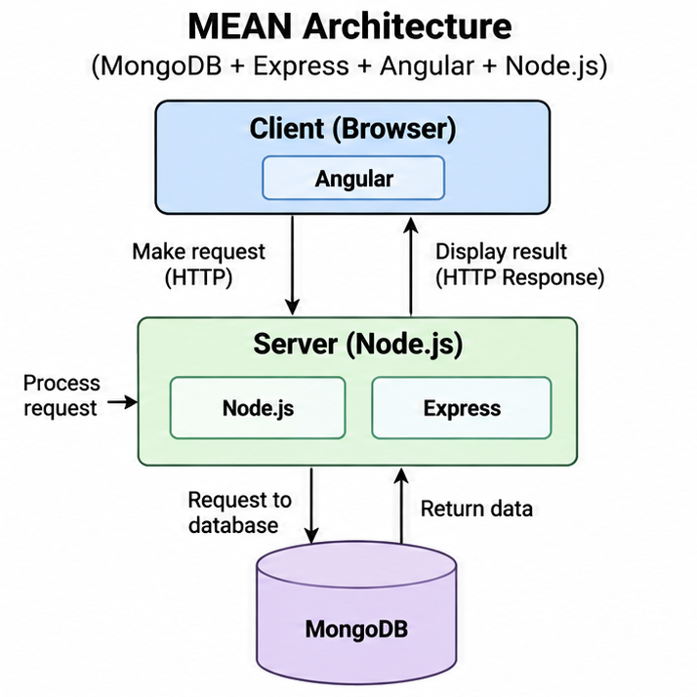

8.2 The MERN Stack
MERN stands for MongoDB, Express.js, React, and Node.js. It is a popular full-stack JavaScript technology stack where React is used to build the frontend, while Node.js and Express.js handle the backend and MongoDB stores the application data.
- MongoDB – NoSQL document database. Stores data in BSON (Binary JSON) format.
- Express.js – Lightweight web framework for Node.js. Handles routing, middleware, APIs, and HTTP requests/responses.
- React – A JavaScript library for building user interfaces using reusable components. Developed and maintained by Meta.
- Node.js – JavaScript runtime built on Chrome's V8 engine. Enables server-side JavaScript execution.
Features
- Component-based UI development
- Reusable React components
- REST API development
- Fast and interactive user interfaces
- Large React ecosystem
- JavaScript across frontend and backend
- Supports Single Page Applications
Examples
- E-commerce websites
- Social media applications
- SaaS applications
- Online learning platforms
- Admin dashboards
Use Cases
MERN is well suited for modern web applications, SaaS products, Single Page Applications, dashboards, e-commerce platforms, and applications requiring highly interactive user interfaces.
Pros
- React makes UI development flexible and reusable
- Large community and ecosystem
- Easy to build interactive applications
- JavaScript can be used across frontend and backend
- Large number of available libraries and tools
- Suitable for rapid application development
Cons
- React is a library, so additional libraries are often required
- Developers need to make more architectural decisions
- Large projects can become difficult to manage without proper structure
- Too many available libraries can sometimes create confusion
- MongoDB is not suitable for every database requirement

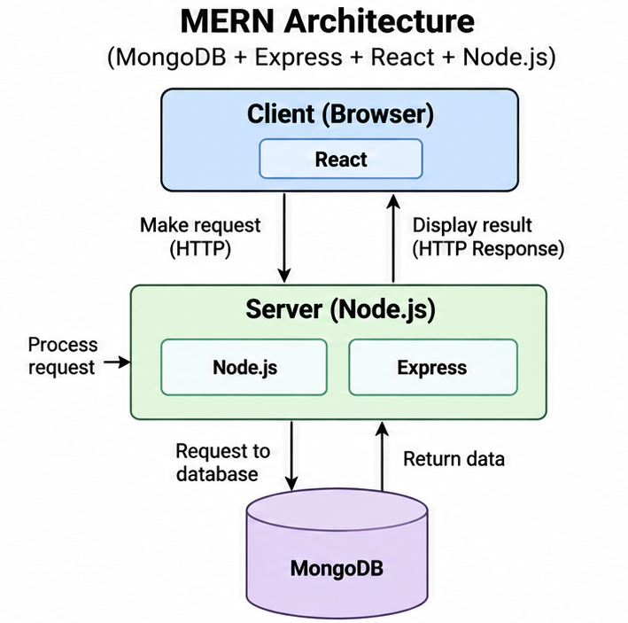

8.3 The MEVN Stack
MEVN stands for MongoDB, Express.js, Vue.js, and Node.js. It is a full-stack JavaScript technology stack where Vue.js is used for the frontend, Express.js and Node.js handle the backend, and MongoDB is used for data storage.
- MongoDB – NoSQL document database. Stores data in BSON (Binary JSON) format.
- Express.js – Lightweight web framework for Node.js. Handles routing, middleware, and HTTP requests/responses.
- Vue.js – Progressive JavaScript framework for building user interfaces using a component-based architecture.
- Node.js – JavaScript runtime built on Chrome's V8 engine. Enables server-side JavaScript execution.
Features
- Component-based UI development
- Reactive data binding
- Simple and flexible frontend development
- REST API support
- MongoDB's flexible document storage
- JavaScript across frontend and backend
- Supports Single Page Applications
Examples
- E-commerce applications
- SaaS applications
- Admin dashboards
- Content management systems
- Interactive web applications
Use Cases
MEVN is well suited for Single Page Applications, dashboards, SaaS applications, e-commerce websites, interactive websites, and applications where a lightweight and approachable frontend framework is preferred.
Pros
- Vue has a relatively gentle learning curve
- Simple and flexible component-based development
- Reactive data binding simplifies UI development
- JavaScript can be used across the application
- Good documentation and developer experience
- Easy to integrate into existing applications
Cons
- Smaller ecosystem and market adoption compared with React in many markets
- Large applications may require additional libraries and architectural decisions
- Different approaches to structuring applications can sometimes cause inconsistency
- Fewer developers may be available in some markets compared with React/Angular
- MongoDB is not suitable for every database requirement

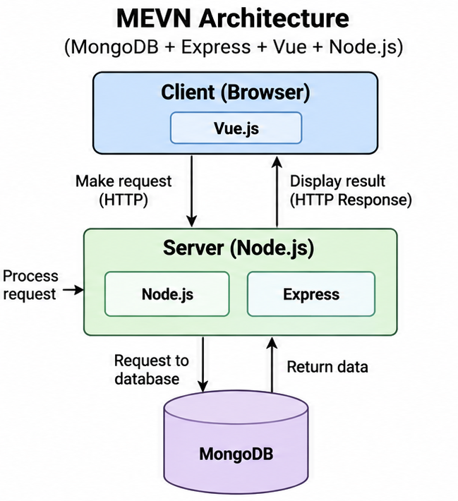

8.4 The LAMP Stack
LAMP stands for Linux, Apache, MySQL, and PHP. It is a popular open-source technology stack traditionally used to develop and deploy dynamic web applications. Unlike MEAN, MERN, and MEVN, LAMP commonly uses PHP for server-side application logic and MySQL for relational database management.
- Linux – Open-source operating system that provides the environment in which the web server and application run.
- Apache – Open-source web server that receives HTTP requests and serves static files or passes dynamic requests to PHP.
- MySQL – Relational database management system (RDBMS) used to store structured application data in tables.
- PHP – Server-side scripting language used to implement application logic and generate dynamic web content.
Features
- Open-source technologies
- Relational database using MySQL
- Server-side scripting with PHP
- Apache handles HTTP requests
- Linux provides the server operating environment
- Supports dynamic and database-driven websites
Examples
- WordPress websites
- Content Management Systems (CMS)
- E-commerce websites
- Blogging platforms
- Business websites
- Web portals
Use Cases
LAMP is well suited for content management systems, database-driven websites, blogs, e-commerce applications, business portals, and traditional server-rendered web applications.
Pros
- Open-source and widely available
- Mature and well-established technology stack
- Large PHP developer community
- MySQL provides powerful relational database capabilities
- Relatively inexpensive to deploy
- Large number of existing PHP applications and libraries
Cons
- PHP-based applications can become difficult to maintain if poorly structured
- Traditional LAMP applications are often less suited to highly interactive frontend experiences than modern SPA architectures
- Scaling complex applications may require additional architecture and infrastructure
- Apache and PHP require proper configuration for security and performance
- Developers may need separate frontend technologies for highly interactive user interfaces

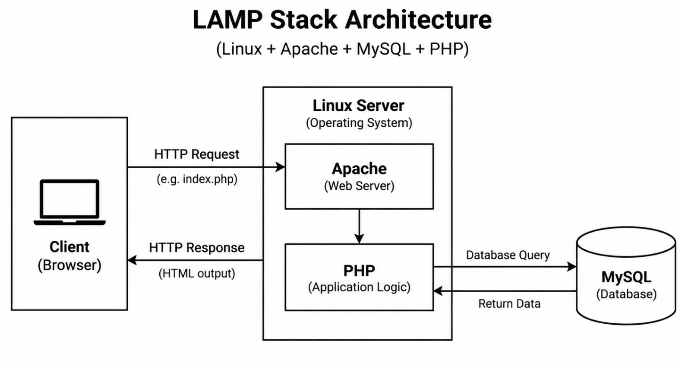

8.5 Django Stack
Django is a high-level Python web framework used to build secure, scalable, and database-driven web applications. Django follows the Model-View-Template (MVT) architecture and provides many built-in features such as URL routing, ORM, authentication, forms, middleware, and an administrative interface.

- Python – Programming language used to develop Django applications and implement business logic.
- Django – Full-featured Python web framework that handles URL routing, views, templates, authentication, middleware, and application structure.
- Models – Define the structure of application data and communicate with the database through Django's ORM (Object-Relational Mapper).
- Views – Handle HTTP requests, execute application/business logic, communicate with models, and return HTTP responses.
- Templates – HTML files used to generate and display dynamic content to the user.
- Database – Django can work with relational databases such as PostgreSQL, MySQL, SQLite, and others through its ORM.
Features
- MVT architecture for structured application development
- Built-in ORM for database operations
- Built-in authentication and authorization
- Automatic admin interface
- URL routing
- Template engine
- Form handling and validation
- Middleware support
- Security features such as CSRF protection
- Support for building REST APIs through additional packages such as Django REST Framework
Examples
- E-commerce websites
- Blogging platforms
- Learning management systems
- Content management systems
- Business applications
- Admin portals
- REST API backends
- Social networking applications
Use Cases
Django is well suited for database-driven web applications, business applications, content management systems, e-commerce platforms, REST APIs, admin portals, and applications where rapid development and a structured backend are important.
Pros
- Rapid development
- "Batteries-included" framework with many built-in features
- Powerful ORM
- Built-in authentication and admin panel
- Good security features
- Well-structured architecture
- Large Python and Django community
- Suitable for small to large applications
Cons
- Can be more complex than lightweight frameworks such as Flask
- May provide more functionality than needed for very small applications
- Django's synchronous request model can require additional architecture for some highly concurrent workloads
- Developers need to understand Django's conventions and architecture
- Highly interactive frontend applications may require React, Vue, Angular, or other frontend technologies

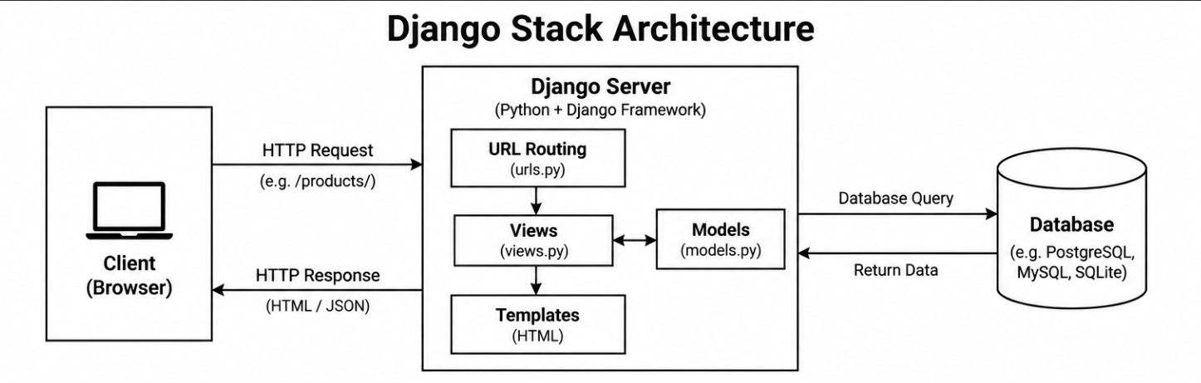

8.6 Ruby on Rails
Ruby on Rails (Rails) is a full-stack web application framework written in Ruby. It is designed to make web application development faster by providing conventions, built-in tools, and libraries for common tasks such as database operations, routing, authentication, and HTML/API responses. Rails follows the Model-View-Controller (MVC) architecture and follows the principles "Convention over Configuration" and "Don't Repeat Yourself (DRY)".
- Ruby – A high-level, object-oriented programming language used to write Rails applications and business logic.
- Rails – A full-stack web framework built with Ruby. It provides routing, controllers, views, database integration, security features, and application structure.
- Model – Represents application data and communicates with the database using Rails' Active Record ORM.
- View – Responsible for presenting data to the user, commonly using HTML templates such as ERB.
- Controller – Receives HTTP requests, executes application logic, communicates with models, and determines the response.
- Database – Rails commonly works with relational databases such as PostgreSQL, MySQL, and SQLite through Active Record.

Features
- MVC architecture for organized application development
- Active Record ORM for database operations
- Convention over Configuration
- DRY (Don't Repeat Yourself)
- Built-in URL routing
- Database migrations
- Form handling and validation
- Authentication and security support
- Built-in support for HTML and JSON responses
- Generators and scaffolding for rapid development
- Large ecosystem of Ruby gems
Examples
- E-commerce websites
- SaaS applications
- Social networking platforms
- Content management systems
- Business applications
- Online marketplaces
- REST API backends

Use Cases
Ruby on Rails is well suited for rapid development of database-driven web applications, SaaS products, e-commerce platforms, marketplaces, business applications, and applications where developer productivity and convention-based development are important.
Pros
- Very fast application development
- Strong conventions reduce configuration and boilerplate code
- Powerful Active Record ORM
- Built-in database migrations
- Large ecosystem of reusable Ruby gems
- Well-structured MVC architecture
- Good for startups and products requiring rapid development
- Mature framework with a long history
Cons
- Ruby/Rails applications can require significant resources as they scale
- Convention-heavy approach can be difficult for beginners to understand initially
- Performance may require additional optimization for very high-traffic applications
- Smaller developer market compared with JavaScript, Python, or Java in many regions
- Less commonly chosen for highly interactive frontend applications without an additional frontend technology
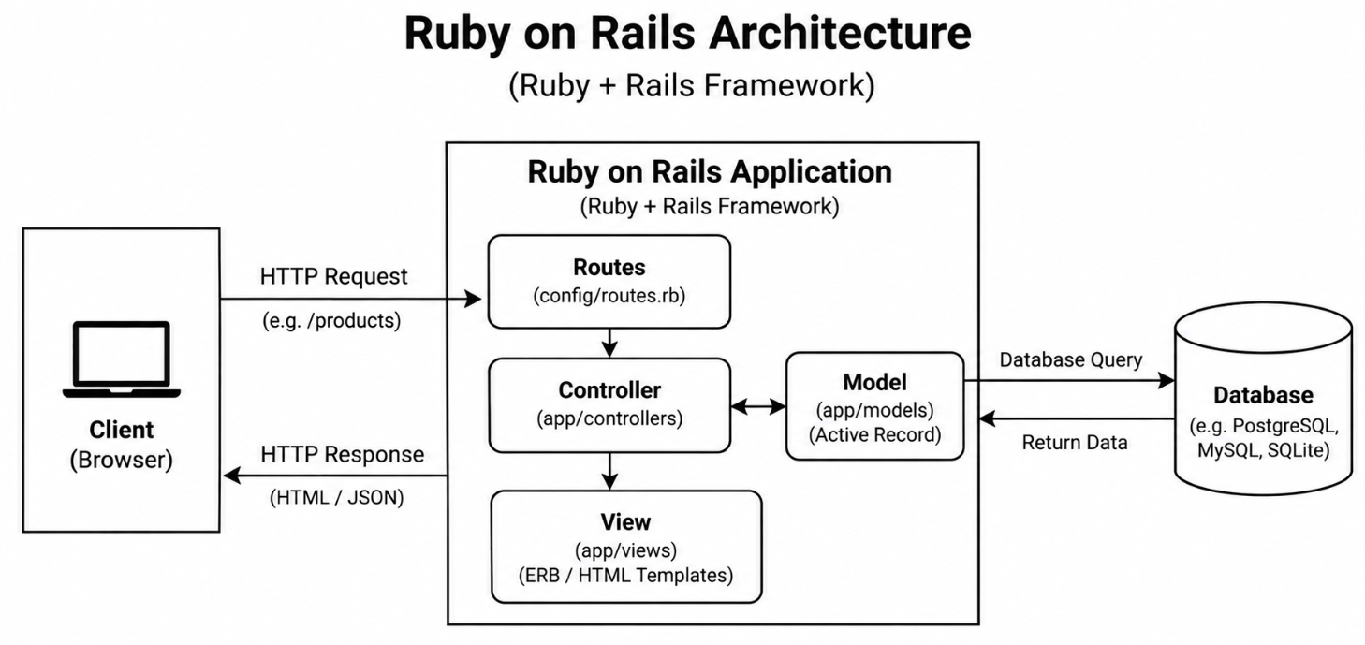

Quick Overview of all the Stack Frameworks

Stack | Frontend | Backend | Database | Language
MEAN | Angular | Node.js + Express | MongoDB | JavaScript
MERN | React | Node.js + Express | MongoDB | JavaScript
MEVN | Vue.js | Node.js + Express | MongoDB | JavaScript
LAMP | HTML/CSS/PHP | Apache + PHP | MySQL | PHP
Django Stack | HTML/CSS/JS | Python + Django | PostgreSQL / SQLite | Python
Ruby on Rails | ERB Templates | Ruby + Rails | PostgreSQL / MySQL | Ruby

9. Introduction to Node.js
Node.js is an open-source, cross-platform runtime environment that allows JavaScript to be executed outside the browser, on the server side. It was created by Ryan Dahl in 2009 and is built on Google Chrome's V8 JavaScript engine. Before Node.js, JavaScript could only run in the browser; Node.js changed this by making JavaScript a viable language for server-side development.

9.1 Key Features of Node.js
Asynchronous and Non-Blocking I/O
Traditional web servers (e.g., Apache with PHP) handle each request by creating a new thread. If one request involves a time-consuming operation – such as reading a file from disk or querying a database – that thread waits (blocks) until the operation completes, consuming memory and processor time.
Node.js uses a single-threaded event loop with non-blocking I/O. When a time-consuming operation is initiated, Node.js does not wait for it to complete. Instead, it registers a callback function and moves on to handle the next request. When the operation finishes, the callback is placed in the event queue and executed. This approach allows Node.js to handle thousands of concurrent connections with minimal overhead.
Event-Driven Architecture
Node.js is built around the concept of events and event emitters. The core of Node.js is the event loop – a mechanism that continuously polls for events (such as an incoming request, a file read completing, or a timer firing) and dispatches them to the appropriate handler. This makes Node.js particularly well suited for real-time applications such as chat servers, live dashboards, and collaborative tools.
V8 JavaScript Engine
Node.js uses Google's V8 engine, which compiles JavaScript directly to native machine code rather than interpreting it. This gives Node.js significantly better performance than older scripting-language runtimes.
Single Language Across the Stack
One of Node.js's most valued advantages is that the same language – JavaScript – can be used on both the frontend and the backend. This reduces context-switching for developers, allows code and libraries to be shared between client and server, and makes it easier to build full stack teams.

9.2 npm – Node Package Manager
npm (Node Package Manager) is the default package manager for Node.js and the world's largest software registry, hosting over two million packages. It is installed automatically with Node.js and is used to:
- Install third-party libraries (packages) into a project.
- Manage project dependencies and their versions.
- Run scripts defined in the project configuration.
- Publish and share packages with the community.

package.json
Every Node.js project contains a package.json file in its root directory. This file acts as the manifest for the project. It records the project name and version, a list of all dependencies (packages the project requires to run) and devDependencies (packages needed only during development, such as testing tools), and custom scripts that can be run with npm run <script-name>.
Example: Running "npm install express" downloads the Express package into the node_modules folder and adds it to the dependencies in package.json automatically.

9.3 Use Cases for Node.js
- REST APIs – Node.js with Express is one of the most popular combinations for building RESTful APIs.
- Real-Time Applications – Chat applications, multiplayer games, and live notifications leverage Node.js's non-blocking, event-driven nature.
- Streaming Applications – Node.js handles data streams efficiently, making it suitable for video and audio streaming services.
- Microservices – Its lightweight footprint makes Node.js a natural fit for microservice architectures.

10. Introduction to MongoDB
MongoDB is a document-oriented NoSQL database designed for high availability, high performance, and easy scalability. Released in 2009 by MongoDB, Inc., it departs from the traditional tabular relational model by storing data as flexible, JSON-like documents. This makes it a natural fit for JavaScript-based stacks such as MEAN and MERN.

10.1 Key Concepts
Documents
The fundamental unit of data in MongoDB is a document. A document is a set of key-value pairs stored in BSON (Binary JSON) format, which is similar to JSON but supports additional data types such as dates and binary data. Unlike rows in a relational table, documents within the same collection are not required to have identical fields – each document can have its own structure.
Collections
Documents are grouped into collections, which are analogous to tables in a relational database. However, because MongoDB is schema-less, a collection does not enforce a fixed structure on its documents. A "users" collection might contain documents with varying fields as long as the application logic handles the variation.
BSON Format
MongoDB stores documents internally in BSON (Binary JSON). While developers interact with MongoDB using standard JSON-like syntax, BSON adds support for data types not present in plain JSON, including 32-bit and 64-bit integers, floating-point numbers, dates, binary data, and regular expressions. BSON is also more efficient to parse than plain JSON.

10.2 MongoDB vs Relational Databases
Concept | Relational Database (MySQL) | MongoDB
Storage Unit | Row in a table | Document in a collection
Structure | Table | Collection
Schema | Fixed (defined upfront) | Flexible (schema-less)
Query Language | SQL | MongoDB Query Language (MQL)
Joins | Supported natively | Embedded documents or $lookup aggregation
Scaling | Vertical (more RAM/CPU) | Horizontal (sharding across servers)

10.3 When to Use MongoDB
MongoDB is the right choice when:
- The data model is flexible or evolving – e.g., a product catalogue where different products have different attributes.
- The application requires high write throughput – e.g., logging systems, IoT data ingestion.
- Documents are naturally nested – e.g., a blog post that contains an array of comments, each with replies.
- The development team is working with a JavaScript stack and wants to keep data representation consistent from frontend to backend to database.

Quick Revision – Important Terms

Term | Definition
Full Stack Development | Building both the frontend (UI) and backend (server + database) of a web application.
Frontend | The client-side layer rendered in the browser. Uses HTML, CSS, JavaScript.
Backend | The server-side layer handling business logic, authentication, and data processing.
Database | Persistent storage for application data. Can be SQL (structured) or NoSQL (flexible).
HTTP | HyperText Transfer Protocol – the communication protocol between browser and server.
GET | HTTP method to retrieve data from the server. Data is in the URL.
POST | HTTP method to send data to the server to create a new resource. Data is in the body.
PUT | HTTP method to replace an existing resource entirely.
DELETE | HTTP method to remove a resource from the server.
Node.js | Server-side JavaScript runtime built on Chrome's V8 engine.
npm | Node Package Manager – used to install and manage JavaScript packages.
package.json | Project manifest file listing metadata, dependencies, and scripts.
MongoDB | NoSQL document-oriented database storing data in BSON format.
BSON | Binary JSON – MongoDB's internal storage format supporting extra data types.
Collection | A group of MongoDB documents, analogous to a table in SQL.
MEAN Stack | MongoDB + Express.js + Angular + Node.js.
MERN Stack | MongoDB + Express.js + React + Node.js.
LAMP Stack | Linux + Apache + MySQL + PHP – a classic web stack.
Client-Server | A model where the client requests and the server provides services over a network.
3-Tier Architecture | Presentation + Application + Data tiers, each independently deployable.

— End of Unit I Notes —

