Chromatism

Matheus Alexandre

Cs 298 – Game Programming

Dr. Joel

09 May 2020

**Table of Contents**

**TABLE OF CONTENTS ………………………………………………………………………………………………………………………… 2**

1. **GAME OVERVIEW …………………………………………………………………………………………………………………… 3**
2. **GAMEPLAY ………………………………………………………………………………………………………………………………… 5**
3. **MECHANICS ……………………………………………………………………………………………………………………………… 8**
4. **STORY AND NARRATIVE …………………………………………………………………………………………………… 12**
5. **GAME WORLD …………………………………………………………………………………………………………………………… 14**
6. **CHARACTERS …………………………………………………………………………………………………………………………… 15**
7. **LEVELS ……………………………………………………………………………………………………………………………………… 21**
8. **INTERFACE ……………………………………………………………………………………………………………………………… 30**

**GAME OVERVIEW**

1. **Game Concept**

The concept of Chromatism is of a puzzle in which the player must solve by having to change the colors of the entire “scene” in order to progress. The game scene can be changed into four different colors, with each color displaying a new part of the puzzle that was hidden behind another color.

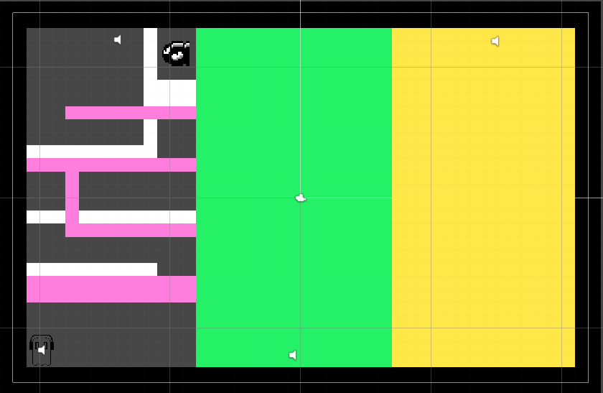

1. **Genre**

Since the game is a top-down puzzle game, Chromatism is an Action platformer.

1. **Game Flow and Style**

The main character, Napstablook, is a ghost, therefore he will be able to traverse around the screen with no gravitational forces acting upon him; however, he is stuck in the color dimension, which means that he cannot phase through colorful walls until he solves the dimensional maze.

The basic visual style of the game will be minimalistic and memorable. With easy to remember colors as well as with easy concepts, the game will be easy to understand and navigate, but difficult to complete.

**GAMEPLAY**

1. **Objectives**

The objectives of the game are simple, the player must be able to traverse the room and go around the “maze” which must be solved by switching the colors of the room. In the room there are three characters to interact with. Each character is more difficult than the last, and in order to win the game you must defeat all characters.

1. **Game Progression**

The player begins the game on the bottom left side of the scene, and they have to progress through the game by reaching the top right of the screen. They can only progress (and unlock a new color) by defeating each character. The game ends once the player defeats all enemies.

1. **Play Flow**

The game begins with the character having to move up the maze that the first enemy is hiding behind. The attacks are easy to dodge, and once the character is defeated they will allow you to use a different color to progress to the next part of the scene. The next character will be of intermediate difficulty, with the last one being the most difficult to complete.

1. **Mission/Challenge Structure**

The mission for the player is to traverse through the game maze by switching the background colors until they can escape. They do so by dodging the attacks (fireballs) that the enemies shoot at the player. The level of difficulty of each challenge will be as follows:

* 1. The first enemy requires the player to simply dodge slow moving bullets. The player must then be in a horizontal line against the enemy and shoot them only once to have them stop shooting bullets.
  2. The second enemy will have a more difficult puzzle as well as a more fireballs being shot at them.
  3. The last enemy will have the most difficult puzzle as well as the most amount of fireballs.

1. **Puzzle Structure**

The puzzle will be that there are parts of the game that are inaccessible until the colors are swapped. Once the colors swap, new walls will appear and others will disappear in the background, making the player able to move through them.

**Mechanics**

1. **Rules**

The player will be able to move around freely, with no gravity weighing them down. The movement will be simple with WASD, and the color will change with the Space bar. The colors will strictly be swapped on the same order, and the player can only change the colors that way. This means White -> Pink -> Green -> Yellow -> White -> Pink…

* 1. All enemies will shoot fireballs that the player must dodge.

The main rule is that the player must not progress to the next enemy without having to defeat the current enemy.

1. **Model of the Game Universe**

The universe of the game is based on the color of the background. Everything that is not the color of the background is an obstacle that the player collides with. There is no gravity in the universe and the player can move around freely.

1. **Physics**

No gravity.

Collision between character, bullets, and walls.

Bullets move with no friction.

1. **Economy**

The economy of the game is based on the colors. Experience is gained by speaking with the enemy once they are done attacking. The enemy stops attacking only when the player hits them 3 times. Progress is made when they provide the player with a new color to go to the next enemy.

1. **Character movement in the game**

Free movement with the collision of walls that are of a different color than the background.

1. **Objects**

Fireballs and walls.

1. **Actions**

The only actions required by the player are to move, switch colors, and shoot. The rest of the game relies upon whether the player dies by being hit by a bullet or light beam.

1. **Combat**

The player will be able to Left-Click with their mouse in order to shoot a bullet. Bullets only go towards the right, so the player can only hit their target if they have managed to dodge incoming bullets from the enemy.

1. **Screen Flow**

The game will be set in 5 screens:

* + 1. Main menu
    2. Tutorial
    3. Game
    4. Win screen
    5. Lose screen

If the player wins, they go to the win screen and have the option to return to the main menu. If they lose, they have the option to either quit the game or to return to the tutorial to try again.

1. **Game Options**

No options included.

1. **Replaying and Saving**

Not necessary to save, the game is quick. The game restarts whenever the player dies, so it must be replayed from the beginning.

1. **Cheats and Easter Eggs**

No cheats or Easter eggs implemented due to lack of time.

**STORY AND NARRATIVE**

1. **Backstory**

Napstablook is known as the shy, weird, and quietly humorous side-character in the lately hit game *Undertale*. Once the game reached its end, Napstablook was transported to the color dimension along with other video game characters whose video games also ended. Not much is known about this dimension, except that it can be affected by those who are already dead. He is a ghost, so he is one of the few with the power to affect the color dimension.

1. **Plot Elements**

The game begins with Napstablook being stuck in the Chroma dimension, where he has the power to swap between other Chroma dimensions. It begins with him trying to understand what has happened and where his house went, and once he gets ahold of his new powers he finds, in another dimension, that someone else is stuck in there as well.

Napstablook quickly discovers that this dimension is the one in which all video game characters are sent to when their files are deleted from a computer. All characters are hostile and will try to attack Napstablook, who only wishes to survive.

1. **Game Story Progression**

After gaining his powers and interacting with the first lost video game character, Napstablook must solve a series of puzzles in order to interact with all other main characters: the sad bullet Magnum Bill, and the angry Doodlebob, and the cool skeleton Sans.

The problem, however, is that each character interaction will not be easy. They are angry and willing to kill whoever appears in front of them. Once you are able to destroy them all, you will be able to escape and win the game.

1. **Cut Scenes**

No cut scenes implemented.

**Game World**

* + 1. **General Look and Feel**

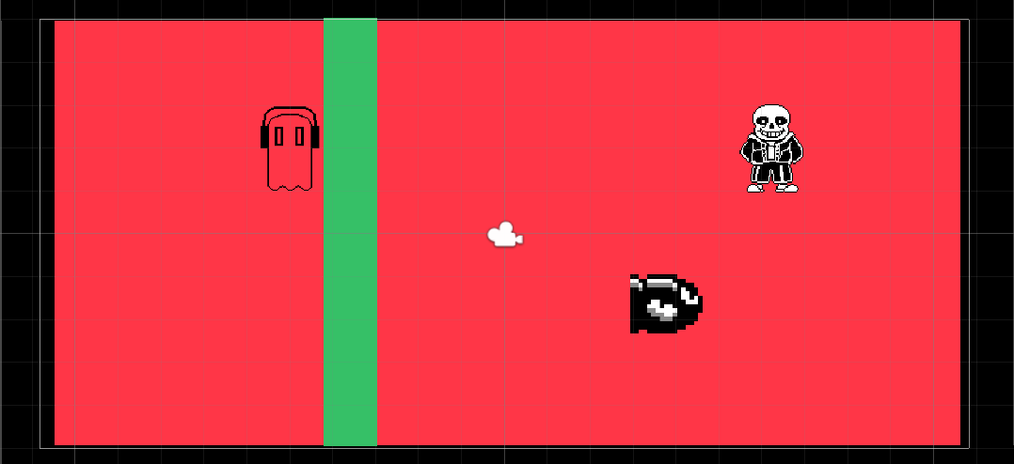

As this picture indicates, there will be different background colors throughout the gameplay with walls such as the green one. The colors will be green, pink, yellow, and white but the general look and feel is that of a universe bathed in color.

* + 1. **Areas**

Areas will be separated by the walls that prevent the player from going into the next area. The first area will be on the left side of the scene. The second area is in the middle. The last area is on the right side.

**Characters**

1. **Napstablook**
   1. **Back story**

This is the main character of the game. He is one of the characters from the mainstream game Undertale and he is a ghost who used to be a DJ.

* 1. **Personality**

He is a very shy ghost and likes to be alone, enjoying his music.

* 1. **Appearance**



* 1. **Abilities**

Switch the colors of the universe, traverse around, and shoot bullets.

* 1. **Relevance to the Story**

He is the main character trying to survive against the hostile people.

* 1. **Relationship to the other characters**

The other characters are all enemies.

1. **A.I. in Opponent and enemy**

There is no artificial intelligence, they will be shooting in a pattern that the player will eventually learn to predict in order to beat the game.

1. **Bullet Bill**
   1. **Back Story**

He is one of the characters from Super Mario whose sole purpose is to be an obstacle, now that he is in a different world he feels sad and scared.

* 1. **Personality**

He is very quiet, just like Napstablook. He uses very few words but each of them have a purpose.

* 1. **Appearance**

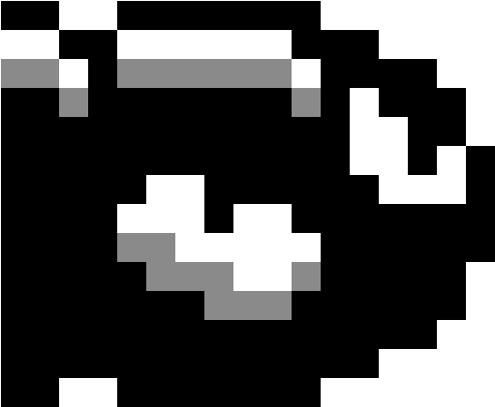

* 1. **Abilities**

Shoot bullets.

* 1. **Relevance to the Story**

He teaches Napstablook a new color and also teaches him important information about the upcoming enemy.

* 1. **Relationship to other characters**

He does not know other characters since he comes from a different dimension than all other characters.

1. **Doodlebob**
   1. **Back Story**

He is a character from Spongebob Squarepants who was created by Spongebob himself. In the cartoon he caused mayhem around Bikini Bottom and started to use his pencil to draw and erase things in the universe.

* 1. **Personality**

He has a very chaotic energy. He cannot speak in any language but his own.

* 1. **Appearance**

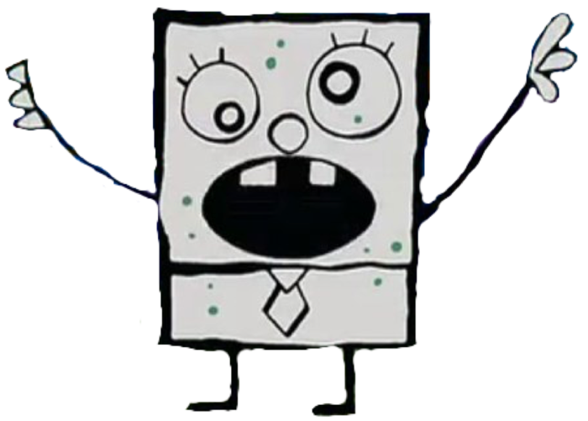

* 1. **Abilities**

Shoot bullets.

* 1. **Relevance to the Story**

He, just like Bullet Bill, teaches Napstablook a new color and also teaches him important information about the final boss.

* 1. **Relationship to other characters**

He also does not know other characters since he comes from a different dimension than all other characters.

1. **Sans**
   1. **Back Story**

He is one of the main characters in Napstablook’s main game Undertale. He is a skeleton that can warp reality to his will and makes jokes every time he talks.

* 1. **Personality**

Sans is a prankster. His name follows the font “Comic Sans” which is in itself a pun. He loves to talk to people and is very outgoing.

* 1. **Appearance**

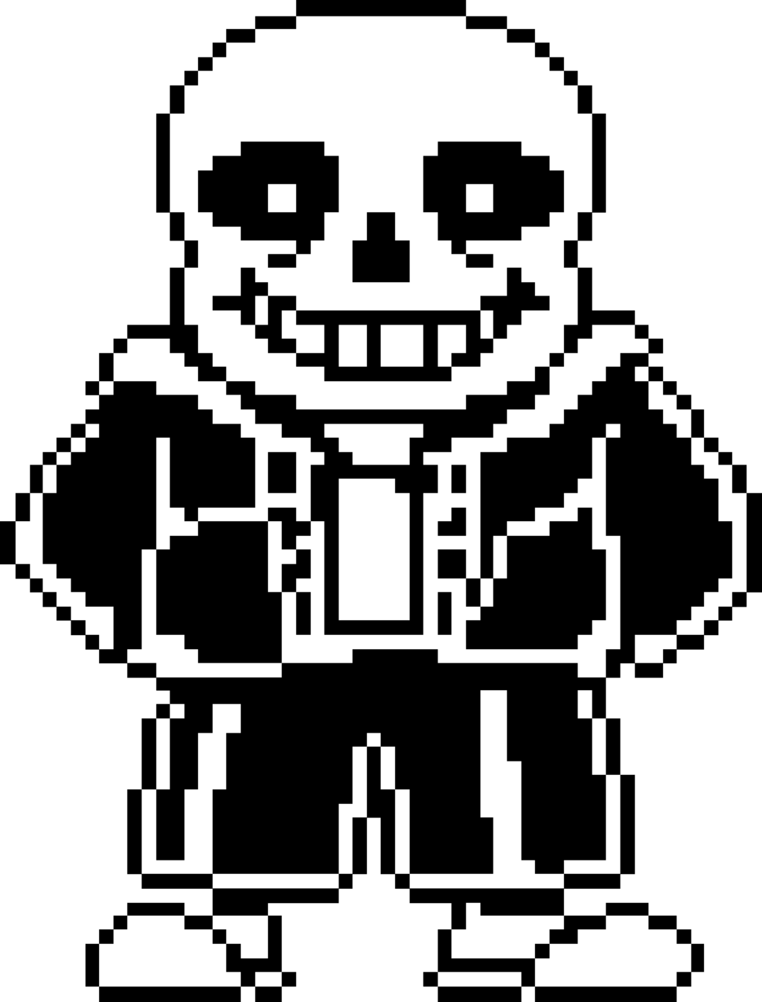

* 1. **Abilities**

Shoot bullets, light beams, and change the game colors.

* 1. **Relevance to the Story**

He is the final enemy of the game. His relevance is that he gives you the key to open the portal to beat the game.

* 1. **Relationship to other characters**

He has a vague relationship with Napstablook since they know each other from Undertale. That is what allows him to provide the player with the key to beat the game.

**Levels**

1. **Training Level**

There won’t be a training level in the game. The game begins with the player picking up the lantern in the beginning which allows them to change the colors of the background.

Instead, the first screen will be a blank screen with instructions and with the character being in the bottom left side of the screen, with the prompt explaining what each button does and with the prompt “Press F to pickup the lantern.” Once F is pressed, the game starts.

1. **Level 1**

This is the beginning of the game. All levels are on the same screen.

**2.1. Synopsis**

- This is the intro level where the player is faced with few obstacles and with an easy enemy to defeat. Napstablook sees that Bullet Bill is attacking him and he must stop him and help him get out of the current dimension they are in.

**2.2 Required Introductory Mateiral**

- To play this level the player must first pass the introduction, which is to simply hit F.

**2.3 Objectives**

- The main objective is to dodge the bullets being fired by Bullet Bill and to shoot a single bullet at him to make him stop.

**2.4 Details of What happens in the level**

- After passing the introductory screen, the player will find themselves in a narrow corridor that goes straight up. The player is at the bottom, and the entire room is bathed in white, there is a wall on the right side of the green color, and pink obstacles are in between the player and Bullet Bill (who is at the top of the level, shooting bullets that pass through walls).

- The obstacles can only be passed through if the player changes the white background to a pink background. This allows them to move through the pink obstacles, but now white obstacles will appear instead. After the player is able to complete the puzzle while dodging bullets they will have a clear shot on Bullet Bill, which allows them to pass on to the next level.

**2.4.1 Map**

**BOTH MAPS ARE THE SAME.** P is the initial location of the player. E is the location of the Enemy. The level will first begin taking the form on the left.

**2.4.2 Crucial path that the player needs to take**

As illustrated in the map, the player needs to traverse through the map by following the black line. Once they reach the red hexagons (which will not be visible in game, they are simply markers), if they hit the Space button they will change the colors of the map so that it becomes the map on the right. This way, the player can traverse to the next point where they must again switch the color back to what it initially was.

**2.4.3 Important and incidental encounters**

Once the player reaches the top, where the Bang symbol is, the player will be able to shoot the Enemy and pass the level.

1. **Level 2**

**3.2.1 Synopsis**

After beating the first level, the player is now able to control the color green. This level will be surrounded by a yellow wall instead, and the player can now shift between the colors White, Pink, and Green. They see now that at the bottom of the level is Doodlebob, who is angrily shooting at the player.

**3.2.2 Required introductory material and how it is provided**

In order to reach level 2 the player must first beat level 1, where they will gain the power to control the green color.

**3.2.3 Objectives**

Like level 1, the objective is to beat the puzzle and defeat the enemy at the opposite end of the map.

**3.2.4 Details of what happens in the level**

Unlike level 1, this level includes the addition of light beams. This means that not only are bullets being fired by the enemy, but they also shoot beams of light (which take over the entire map horizontally) towards the player. If they do not change the color of the background to the color of the light beam the player is hit and dies.

**3.2.4.1 Map**

With the addition of a new color, the complexity of the puzzle increases. Although it is not necessarily difficult to solve on its own, the challenge lies behind using the empty space to dodge the bullets as well as to know the right time to switch the color once a light beam is shot.

This follows the same layout and logistics as the previous level. The red hexagons indicate points where the player should switch colors (preferably) and the orange bang is where the player is free to shoot the enemy.

1. **Level 3**
   * 1. **Synopsis**

This is the final level where the player faces their biggest challenge yet: the level is not a puzzle at all, but a test of skill. This is where Sans is trapped, and being a really powerful character, he got rid of all puzzle pieces and instead decides to fight the player until he has finally beat him.

* + 1. **Required introductory material and how it is provided**

Same as last level, must pass level 2 to reach level 3.

* + 1. **Objectives**

The objectives are not to solve a puzzle, but to be able to dodge all bullets and all light beams passing by. They are much faster than the two previous levels, and the player has very little time to react.

Sans will not be defeated with only one bullet. A single bullet will teleport him to a different location where the player must again dodge him and hit him again. This must be done until Sans is hit 3 times.

* + 1. **Details of what happens in the level**

Sans will sometimes trap the player on different colors. He will automatically switch the color and the player will be forced to stay in that area and dodge bullets only. To escape, the player must escape the 10 bullets he will shoot.

* + - 1. **Map**

Next page

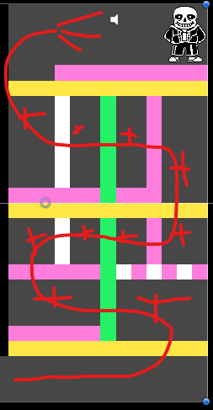

To fight Sans, the player will constantly need to avoid his bullets and light beams. When the player moves up towards Sans, he will trap the player in a pink box with green walls and prevent the player from switching to the green color to escape. This forces the player inside the box and allows Sans to attack them. The player can only dodge. Once the player dodges a certain number of bullets they will be able to use the green color again (will be announced by Sans), and they will be able to go to the next stage, which will be a similar trap, but much smaller and harder to dodge bullets. Eventually, the player will be able to go next to Sans and shoot him.

**8.2.4.2 Critical path that the player needs to take**

To be able to shoot Sans by standing directly to the right of him.

**8.2.4.3 Important and incidental encounters**

Every shot that Sans takes will teleport him to the other side of the room, and the player must again go through the same process in order to get to him.

**Interface**

1. **Visual System**
   1. **HUD**

The game will not have the need for a HUD, because it will disrupt the Game Art and the minimalistic feel of the game.

* 1. **Menus**

The player will be able to pause the game, and in the pause menu they have the option to Continue, Restart, Help, or Quit.

Continue will resume the game from where it stopped.

Restart will bring the game back to the beginning.

Help displays a message explaining the goal of the game and which buttons to use.

Quit will exit the game.

* 1. **Camera model**

The game will follow a 2D top-down game, where the player can not only go to the left and right but also up and down. It will be static and remain in the same place at all points in game.

1. **Control System**

* WASD for movement (Up, left, down, and right respectively)
* Space Bar to change colors
* Mouse Click to shoot
* F to pick up lantern to start the game and to enter the portal to end the game.

1. **Audio, music, sound effects**

* All audio, music, and sound effects will be borrowed from the games in which the characters come from.
* Voice lines and death sounds will be respective to the characters, those will be extracted from youtube.
* Music will also be used in respect to each character. Therefore, Bullet Bill will play a boss song from a Super Mario game; Doodlebob will play a Spongebob song, and Sans will play a song from Undertale.
* Sound effects will be extracted from youtube to match the ones to each character. All audio and music being used is free of copyrights and will be credited at the end of the game (in the credits scene).

1. **Game Art**

The intended style of the game is to be minimalistic and colorful. As intended, each level will rely heavily on the colors visible on screen, and each character will be black and white in order to create a contrast with the rest of the game. With the music and sound effects, the game will become a mesh of 8-bit and futuristic altogether. After all, that is the plot: characters from those games were taken away from their own universe and put into a universe they have never been to.

1. **Help System**

As stated in the Menus tab, the help system will be available once the player pauses the game. They will be able to see what their objective is and will also be able to read the instrcutions for bullet number 2. Control System.