CaloryCal

AI-Based Food Calorie Estimation System
Project Proposal
Current status: The project has progressed beyond initial dataset conversion and proof-of-concept segmentation. The latest training run, using oversampled training data and a stronger YOLO segmentation model, achieved measurable improvement and confirmed that the next bottleneck is primarily data quality, class imbalance, and long-tail class coverage rather than basic pipeline failure.

Project overview
CaloryCal is an AI-powered system designed to estimate the caloric content of food from a single image. The workflow identifies food items, segments them, estimates their relative size using depth information, and then converts those measurements into portion-level calorie estimates.
The system currently follows a practical multi-stage pipeline: image input, food segmentation, depth estimation, relative portion analysis, and calorie estimation. This proposal updates the original concept with the latest segmentation results and clarifies the next actions required to address the current data bottleneck.

Core Idea
The system follows three main stages:
- Food Identification: Detect and segment individual food items in an image.
- Size Estimation: Estimate physical dimensions (Length, Width, Depth) of each food item.
- Calorie Calculation: Compute calories based on estimated volume, density, and nutritional values.
This approach enables per-item calorie estimation rather than treating the entire plate as a single unit.
- Project Objectives
- Develop an automated system for food recognition and segmentation.
- Estimate physical dimensions (L, W, D) from images.
- Calculate food volume, mass, and calorie values.
- Integrate external nutritional databases for accuracy (future work).

Current technical workflow and Architecture
The current prototype pipeline is:
- FoodSeg103 dataset preparation and semantic-mask conversion into YOLO segmentation labels.
- YOLO segmentation training for food recognition and mask generation. (Figure 2)
- Depth Anything V2 to produce a relative depth map from the same image.(Figure 3)
- Per-item extraction of mask area and depth statistics.
- Relative portion scaling and calorie estimation using a reference calorie dictionary.

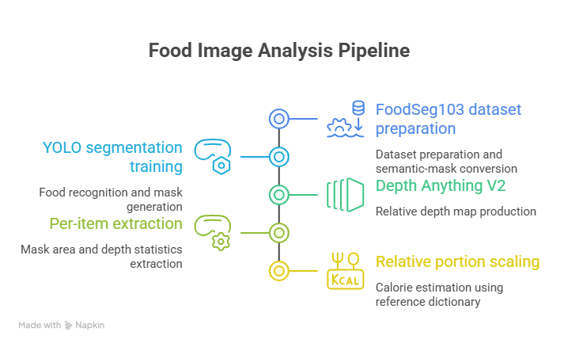
Figure 1 Food recognition and calorie estimation pipeline

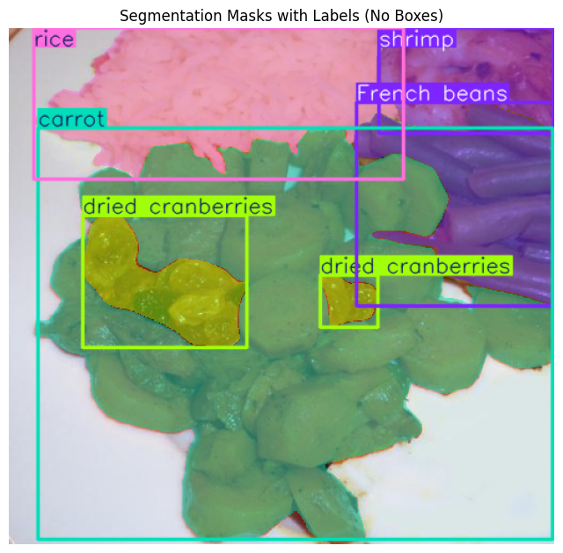
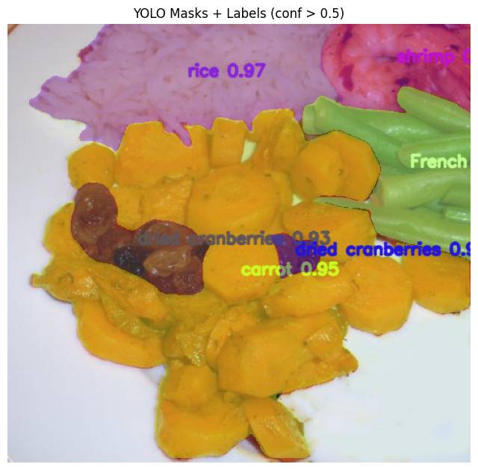
Figure 2 Segmentation masks with labels and YOLO masks and labels after confidence filtering (conf > 0.5).

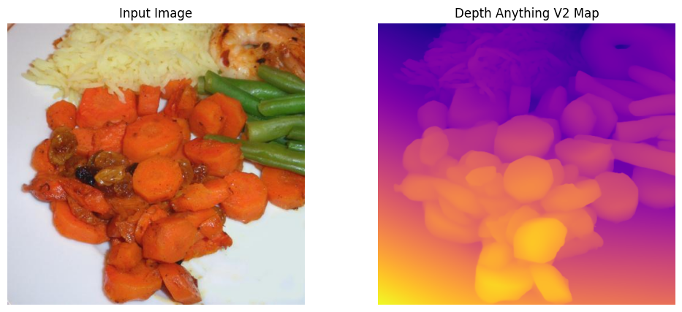

Figure 3 Input image and Depth Anything V2 map
- Dataset Challenges and Data-Centric Improvement Strategy

5.1 Dataset Challenges
The system is trained on the FoodSeg103 dataset, which contains 103 food categories with pixel-level annotations. While comprehensive, the dataset presents several challenges that affect segmentation performance.
- The dataset suffers from class imbalance (Figure 4), where a small number of food categories appear frequently while many others have very limited samples. This leads to strong performance on common foods and weak detection of rare classes.
- The large number of classes introduces high classification complexity. Many categories are visually similar or context-dependent, which increases confusion and reduces prediction stability.
- Some labels are visually ambiguous (e.g., sauces or mixed ingredients), making them difficult to identify reliably from images. This results in inconsistent or duplicated predictions.
- The dataset follows a long-tail distribution, where most classes are underrepresented. Oversampling partially mitigates this but does not introduce new visual variation. In addition, minor inaccuracies in mask conversion introduce segmentation noise, affecting boundary quality.
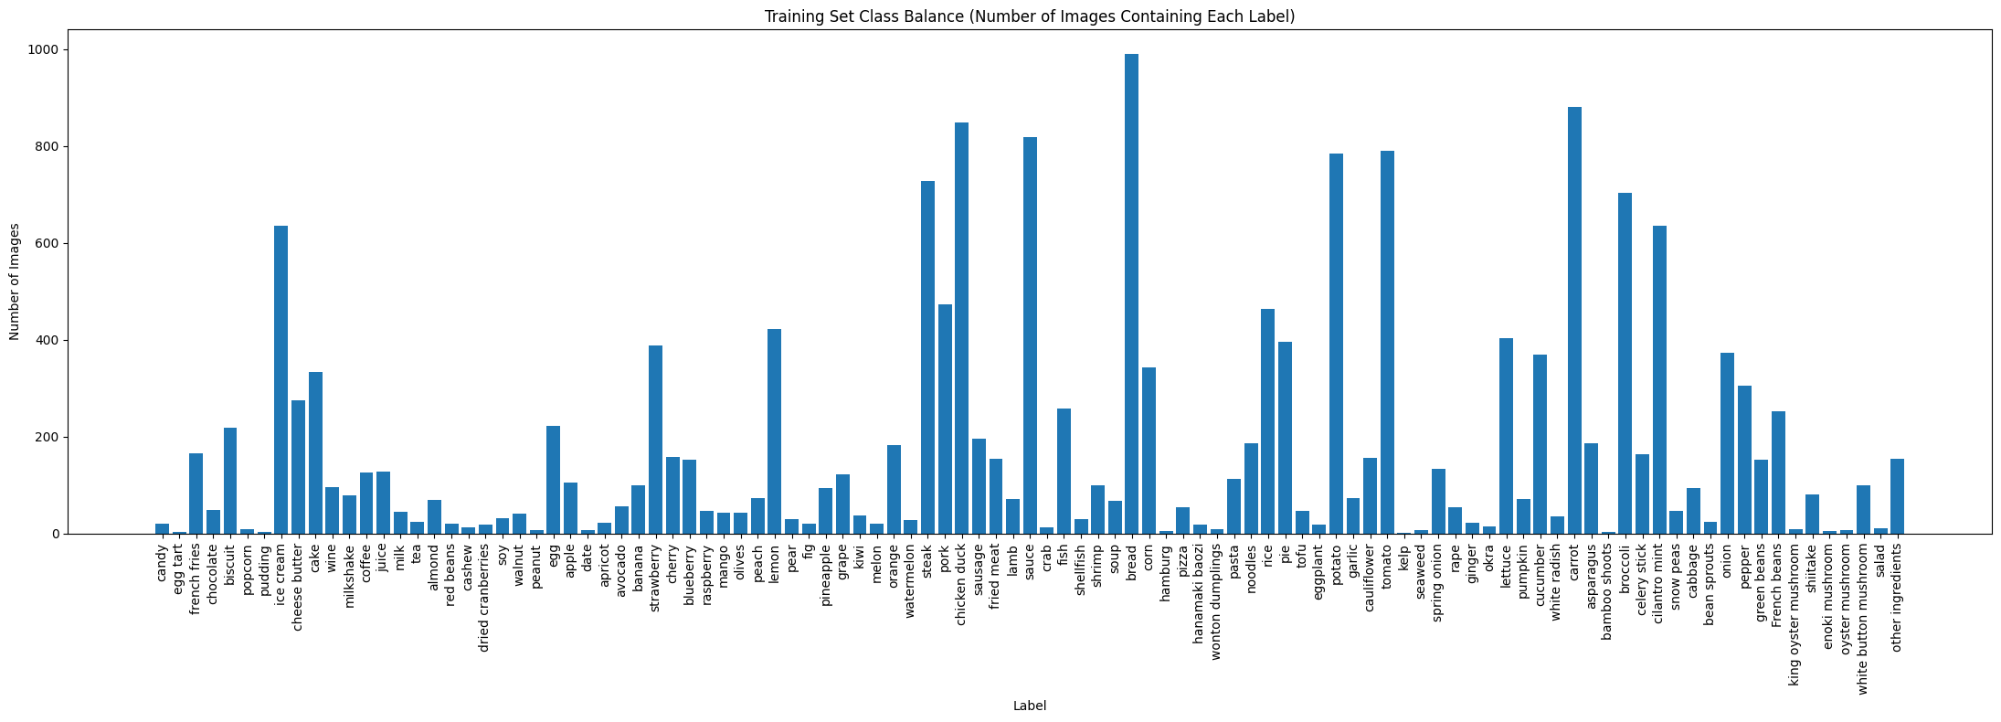
Figure 4 Training set Class balance

5.2 Impact on the System
These issues directly affect the full pipeline:
Segmentation → Area → Depth → Calories
Errors in segmentation lead to inaccurate area estimation, unreliable depth extraction, and incorrect calorie calculation. For example, missed detections cause underestimation, while duplicate or incorrect labels may lead to overestimation.

5.3 Current data issue Addressing
- The semantic masks were converted carefully into YOLO segmentation format and checked visually to reduce conversion errors at the dataset-preparation stage.
- Rare classes in the training split were oversampled so that the model would see weak classes more often during training.
- The training configuration was strengthened by moving to a larger model and higher input resolution, helping the model make better use of the available data.
- Prediction outputs were filtered with a confidence threshold above 0.5 so that the prototype analysis focuses on stronger detections instead of noisy low-confidence outputs.
- Depth extraction and calorie estimation were kept downstream of segmentation, which allowed the team to isolate segmentation as the main current bottleneck.

Validation results
The latest model run improved on the earlier baseline and provides a stronger foundation for the prototype. The current best results are shown below.
Table 1 Latest experiment outputs.
Prototype completed with YOLO segmentation, Depth Anything V2, and relative calorie estimation workflow.
Box mAP50 | 0.37697
Box mAP50–95 | 0.31605
Mask mAP50 | 0.37852
Mask mAP50–95 | 0.30145

What the current results tell us about the remaining data problem
The present mAP values show that the model is no longer failing at a basic level; however, the improvement is not yet sufficient for dependable per-item calorie estimation across the full class set. The remaining problem is mainly driven by three factors:

6.1 Future work to solve the data problem
Area | Current work already completed | Planned next work
Dataset quality | Mask conversion completed and visually checked on sample images. | Run a broader audit of converted masks and labels, especially weak classes, to identify inaccurate polygons, fragmented masks, and confusing labels that still affect learning.
Class imbalance | Oversampling has already been applied in the training split. | Replace broad repetition with more targeted sampling and focused improvement for underperforming classes, using validation feedback to identify which categories need priority treatment.
Data coverage | The project currently relies mainly on FoodSeg103. | Add more representative images for weak or important categories, with wider variation in camera angle, lighting, food arrangement, and portion size so the model can generalize better.
Label structure | The current class map follows the dataset structure. | Review whether some categories should be merged, simplified, or staged for later expansion when they are visually ambiguous and not critical to the first reliable prototype.
Prototype scope | The full class set has been used to test the general capability of the pipeline. | Define a more reliable first operational subset based on classes that are both nutritionally relevant and learnable with acceptable quality, while keeping the broader dataset for future expansion.
Evaluation strategy | Current evaluation uses the overall segmentation metrics and qualitative inspection. | Track per-class performance more explicitly and use the weakest classes to drive data collection, relabeling, and targeted re-training rather than relying only on the global score.

7. Future Work and Implementation Plan
The next phase of the project will focus on improving data quality, stabilizing the segmentation pipeline, and progressing towards a deployable system through a structured, data-centric approach. The development will follow incremental phases to ensure reliability at each stage.

7.1 Phase 1: Model Stabilization and Data-Centric Optimization (Current Focus)
The immediate priority is to consolidate the current model as a stable baseline while addressing the underlying dataset limitations.
- Retain the current trained model as the baseline configuration for all future experiments
- Develop a reduced and task-focused class set, prioritizing food categories most relevant to calorie estimation
- Improve dataset handling through On-the-Fly Balanced Sampling, which dynamically balances class representation during training without duplicating static data
- Store the final dataset configuration (YAML and structure) in Google Drive to ensure full reproducibility
- Continue improving data quality through targeted sampling and annotation refinement
Rationale:
At this stage, performance is primarily constrained by data distribution rather than model capacity. On-the-fly balancing is particularly valuable because it mitigates class imbalance while preserving data diversity, making it more effective than static oversampling.

7.2 Phase 2: Lightweight Inference Pipeline Development
Once the baseline model becomes stable, the focus will shift to building an efficient and reusable inference pipeline.
- Develop a lightweight inference workflow that:
  - Loads trained weights
  - Perform segmentation
  - Applies depth estimation
  - Computes calorie estimates
- Separate inference from training to improving speed, reproducibility, and usability
- Ensure consistent performance on individual images before scaling to real-world scenarios

7.3 Phase 3: Mobile-Based Implementation (iPhone Integration)
The system will then transition to a real-world deployment scenario, starting with iPhone devices.
- Utilize iPhone camera and depth capabilities (e.g., LiDAR or depth APIs) to capture food images
- Integrate the trained model into a simplified pipeline for near real-time inference
- Evaluate system performance under real-world conditions, including:
  - varying lighting conditions
  - different backgrounds and plate types
  - multiple and overlapping food items
Rationale:
Starting with iPhone provides access to reliable depth sensing and a controlled hardware environment, which is critical for validating the depth-based calorie estimation approach.

7.4 Phase 4: Segmentation Refinement Using SAM
After the data foundation and baseline model are stable, segmentation quality will be further enhanced using advanced models.
- Integrate Segment Anything Model (SAM) for mask refinement
- Use SAM to:
  - improve boundary precision
  - better separate overlapping or adjacent food items
  - reduce segmentation noise
This step will be introduced after addressing data set limitations, ensuring that improvements come from refinement rather than compensating for poor data quality.

7.5 Phase 5: Progressive System Expansion
The final phase focuses on scaling and improving system robustness.
- Gradually expand the number of supported food categories
- Improve generalization across diverse real-world scenarios
- Enhance calorie estimation accuracy through improved segmentation and depth integration

7.6 Summary
The proposed development strategy follows a structured progression:
Data optimization → Stable baseline → Mobile deployment → Advanced refinement → System expansion
By prioritizing data quality—particularly through techniques such as On-the-Fly Balanced Sampling—before introducing advanced models like SAM, the system can evolve into a reliable and practical calorie estimation solution.

8. Conclusion
CaloryCal has advanced to a functional end-to-end prototype that integrates segmentation, depth estimation, and calorie calculation. The current results demonstrate solid progress and confirm the feasibility of the approach. At this stage, further improvement is primarily limited by dataset quality rather than model capability.
The next phase will focus on a data-centric strategy, including class refinement, improved annotations, and techniques such as On-the-Fly Balanced Sampling. Development will proceed in phases, starting with a stable baseline, followed by mobile deployment (iPhone), and later integration of refinement methods such as SAM.

