TASK 1.

Analysing the scenario and listing out the candidate classes is very first step to do before the actual development of the application. I have used **Natural Language Analysis (NLA)** to abstract all candidate classes from the scenario.

**NLA** is the process where we analyse the scenario then identify the nouns, verbs, adjectives and then transform into classes, methods, and attributes respectively.

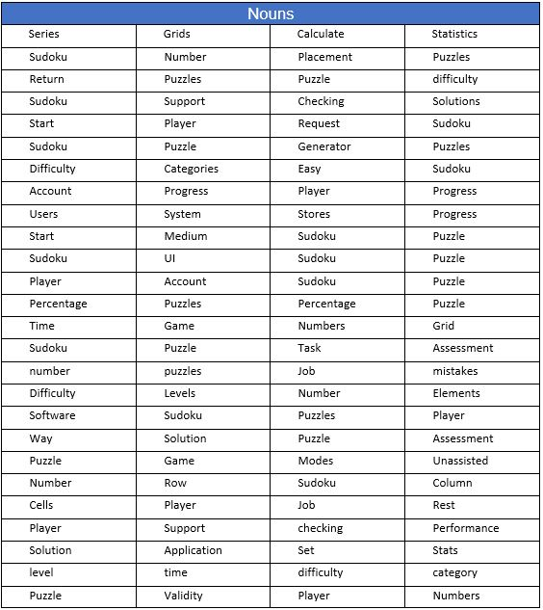

Step 1 List all nouns from the given scenario

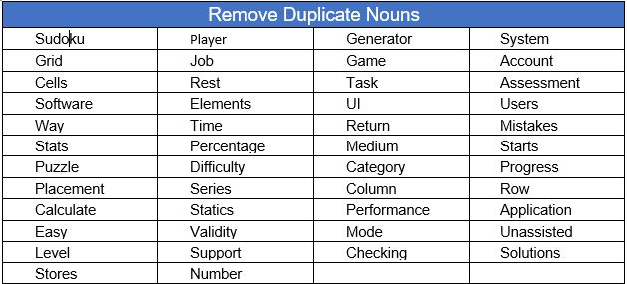

Step 2 Remove duplicate nouns

* Sudoku > Game > Puzzle > Software > System > Application = Puzzle
* Player > Users = Player
* Category > Mode > Difficulty > level = Level
* Progress > Performance > Mistakes >