**MicroControllers**

**Lab7**

William L. Cole

13/12/2018

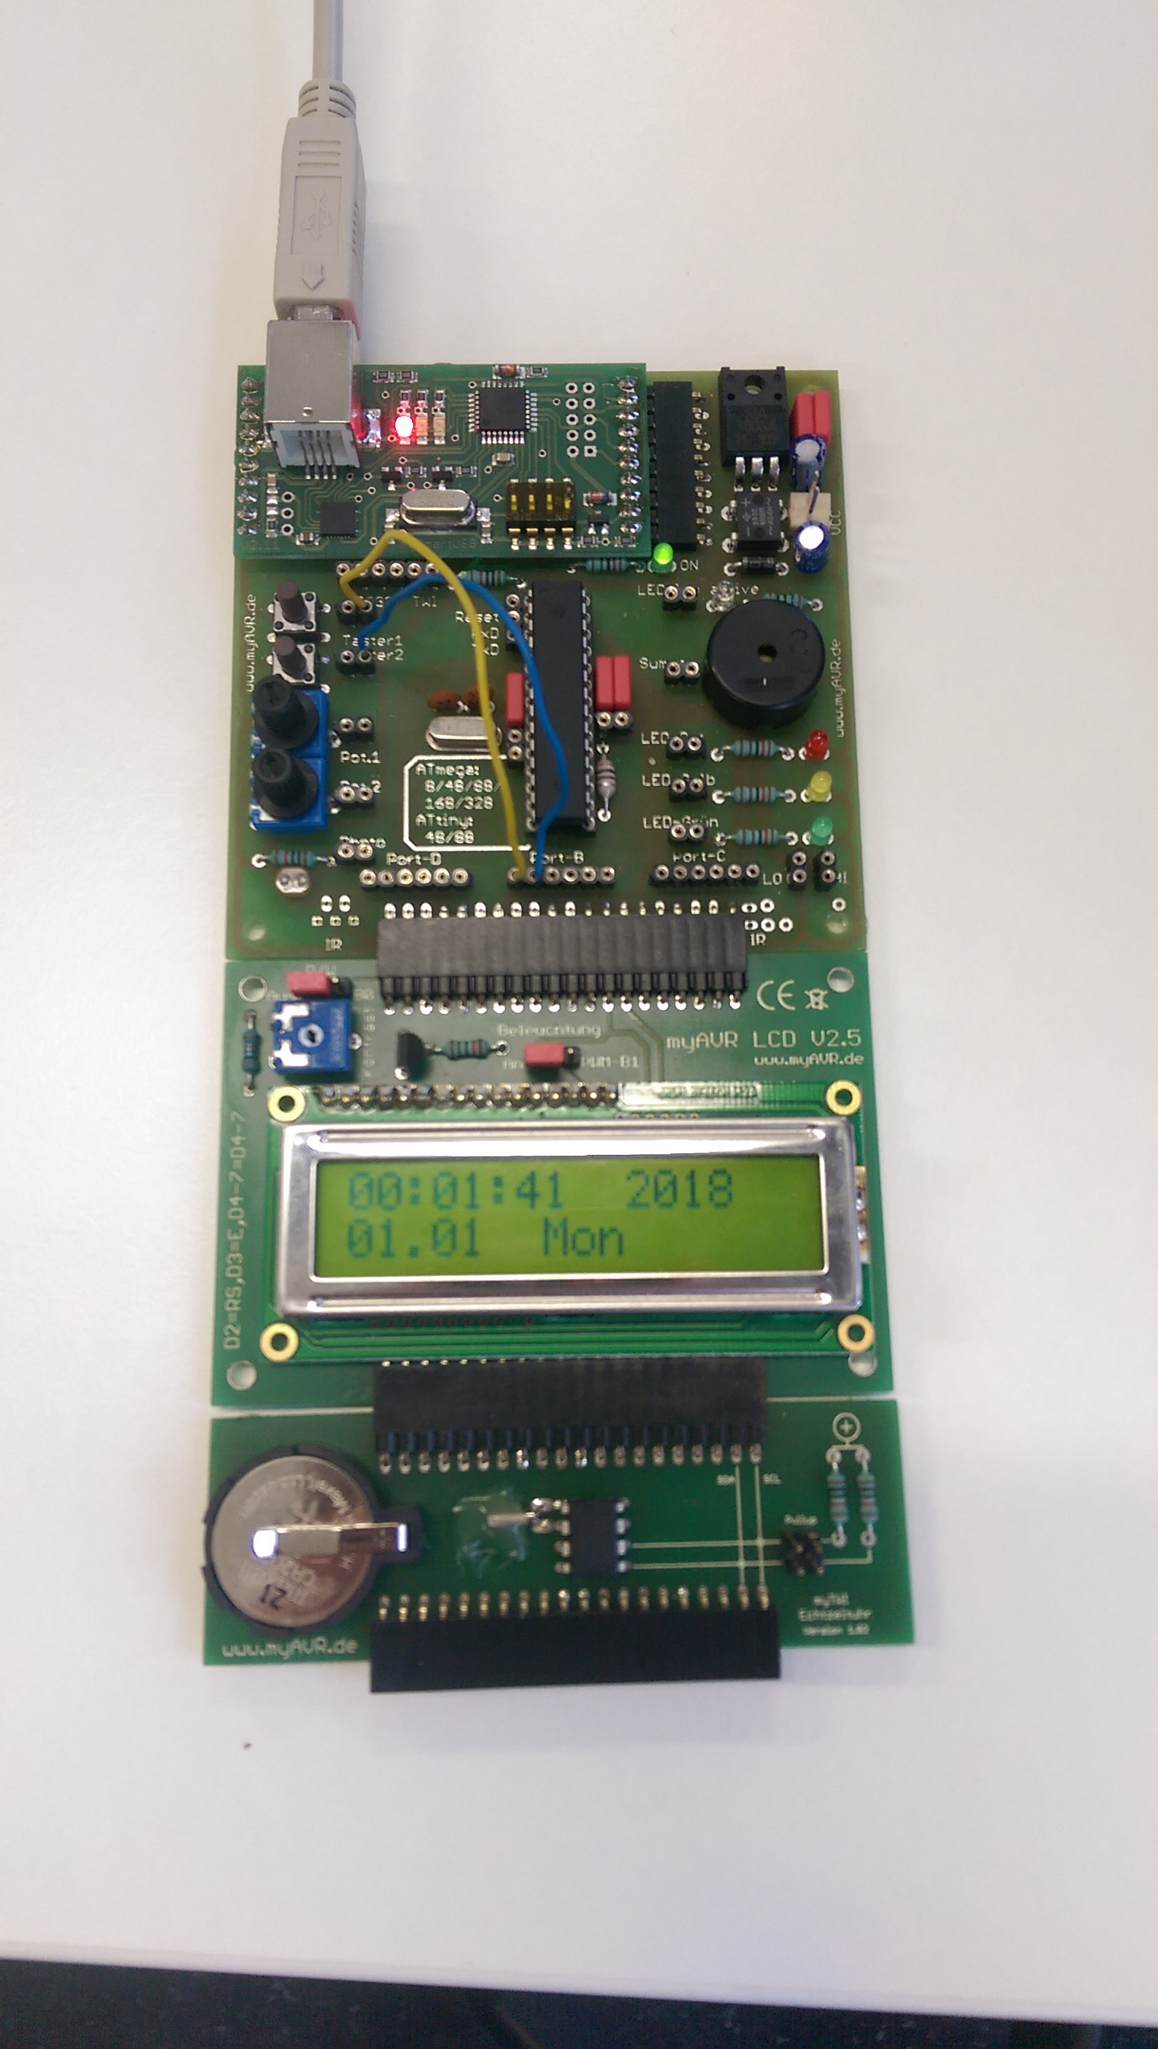

**Circuitry**

* Key 1 to PB0
* Key 2 to PB1

**Programming**