Found 910 files belonging to 2 classes.

Using 728 files for training.

Found 910 files belonging to 2 classes.

Using 182 files for validation.

ML InceptionV3 at 5 epochs

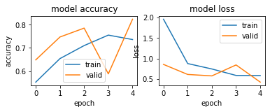

ML Inception V3 at 10 Epochs

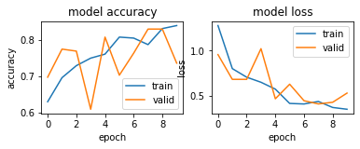

ML Inception V3 at 15 epochs

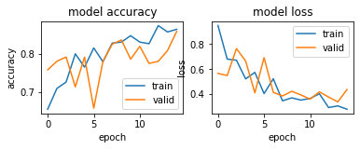

ML Inception V3 at 20 epochs

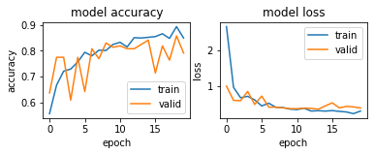

ML Inception V3 at 25 epochs

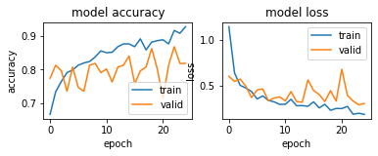

ML Inception V3 at 30 epochs

