Found 910 files belonging to 2 classes.

Using 728 files for training.

Found 910 files belonging to 2 classes.

Using 182 files for validation.

ML MobileNetV2 at 5 epochs

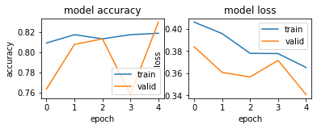

ML MobileNetV2 at 10 epochs

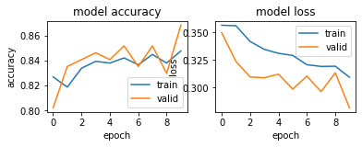

ML MobileNetV2 at 15 epochs

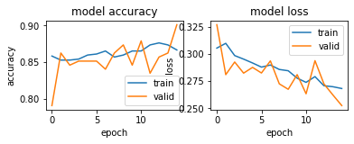

ML MobileNetV2 at 20 epochs

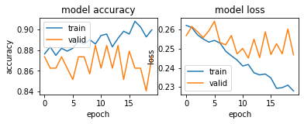

ML MobileNetV2 at 25 epochs

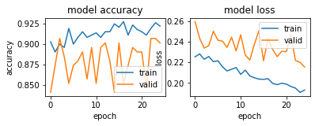

ML MobileNetV2 at 30 epochs

