**I. Prerequisites**

A. Python 3.4.x

B. MySQL Connector/Python (<https://dev.mysql.com/downloads/connector/python/>)

- Select “Platform independent”, then download zip archive (There is a copy of this zip file in the “python” directory of this project directory zip)

- Run the “setup.py” to install the mysql python module

> python setup.py install –verbose

- Check if mysql is added to the python modules

* htt<ps://dev.mysql.com/doc/connector-python/en/connector-python-ver>ification.html

(/python_installation_dir/Lib/site_packages)

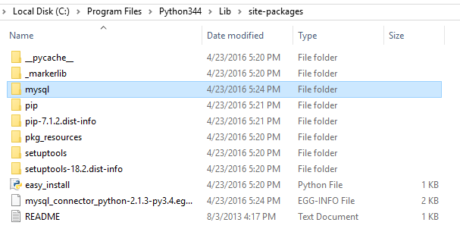

**II. Testing the time slider feature**

A. Run migration files

> node_modules\.bin\sequelize db:migrate

B. Run seeder files

> node_modules\.bin\sequelize db:seed:all

C. Start web server

> npm start

D. Run python script in “/python” of this project directory

> python main.py

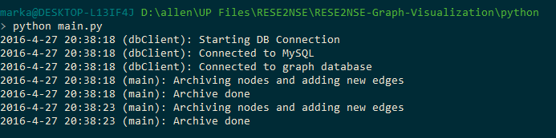

- This python script creates an archive of the “Nodes” table by copying the contents of the “Nodes” table to the “Node_archives” table. This script also updates the “Edges” table with new random links to simulate the real-time update of the network.

E. Go to “localhost:3000/graph”. Move the slider of a floor to view the graph network for a specific time.

