Despite a predicted boom, fertility dipped during 2020 lockdown

US Google search frequencies show how quarantine kept couples apart

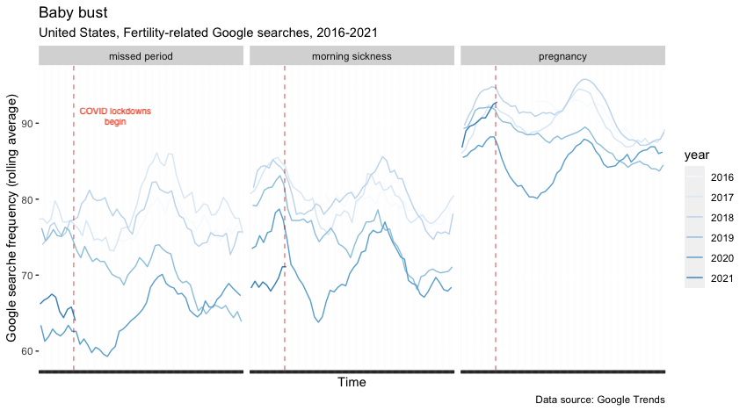

After a year in lockdown, cohabitation took on a new meaning. While some predicted that a rise in birth rate would accompany forced isolation, dips in fertility have been observed in previous epidemics. This time, it seems that quarantine did not inspire an explosion of baby-making.

Data on births is not yet available for most of 2020 and there is a nine month lag for understanding how COVID affected birth rate. However, trends in Google searches for fertility-related queries provide some early insight into how the pandemic impacted American’s family planning.

Birth rates in the developed world have been declining for years. Families are having fewer children later in life. Even in the US, historically an outlier with respect to population growth, birth rates are declining. Most rich countries have instituted pronatalist policies, government programs which encourage reproduction, to combat the drop in fertility. The Biden administration’s American Rescue Plan includes a child tax credit in this mold. Governments have reason to worry; with fewer children born and people living longer than ever demographic change follows rapidly. Progressively smaller generations will struggle to shoulder the burden of their parents' social safety net.

In the immediate aftermath of the COVID lockdown searches for ‘pregnancy’ and ‘morning sickness’ collapsed. Spending a year at home alone with your partner may inspire more rage than romance, but economic and other anxieties surely played a role as well.

However, couples might simply be delaying pregnancy until normal life resumes. Although the situation may not have improved for those stuck at home quite yet, the family planning conversation seems to be back on the table. Rates of searches for ‘pregnancy’, ‘missed period’, and ‘morning sickness’ climbed back towards 2019 levels starting mid-last year. What’s more, searches for both ‘pregnancy’ and ‘missed period’ are higher in early 2021 than they were in the same period of 2020 -- prior to the pandemic. The baby boom may yet arrive; brace yourselves for a summer of love.