US record for number billion dollar weather disasters set in 2020

After a winter storm devastates Texas, this year is off to an abysmal start

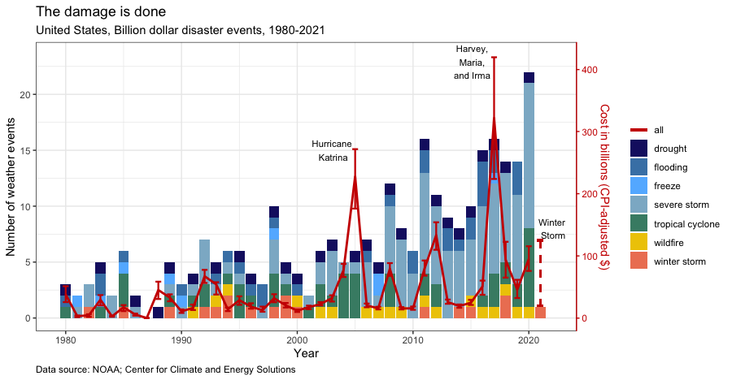

Contrary to comments by Texas Governor Greg Abbott, [green energy did not cause the winter storm disaster](https://www.washingtonpost.com/nation/2021/02/17/texas-abbott-wind-turbines-outages/) in Texas and beyond. In the last forty years the number of weather events with a billion dollars or more in damages has skyrocketed. In 1980 three weather events -- a drought, flood, and tropical cyclone -- incurred a billion dollars or more in damages. Last year 22 storms did the same.

Although the cost per weather event is not increasing over time, the accumulated costs of many extreme weather events is causing the overall spending on damages to rise. Between 1980 and 2020, costs associated with billion-dollar disasters have grown by 150% -- from 37.9 billion to 95 billion. As the red line in the figure above indicates, this is not a steady increase but one punctuated with enormous spikes in spending. Hurricane Katrina in 2005, Sandy in 2012, and Harvey, Maria, and Irma in 2017, caused spending on weather related damages to leap well above prior levels.

There is not yet a reliable estimate for the damages associated with this years’ winter storm -- which left much of Texas without power or water -- yet we can be sure that damages will surpass a billion dollars. Early estimates range from $20 billion to $50 billion but some are arguing that the sum total of economic losses from the storm could [surpass those caused by Hurricane Harvey](https://www.dallasnews.com/business/2021/02/18/this-years-winter-storm-could-become-the-costliest-weather-event-in-texas-history/), which accumulated $125 billion in damages.

Winter weather rarely drives annual disaster costs -- and even less frequently in recent years. In the 1980s and 90s winter weather caused disasters with over a billion dollars in damage twelve times. In the two decades since, only five winter storms caused a billion dollars in damage. Increases in billion dollar weather events has been driven by severe storms of other types, cyclones, and wildfires. That said, intense winter weather does not disprove the reality of human-induced climate change. The scientific community has agreed that [climate change will produce more extreme weather events](https://www.epa.gov/climate-indicators/weather-climate#:~:text=Scientific%20studies%20indicate%20that%20extreme,storms%2C%20floods%2C%20and%20droughts.), including unprecedented winter storms. Last year was the [Arctic’s second warmest](https://www.climate.gov/news-features/featured-images/2020-arctic-air-temperatures-continue-long-term-warming-streak#:~:text=According%20to%20NOAA's%2015th,over%20land%20in%20the%20Arctic.&text=This%20map%20shows%20near%2Dsurface,to%20the%201981%E2%80%932010%20average.) on record. Warm temperatures in the arctic weaken the jet stream, allow the cold air to escape to the south, and send [polar vortexes to seemingly unlikely places](https://twitter.com/UNFCCC/status/1361355803949756416?ref_src=twsrc%5Etfw%7Ctwcamp%5Etweetembed%7Ctwterm%5E1361355803949756416%7Ctwgr%5E%7Ctwcon%5Es1_&ref_url=https%3A%2F%2Fwww.vox.com%2F22287295%2Ftexas-uri-climate-change-cold-polar-vortex-arctic).

Time is short to accept the reality of climate change and invest in infrastructure that can withstand extreme weather. Americans can pay up now or incur many more billions of dollars in economic damages and incalculable loss of human life.