Get:

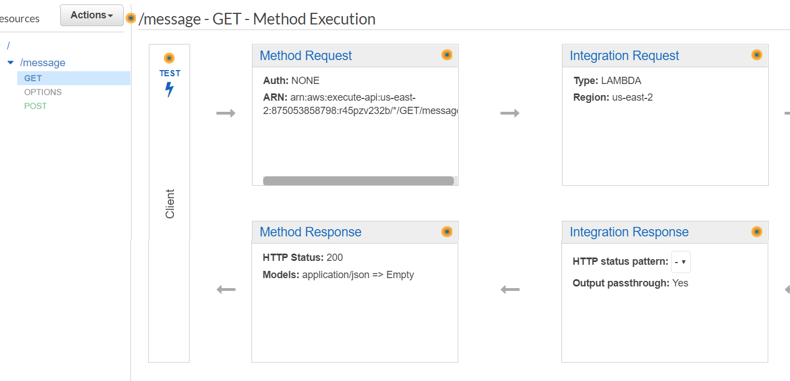

Lambda – NodeApi:

Handler: index.handler

console.log('Loading function');

const AWS = require('aws-sdk');

const docClient = new AWS.DynamoDB.DocumentClient({region: 'us-east-2'});

exports.handler = (event, context, callback) => {

let scanningParameters ={

TableName: 'chat2',

Limit: 100

};

docClient.scan(scanningParameters, function (err, data){

if(err){

callback(err, null);

}

else{

callback(null, data);

}

});

//callback(null, event.key1); // Echo back the first key value

//callback('Something went wrong');

};

POST:

Lambda- nodePost

console.log('Loading function');

const AWS = require('aws-sdk');

const docClient = new AWS.DynamoDB.DocumentClient({region: 'us-east-2'});

exports.handler = (event, context, callback) => {

var params ={

Item: {

date: Date.now(),

name : event.name,

message : event.message,

},

TableName: 'chat2'

};

docClient.put(params, function (err, data){

if(err){

callback(err, null);

}

else{

callback(null, data);

}

});

//callback(null, event.key1); // Echo back the first key value

//callback('Something went wrong');

};

/message - POST - Integration Request

#### **Body Mapping Templates**

application/json:

{

"name": $input.json('$.name'),

"message": $input.json('$.message')

}