Problem Formulation:
(1)
Given a sequence of real values, i.e., x = $x_1, x_2, ..., x_n$,
the task of time-series anomaly detection is to produce an output
sequence, y = $y_1,y_2, ...,y_n,$ where $y_i \in \{0, 1\}$ denotes whether $x_i$ is an anomaly point.

(2) Our objective is to train an unsupervised network that detects anomalies using a dataset that is highly biased towards a particular class -i.e, comprising normal non-anomalous occurrences only for training.

Goal:
For normal data, the gap between the latent space obtained after encoding and decoding and re-encoding is not particularly large. However, when the AE under normal sample training is used to encode and decode abnormal samples that have never been seen before, the potential spatial gap is often large after going through the encoding process twice .

GANomaly network

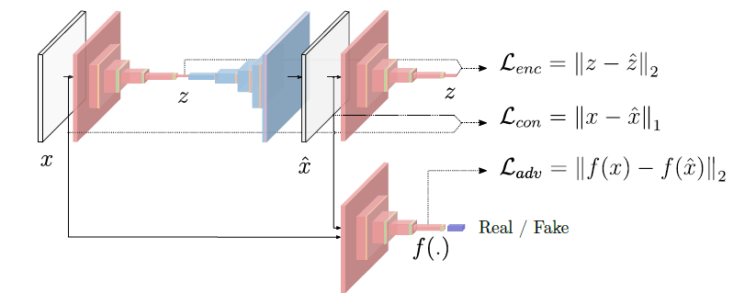
We have 3 sub-network
First sub-network is a bow tie autoencoder network behaving as the gener-
ator part of the model. The generator learns the input data representation and
reconstructs the input time serias data via the use of an encoder and a decoder network,
respectively.
The second sub-network is the encoder network that compresses the time series data
named x’ that is reconstructed by the network G. All the Encoder network has the same network
structure . Only the network parameters is different.
The last sub-network is the Encoder network with the linear classification layers.
Loss function:
NetG loss
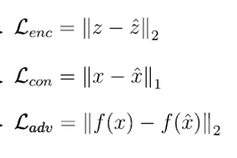
NetD loss :fake and real classifier BCEloss

Lenc: Encoder Loss:minimize the gap between the latent space obtained after encoding and decoding and re-encoding
Lcon: Contextual Loss.: minimize the gap between the input series and after encoding and decoding times series
Ladv: Adversarial Loss: feature matching computes the L2 distance between the feature
representation of the original and the generated images,

