DAWN
Feasibility Analysis Report

Version 1.0
By:
Dawn Group
2019-04

Group Member:
Zihan Xu
Yi Kuang
Chenyu Yang
Yuting Lan
Jianzhen Cao

Document Language:
English

Revision History
Date | Version | Description | Author
2019-4-2 | 1.0 | Finish the 1st edition of feasibility analysis report | Zihan Xu, Yi Kuang, Chenyu Yang, Yuting Lan, Jianzhen Cao

1 Introduction 1
1. Purpose 1
2. Background 1
3. Definition 1
4. Reference 2
2. Presupposition 2
1. Requirement 2
2. Objective 3
3. Condition, Supposition and Limitation 3
4. Feasibility Analyzing Method 3
5. Evaluation Criteria 3
3. Excising System Analysis 4
1. Workflow and Dataflow 4
2. Working Load 4
3. Expenditure 4
4. Personnel 5
5. Devices 5
6. Limitation 5
4 Proposed System 5
4.1 Introduction to the Proposed System 5
4.2 Workflow and Dataflow 7
4.3 Improvement 8
4.4 Impact 9
4.4.1 Impacts to the Devices 9
4.4.2 Impacts to the Software 9
4.4.3 Impacts to the User 10
4.4.4 Impacts to the Run-time Process 10
4.4.5 Impacts to the Development 10
4.4.6 Impacts to the Location and Equipment 11
4.4.7 Impacts to the Expenditure 11
4.5 Limitation 11
4.6 Technique Capability 11
5 Alternative Solutions 12
6 Cost/Benefit Analysi 12
6.1 Cost 12
6.1.1 Cost for Infrastructure 12
6.1.2 Other Cost for One-off Investment 12
6.1.3 Non-One-off Investment 13
6.2 Benefit 13
6.2.1 One-off Benefit 13
6.2.2 Non-One-off Benefit 13
6.2.3 Immeasurable Benefit 14
6.3 Cost/Benefit Ratio 14
6.4 Investment Return Period 15
6.5 Sensibility Analysis 15
7 Other Social Factor 16
7.1 Law Based Factors 16
7.2 Feasibility of use 16
8 Conclusion 17

FEASIBILITY ANALYSIS

1 Introduction

Purpose
- Through the investigation of the mobile phone game project in class, the system's feasibility report is preliminarily formulated, and the problems faced in the software development process and the corresponding solutions are reviewed and rationally arranged. Identify the goals of this system by understanding the economic benefits and risks that software development may bring.
- The arrangement of personnel, funds, system resources and other issues involved in the project development process will be recorded in the form of documents, so that software developers and related personnel can facilitate the corresponding inspection of the project.
- After the report has been reviewed, it will be reviewed by the responsible person.

Background
The name of the software system: DAWN
Project task proposer: Xu Zihan (team leader)
Project developer: Xu Zihan, Kuang Yi, Yang Chenyu, Lan Yuting, Cao Jianzhen
Users the project orient to: all the players
The basic relationship between the software system and other systems or other institutions: the system is relatively independent, and third-party software services or other frameworks may be used in development.

Definition
DAWN: name of the game
Android: A popular smart terminal operating system from Google
App: Abbreviation for application, generally refers to the published application running on a smartphone
TCP/IP: Internet transmission of the most basic protocol
Player: the person who participate in game
Room: a group of players
Occupation: a profession with certain attributes and skills

Reference
<<Object-Oriented Software Engineering Practice Guide-2>>
<<Object-Oriented Software Engineering - Using UML, Patterns, and Java>> (3rd edition), Tsinghua University Press, 2011

Presupposition

Requirement
DAWN is a game based on local area network which is often played together with friends, classmates or companions in parties. Also it is used to make acquaintance with some new friends through a shared course of game.

- Functional requirements
DAWN is a kind of shared game, of which the interesting quality is to play a game with other people at the same time on the same platform.

First of all, DAWN wants to provide a platform on which in a party some people can start a game conveniently and quickly, which means if there are some people sitting together, that is to say, they are not very far from each other, then they can create a local area network and they all join into the network to get into a shared game.
For example, one of them can create a hot spot and all others can join into the local area network. In this way the game can start in a short term, no network delay and no matching time and so on.

Secondly, DAWN provides a vast occupation system and a great game setting. DAWN provides 4 occupations which has different quality and skills to enrich the game experience. In this game the four occupations have no absolute advantages but is relatively more powerful than others in certain aspects so players can enjoy different occupations fairly. Besides that, we design a rich game setting including stages and properties. Players can use different properties to realize different effects and different stages the game has different settings.

- Non-functional requirements
1) easy to handle
The game needs to control the operation of the user so that the user can use the game reasonably and legally. For illegal operations, it is necessary to be able to identify and eliminate interference, correctly implement the function, and give appropriate prompt information during operation.
2) Design constraints
It is relevant with the software. In consideration of the applicable population, the software should support English, Simplified Chinese. The software development language is Java.
3) System Oriented
The user interface of this game is Android App on the mobile phone side.
4) Communication Interface
The communication protocol used by this game is as follows:
a. TCP/IP protocol
b. UDP protocol
c. HTTP protocol
5) Data Input
a. user information
source: user registration;
data type: complex types;
quantity: <10000,>5000;
composition: user account (integer), user name (string), user e-mail(string)
b. user manipulation
source: user manipulation
data type, quantity: as above
composition: attack, move, prop
6) Data Output
a.time
meaning: the time left to end
producing frequency: very high
interface: no
b.attributes
meaning: the player’s attributes such as HP, Prop quantity
producing frequency: high
interface: no
c.results:
meaning: the game’s results about each player
producing frequency: according to the game time
interface: no
d.room status
meaning: to show a room is full or not, running or not
producing time: according to the number of people
interface: no

7) Deadline Time
The whole game should be completed on June 14th.

- Deadline
The whole game should be completed on June 14th.

Objective
- Provide a popular way to assist in ice-breaking in a relatively small range.
- Easily start a game and learn how to play.
- Provide a relatively rich game system to maintain long interest to play.

Condition, Supposition and Limitation
- Minimum life time of game: 1 year
- Time to select suitable solution: 1 week
- Sources and restrictions on funding and investment: members of the group
- Hardware environment: server, cellphone
- Available information and resources: web resources, library materials
- The latest time the system is put into use: June 2019.
- Conditions of developing/run-time environment in hardware and software
Hardware:
- PIII or more advanced PC, laptop
- Minimum runtime memory requirements: 128M
- Hard disk space for installation: except the application server and database server, clients use browsers to get access to the service.
Software:
- Windows 10
- macOS Mojave 10.x

Feasibility Analyzing Method
- Customer survey
- Experts consultation
- Market survey of similar or relevant products

Evaluation Criteria
The criteria of evaluating the game are:
- functions supported or provided by the game
- time cost to develop the game
- the usability of the game.
- Evaluation of the total cost of the system

Excising System Analysis
The traditional phone game is ether stand-alone or connected to the Internet. The former can only be played by one player. The latter depends on the Internet to do everything. However, the Internet status is not always good and trustable, which causes some problems.

Workflow and Dataflow
We used to play an online game connected to Internet. Work flow as follows:

Connect to Internet and log in

Get into a room and match through Internet

Play together through Internet

Game over and choose to play again or quit on the Internet

Note that all manipulations are accomplished on the Internet so the response may be not stable and matching time may be long and maybe you do not know the people who play with you and so on.

Working Load
Since all the work is done by manual work, so
(1) extra employee is needed
(2) it is time, resource and labor exhausting.

Expenditure
Large amount of money is needed to maintain the game system. Usually 2000 per person-month.

Personnel
About three people need to maintain the game system itself and another three people need to solve Internet problems.

Devices
A PC and a phone with android system are needed.

Limitation
As has mentioned above, 2 main factors limit the existing game system:
  - The Internet status is not stable
  - The process of a game is complex and slow

4 Proposed System
This charpter will be used to illustraye the goal for our proposed system and how the requirements will be fulfilled.

4.1 Introduction to the Proposed System
Our game is based on client-server architecture. With our server collecting real-time data from player's devices, it also does the job of computation.
The brief physical architecture view can be showed as follow: 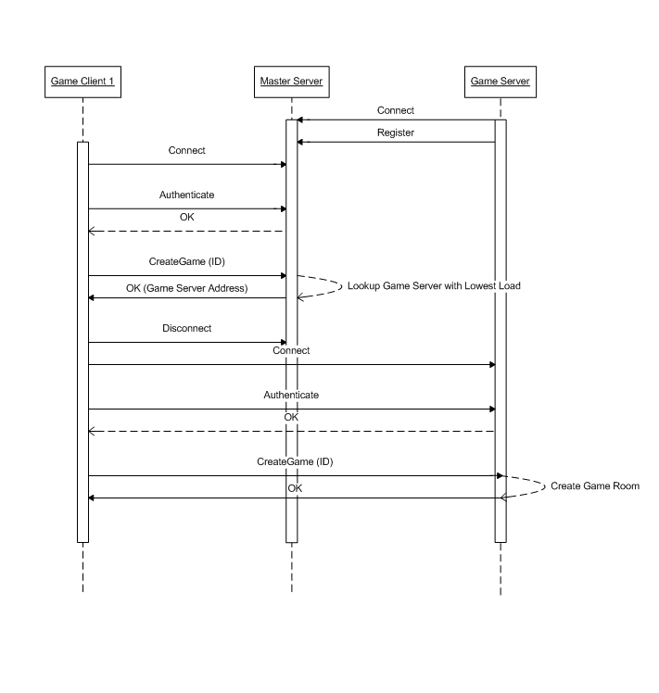
a) Client-server architecture is applied in our game system. Most of the multiplayer games available online are based on a client-server architecture because this architecture gives better administration control to the game providers. This architecture prevents players from cheating as all the game logic is executed on the centralized server. However, because of the varying and high latency of wireless networks and of the changing consistency requirements during the game play, it is difficult to keep the user experience highly interactive in client-server architecture. The server applies consistency mechanism on its side, as in the traditional client-server architecture and dynamically switches to apply a client side consistency mechanism when inconsistencies occur at the client side because of the change in network conditions and/or game requirements.
b) Client side will include sending and receiving data simultaneously. When player executes an order, like clicking a control button, the executing order will be sent to the server through internet protocol. When the server receives data, it starts computing with game logic, and sends the state data to all the players synchronously. This is a classic loop of game process, where all the game logic is decided by a specific server.
c) Server side will include receiving data and making judgements by game logic. We would like to build up a control panel for the server side, so that all the competition can be visible through this control panel. Meantime there are several problems to interfere with.
Synchronization Problem: A serious problem we will be facing would be the synchronization problem. We will have to figure out what to do when a communication delay occurs, or even worse, when a connection is totally lost (due to internet breakdown or quitting of game).
Game Logic: Our team will have to figure out a set of game logic to make the game playable and leverage the computing pressure at the same time. This kind of game logic would require careful design. Besides, we need a logic tool to prevent players from cheating.

4.2 Workflow and Dataflow
a) Workflow
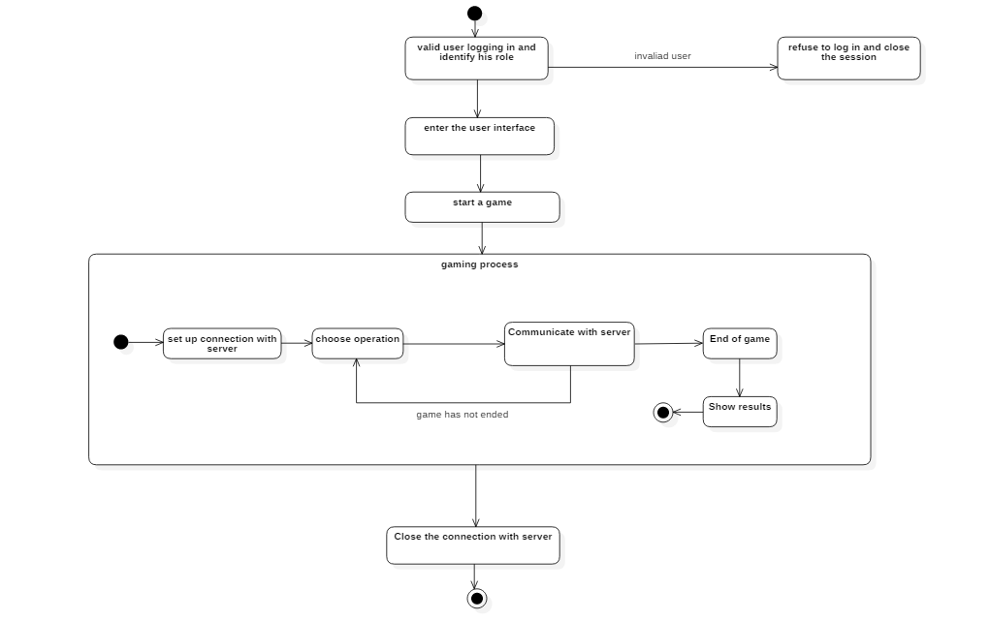

- Dataflow
- 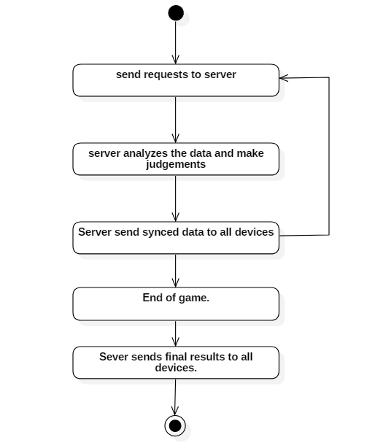

4.3 Improvement
The Dawn game is based on battle royal game mode, this gaming mechanism involves many pre-settings like size of map, refreshing time for safety zone, rate for gears, etc. So the gaming logic needs frequent adjustment in order to cater to the players' favor. As a consequence, we are considering of introducing a automatic tool for the adjustment. The new system would collect player data from database and make pre-programmed analysis, after which it will choose better parameters and upload these data to the game logic.
Advanced Communication Protocol
The game logic itself is essential to the gaming experience, but the communication technology we use is even more fundamental. A better internet communication protocol could benefit gaming experience in varying ways. Existing protocols includes TCP/IP and UDP, which is widely used in game development. However, many serious problems occurred during practice, for instance, a bad internet condition could contribute to a terrible communication quality or high delay. A brand new protocol called KCP has been developed to promote communication quality under bad internet condition. It is completely open-source, and has proven useful.
Multi-platform Development
Current development focuses on Android development, which is based on Java. In the future, we would consider developing the same game in IOS device. As we know, ios-development involves Swift, given the fact that only one member in the team possesses a MacBook, we decided to put this idea aside temporarily and focus on the Android game currently. This is for the satisfaction for users from all platforms.

4.4 Impact
This charpter will illustrate the impact when building up our system, including:

4.4.1 Impacts to the Devices
The server used to run the game system must require:
CPU: PentiumIV 1.3Ghz or better
Main memory: 512MB or more

Minimum requirements for DAWN is as follows:
OS: Android™4.3 or higher verison
Memory: 2 GB RAM
Network: Wifi or 4G connection
Recommended requirements for DAWN is as follows:
OS: Android™4.3 or higher verison
Memory: 4 GB RAM
Network: Wifi or 4G connection

4.4.2 Impacts to the Software
The game server need to be run under the JAVA environment, so Linux or Windows will satisfy our requirements.

The Dawn Game need to be run on Android™4.3 or higher version. Our future plan is to transplant the game to ios devices.

4.4.3 Impacts to the User
Any android user will have access to the game. Windows users are allowed to use virtual environment to enjoy the same game.
A server administrator is needed to maintain the normal operation of game server.

4.4.4 Impacts to the Run-time Process
In this section I will talk about the influence on the Run-time Process.
a) The user can play this game in almost any generation of Android devices, or he can play it in a virtual machine based on Windows/Linus/MacOS;
b) The game is supposed to be friendly-to-user, anyone can learn to paly this game in a relative short time;
c) The gaming data will be stored in our central server, and we will thus be able to repeat the specific game and identify the possible cheater.
d) When the user triggers a bug, there should be a way to stop the procedure and at least spare the system from dying.
e) When a connection is lost, users should be able to reconnect to the server and continue the game.

4.4.5 Impacts to the Development
For this section I will talk about the impacts to the development.
There are two essential parts of the game system. One is the game logic system, this determines how the game is going to proceed, we should develop a game logic system with feasibility and playability. Another is the communication system, this is important since our game is for multi-player, we need to build up a good communication system and tell the system what to do when the connection is down or the internet condition is terrible.
To test the whole gaming system, we will have to possess several Android devices. Actually, we are considering using virtual machine to make this easier, and the use of virtual machine is going to make the adaptability test easier because it will be convenient to change device parameters.
Luckily, our system is product-oriented; all the knowledge we need to know is common and open to every software developer. And there is no security problem in the current concern.

4.4.6 Impacts to the Location and Equipment
Players will only need to possess an Android device that meets our requirement. The game server will be provided by us.

4.4.7 Impacts to the Expenditure
Actually this topic will be talked about in Chapter 4.6 Cost/Benefit Analysis, I would say that our game development is not going to take a lot budget, and our goal is to develop a playable game, not a game to make profit.

4.5 Limitation
This software can’t run low-performance hardware equipment, because our system is a large web-based system. Actually, the hardware is cheaper and cheaper recently. This is not a big problem any longer.
Our game can only run in Android device, which is a fundamental limitation

4.6 Technique Capability
Generally, our game is not quite so simple to implement considering that we are not so familiar with JAVA development, and now I will go deeper analyze the feasibility in technique:
a) With current technology, the communication part is easy to achieve, we intend to use TCP/IP or UDP to implement the communication model. Besides, the JAVA has various modules for us to write a complete game, so it is not a problem as long as we study the JAVA well.
b) With the limitation mentioned above, there is nothing in particular that will inhibit us from developing the whole project.
c) We have five peoples in our team, and we are all experienced in software developing. Besides we have a talented professor who will supervise us during the whole project life cycle. Five people are enough to develop such a system, and we are sure we can finish it ahead of the deadline. See details in the project plan documents.
d) The expected project life cycle is the whole semester, and additionally with the professor’s help, we all believe that this will not be a hard rock to crack.

5 Alternative Solutions
We used to think other solutions for realize the function of Dawn. However, as a new software development team, it is difficult for us to find a way to figure out the software project. Also, we should do this project by ourselves in every part .So we don’t have alternative solution temporarily.

6 Cost/Benefit Analysi

Cost

Cost for Infrastructure
a) Hardware Devices: Server (one or more than one)
5 Personal Computers (for programming)
3-4 smartphones based on Android (for test)

b) Software: Linux/.Windows server
Android Studio 3.3.2
JVM :OpenJDK 64-bit server by Jetbrains s.r.o
Mysql
STARUML for writing documents

c) Facilities: Net construction: Net wire, Net Adaptation, Hub
Security Device: Firewall
e) Update the original system: none for now
f) Necessary place to locate hardware device: no need, since we can develop in our domitory
g) Cost of fixing hardware and software: none if no accident happens
h) Cost of recruiting employers: none

Other Cost for One-off Investment
      - The payment of buying some similar games (for comparison)
      - Requirement Research & Design Research
      - Develop Plan Research & Measure Criterion Research
      - Cost for technology management
      - Cost of some reference books
      - Cost of some picture materials

Non-One-off Investment
      - Device(server) rent and cost to maintain
      - Software rent and cost to maintain
      - Cost of the communication between team members
      - Cost of advertisement
      - Cost for collecting users’ feedback and fixing bugs.
      - Other necessary usual expense such as the electric and water expense

Benefit

One-off Benefit
      - Android Studio is more official, by using which we makes our level of program files more clear and easy to be integrated.
      - The VPN allows us to use some java templates from dl.google.com, which saves us a large amount of work.
      - The quality of our product can been increased greatly.
      - We can use our own personal VPN, which reduces the payment.
      - We invited some professionals to paint the game scenes, which makes us concentrate on the code.

Non-One-off Benefit
      - Delicated scenes and characters can appeal to more potential players.
      - A stable server brings fluent game process. It will largely optimize users’ game experience and attract more people.
      - The new hardware device and software imported can be reused in the coming projects; we can save money in the future’s projects.
      - The experience in this project can be used in the similar projects; we can accelerate the speed and quality of new project.
      - Mobile games are more popular than which in PC so we can gain more income.

Immeasurable Benefit
      - Referring to different games with the similar playing method offers us idea about how to improve ours’ playability.
      - We can get the information more by viewing papers on Google.
      - The organizational planning can be improved. Every member can have a clear task.
      - The organizational flexibility can be raised. The project plan can be modified more easily, and when facing risk, we can get a quick solution.
      - We gain experience about both how to write java code and how to develop apps on mobile phone through practice.

Cost/Benefit Ratio
Project cash flow projection
Year Project
0 -$1,000
1 $500
2 $300
3 $200
4 $100
Net Profit $100

According to similar software and our experience in development, we suppose the life cycle of this software is over 4 years. The total cost, including develop cost and maintain cost, is about $1000. The benefit from this product will come to $200.

Investment Return Period
Concerning the cash flow analyze and our experience in similar project, we suppose we can have net profit in about 3 half years. So the investment return period is 3 years.

Sensibility Analysis
- The stability of the server.
If the server stops working, our project will delay greatly, and the cost will rise roughly. So the server must be opened all the time. If one server fails to start because of some unpredicted accidents, a second server shall work at once to replace the last one.

- The efficiency of data transfer
In the game players are competing against one another, delays even no longer than one second can decrease their experience greatly. So the data rates must high enough.

- The security of data
Once some malicious players modify the data passed between personal divice and server, they can make their character more powerful by cheating or even steal others’ account, which should be strictly forbidden.So paying attention to the security of data is necessary.

- The similar product from the counterpart
If our competitors release a similar product, our profit may be influence. We shall release our product before our competitors.

- The resource
Make full use of the resource and cut some unnecessary waste can I increase the profit.

- Market driven (User’s interest)
If people are not interested in our game, we cannot attract users’ eye.So our game must conform to the market trend, and update it regularly. Adding more playing methods longs the game’s life.

7 Other Social Factor

7.1 Law Based Factors
It's exciting to set up an independent game development team or think tank for the first time. We already have some wonderful ideas and prepared to put it into action, but we should also think carefully and plan ahead for LAW factor we will face in the software development.
In addition, our team hopes that eventually this game will help everyone relax and entertain in different situations. To achieve this goal, we should try our best to make it a non-law-violate firstly.
In our software development, we will obey this rules:
(1) The name of the game doesn’t contain the words of infringement, vulgarity and sensitivity.
(2) Don’t exist malicious jump links or mandatory bullet windows in the game, which may result in loss of privacy or property or security concealment
(3) If a game is purchased by a user, it should be clearly prompted and priced, and no false information or malicious deductions should be made.
(4) The game cannot contain other platforms to share, advertising information, as well as other third-party platforms, companies, services and other propaganda letters.

7.2 Feasibility of use
7.2.1 Bug processing
There is no doubt that bug processing is a huge difficulty for all the software development. Our software will design a user feedback function on the UI interface to receive the feedback when bug occurs. Our project will be open-source and welcome to any developer to offer his wonderful ideas and offer his help.

7.2.2 Development team
Our development team is composed of students from Shanghai Jiaotong University.We master the related skills as a Product Manager , Systems Architect ,Systems Analyst, Software Development Engineer, Project Manager. We will strain our nerve to collaborate. create a successful software.

8 Conclusion
After analyze all those things above，we can draw a conclusion that we can start the project at once.

