DAWN
Feasibility Analysis Report

Version 1.0
By:
Dawn Group
2019-04

Group Member:
Zihan Xu
Yi Kuang
Chenyu Yang
Yuting Lan
Jianzhen Cao

Document Language:
English

Revision History
Date | Version | Description | Author
2019-4-2 | 1.0 | Finish the 1st edition of feasibility analysis report | Zihan Xu, Yi Kuang, Chenyu Yang, Yuting Lan, Jianzhen Cao

1 Introduction 1
1. Purpose 1
2. Background 1
3. Definition 1
4. Reference 2
2. Presupposition 2
1. Requirement 2
2. Objective 3
3. Condition, Supposition and Limitation 3
4. Feasibility Analyzing Method 3
5. Evaluation Criteria 3
3. Excising System Analysis 4
1. Workflow and Dataflow 4
2. Working Load 4
3. Expenditure 4
4. Personnel 5
5. Devices 5
6. Limitation 5
4 Proposed System 5
4.1 Introduction to the Proposed System 5
4.2处理流程和数据流程 7
4.3 Improvement 7
4.4 Impact 8
4.4.1 Impacts to the Devices 8
4.4.2 Impacts to the Software 8
4.4.3 Impacts to the User 9
4.4.4 Impacts to the Run-time Process 9
4.4.5 Impacts to the Development 9
4.4.6 Impacts to the Location and Equipment 10
4.4.7 Impacts to the Expenditure 10
4.5 Limitation 10
4.6 Technique Capability 10
5可选择的其他系统方案 11
5.1可选择的系统方案1 11
5.2可选择的系统方案2 11
6投资及效益分析 11
6.1支出 11
6.1.1基本建设投资 11
6.1.2其他一次性支出 12
6.1.3非一次性支出 12
6.2收益 12
6.2.1一次性收益 13
6.2.2非一次性收益 13
6.2.3不可定量的收益 13
6.3收益／投资比 13
6.4投资回收周期 13
6.5敏感性分析 14
7社会因素方面的可行性 14
7.1法律方面的可行性 14
7.2使用方面的可行性 14
8结论 14

可行性研究报告

1 Introduction

Purpose
- Through the investigation of the mobile phone game project in class, the system's feasibility report is preliminarily formulated, and the problems faced in the software development process and the corresponding solutions are reviewed and rationally arranged. Identify the goals of this system by understanding the economic benefits and risks that software development may bring.
- The arrangement of personnel, funds, system resources and other issues involved in the project development process will be recorded in the form of documents, so that software developers and related personnel can facilitate the corresponding inspection of the project.
- After the report has been reviewed, it will be reviewed by the responsible person.

Background
The name of the software system: DAWN
Project task proposer: Xu Zihan (team leader)
Project developer: Xu Zihan, Kuang Yi, Yang Chenyu, Lan Yuting, Cao Jianzhen
Users the project orient to: all the players
The basic relationship between the software system and other systems or other institutions: the system is relatively independent, and third-party software services or other frameworks may be used in development.

Definition
DAWN: name of the game
Android: A popular smart terminal operating system from Google
App: Abbreviation for application, generally refers to the published application running on a smartphone
TCP/IP: Internet transmission of the most basic protocol
Player: the person who participate in game
Room: a group of players
Occupation: a profession with certain attributes and skills

Reference
<<Object-Oriented Software Engineering Practice Guide-2>>
<<Object-Oriented Software Engineering - Using UML, Patterns, and Java>> (3rd edition), Tsinghua University Press, 2011

Presupposition

Requirement
DAWN is a game based on local area network which is often played together with friends, classmates or companions in parties. Also it is used to make acquaintance with some new friends through a shared course of game.
- Functional requirements
DAWN is a kind of shared game, of which the interesting quality is to play a game with other people at the same time on the same platform.

First of all, DAWN wants to provide a platform on which in a party some people can start a game conveniently and quickly, which means if there are some people sitting together, that is to say, they are not very far from each other, then they can create a local area network and they all join into the network to get into a shared game.
For example, one of them can create a hot spot and all others can join into the local area network. In this way the game can start in a short term, no network delay and no matching time and so on.

Secondly, DAWN provides a vast occupation system and a great game setting. DAWN provides 4 occupations which has different quality and skills to enrich the game experience. In this game the four occupations have no absolute advantages but is relatively more powerful than others in certain aspects so players can enjoy different occupations fairly. Besides that, we design a rich game setting including stages and properties. Players can use different properties to realize different effects and different stages the game has different settings.

- Non-functional requirements
1) easy to handle
The game needs to control the operation of the user so that the user can use the game reasonably and legally. For illegal operations, it is necessary to be able to identify and eliminate interference, correctly implement the function, and give appropriate prompt information during operation.
2) Design constraints
It is relevant with the software. In consideration of the applicable population, the software should support English, Simplified Chinese. The software development language is Java.
3) System Oriented
The user interface of this game is Android App on the mobile phone side.
4) Communication Interface
The communication protocol used by this game is as follows:
a. TCP/IP protocol
b. UDP protocol
c. HTTP protocol

- Deadline
The whole game should be completed on June 14th.

Objective
- Provide a popular way to assist in ice-breaking in a relatively small range.
- Easily start a game and learn how to play.
- Provide a relatively rich game system to maintain long interest to play.

Condition, Supposition and Limitation
- Minimum life time of game: 1 year
- Time to select suitable solution: 1 week
- Conditions of developing/run-time environment in hardware and software
Hardware:
- PIII or more advanced PC, laptop
- Minimum runtime memory requirements: 128M
- Hard disk space for installation: except the application server and database server, clients use browsers to get access to the service.
Software:
- Windows 10
- MacOS Mojave 10.x

Feasibility Analyzing Method
- Customer survey
- Experts consultation
- Market survey of similar or relevant products

Evaluation Criteria
The criteria of evaluating the game are: functions supported or provided by the game, time cost to develop the game, and the usability of the game.

Excising System Analysis
The traditional phone game is ether stand-alone or connected to the Internet. The former can only be played by one player. The latter depends on the Internet to do everything. However, the Internet status is not always good and trustable, which causes some problems.

Workflow and Dataflow
We used to play an online game connected to Internet. Work flow as follows:

Connect to Internet and log in

Get into a room and match through Internet

Play together through Internet

Game over and choose to play again or quit on the Internet

Note that all manipulations are accomplished on the Internet so the response may be not stable and matching time may be long and maybe you do not know the people who play with you and so on.

Working Load
Since all the work is done by manual work, so extra employee is needed and it is time, resource and labor exhausting. The working load is almost same as coding.

Expenditure
Large amount of money is needed to maintain the game system. Usually 2000 per person-month.

Personnel
About three people need to maintain the game system itself and another three people need to solve Internet problems.

Devices
A PC and a phone with android system are needed.

Limitation
As has mentioned above, 2 main factors limit the existing game system:
  - The Internet status is not stable
  - The process of a game is complex and slow

4 Proposed System
This charpter will be used to illustraye the goal for our proposed system and how the requirements will be fulfilled.

4.1 Introduction to the Proposed System
Our game is based on client-server architecture. With our server collecting real-time data from player's devices, it also does the job of computation.
The brief physical architecture view can be showed as follow: 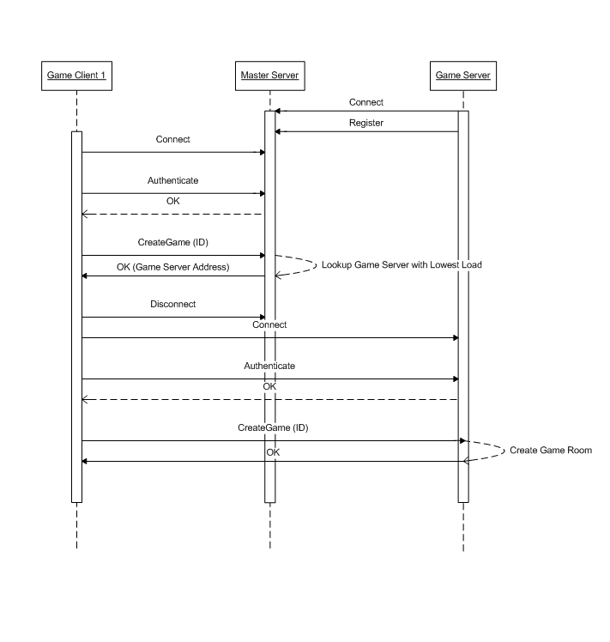
a) Client-server architecture is applied in our game system. Most of the multiplayer games available online are based on a client-server architecture because this architecture gives better administration control to the game providers. This architecture prevents players from cheating as all the game logic is executed on the centralized server. However, because of the varying and high latency of wireless networks and of the changing consistency requirements during the game play, it is difficult to keep the user experience highly interactive in client-server architecture. The server applies consistency mechanism on its side, as in the traditional client-server architecture and dynamically switches to apply a client side consistency mechanism when inconsistencies occur at the client side because of the change in network conditions and/or game requirements.
b) Client side will include sending and receiving data simultaneously. When player executes an order, like clicking a control button, the executing order will be sent to the server through internet protocol. When the server receives data, it starts computing with game logic, and sends the state data to all the players synchronously. This is a classic loop of game process, where all the game logic is decided by a specific server.
c) Server side will include receiving data and making judgements by game logic. We would like to build up a control panel for the server side, so that all the competition can be visible through this control panel. Meantime there are several problems to interfere with.
Synchronization Problem: A serious problem we will be facing would be the synchronization problem. We will have to figure out what to do when a communication delay occurs, or even worse, when a connection is totally lost (due to internet breakdown or quitting of game).
Game Logic: Our team will have to figure out a set of game logic to make the game playable and leverage the computing pressure at the same time. This kind of game logic would require careful design. Besides, we need a logic tool to prevent players from cheating.

4.2 Workflow and Dataflow
a) Workflow
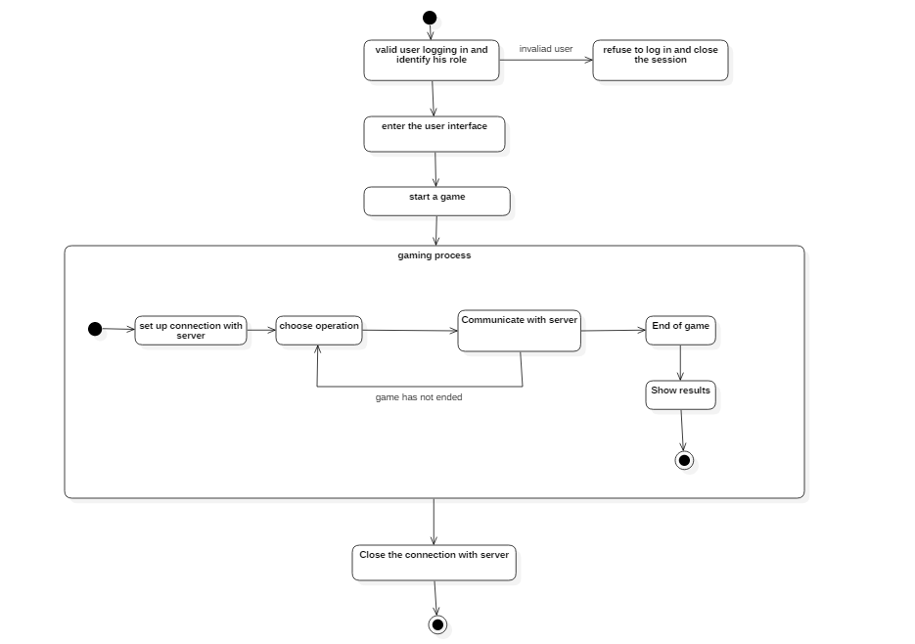

- Dataflow
- 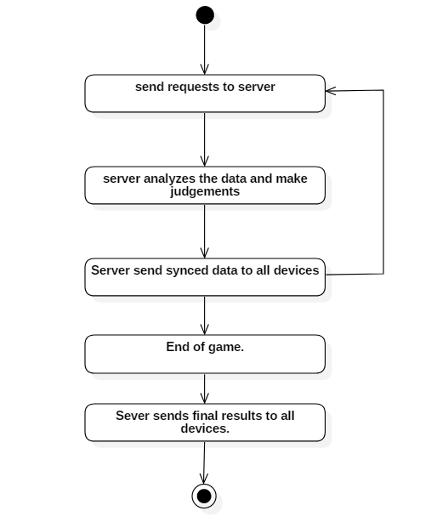

4.3 Improvement
The Dawn game is based on battle royal game mode, this gaming mechanism involves many pre-settings like size of map, refreshing time for safety zone, rate for gears, etc. So the gaming logic needs frequent adjustment in order to cater to the players' favor. As a consequence, we are considering of introducing a automatic tool for the adjustment. The new system would collect player data from database and make pre-programmed analysis, after which it will choose better parameters and upload these data to the game logic.
Advanced Communication Protocol
The game logic itself is essential to the gaming experience, but the communication technology we use is even more fundamental. A better internet communication protocol could benefit gaming experience in varying ways. Existing protocols includes TCP/IP and UDP, which is widely used in game development. However, many serious problems occurred during practice, for instance, a bad internet condition could contribute to a terrible communication quality or high delay. A brand new protocol called KCP has been developed to promote communication quality under bad internet condition. It is completely open-source, and has proven useful.
Multi-platform Development
Current development focuses on Android development, which is based on Java. In the future, we would consider developing the same game in IOS device. As we know, ios-development involves Swift, given the fact that only one member in the team possesses a MacBook, we decided to put this idea aside temporarily and focus on the Android game currently. This is for the satisfaction for users from all platforms.

4.4 Impact
This charpter will illustrate the impact when building up our system, including:

4.4.1 Impacts to the Devices
The server used to run the game system must require:
CPU: PentiumIV 1.3Ghz or better
Main memory: 512MB or more

Minimum requirements for DAWN is as follows:
OS: Android™4.3 or higher verison
Memory: 2 GB RAM
Network: Wifi or 4G connection
Recommended requirements for DAWN is as follows:
OS: Android™4.3 or higher verison
Memory: 4 GB RAM
Network: Wifi or 4G connection

4.4.2 Impacts to the Software
The game server need to be run under the JAVA environment, so Linux or Windows will satisfy our requirements.

The Dawn Game need to be run on Android™4.3 or higher version. Our future plan is to transplant the game to ios devices.

4.4.3 Impacts to the User
Any android user will have access to the game. Windows users are allowed to use virtual environment to enjoy the same game.
A server administrator is needed to maintain the normal operation of game server.

4.4.4 Impacts to the Run-time Process
In this section I will talk about the influence on the Run-time Process.
a) The user can play this game in almost any generation of Android devices, or he can play it in a virtual machine based on Windows/Linus/MacOS;
b) The game is supposed to be friendly-to-user, anyone can learn to paly this game in a relative short time;
c) The gaming data will be stored in our central server, and we will thus be able to repeat the specific game and identify the possible cheater.
d) When the user triggers a bug, there should be a way to stop the procedure and at least spare the system from dying.
e) When a connection is lost, users should be able to reconnect to the server and continue the game.

4.4.5 Impacts to the Development
For this section I will talk about the impacts to the development.
There are two essential parts of the game system. One is the game logic system, this determines how the game is going to proceed, we should develop a game logic system with feasibility and playability. Another is the communication system, this is important since our game is for multi-player, we need to build up a good communication system and tell the system what to do when the connection is down or the internet condition is terrible.
To test the whole gaming system, we will have to possess several Android devices. Actually, we are considering using virtual machine to make this easier, and the use of virtual machine is going to make the adaptability test easier because it will be convenient to change device parameters.
Luckily, our system is product-oriented; all the knowledge we need to know is common and open to every software developer. And there is no security problem in the current concern.

4.4.6 Impacts to the Location and Equipment
Players will only need to possess an Android device that meets our requirement. The game server will be provided by us.

4.4.7 Impacts to the Expenditure
Actually this topic will be talked about in Chapter 4.6 Cost/Benefit Analysis, I would say that our game development is not going to take a lot budget, and our goal is to develop a playable game, not a game to make profit.

4.5 Limitation
This software can’t run low-performance hardware equipment, because our system is a large web-based system. Actually, the hardware is cheaper and cheaper recently. This is not a big problem any longer.
Our game can only run in Android device, which is a fundamental limitation

4.6 Technique Capability
Generally, our game is not quite so simple to implement considering that we are not so familiar with JAVA development, and now I will go deeper analyze the feasibility in technique:
a) With current technology, the communication part is easy to achieve, we intend to use TCP/IP or UDP to implement the communication model. Besides, the JAVA has various modules for us to write a complete game, so it is not a problem as long as we study the JAVA well.
b) With the limitation mentioned above, there is nothing in particular that will inhibit us from developing the whole project.
c) We have five peoples in our team, and we are all experienced in software developing. Besides we have a talented professor who will supervise us during the whole project life cycle. Five people are enough to develop such a system, and we are sure we can finish it ahead of the deadline. See details in the project plan documents.
d) The expected project life cycle is the whole semester, and additionally with the professor’s help, we all believe that this will not be a hard rock to crack.

5可选择的其他系统方案
扼要说明曾考虑过的每一种可选择的系统方案，包括需开发的和可从国内国外直接购买的，如果没有供选择的系统方案可考虑，则说明这一点。

5.1可选择的系统方案1
参照第4章的提纲，说明可选择的系统方案1，并说明它未被选中的理由。

5.2可选择的系统方案2
按类似5.1条的方式说明第2个乃至第n个可选择的系统方案。
......

6投资及效益分析

6.1支出
对于所选择的方案，说明所需的费用。如果已有一个现存系统，则包括该系统继续运行期间所需的费用。

6.1.1基本建设投资
包括采购、开发和安装下列各项所需的费用，如：
- 房屋和设施；
- ADP设备；
- 数据通讯设备；
- 环境保护设备；
- 安全与保密设备；
- ADP操作系统的和应用的软件；
- 数据库管理软件。

6.1.2其他一次性支出
包括下列各项所需的费用，如：
- 研究（需求的研究和设计的研究）；
- 开发计划与测量基准的研究；
- 数据库的建立；
- ADP软件的转换；
- 检查费用和技术管理性费用；
- 培训费、旅差费以及开发安装人员所需要的一次性支出；
- 人员的退休及调动费用等。

6.1.3非一次性支出
列出在该系统生命期内按月或按季或按年支出的用于运行和维护的费用，包括：
- 设备的租金和维护费用；
- 软件的租金和维护费用；
- 数据通讯方面的租金和维护费用；
- 人员的工资、奖金；
- 房屋、空间的使用开支；
- 公用设施方面的开支；
- 保密安全方面的开支；
- 其他经常性的支出等。

6.2收益
对于所选择的方案，说明能够带来的收益，这里所说的收益，表现为开支费用的减少或避免、差错的减少、灵活性的增加、动作速度的提高和管理计划方面的改进等，包括；

6.2.1一次性收益
说明能够用人民币数目表示的一次性收益，可按数据处理、用户、管理和支持等项分类叙述，如：
- 开支的缩减包括改进了的系统的运行所引起的开支缩减，如资源要求的减少，运行效率的改进，数据进入、存贮和恢复技术的改进，系统性能的可监控，软件的转换和优化，数据压缩技术的采用，处理的集中化／分布化等；
- 价值的增升包括由于一个应用系统的使用价值的增升所引起的收益，如资源利用的改进，管理和运行效率的改进以及出错率的减少等；
- 其他如从多余设备出售回收的收入等。

6.2.2非一次性收益
说明在整个系统生命期内由于运行所建议系统而导致的按月的、按年的能用人民币数目表示的收益，包括开支的减少和避免。

6.2.3不可定量的收益
逐项列出无法直接用人民币表示的收益，如服务的改进，由操作失误引起的风险的减少，信息掌握情况的改进，组织机构给外界形象的改善等。有些不可捉摸的收益只能大概估计或进行极值估计（按最好和最差情况估计）。

6.3收益／投资比
求出整个系统生命期的收益／投资比值。

6.4投资回收周期
求出收益的累计数开始超过支出的累计数的时间。

6.5敏感性分析
所谓敏感性分析是指一些关键性因素如系统生命期长度、系统的工作负荷量、工作负荷的类型与这些不同类型之间的合理搭配、处理速度要求、设备和软件的配置等变化时，对开支和收益的影响最灵敏的范围的估计。在敏感性分析的基础上做出的选择当然会比单一选择的结果要好一些。

7社会因素方面的可行性
本章用来说明对社会因素方面的可行性分析的结果，包括：

7.1法律方面的可行性
法律方面的可行性问题很多，如合同责任、侵犯专利权、侵犯版权等方面的陷阱，软件人员通常是不熟悉的，有可能陷入，务必要注意研究。

7.2使用方面的可行性
例如从用户单位的行政管理、工作制度等方面来看，是否能够使用该软件系统；从用户单位的工作人员的素质来看，是否能满足使用该软件系统的要求等等，都是要考虑的。

8结论
在进行可行性研究报告的编制时，必须有一个研究的结论。结论可以是：
- 可以立即开始进行；
- 需要推迟到某些条件（例如资金、人力、设备等）落实之后才能开始进行；
- 需要对开发目标进行某些修改之后才能开始进行；
- 不能进行或不必进行（例如因技术不成熟、经济上不合算等）。

