DAWN
Project Development Plan

Version 1.0
By:
Dawn Group
2019-04

Group Member:
Zihan Xu
Yi Kuang
Chenyu Yang
Yuting Lan
Jianzhen Cao

Document Language:
English

Revision History
Date | Version | Description | Author
2019-4-2 | 1.0 | Finish the 1st edition of feasibility analysis report | Zihan Xu, Yi Kuang, Chenyu Yang, Yuting Lan, Jianzhen Cao

1 Introduction 1
1.1 Purpose For This Documentation 1
1.2 Background 1
1.3定义 1
1.4 Reference 1
2 Introduction of Project 1
2.1 Goal and Job 1
2.2 Structure of Team 2
2.3 Product 2
2.3.1 Program 2
2.3.2 Files 2
2.3.3 Service 3
2.3.4 Non-deliverable Products 3
2.4 Acceptance Standard 3
2.5 Planned completion time and deadline of the project 3
3 Implement Plan 3
3.1 Task breakdown and division of labor 3
3.2 阶段计划 4
3.3预算 5
3.4关键问题 5
4 Technology Planning Process 5
4.1 Method, Tools and Technique 5
4.2 Technical Standard 5
5 External Support Conditions 6
5.1 Work to be done by users 6
5.2 Work to be done by other units 6
6 Key Point For Project Plan 6

Project Development Plan

1 Introduction

Purpose For This Documentation
In this section, I will talk about our goal for writing this plan and point out the ecpected reader.

1.2 Background
- Name for our project: DAWN;
- Proposer of this project: The five menbers in our team;
- Developer of this project: The five menbers in our team;
- User of our app: Anyone with a proper Android device;
- Basic relationship of our system and other sysetms: Our game needs a server to provide network and computation service;

1.3定义
列出本文件中用到的专门术语的定义和外文的首字母组词的原词组。

1.4 Reference
Ron Patton 《software testing》
Roger S.Pressman《Software Engineering a Practitioner’s Approach and Caojian note of project manament》
Pressman, Roger (2010) Software Engineering: A Practitioner's Approach, McGraw Hill , New York, NY.

2 Introduction of Project

2.1 Goal and Job
Our goal is quite simple: we only have to develop a playable game which has basic basic functions. All functions are only for the basic use, and there is no commercial purpose and activity for us.
The work we need to accomplish is also clear, and I will clarify here:
- Complete the gaming logic system;
- Make a good stragety for network connection;
- Proceed testing and debugging;

2.2 Structure of Team
There are five menbers in our team, and I will introduce them and their role in the development:
Name | Skill | Role | Main Job
Zihan Xu | Java, Network Communication | Full Stack | Develop the Game system and build up communication strategy.
Chenyu Yang | Java | Game Analyzer, Game design | Determine the game logic and develop the logic system
Yi Kuang | Java, Database | Full Stack | Design the game system in Android device
Yuting Lan | Java, Network Communication | Full Stack | Design the game system in server.
Jianzhen Cao | Java | Testing Engineer | Proceed the testing job and propose bugs.

2.3 Product

2.3.1 Program
Name of Program: DAWN
Language: Java
Form of our project: Android APP

2.3.2 Files
(1) feasibility analysis report.
(2) project development plan.
(3) risk list.
(4) software requirements specification.
(5) vocabulary.
(6) software architecture documents.
(7) software design model.
(8) module development file.
(9) software test plan.
(10) software test summary report.
(11) user manual.
(12) software acceptance report.
(13) delivery list.
(14) software project summary report.
(15) source code.

2.3.3 Service
(1) We will provice free server service. Users can play our game online for free, and we can develop a cloud service to store users’ personal information.
(2) We will continue to fix bugs and propose more updates if possible.

2.3.4 Non-deliverable Products
None.

2.4 Acceptance Standard
The game is playable, all the basic functions are met.

2.5 Planned completion time and deadline of the project
The planned completion time: 2019.6.1
The deadline of the project: 2019.6.15 (determined by professor)

3 Implement Plan

3.1 Task breakdown and division of labor
The project work breakdown and the task assignment is listed below.
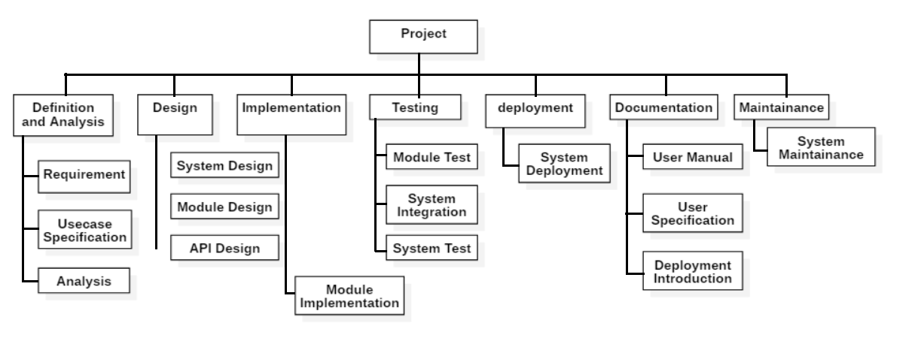
Project Job | Manager | Participant
Requirement Define | Chenyu Yang | All members
Usecase Specification | Zihan Xu | All members
Analysis | Yuting Lan | Chenyu Yang
System Design | Yi Kuang | Jianzhen
Module Design | Yuting Lan | Chenyu Yang
API Design | Jianzhen Cao | Yi Kuang
Module Implementation | Zihan Xu | Yi Kuang
Module Test | Yi Kuang | Zihan Xu
System Integration | Chenyu Yang | Zihan Xu
System Deployment | Zihan Xu | All members
User Manual | Zihan Xu | Yuting Lan
System Specification | Yi Kuang | Zihan Xu
Deployment Specification | Jianzhen Cao | Chenyu Yang
System Maintainance | Chenyu Yang | Jianzhen Cao

3.2
Milestone Incident | Scheduled Time
Requirement Documentation | 2019-04-07
Software Architecture Document | 2019-04-20
Module implementation | 2019-05-05
System Intergration | 2019-05-14
System Test | 2019-05-20
System Deployment | 2019-05-28
Project Completed | 2019-06-01

The Gantt Chart of our project (you may want to zoom in to read this):
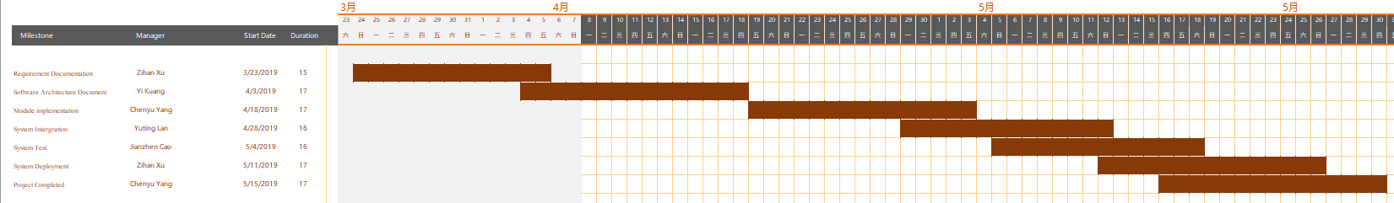

3.3 Budget
In the feasibility analysis, we had talked about the cost for developing the project.
a) Hardware Devices: Server (one or more than one)
5 Personal Computers (for programming)
3-4 smartphones based on Android (for test)

b) Software: Linux/.Windows server
Android Studio 3.3.2
JVM :OpenJDK 64-bit server by Jetbrains s.r.o
Mysql
STARUML for writing documents

c) Facilities: Net construction: Net wire, Net Adaptation, Hub
Security Device: Firewall
e) Update the original system: none for now
f) Necessary place to locate hardware device: no need, since we can develop in our domitory
g) Cost of fixing hardware and software: none if no accident happens
h) Cost of recruiting employers: none
The expected budget is: $1000

3.4 Key Problem
The key difficulty for the project are:
- High expenditure of developing
- Difficulty of Android developing (technique difficulty)
- Comlicate gaming logic
- Internet Communication
- Information sync between different devices and server
- …

4 Technology Planning Process

4.1 Method, Tools and Technique
This game is mainly developed in JAVA, we will be using Visual Studio Code as our IDE.
The database of our system will be developed based on MySQL.
The project development process adopts the method of structured development, which divides the system into several modules. The development life cycle of this project adopts waterfall model.

4.2 Technical Standard
In this section, I will introduce the technical standard we are going to follow.
- Business modeling guide
<< Business modeling guide>>
- User Interface Standard
Android Developer (https://developer.android.com/design)
Google Material design(https://design.google/library/welcome-new-google-design/)
- Use case specification Standard
<< Use case specification Standard>>
- Design Guide
Google Material design(https://design.google/library/welcome-new-google-design/)
- Programming Guide
Google Open Source Guide (https://zh-google-styleguide.readthedocs.io/en/latest/contents/#)
- Testing Guide
GBT 15532—2008
- Code Style Guide
- Google Open Source Programming and code style Guide (https://zh-google-styleguide.readthedocs.io/en/latest/contents/#)

5 External Support Conditions

5.1 Work to be done by users
Users need to play the game with proper ways, and they would better report bugs in time (in case there is some bugs).

5.2 Work to be done by other units
We need to deploy a cloud server to provide network and computation service, and we will need professional maintainer to help us maintain our server.

6 Key Point For Project Plan
- Requirement Management Plan: we need to keep an open mind and update the requirements as long as it is necessary.
- Progress Management Plan: we need to stick to the Progress Plan (the Gantt Chart), no delay should happen if nothing particular happens.
- Budge Control Plan: we need to contain our expense to keep our budget balanced.
- Quality Control Plan: the quality of the project should be strictly controllled.
- Risk Control Plan: according to the risk list, we have lots of risks, we will have to collect and analyze our risks all the time.
- System Test Plan: since our system is very complicated, we will need to test our system every time a module is implemented, we will have a specific testing engineer to do this work.

