DEPARTMENT OF COMPUTER SCIENCE & ENGINEERING
LABORATORY OBSERVATION & RECORD
BASIC INFORMATION
Student Name: M. Surya Prabhath
Roll No: A24126552094
Branch & Sec: CSM-B
Date of Execution: 04/09/2026
Course Name: Full Stack Web Development
Course Code: 23CM4121
Experiment No: 02
Title: Creating an Interactive To-Do List Application using HTML, CSS, and JavaScript
OBJECTIVE / AIM
To design and implement an interactive To-Do List web application featuring dynamic DOM manipulation, task status toggling, deletion, and local storage data persistence using HTML, CSS, and JavaScript.
SYSTEM REQUIREMENTS
Hardware Requirements:
Processor (Intel Core i5 / AMD Ryzen 5), 8GB RAM, Storage.
Software Requirements:
Operating System: Windows 11 / Linux
Code Editor: Visual Studio Code
Browser: Google Chrome / Mozilla Firefox
ARCHITECTURE / DESIGN
1. System Architecture Block:
• Frontend UI Layer: Structured using HTML5 (index.html) and styled using CSS3 (style.css) with linear gradient backgrounds and responsive card layouts.
• Application Logic & State: JavaScript (script.js) manages event listeners, dynamic DOM element creation/deletion, and browser localStorage persistence.
2. Execution Process Flow:
[Start] --> [Input Task Text] --> [Click Add Button]
│
▼
[Validate Input: Empty?] ── Yes ──> [Alert 'Write Something!']
│
No
▼
[Create <li> & Deletion <span>] ──> [Append to list-container]
│
▼
[Save HTML to LocalStorage] <── [Toggle Checked / Remove Task]
3. Execution Steps Summary:
Step 1: Initialize HTML container and input row structure linked with CSS and JavaScript.
Step 2: Capture input field value on 'Add' button click; validate that string is non-empty.
Step 3: Dynamically append list item (<li>) with delete button (<span>) to target <ul> container.
Step 4: Attach click event listener to toggle task completion status or delete task element.
Step 5: Persist list DOM tree state across reloads using localStorage.setItem() and showTask().
SOURCE CODE
HTML (index.html):
<!DOCTYPE html>
<html lang="en">
<head>
<meta charset="UTF-8">
<meta name="viewport" content="width=device-width, initial-scale=1.0">
<title>To-Do-List</title>
<link rel="stylesheet" href="style.css">
</head>
<body>
<div class="container">
<div class="todo-app">
<h2>To-Do List <img src="images/icon.png"></h2>
<div class="row">
<input type="text" id="input-box" placeholder="Add your text">
<button onclick="addTask()">Add</button>
</div>
<ul id="list-container"></ul>
</div>
</div>
</body>
<script src="script.js"></script>
</html>
CSS (style.css):
*{
margin: 0;
padding: 0;
font-family: "Poppins", sans-serif;
box-sizing: border-box;
}
.container{
width: 100%;
min-height: 100vh;
background: linear-gradient(135deg, #153677, #4e085f);
padding: 10px;
}
.todo-app{
width: 100%;
max-width: 540px;
background: white;
margin: 100px auto 20px;
padding: 40px 30px 70px;
border-radius: 10px;
}
.todo-app h2{
color: #002765;
display: flex;
align-items: center;
margin-bottom: 20px;
}
.todo-app h2 img{
width: 30px;
margin-left: 10px;
}
.row{
display: flex;
align-items: center;
justify-content: space-between;
background: #edeef0;
border-radius: 30px;
padding-left: 20px;
margin-bottom: 25px;
}
input{
flex: 1;
border: none;
outline: none;
background: transparent;
padding: 10px;
font-weight: 14px;
}
button{
border: none;
outline: none;
padding: 16px 50px;
background: #ff5945;
color: #fff;
font-size: 16px;
cursor: pointer;
border-radius: 40px;
}
ul li{
list-style: none;
font-size: 17px;
padding: 12px 8px 12px 50px;
user-select: none;
cursor: pointer;
position: relative;
}
ul li::before{
content: "";
position: absolute;
height: 28px;
width: 28px;
border-radius: 50%;
background-image: url(images/unchecked.png);
background-size: cover;
background-position: center;
top: 12px;
left: 8px;
}
ul li.checked{
color: #555;
text-decoration: line-through;
}
ul li.checked::before{
background-image: url(images/checked.png);
}
ul li span{
position: absolute;
right: 0;
top: 5px;
width: 40px;
height: 40px;
font-size: 22px;
color: #555;
line-height: 40px;
text-align: center;
border-radius: 50%;
}
ul li span:hover{
background: #edeef0;
}
JavaScript (script.js):
const inputBox = document.getElementById("input-box");
const listContainer = document.getElementById("list-container");
function addTask(){
if(inputBox.value === ''){
alert("You Must Write Something!");
}
else{
let li = document.createElement("li");
li.innerHTML = inputBox.value;
listContainer.appendChild(li);
let span = document.createElement("span");
span.innerHTML ="\u00d7";
li.appendChild(span);
}
inputBox.value = "";
saveData();
}
listContainer.addEventListener("click", function(e){
if(e.target.tagName === "LI"){
e.target.classList.toggle("checked");
saveData();
}
else if(e.target.tagName === "SPAN"){
e.target.parentElement.remove();
saveData();
}
}, false);
function saveData(){
localStorage.setItem("data", listContainer.innerHTML);
}
function showTask(){
listContainer.innerHTML = localStorage.getItem("data");
}
showTask();
COMPILATION / EXECUTION STEPS
Step 1: Create a project directory containing index.html, style.css, script.js, and an images/ folder.
Step 2: Ensure image assets (icon.png, unchecked.png, checked.png) are placed inside the images directory.
Step 3: Open index.html directly using any modern web browser or start Live Server in Visual Studio Code.
Step 4: Enter task text into the input field and click the 'Add' button to create a task.
Step 5: Click on any task item to toggle its completed state, or click the 'x' button to delete it.
Step 6: Refresh the page to verify that localStorage preserves task data automatically.
EXPECTED OUTPUT / SCREENSHOTS
Test Cases & Verification Results:
Test ID | Test Input / Action | Expected Output | Status
TC-01 | Click 'Add' with empty input box | Alert popup 'You Must Write Something!' displayed | Passed
TC-02 | Enter text and click 'Add' button | Task appended to list with delete icon | Passed
TC-03 | Click on added task list item | Toggles strikethrough class 'checked' and checked icon | Passed
TC-04 | Click 'x' span on task item | Task item removed permanently from list | Passed
TC-05 | Refresh / reload browser page | Saved list items rendered from localStorage | Passed
OUTPUT:
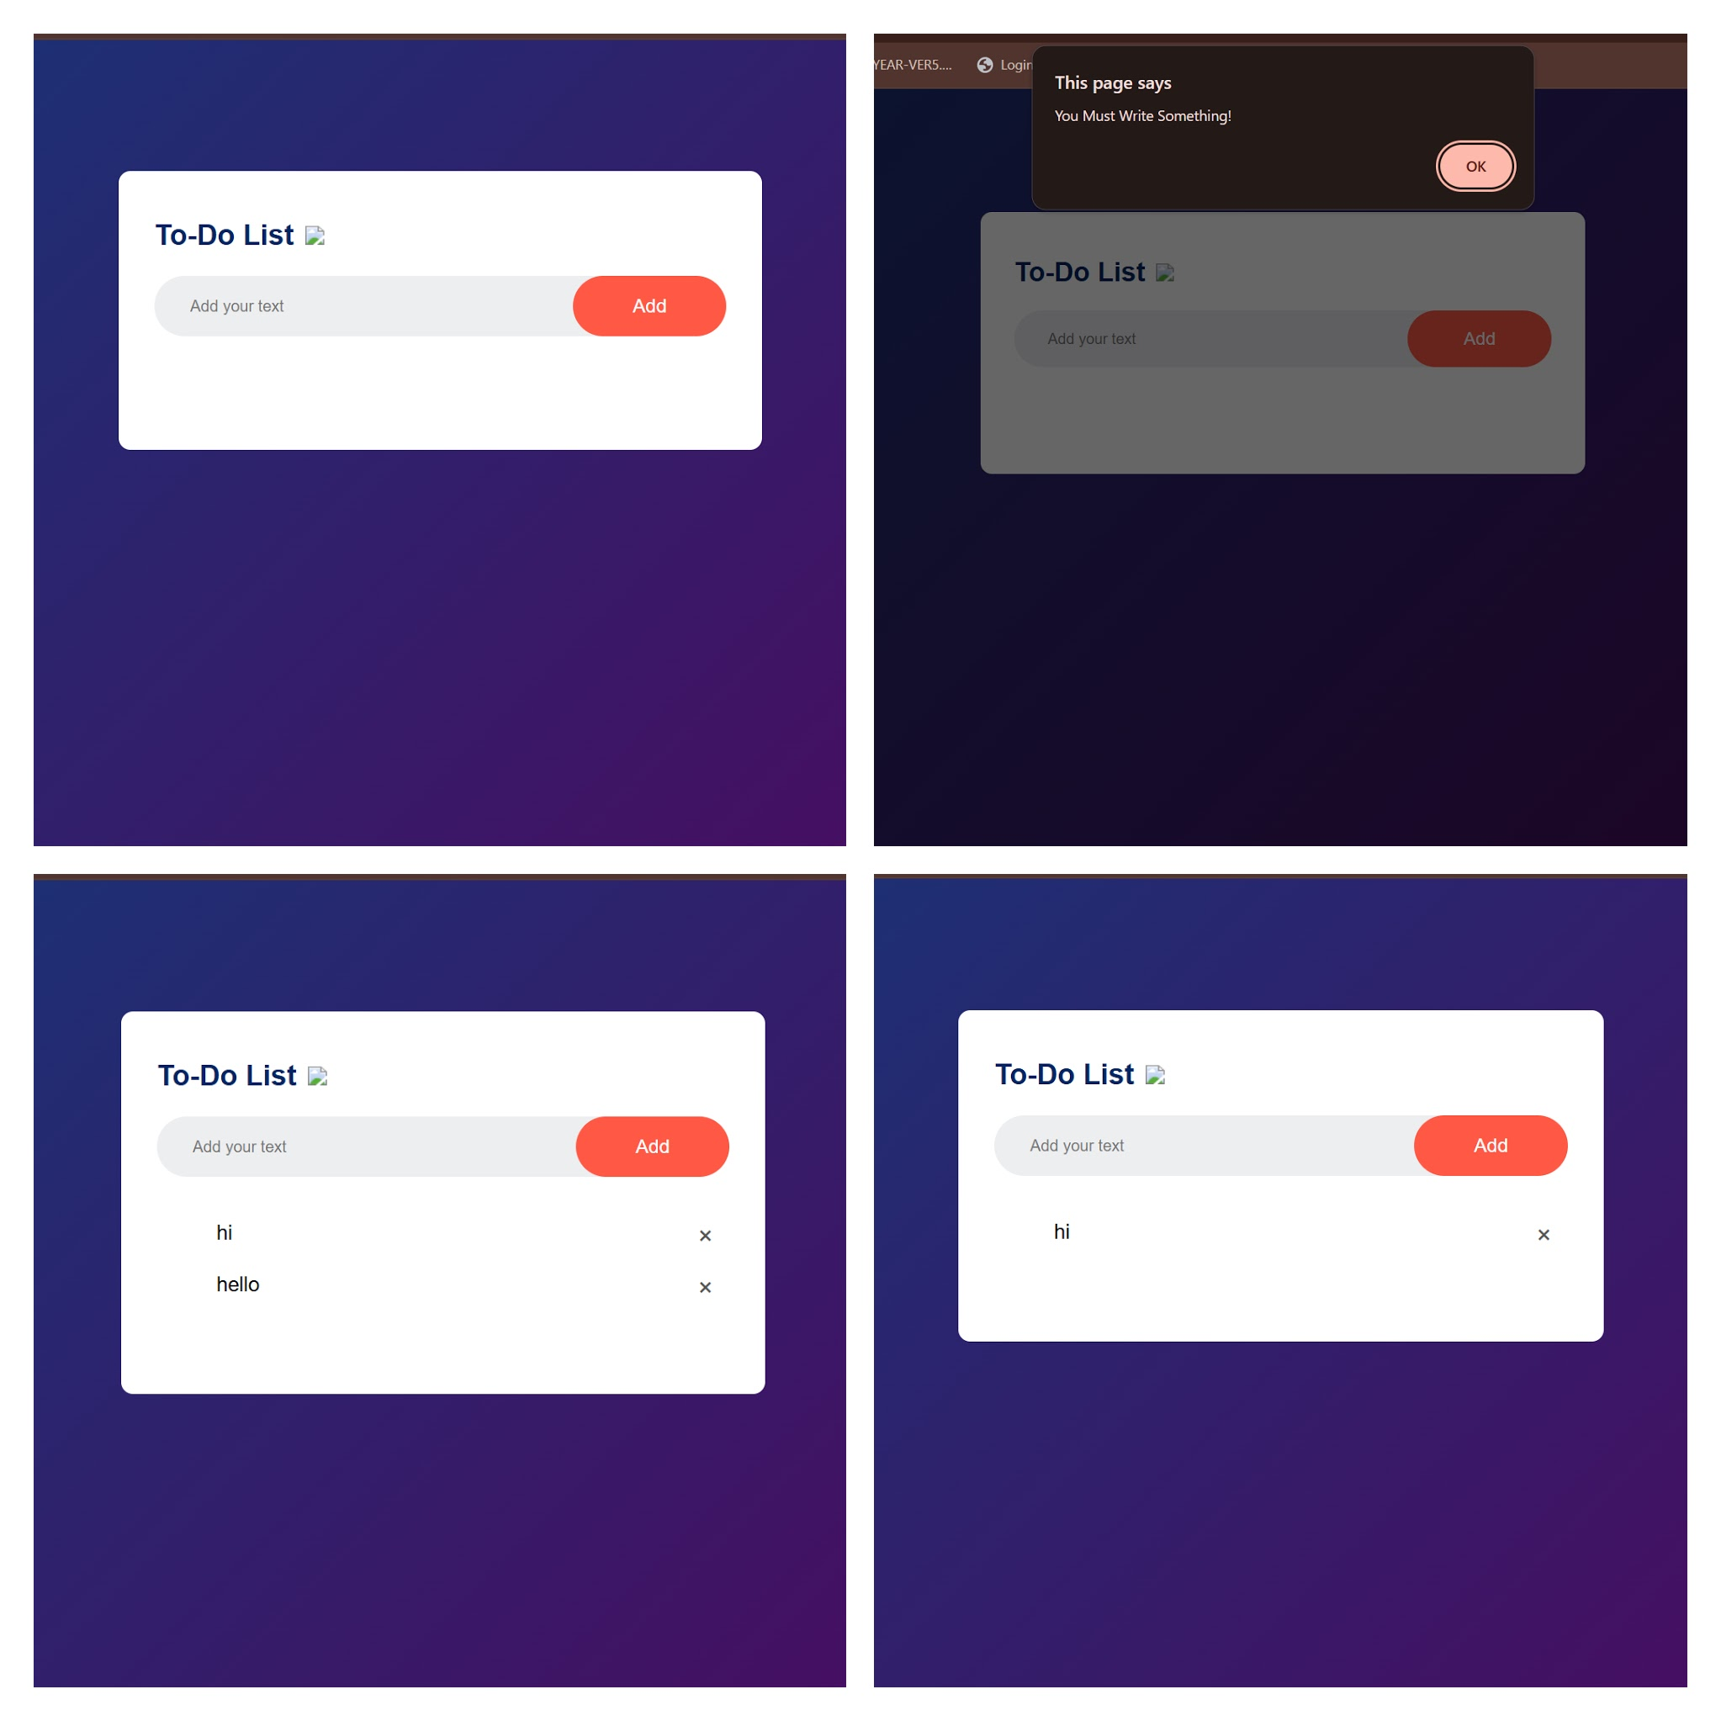

RESULT / CONCLUSION
The interactive To-Do List application was successfully implemented, tested, and verified using HTML5, CSS3, and JavaScript. Task addition, deletion, completion toggling, and localStorage data persistence functioned as expected.

