DEPARTMENT OF COMPUTER SCIENCE & ENGINEERING
LABORATORY OBSERVATION & RECORD
BASIC INFORMATION
Student Name: M. Surya Prabhath
Roll No: A24126552094
Branch & Sec: CSM-B
Date of Execution: 25/08/2026
Course Name: Full Stack Web Development
Course Code: 23CM4121
Experiment No: 01
Title: Creating a Responsive User Registration Form / Static Web Page
OBJECTIVE / AIM
To design and implement a responsive static web page with validation using HTML5, CSS3, and JavaScript incorporating semantic elements, inline styling, hyperlinking, and custom form controls.
SYSTEM REQUIREMENTS
Hardware Requirements:
Processor (Intel Core i5 / AMD Ryzen 5), 8GB RAM, Storage.
Software Requirements:
Operating System: Windows 11 / Linux
Code Editor: VS Code
Browser: Google Chrome / Firefox
ARCHITECTURE / DESIGN
Step 1: Document Structure & Boilerplate: Initialize the HTML5 document structure with standard head metadata and UTF-8 charset encoding.
Step 2: Main Header & Semantic Layout: Create a centered primary page heading (<h1>). Add a <section> element containing embedded <header>, <p>, and <footer> semantic elements styled with basic inline CSS.
Step 3: External Hyperlinking: Insert an anchor (<a>) tag pointing to an external web address (https://google.com).
Step 4: Form Controls & Layout: Build an interactive enquiry form enclosed within a <fieldset> and labeled using <legend>. Implement interactive field inputs including standard text, email, phone number, textarea, submit button, and form reset triggers.
Step 5: Styled Text Content & Render: Construct a bottom content paragraph incorporating customized font styling (font-family: cursive) and inline text formatting (<u>) before closing all active HTML elements.
SOURCE CODE
Frontend Code (HTML5 / CSS3):
<!DOCTYPE html>
<html lang="en">
<head>
<meta charset="UTF-8">
<meta name="viewport" content="width=device-width, initial-scale=1.0">
<title>Static HTML Web Page</title>
</head>
<body>
<h1 style="text-align: center;">Static HTML Web Page</h1>
<section>
<header style="text-align: center;">Lorem ipsum dolor sit amet.</header>
<p>Lorem ipsum dolor sit, amet consectetur adipisicing elit. Illum voluptas non sequi animi repellat commodi quaerat quod deserunt officiis alias!</p>
<footer>Lorem ipsum dolor sit amet.</footer>
</section>
<br>
<a href="https://google.com">click here</a>
<br><br>
<section>
<form action="#" style="align-items: start;">
<fieldset style="width: min-content;">
<legend>Enquiry Form</legend>
<label for="name">Name</label>
<input type="text" id="name" required placeholder="Enter Your Name">
<br><br>
<label for="mail">Mail</label>
<input type="email" id="mail" required placeholder="Enter your mail id">
<br><br>
<label for="phone">Phone</label>
<input type="number" id="phone" required placeholder="Enter your mobile number">
<br><br>
<label for="address" style="text-align: center;">Enter Your address</label>
<textarea id="address" name="address" rows="5" cols="40" placeholder="Please Enter Your Address"></textarea>
<br><br>
<button type="submit" style="align-items: center;">Submit</button>
<input type="reset" value="Clear Entries">
</fieldset>
</form>
</section>
<p>
Lorem, ipsum dolor sit amet
<span style="font-family: cursive;">
consectetur adipisicing elit. <u>Dolor, aliquid ipsum</u>, tempore et dolore iste tempora aperiam consequuntur
</span>
iure enim eligendi eos earum, labore mollitia ab itaque perspiciatis pariatur autem.
</p>
</body>
</html>
COMPILATION / EXECUTION STEPS
Step 1: Save the complete HTML source code inside a file named week-1.html.
Step 2: Ensure all file dependencies and metadata headers are verified.
Step 3: Open a web browser (e.g., Google Chrome or Mozilla Firefox).
Step 4: Open http://localhost or double-click week-1.html in the web browser to execute.
EXPECTED OUTPUT / SCREENSHOTS
GitHub Link: https://github.com/maddalasuryaprabhath/fs_lab/blob/main/Record/week-1-record/week-1.html
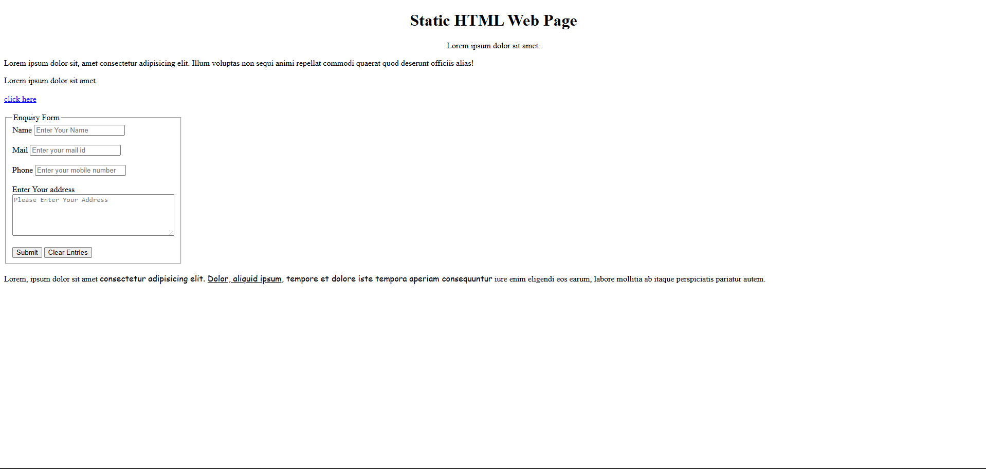
Test Cases & Execution Results:
Test ID | Test Input / Action | Expected Output | Status
TC-01 | Load the web page in browser | Main title renders centered at top | Passed
TC-02 | Inspect semantic content section | Header, body, and footer render correctly | Passed
TC-03 | Click 'click here' hyperlink | Browser redirects to destination URL | Passed
TC-04 | Interact with form input fields | Data entry works with inline placeholder cues | Passed
TC-05 | Click 'Clear Entries' button | All input fields clear instantly | Passed
TC-06 | Inspect footer text paragraph | Renders cursive and underlined text | Passed
RESULT / CONCLUSION
The responsive static web page was successfully created, tested, and verified using HTML5 and CSS3.
═════════════════════════════════════════════════════
RUBRIC EVALUATION (Faculty Use Only)
═════════════════════════════════════════════════════
Design & Logic (5 Marks):
Execution & Output (5 Marks):
Viva & Record (5 Marks):
───────────────────────────────────────────────────────
TOTAL MARKS: [ / 15 ]
Faculty Signature: _______________

