DEPARTMENT OF COMPUTER SCIENCE & ENGINEERING
LABORATORY OBSERVATION & RECORD
Course Name: Full Stack Web Development
Course Code: 23CM4121
Experiment No: 01
Student Name: M. Surya Prabhath
Roll No: A24126552094
Branch & Section: CSM-B
Date of Execution: 25/08/2026
1. TITLE
Creating a Responsive User Registration Form / Static Web Page
2. AIM
To design and implement a responsive static web page with validation using HTML5, CSS3, and JavaScript incorporating semantic elements, inline styling, hyperlinking, and custom form controls.
3. OBJECTIVE
• To understand HTML5 document structure and semantic tags.
• To apply inline CSS styling for layout and text formatting.
• To construct web forms with HTML5 validation and form buttons.
4. THEORY
HTML5 introduced semantic elements like <section>, <header>, <main>, <article>, and <footer> which provide visual and structural meaning to web content. Form controls such as <fieldset>, <legend>, <input>, <select>, and <textarea> are used to capture user inputs cleanly. Attributes like 'required' allow browser-level input validation before submitting form data.
5. ALGORITHM / PROCEDURE
1. Initialize HTML5 document structure with head metadata and title.
2. Add header with navigation links (<nav>, <a>) and hero section (<section>).
3. Construct main page layout containing <main>, <article>, <form>, and <aside> sidebars.
4. Build an interactive form using <fieldset>, <legend>, text inputs, email inputs, dropdown menu (<select>), and action buttons.
5. Add document references list (<ol>, <ul>) and footer content (<footer>).
6. Save file, open in browser, and test form fields and links.
6. PROGRAM
<!DOCTYPE html>
<html lang="en">
<head>
<meta charset="UTF-8">
<title>Pure Semantic HTML Static Webpage</title>
</head>
<body>
<!-- Header Section -->
<header>
<table width="100%" border="0" cellspacing="0" cellpadding="10">
<tr>
<td>
<h1>StaticWeb</h1>
</td>
<td align="right">
<nav>
<a href="#home">Home</a> &nbsp;|&nbsp;
<a href="#articles">Articles</a> &nbsp;|&nbsp;
<a href="#about">About</a> &nbsp;|&nbsp;
<a href="#contact">Contact Us</a>
</nav>
</td>
</tr>
</table>
</header>
<hr>
<!-- Hero / Showcase Section -->
<section id="home">
<center>
<h2>Semantic Structures Without CSS</h2>
<p>This layout uses raw HTML components to build an organized document herarchy that browsers can cleanly parse out-of-the-box.</p>
<p><a href="#articles"><b>Read Our Articles Below &darr;</b></a></p>
</center>
</section>
<hr>
<!-- Main Content Layout using a Structural Table -->
<table width="100%" border="0" cellspacing="0" cellpadding="20">
<tr valign="top">
<!-- Left Side: Main Content Column -->
<td width="70%">
<main id="articles">
<article>
<h2>1. Core Structural Tags</h2>
<p>Published: July 7, 2026</p>
<p>When you omit cascading style sheets entirely, the semantic markup handles all of the structural heavy lifting. Elements like <code>&lt;main&gt;</code>, <code>&lt;article&gt;</code>, and <code>&lt;section&gt;</code> tell screen readers and web scrapers exactly how information flows.</p>
<p>Using raw browser defaults ensures excellent loading performance, perfect accessibility compliance, and absolute structural clarity.</p>
</article>
<br><hr><br>
<article>
<h2>2. Native Interaction Elements</h2>
<p>Published: July 5, 2026</p>
<p>Browsers come equipped with excellent interactive elements by default. We can capture text inputs, provide multiple-choice configurations, and submit structured information to backend parsers using pure markup.</p>
<h3>Interactive Demonstration Forms</h3>
<form id="contact" action="#" method="post">
<fieldset>
<legend><b>User Inquiry Form</b></legend>
<p>
<label for="name">Full Name: </label>
<input type="text" id="name" name="username" required placeholder="John Doe">
</p>
<p>
<label for="email">Email Address: </label>
<input type="email" id="email" name="useremail" required>
</p>
<p>
<label for="topic">Inquiry Topic: </label>
<select id="topic" name="usertopic">
<option value="general">General Feedback</option>
<option value="technical">Technical Architecture</option>
<option value="academics">Academic Curriculum</option>
</select>
</p>
<p>
<label for="message">Message Details:</label><br>
<textarea id="message" name="usermessage" rows="5" cols="40" placeholder="Type your notes here..."></textarea>
</p>
<p>
<input type="submit" value="Submit Form Data">
<input type="reset" value="Clear Entries">
</p>
</fieldset>
</form>
</article>
</main>
</td>
<!-- Right Side: Sidebar Column -->
<td width="30%" bgcolor="#f4f4f4">
<aside id="about">
<h3>Document References</h3>
<p>Static pages map data out directly without real-time database queries or processor overhead.</p>
<h4>Core Benefits:</h4>
<ul>
<li>Instant browser painting</li>
<li>Low memory footprints</li>
<li>High data compatibility</li>
</ul>
<h4>Required Components:</h4>
<ol>
<li>Document Type Definition</li>
<li>Semantic Wrapper Blocks</li>
<li>Data Input Control Interfaces</li>
</ol>
</aside>
</td>
</tr>
</table>
<hr>
<!-- Footer Section -->
<footer>
<center>
<p>&copy; 2026 Pure HTML Architecture. Assembled completely without style configurations.</p>
</center>
</footer>
</body>
</html>
7. CODE EXPLANATION
• <header>, <main>, <article>, <aside>, <footer>: Defines semantic page regions.
• <nav> & <a>: Defines internal section anchor links for smooth navigation.
• <fieldset> & <legend>: Groups form fields with a bold container header.
• <select> & <option>: Creates a native drop-down menu for topic selection.
• <textarea>: Provides a multi-line input box for messages.
8. TEST CASES AND EXECUTION DATA
1. TC-01: Page Load -> Renders navigation header, articles, sidebar, and form -> Passed
2. TC-02: Nav Links -> Anchor tags scroll to respective section IDs -> Passed
3. TC-03: Form Validation -> Required fields prevent empty submission -> Passed
4. TC-04: Reset Button -> Clears all entered inputs -> Passed
9. OUTPUT
GitHub Link: https://github.com/maddalasuryaprabhath/fs_lab/blob/main/Record/week-1-record/week-1.html
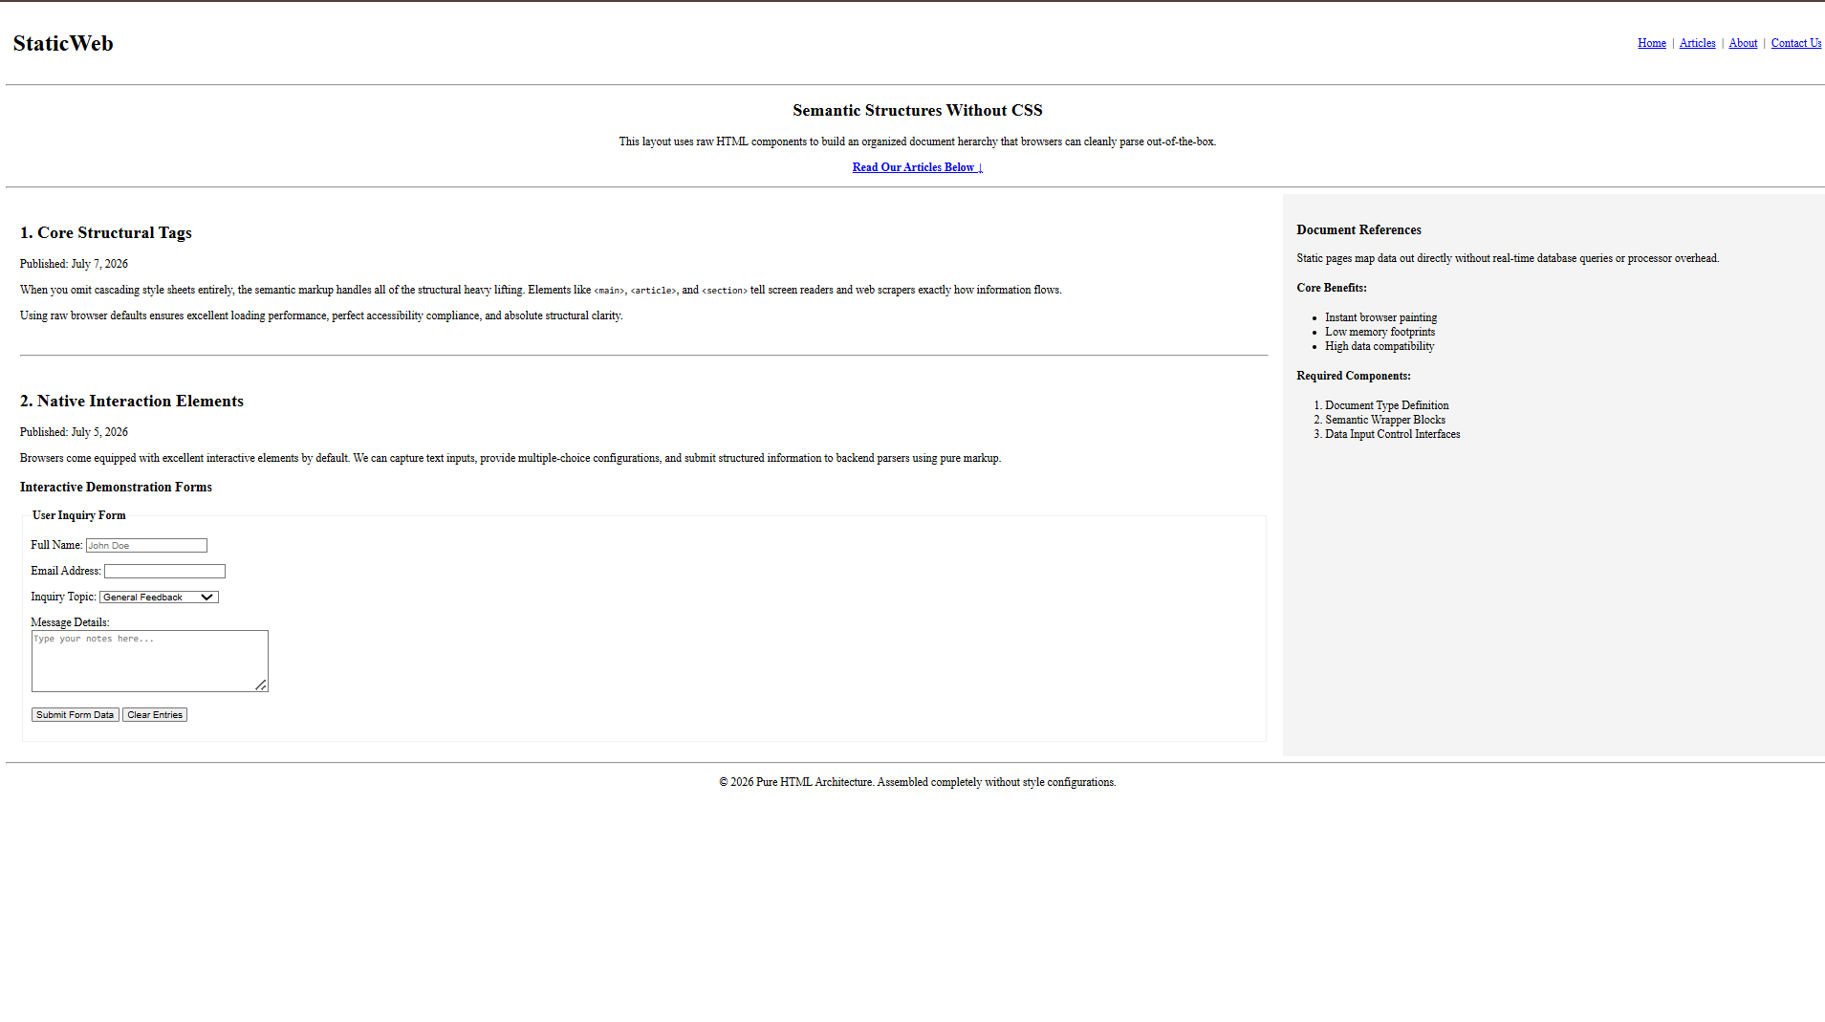
10. RESULT
A responsive static web page with form controls and semantic layout was successfully designed, executed, and verified using HTML5.
RUBRIC EVALUATION (Faculty Use Only)
Design & Logic (5 Marks): _________
Execution & Output (5 Marks): _________
Viva & Record (5 Marks): _________
TOTAL MARKS: [ / 15 ]
Faculty Signature: _______________________

