GENERAL OBJECTIVES;

- To fulfil the clients requirements

- To deliver a fully functioning project that services to the needs of the client.

SPECIAL OBJECTIVES:

- To make their school more innovative, more efficient and up to date to the trend of technologies.

- Make an application that lets the parents and student access their school standing, grades, and tuition balance fast and easily through their mobile phones.

TARGET AUDIENCE;

* Arandia College IT Administrator

CITE RELATED ARCHITECTURE

* Arandia College Database

PROJECT DESCRIPTION

* A software that lets the student see and access their school status online through the web or through a mobile phone. A software that also let parents see when is the nest payment of their children's tuition and how their children doing in school

GLOSSARY

EVENT TABLE

Enrolment Table

|  |  |  |  |  |  |
| --- | --- | --- | --- | --- | --- |
| EVENTS | TRIGGER | SOURCE | USE CASE | RESPONSE | DESTINATION |
| Parent inquire registration and enrollment availability | Enrollment Day | Parent | Check for registration and enrollment availability | Registration and enrollment details | Parent/Admission |
| Parent pays corresponding tuition amount | Enrollment day | parent | Parent pays tuition | Cashier issues OR | Parent/Accounting |
| Parent checks Student validation | Enrollment day | parent | Registrar checks/  validate  student assessment record | Issues new student assessment | Parent/student |

Student’s Event Table

|  |  |  |  |  |  |
| --- | --- | --- | --- | --- | --- |
| EVENTS | TRIGGER | SOURCE | USE CASE | RESPONSE | DESTINATION |
| Student wants to know the class standing | List of Honors  Inquiry | Student | View Class Standing | List of outstanding students Details | Student |
| Student wants to know his/her grade | Student’s Grade Inquiry | Student | View Student Grade | Student’s Grade Record | Student |
| Student wants to know her remaining tuition balance | Periodical exam permit | Student | Check Student balance and permit availability | Student’s Accounting record | Student |
| Student wants to consult a teacher | End of quarter consultation | student | Checks Subject teacher Availability | Teacher Consultation  Details | Teacher |
| Student wants to know if they pass the periodical exam | Examination results | Student | Checks student exam results | Examination Results | Student |

Parent’s Event Table

|  |  |  |  |  |  |
| --- | --- | --- | --- | --- | --- |
| EVENTS | TRIGGER | SOURCE | USE CASE | RESPONSE | DESTINATION |
| Parents wants to see his/her child’s grade | Distribution of grades | Parent | Check student grade record | Student Report Card | Parent |
| Parent wants to pay his/her child’s tuition | Monthly tuition Payment | Parent | Pays tuition at accounting | Official receipt | Cashier |
| Parent wants to inquire for the remaining balance of his/her child | Next Tuition Payment | Parent | Check student’s tuition record in Accounting | Student Assessment | Parent |
| Parent-teacher consultation | Parent Interview | Parent | talk/interview student’s with problem with  adviser | Parent-teacher Consultation | Parent |
| Parents wants to see their child’s Class Standing or student status | End of quarter consultation | Parent | Checks Student record from adviser | Student Record Details | Parent |

Administrator’s Event Table

|  |  |  |  |  |  |
| --- | --- | --- | --- | --- | --- |
| EVENTS | TRIGGER | SOURCE | USE CASE | RESPONSE | DESTINATION |
| Admin gets the student grade from adviser | Student Assessment | Admin | Encode/  Record grades of students | Student grade average | database |
| Admin monitors student grades | Student’s grade inquiry | Admin | Grade monitoring | Student’s grade | database |
| Admin validates the student grade | Student Assessment | Admin | Validate the student’s grade | Accurate and final grade | database |
| Admin wants to inform parents of his/her child’s outstanding balance | Monthly tuition payment | Admin | check/Update students outstanding balance record | Tuition Fee Details | parents |

USE CASE

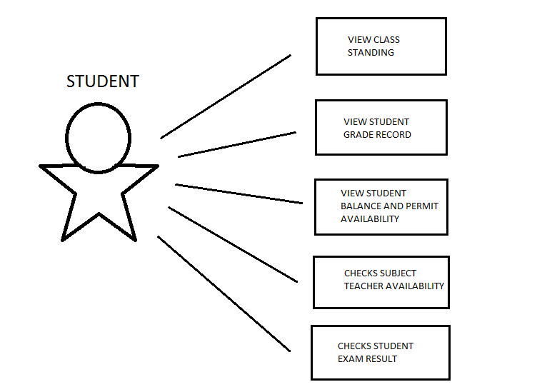

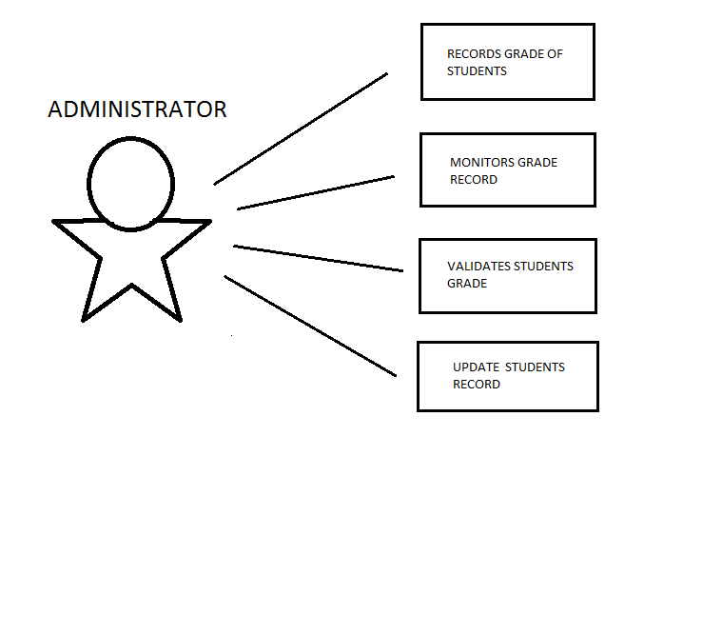

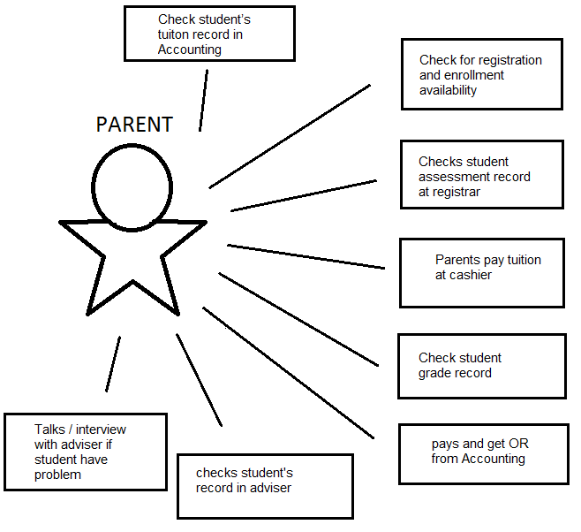

USE CASE FULL DESCRIPTION

|  |  |
| --- | --- |
| Use Case Name: | Check for registration and enrolment availability |
| Scenario: | Parent inquire for registration and enrolment availability |
| Triggering Event: | Students will enrol in the specific day |
| Brief Description: | Parents inquire for registration and enrolment information |
| Actor/s: | Parent |
| Related Use Case: |  |
| Stakeholders: | Admission: to assist the parents for their inquiries |
| Pre-conditions: | N/A |
| Post-conditions: | N/A |
| Flow of Events: | Actor System   1. Parents inquires about the   enrolment day |
| Exception Conditions: | N/A |

|  |  |
| --- | --- |
| Use Case Name: | Parent pays tuition |
| Scenario: | Parents pay for the corresponding tuition fee amount |
| Triggering Event: | Specific enrolment date |
| Brief Description: | When the Parent pays the tuition fee |
| Actor/s: | Parent |
| Related Use Case: |  |
| Stakeholders: | Registrar: to accept the payment |
| Pre-conditions: | The Parent must pay according to the instalment or full amount |
| Post-conditions: | Must give the Parents proof of payment/OR |
| Flow of Events: | Actor System   1. Parents pay the tuition fee |
| Exception Conditions: | N/A |

|  |  |
| --- | --- |
| Use Case Name: | Registrar checks/validate student assessment record |
| Scenario: | Registrar checks the validity of the student’s record |
| Triggering Event: | Students will enrol in the specific day |
| Brief Description: | Registrar will validate the student’s assessment record |
| Actor/s: | Registrar |
| Related Use Case: |  |
| Stakeholders: | Registrar: to checks the validity of the student’s assessment record |
| Pre-conditions: | The student’s assessment records must be updated |
| Post-conditions: | N/A |
| Flow of Events: | Actor System   1. Registrar will check the student’s   assessment record |
| Exception Conditions: | N/A |

|  |  |
| --- | --- |
| Use Case Name: | View class standing |
| Scenario: | Students will view the class standing |
| Triggering Event: | Students will be able to see the list of honors inquiry |
| Brief Description: | When the student wants to know his/her class standing |
| Actor/s: | Student |
| Related Use Case: |  |
| Stakeholders: | Adviser: gives the student his/her class standing |
| Pre-conditions: | Student must exist |
| Post-conditions: | Information must be valid |
| Flow of Events: | Actor System   1. Student will view his/her class standing |
| Exception Conditions: | N/A |

|  |  |
| --- | --- |
| Use Case Name: | View student grade |
| Scenario: | Student will view their grade |
| Triggering Event: | Student’s grade inquiry |
| Brief Description: | When the student wants to know his/her grades |
| Actor/s: | Student |
| Related Use Case: | View class standing |
| Stakeholders: | Adviser: to gives the list of student’s grade |
| Pre-conditions: | Student must exist |
| Post-conditions: | The student’s grade must be finished computing and computed correctly |
| Flow of Events: | Actor System   1. Student will view his/her grades |
| Exception Conditions: | N/A |

|  |  |
| --- | --- |
| Use Case Name: | Check student balance and permit availability |
| Scenario: | Student check the availability of his/her balance and permit |
| Triggering Event: | For periodical exam permit |
| Brief Description: | When the student needs his/her permit for the exam |
| Actor/s: | Student |
| Related Use Case: | Registrar checks/validate student assessment record |
| Stakeholders: | Registrar: to check the balance and gives the permit of the student |
| Pre-conditions: | Student must exist  Student must be paid his/her balance |
| Post-conditions: | N/A |
| Flow of Events: | Actor System   1. Student will check his/her balance   and gets his/her permit |
| Exception Conditions: | N/A |

|  |  |
| --- | --- |
| Use Case Name: | Checks subject teacher availability |
| Scenario: | Student checks the availability of the subject teacher |
| Triggering Event: | Student checks by the End of quarter consultation |
| Brief Description: | When the student checks the availability of subject teachers |
| Actor/s: | Student |
| Related Use Case: | Registrar checks/validate student assessment record |
| Stakeholders: | Admin: to gives the record of subject teacher availability |
| Pre-conditions: | Teacher must exist |
| Post-conditions: | N/A |
| Flow of Events: | Actor System   1. Student will check the subject   teacher availability |
| Exception Conditions: | N/A |

|  |  |
| --- | --- |
| Use Case Name: | Checks student exam results |
| Scenario: | Student will check the result of exam |
| Triggering Event: | For examination results |
| Brief Description: | When the students wants to check his/her exam results |
| Actor/s: | Student |
| Related Use Case: |  |
| Stakeholders: | Adviser: to gives the record of exam results |
| Pre-conditions: | Student must took the exam |
| Post-conditions: | N/A |
| Flow of Events: | Actor System   1. Student checks his/her result of exam |
| Exception Conditions: | N/A |

|  |  |
| --- | --- |
| Use Case Name: | Check student grade record |
| Scenario: | Parent’s check the student grade record |
| Triggering Event: | For distribution of grades |
| Brief Description: | When the parent wants to check the student grade record |
| Actor/s: | Parent |
| Related Use Case: | View student grade  Checks student exam results |
| Stakeholders: | Adviser: to gives the grade records to the student’s parent |
| Pre-conditions: | Student must exist  Parent must be legit or guardian must provide authorization letter |
| Post-conditions: | N/A |
| Flow of Events: | Actor System   1. Parent will check the student grade record |
| Exception Conditions: | N/A |

|  |  |
| --- | --- |
| Use Case Name: | Pays tuition at accounting |
| Scenario: | Parents pay tuition to the accounting |
| Triggering Event: | Monthly tuition payment |
| Brief Description: | When the parents pay the tuition fee of the student to the accounting |
| Actor/s: | Parent |
| Related Use Case: | Registrar checks/validate student assessment record |
| Stakeholders: | Registrar: to accepts the payment |
| Pre-conditions: | Student must exist |
| Post-conditions: | Registrar must provide receipts |
| Flow of Events: | Actor System   1. Parent pay the tuition fee of the student |
| Exception Conditions: | N/A |

|  |  |
| --- | --- |
| Use Case Name: | Check student’s tuition record in accounting |
| Scenario: | Parent checks the student’s tuition fee record |
| Triggering Event: | For the next tuition payment |
| Brief Description: | When the parent wants to check the student’s tuition fee records |
| Actor/s: | Parent |
| Related Use Case: | Registrar checks/validate student assessment record  Pays tuition at accounting |
| Stakeholders: | Registrar: to gives the parent of the tuition fee record |
| Pre-conditions: | Student must exist  Parent must be legitimate |
| Post-conditions: | N/A |
| Flow of Events: | Actor System   1. Parent will check the record of   the student’s tuition fee |
| Exception Conditions: | N/A |

|  |  |
| --- | --- |
| Use Case Name: | Talk/interview student’s with problem with adviser |
| Scenario: | Parents will talk to the adviser |
| Triggering Event: | For parent interview |
| Brief Description: | When the parent wants to talk to the advisers regarding to the student’s problem |
| Actor/s: | Parent |
| Related Use Case: |  |
| Stakeholders: | Adviser: to gives interview to the parent |
| Pre-conditions: | Parents must be legitimate |
| Post-conditions: | N/A |
| Flow of Events: | Actor System   1. Parent will talk to the adviser |
| Exception Conditions: | N/A |

|  |  |
| --- | --- |
| Use Case Name: | Checks student records from the adviser |
| Scenario: | Parents will check the student’s record |
| Triggering Event: | For the end of quarter consultation |
| Brief Description: | When the parent wants to check the records of the student |
| Actor/s: | Parent |
| Related Use Case: | Registrar checks/validate student assessment record |
| Stakeholders: | Adviser: to gives the student records |
| Pre-conditions: | Student must exist  Parent must be legitimate/authorized |
| Post-conditions: | N/A |
| Flow of Events: | Actor System   1. Parent will check the record of the student |
| Exception Conditions: | N/A |

|  |  |
| --- | --- |
| Use Case Name: | Encode/record grades of students |
| Scenario: | Administrator will record the grades of the students |
| Triggering Event: | For student assessment |
| Brief Description: | When the administrator records the grades of the students |
| Actor/s: | Administrator |
| Related Use Case: | Registrar checks/validate student assessment record  View student grade  Checks student exam results  Check student grade record |
| Stakeholders: | Administrator: to record the grades of the students |
| Pre-conditions: | Student must exist  Student must be paid |
| Post-conditions: | Student’s grade must be correctly computed |
| Flow of Events: | Actor System   1. Administrator will record the student’s grade |
| Exception Conditions: | N/A |

|  |  |
| --- | --- |
| Use Case Name: | Grade monitoring |
| Scenario: | Administrator checks the validity of grades |
| Triggering Event: | For student’s grade inquiry |
| Brief Description: | When the administrator checks the grades of the student |
| Actor/s: | Administrator |
| Related Use Case: | Registrar checks/validate student assessment record  View student grade  Checks student exam results  Check student grade record |
| Stakeholders: | Administrator: to check the validity of the grades |
| Pre-conditions: | Student’s grade must be completely recorded |
| Post-conditions: | N/A |
| Flow of Events: | Actor System   1. Administrator will monitor the student’s grade |
| Exception Conditions: | N/A |

|  |  |
| --- | --- |
| Use Case Name: | Validate the student’s grade |
| Scenario: | Administrator will check if the student’s grade is valid |
| Triggering Event: | For student assessment |
| Brief Description: | When the administrator checks the validity of the grades of the student |
| Actor/s: | Administrator |
| Related Use Case: | Registrar checks/validate student assessment record  View student grade  Checks student exam results  Check student grade record |
| Stakeholders: | Administrator: to check the validity of the grades |
| Pre-conditions: | Student’s grade must be completely recorded |
| Post-conditions: | N/A |
| Flow of Events: | Actor System   1. Administrator will checks the   validity of the grade |
| Exception Conditions: | N/A |

|  |  |
| --- | --- |
| Use Case Name: | Check/update students outstanding |
| Scenario: | Administrator checks the students outstanding |
| Triggering Event: | For monthly tuition payment |
| Brief Description: | When the administrator checks students class standing |
| Actor/s: | Administrator |
| Related Use Case: | View class standing |
| Stakeholders: | Administrator: to check the class standing of the students |
| Pre-conditions: | Student must be exist |
| Post-conditions: | Information must be valid |
| Flow of Events: | Actor System   1. Administrator will checks the student   fclass standing |
| Exception Conditions: | N/A |

ACTIVITY DIAGRAM

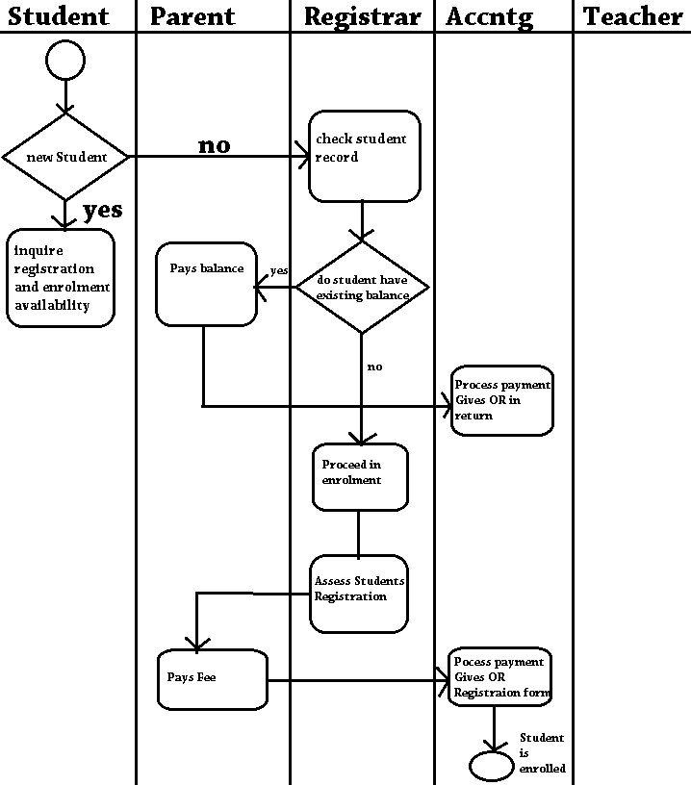

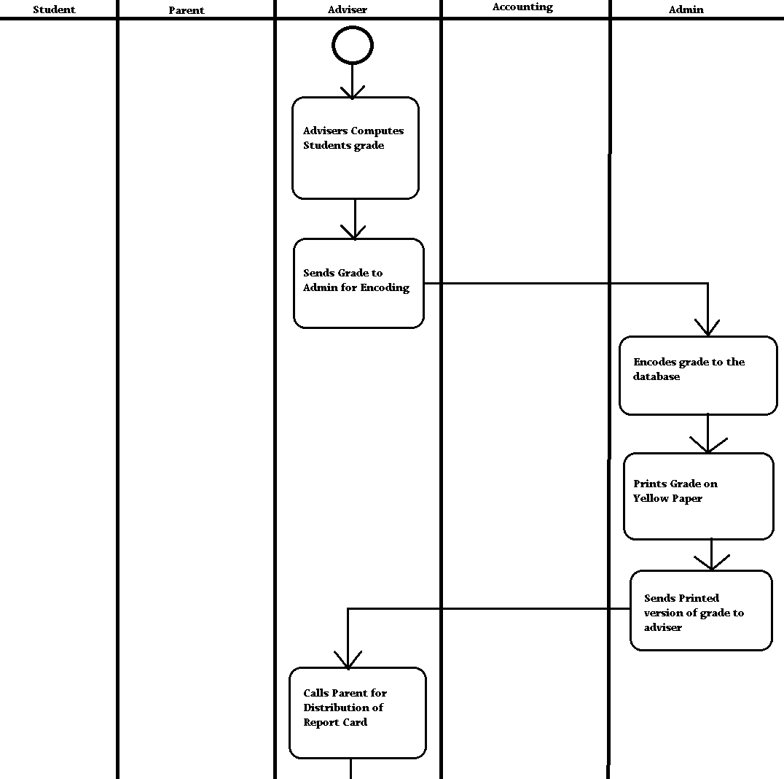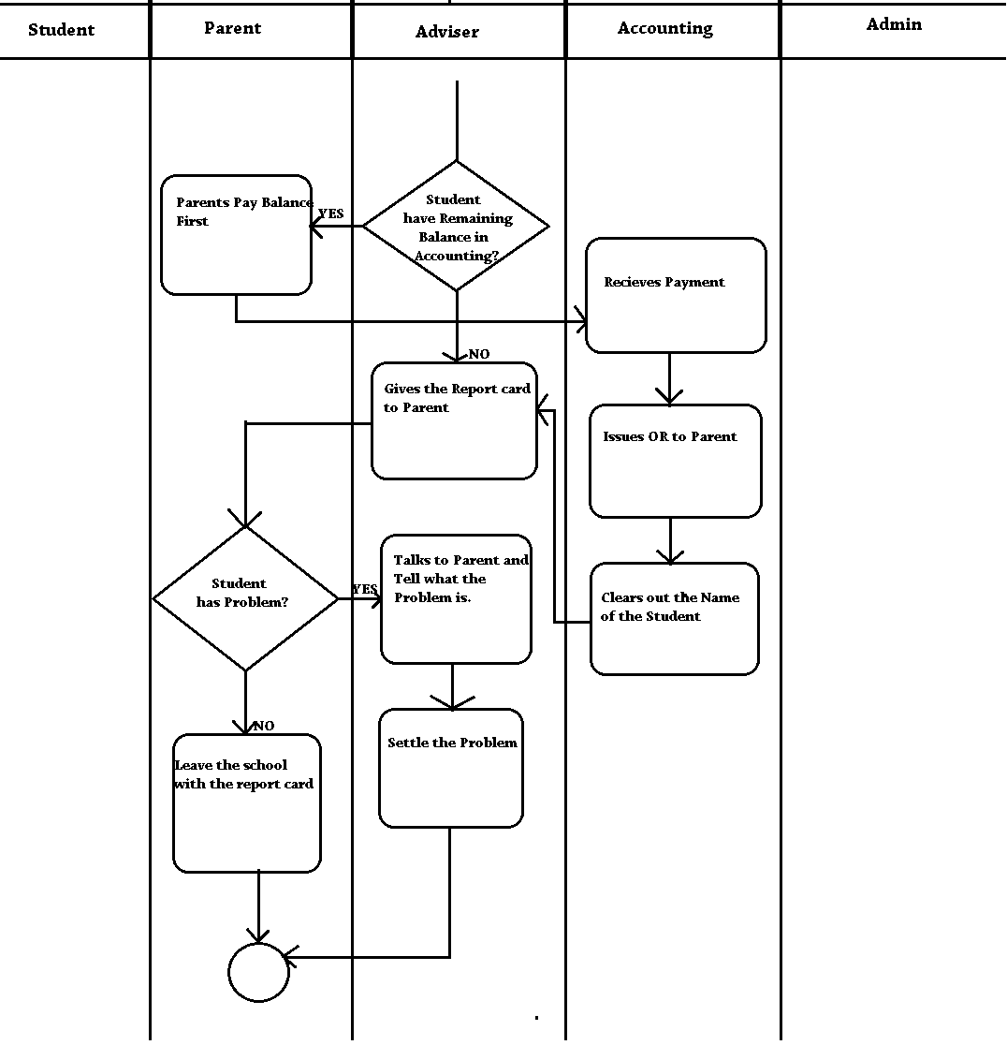

ENTITY RELATIONSHIP DIAGRAM

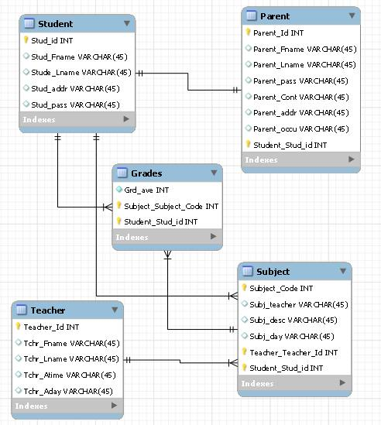

CONTEXT FLOW DIAGRAM

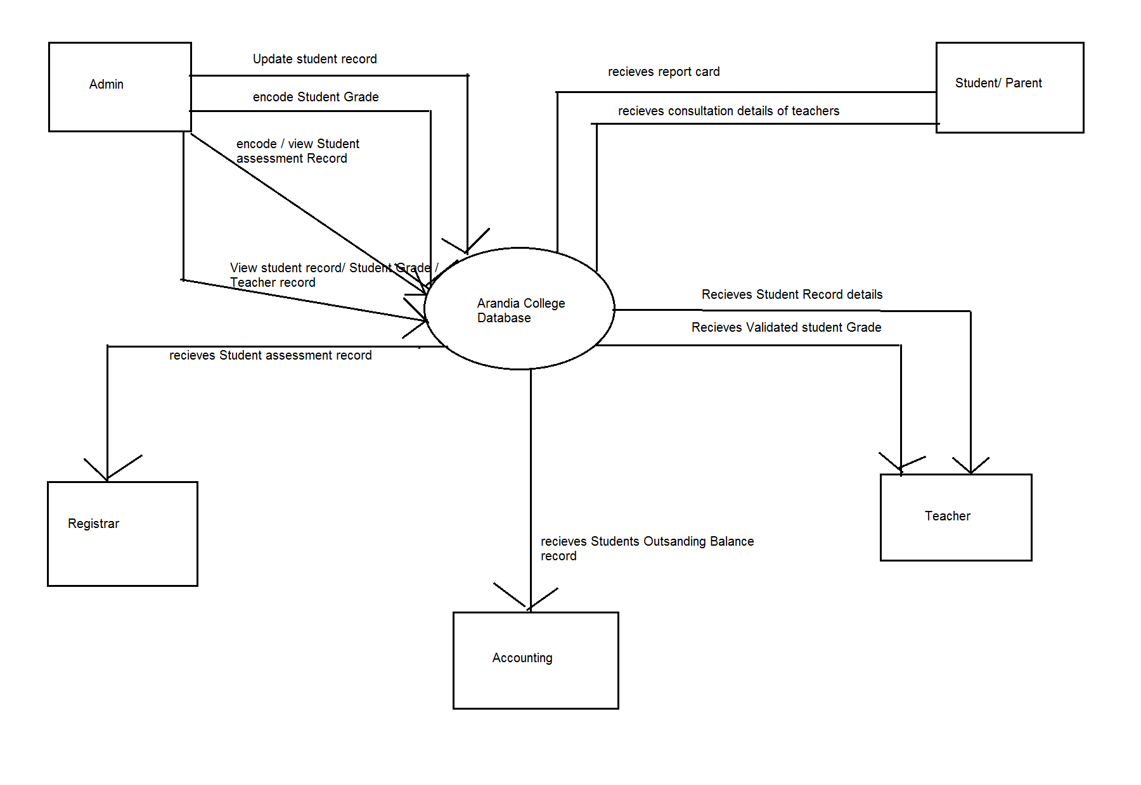

DATA FLOW DIAGRAM

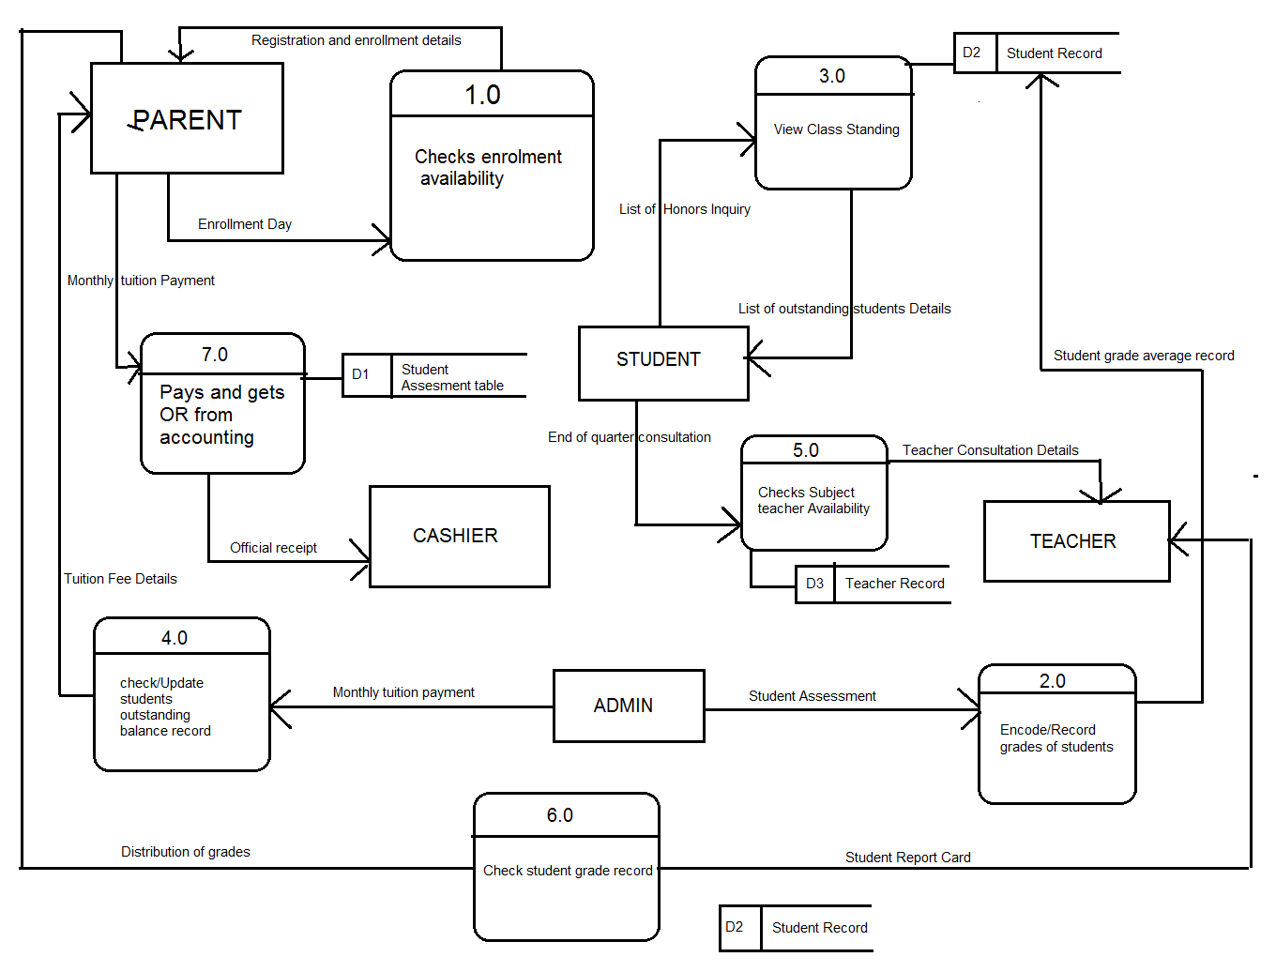

LEVEL 1

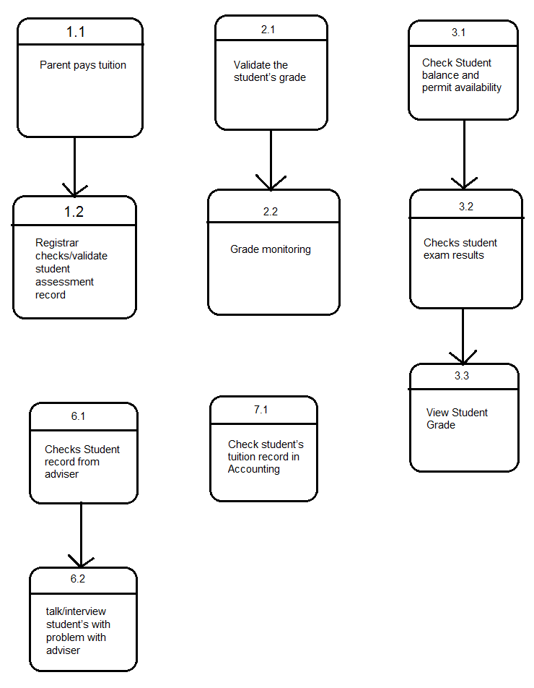

DATA DICTIONARY

|  |  |  |  |  |  |  |  |
| --- | --- | --- | --- | --- | --- | --- | --- |
| Attributes | Comment | Type | Format | Required | PK | FK | Reference Table |
| Stud_Id | Student's Id number | int | xxxx-xxxx | Y | PK |  |  |
| Stud_Fname | Student's First Name | varchar | xxxxxxxx | Y |  |  |  |
| Stude_Lname | Student's Last Name | varchar | xxxxxxxx | Y |  |  |  |
| Stude_addr | Student's Address | varchar | xxxxxxxx | Y |  |  |  |
| Stud_pass | Student's password | varchar | xxxxxxxx | Y |  |  |  |
|  |  |  |  |  |  |  |  |
| Parent_id | Parent's Id Number | int | xx-xxxx | Y | PK |  |  |
| Parent_Fname | Parent's First Name | varchar | xxxxxxx | Y |  |  |  |
| Parent_Lname | Parent's Last Name | varchar | xxxxxxx | Y |  |  |  |
| Parent_pass | Parent's Password | varchar | xxxxxxx | Y |  |  |  |
| Parent_Cont | Parent's Contact Number | varchar | xxx-xxxx | Y |  |  |  |
| Parent_addr | Parent's Address | varchar | xxxxxxx | Y |  |  |  |
| Parent_occu | Parent's Occupation | varchar | xxxxxxx | Y |  |  |  |
| Stud_Id | Student's Id number | Int | xxxx-xxxx | Y |  | FK | Student Table |
|  |  |  |  |  |  |  |  |
| Grd_ave | Grade Average | int | 99.99 | Y |  |  |  |
| Subject_Code | Subject Code | int | xxxxx | Y |  | FK | Subject Table |
| Stud_Id | Student's Id Number | int | xxxx-xxxx | Y |  | Fk | Student Table |
|  |  |  |  |  |  |  |  |
| Teacher_Id | Teacher's Id Number | int | xx-xxxx | Y | PK |  |  |
| Tchr_Fname | Teacher's First name | varchar | xxxxxxx | Y |  |  |  |
| Tchr_Lname | Teacher's Last Name | varchar | xxxxxxx | Y |  |  |  |
| Tchr_Atime | Teacher's Availble Time | Time | 0:00 | Y |  |  |  |
| Tchr_Aday | Teacher's Availble Day | varchar | xxxxxxx | Y |  |  |  |
|  |  |  |  |  |  |  |  |
| Subject_Code | Subject Code | int | xxxxxx | Y | PK |  |  |
| Subj_teacher | Subject Teacher | varchar | xxxxxx | Y |  |  |  |
| Subj_desc | Subject Description | varchar | xxxxxx | Y |  |  |  |
| Subj_day | Subject Day | varchar | xxxxxx | Y |  |  |  |
| Teacher_Id | Teacher Id Number | int | xx-xxxx | Y |  | FK | Teacher Table |
| Stud_Id | Student's Id Number | int | xxxx-xxxx | Y |  | FK | Student Table |
|  |  |  |  |  |  |  |  |

SCREENSHOT OF PROPOSED DESIGN

STUDENT’S LOGIN INTERFACE

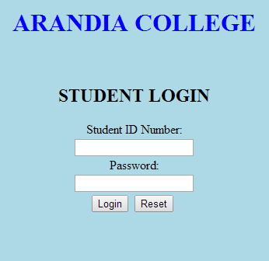

STUDENT’S MENU BOX

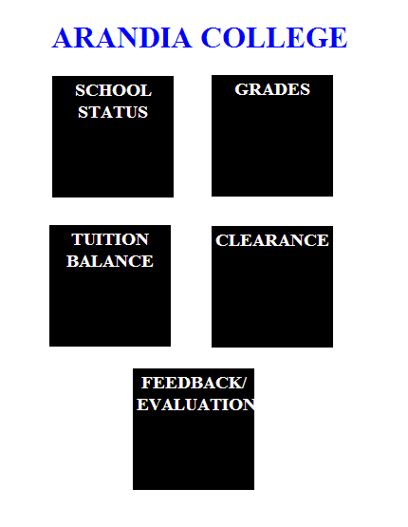

PARENT’S LOGIN INTERFACE

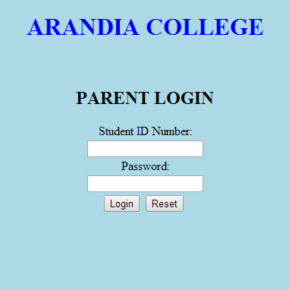

PARENT’S MENU BOX

