**Assignment 4**

**1.Solution**

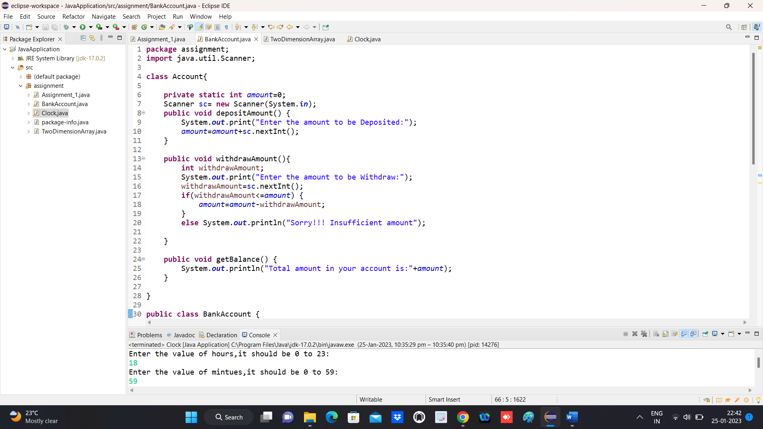

**OUTPUT**

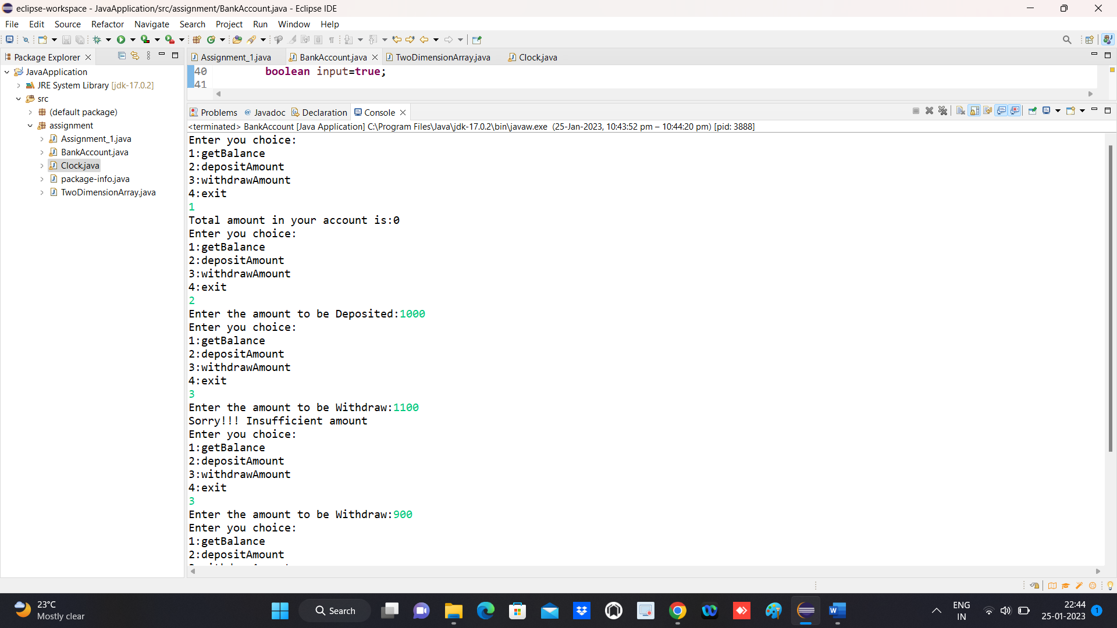

**2.Solution**

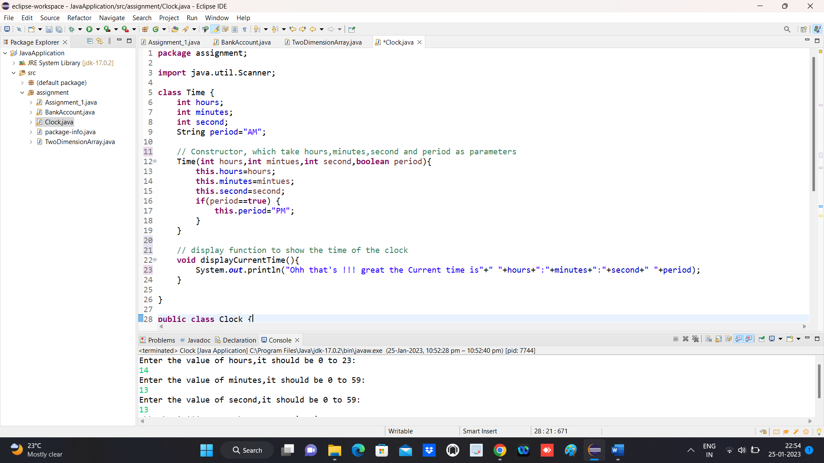

**OUTPUT**

