**ASSIGNMENT 5**

**CODE SCREENSHOT**

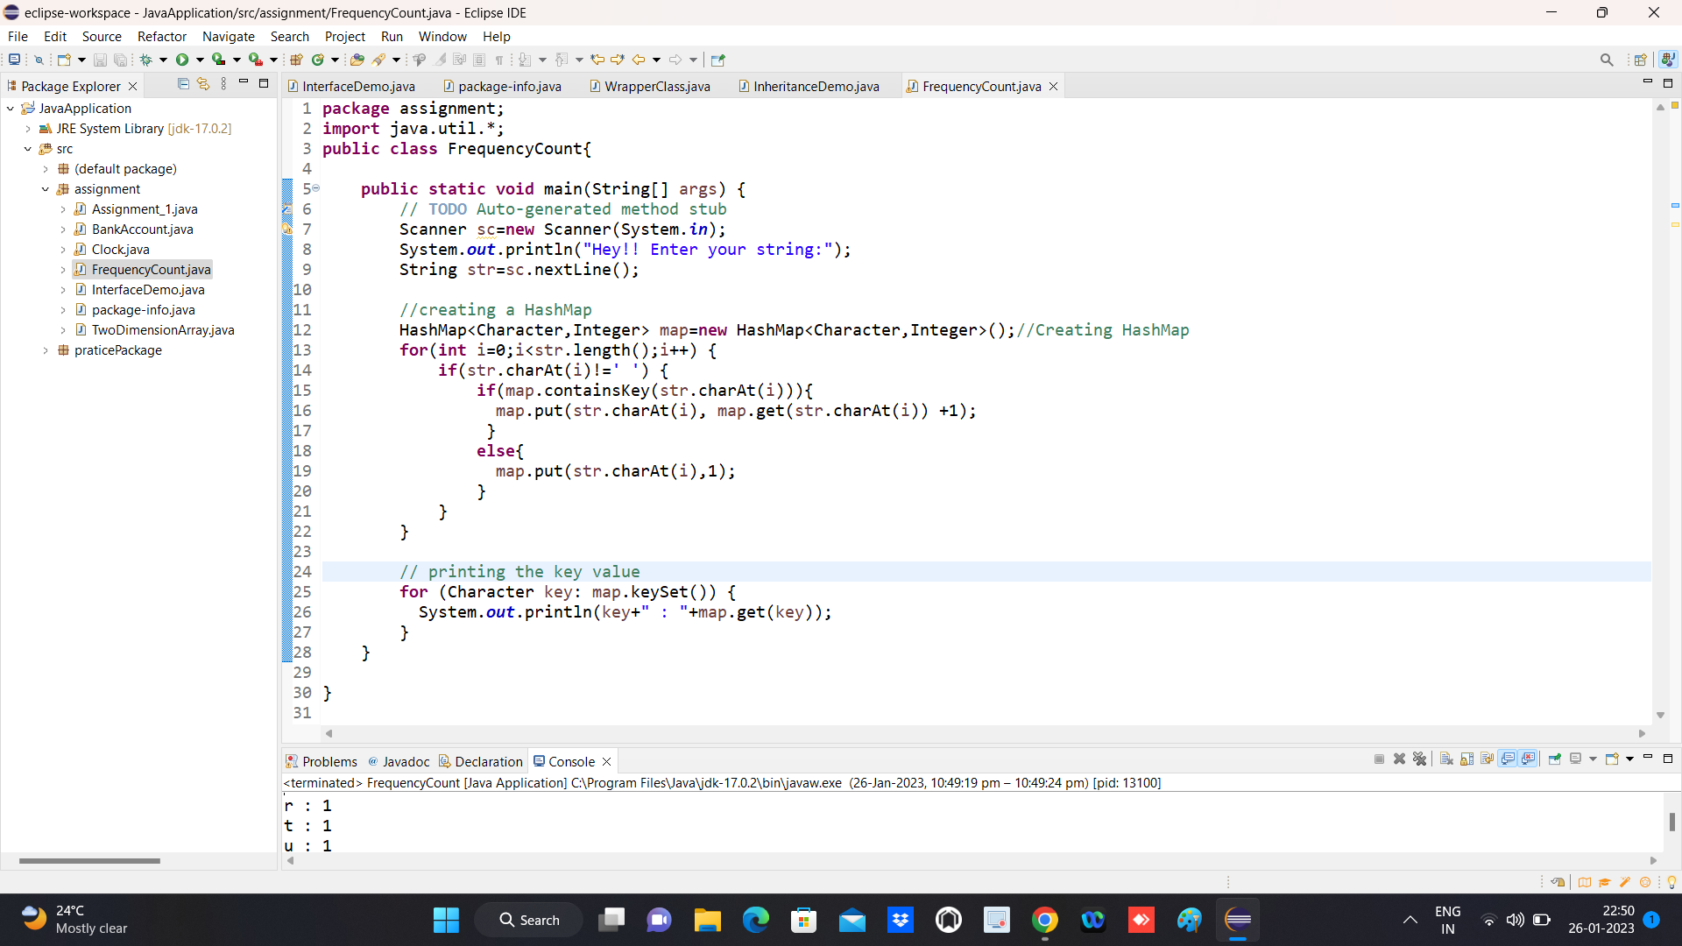

**OUTPUT SCREENSHOT**

