**ASSIGNMENT 6**

**Employee Class**

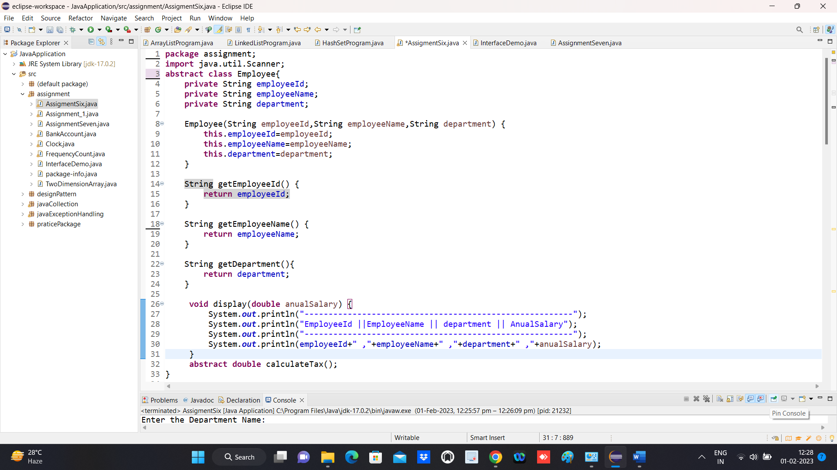

**PermanentEmployee Class**

**ContractEmployee Class**

**Main Function**

**Output**

