1.

create table Employees(

Emp_Id int primary key not null,

Emp_FirstName nchar(20) not null,

Emp_LastName nchar(20) not null,

Emp_City nchar(20) not null,

DOJ date not null,

Salary money not null,

DID int foreign key references Departments(Dept_ID),

BID int foreign key references Branches(BID)

);

2.

insert into Employees(Emp_Id,Emp_FirstName,Emp_LastName,Emp_City,DOJ,Salary,DID,BID) values

(102,'Abhay','Gupta','Kaisa','01-01-2016',35000,2,1);

insert into Employees(Emp_Id,Emp_FirstName,Emp_LastName,Emp_City,DOJ,Salary,DID,BID) values

(103,'Amit','Gupta','Kushinagar','01-08-2017',40000,3,3);

insert into Employees(Emp_Id,Emp_FirstName,Emp_LastName,Emp_City,DOJ,Salary,DID,BID) values

(104,'Atul','Gupta','Kushinagar','02-10-2017',55000,4,4);

insert into Employees(Emp_Id,Emp_FirstName,Emp_LastName,Emp_City,DOJ,Salary,DID,BID) values

(105,'Neha','Singh','Padrauna','02-10-2019',45000,5,1);

insert into Employees(Emp_Id,Emp_FirstName,Emp_LastName,Emp_City,DOJ,Salary,DID,BID) values

(106,'Ruchi','Gupta','Kaisa','01-09-2016',55000,6,2);

insert into Employees(Emp_Id,Emp_FirstName,Emp_LastName,Emp_City,DOJ,Salary,DID,BID) values

(107,'Rohit','Gupta','Deoria','01-10-2016',60000,1,3);

insert into Employees(Emp_Id,Emp_FirstName,Emp_LastName,Emp_City,DOJ,Salary,DID,BID) values

(108,'Himanshu','Singh','Deoria','02-08-2017',25000,2,4);

insert into Employees(Emp_Id,Emp_FirstName,Emp_LastName,Emp_City,DOJ,Salary,DID,BID) values

(109,'Pragati','Gupta','Sapaha','01-11-2016',55000,3,1);

insert into Employees(Emp_Id,Emp_FirstName,Emp_LastName,Emp_City,DOJ,Salary,DID,BID) values

(110,'Arvind','Kuswaha','Kaisa','03-12-2019',70000,4,2);

insert into Employees(Emp_Id,Emp_FirstName,Emp_LastName,Emp_City,DOJ,Salary,DID,BID) values

(111,'Anamika','Singh','Kaisa','01-08-2019',25000,5,3);

insert into Employees(Emp_Id,Emp_FirstName,Emp_LastName,Emp_City,DOJ,Salary,DID,BID) values

(112,'Anant','Singh','Kaisa','11-11-2018',80000,6,4);

insert into Employees(Emp_Id,Emp_FirstName,Emp_LastName,Emp_City,DOJ,Salary,DID,BID) values

(113,'Anuj','Singh','Kaisa','01-08-2015',25000,1,1);

insert into Employees(Emp_Id,Emp_FirstName,Emp_LastName,Emp_City,DOJ,Salary,DID,BID) values

(114,'Suraj','Gupta','Kaisa','01-08-2019',55000,2,2);

insert into Employees(Emp_Id,Emp_FirstName,Emp_LastName,Emp_City,DOJ,Salary,DID,BID) values

(115,'Balram','Patel','Kaisa','01-09-2016',60000,3,3);

3. 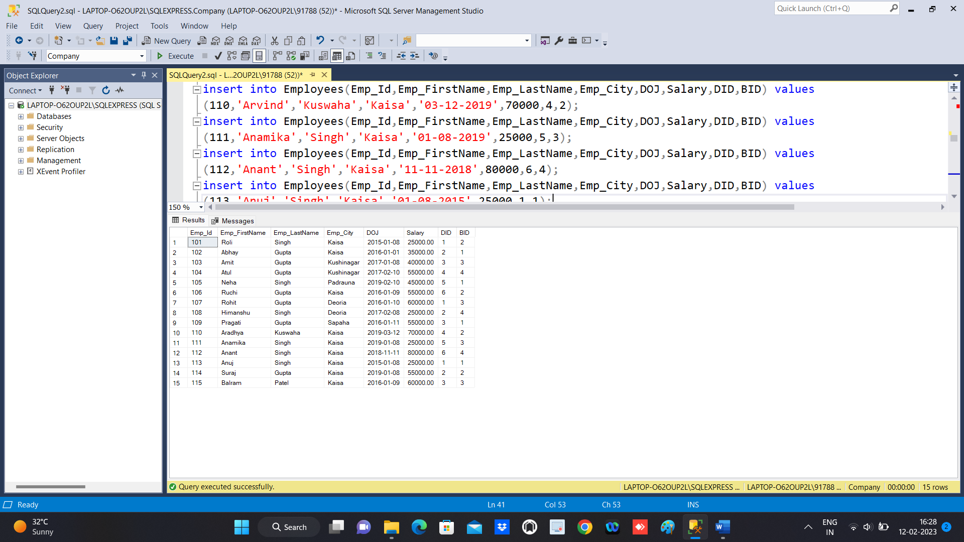

3.

Select Emp_ID,CONCAT(Emp_FirstName,' ',Emp_LastName),Emp_City,DOJ,Salary,DID,BID from Employees;

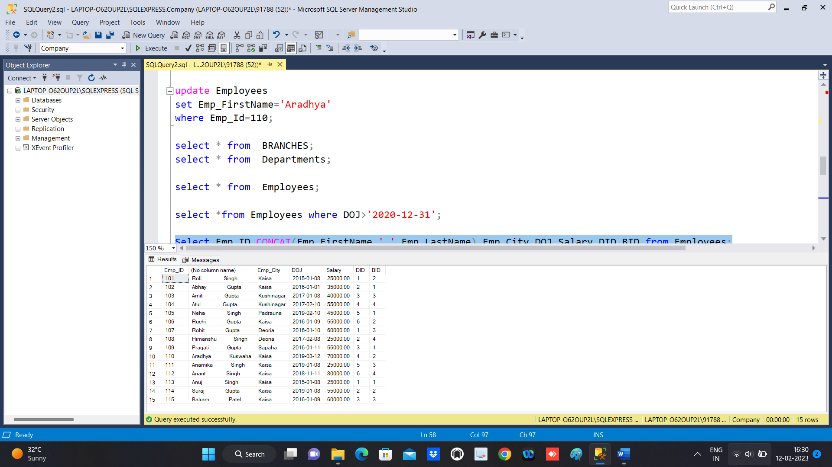

4.

Select * from Employees , Departments where Employees.DID=Departments.DEPT_ID and

Departments.DEPT_NAME='SOFTWARE';

5. Select * from Employees , BRANCHES where Employees.DID=BRANCHES.BID and

BRANCHES.BRACH_NAME='MUMBAI';

6. Select * from Employees, Departments,BRANCHES where Employees.DID=BRANCHES.BID and Employees.BID=BRANCHES.BID

and BRANCHES.BRACH_NAME='MUMBAI' and Employees.DOJ<'2021-01-01' and Departments.DEPT_NAME='SOFTWARE'

and Employees.Salary>15000;

7. Select Emp_FirstName,Emp_LastName,DEPT_NAME from Employees,Departments

where Employees.DID=Departments.DEPT_ID;

8.

Delete from Employees where DID=6;

DELETE FROM Departments WHERE DEPT_ID=6;

select * from Departments;

