**1.**

Use Company;

GO

create function numberOFEmployee (@Branch nchar(20))

returns int

as

Begin

Declare @Total_Employee int

Select @Total_Employee = count(BRANCHES.BRACH_NAME) from Employees,BRANCHES

where Employees.BID=BRANCHES.BID and BRANCHES.BRACH_NAME=@Branch;

return @Total_Employee;

END

GO

select BRANCHES.BRACH_NAME,count(BRANCHES.BRACH_NAME) from Employees,BRANCHES

where Employees.BID=BRANCHES.BID

group by BRANCHES.BRACH_NAME;

select dbo.numberOFEmployee('Chennai') AS Total_Employee;

select dbo.numberOFEmployee('Delhi') AS Total_Employee;

select dbo.numberOFEmployee('Kolkata') AS Total_Employee;

select dbo.numberOFEmployee('Mumbai') AS Total_Employee;

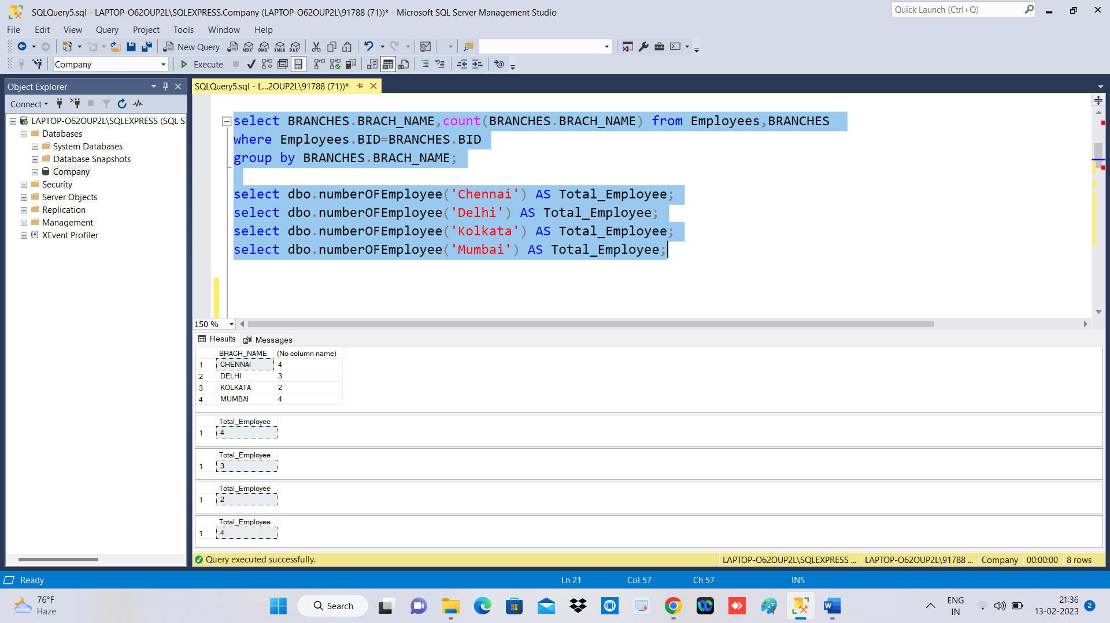

**2.**

GO

CREATE FUNCTION Branch_Id(@BName as nvarchar(20))

RETURNS int

AS

BEGIN

DECLARE @val int;

SELECT @val = BID FROM Branches WHERE @BName = BRACH_NAME;

-- Return the result of the function

RETURN @val;

END

GO

select * from Employees where BID = dbo.Branch_Id('Mumbai') and DOJ <= '2020-12-31';

