**Assignment 6**

**1.**

GO

create Procedure spANewEmplyee

@Emp_id int,@Emp_FirstName nchar(20),@Emp_lastName nchar(20),

@Emp_city nchar(20),@DOJ Date,@salary money,@DID int,@BID int

as

Begin

insert into Employees(Emp_Id,Emp_FirstName,Emp_LastName,Emp_City,DOJ,Salary,DID,BID)

values (@Emp_id,@Emp_FirstName,@Emp_lastName,@Emp_city,@DOJ,@salary,@DID,@BID)

End

GO

**Table Before, Inserting new data.**

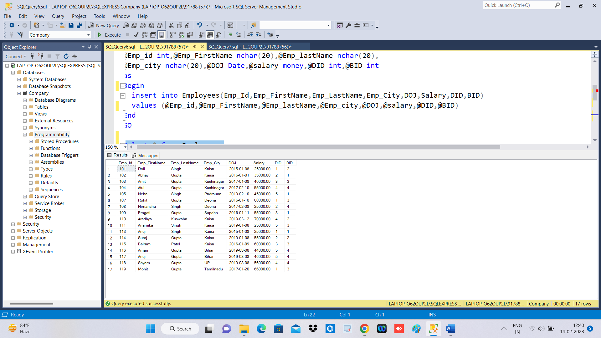

**Table After, Inserting new data.**

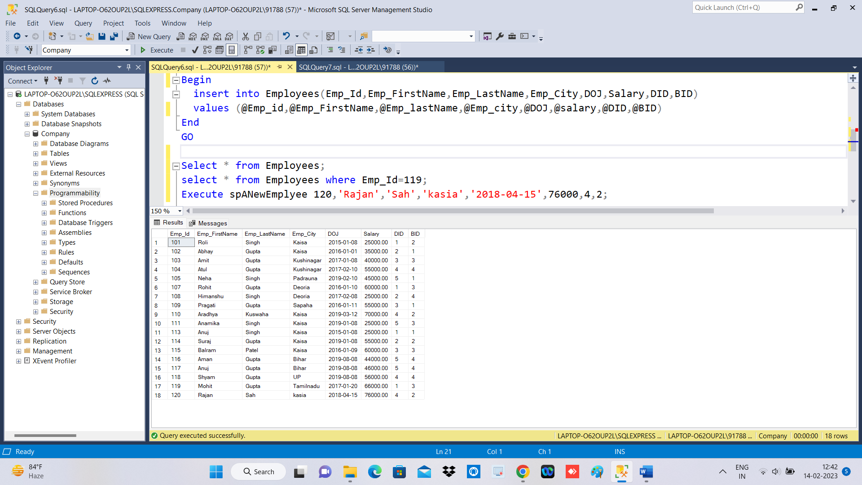

**2.**

GO

Create PROCEDURE spRaiseSalary

@sal_inc int, @sal money

AS

BEGIN

UPDATE dbo.Employees

SET Salary = (Salary + (Salary*@sal_inc)/100)

WHERE Salary < @sal

END

Go

spRaiseSalary 10,40000.00;

**Before Salary Increment**

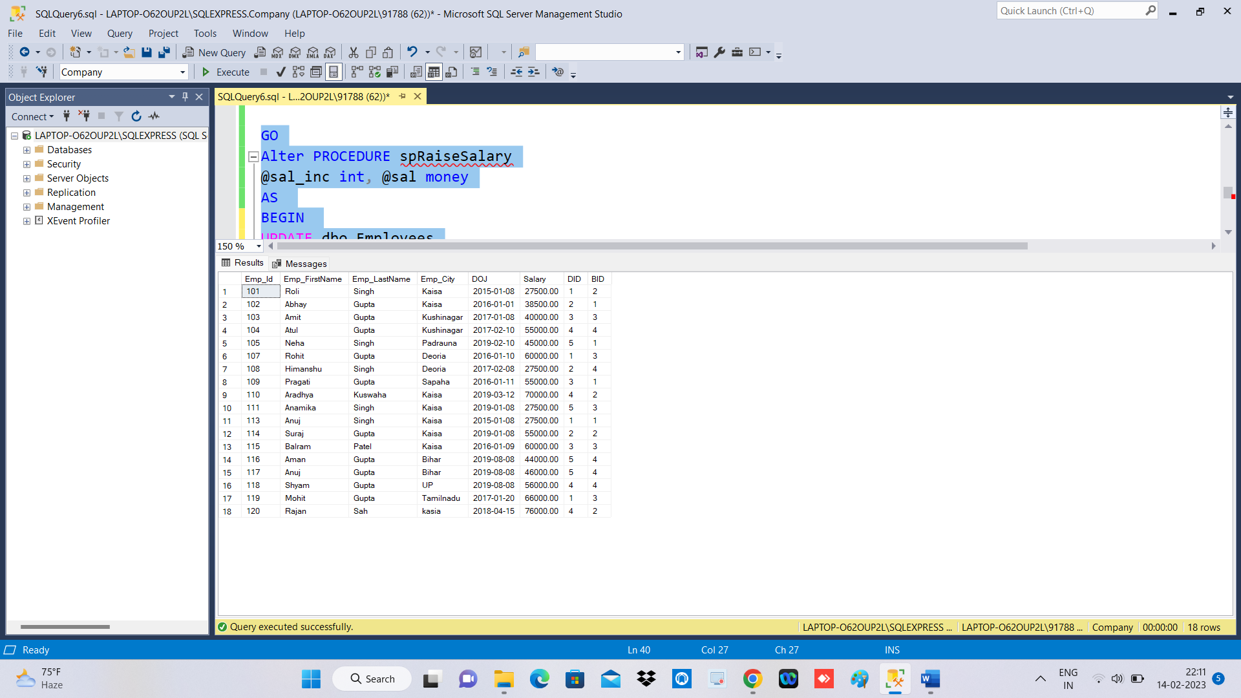

**After Salary Increment by 10% where salary<50000**

