**Unix-Skill Based Assessment**

**Q. 1) Write a shell script to get the current date, time, username, and current working directory.**

Code

Output

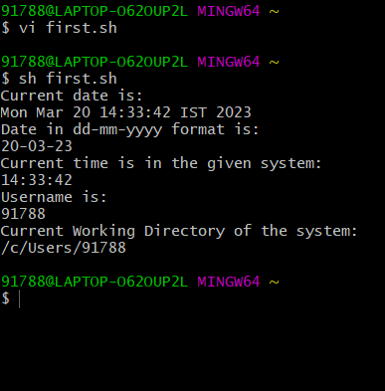

**Q. 2) Write a shell script to print the count of files and subdirectories in the specified directory.**

**Code**

**OUTPUT**

**Q .3) Write a shell script to print the reverse of an input number.**

**Code**

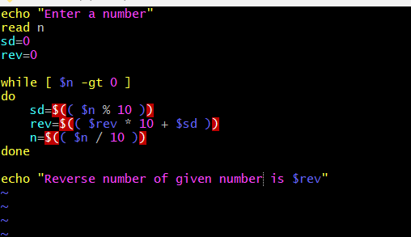

**OUTPUT**

