GEORGIA HIGH SCHOOL MUSICAL THEATRE AWARDS
G
Applicant Account &
Application Guide
Create your account, complete every stage, and submit with confidence.
2026–2027 SEASON • SCHOOL APPLICANTS

Before you begin
- Use the primary school contact’s name, email address, and mobile number.
- Create a password with at least eight characters.
- Have the official school name and production title ready.
- Set aside time to review each required response before submitting a stage.
Guide examples: Peachtree High School and Into the Woods are fictional examples. Your portal will show the programs and questions configured for your school.

PART 1

Create your applicant account
Use the official portal link supplied by the GHSMTA team.
- Open the Awards Portal and choose Create an applicant account.
If you already have an account, skip to the sign-in instructions on the next page.
- Enter the primary school contact’s information.
- Full name: the person responsible for the application.
- Email address: an inbox the school checks regularly.
- Mobile number: include the area code.
- Password: use at least eight characters and do not share it.
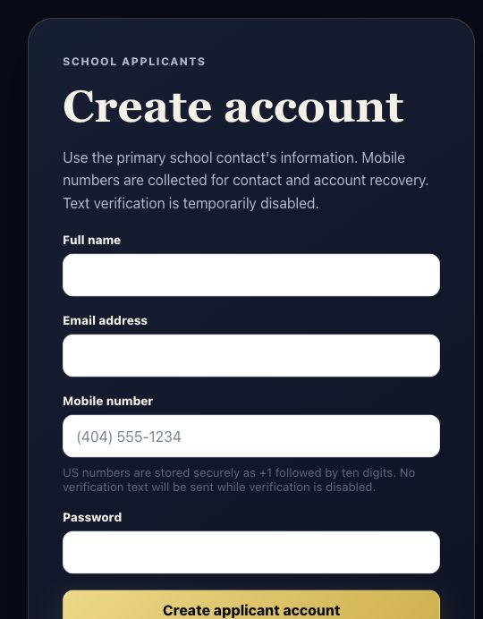
Create account screen. Complete every field, then select Create applicant account.
Important: Use the applicant signup—not Staff signup—which is reserved for GHSMTA staff and adjudicators.

PART 1 CONTINUED

Confirm your email and sign in
- Check your email and confirm the new account.
Open the confirmation message and follow its secure link. Check spam or junk folders if it does not arrive within a few minutes.
- Return to the portal and sign in.
- Password: enter the email address and password created during signup.
- Magic Link: receive a one-time sign-in link by email without entering a password.
- Forgot your password?: start a secure password reset from the sign-in screen.
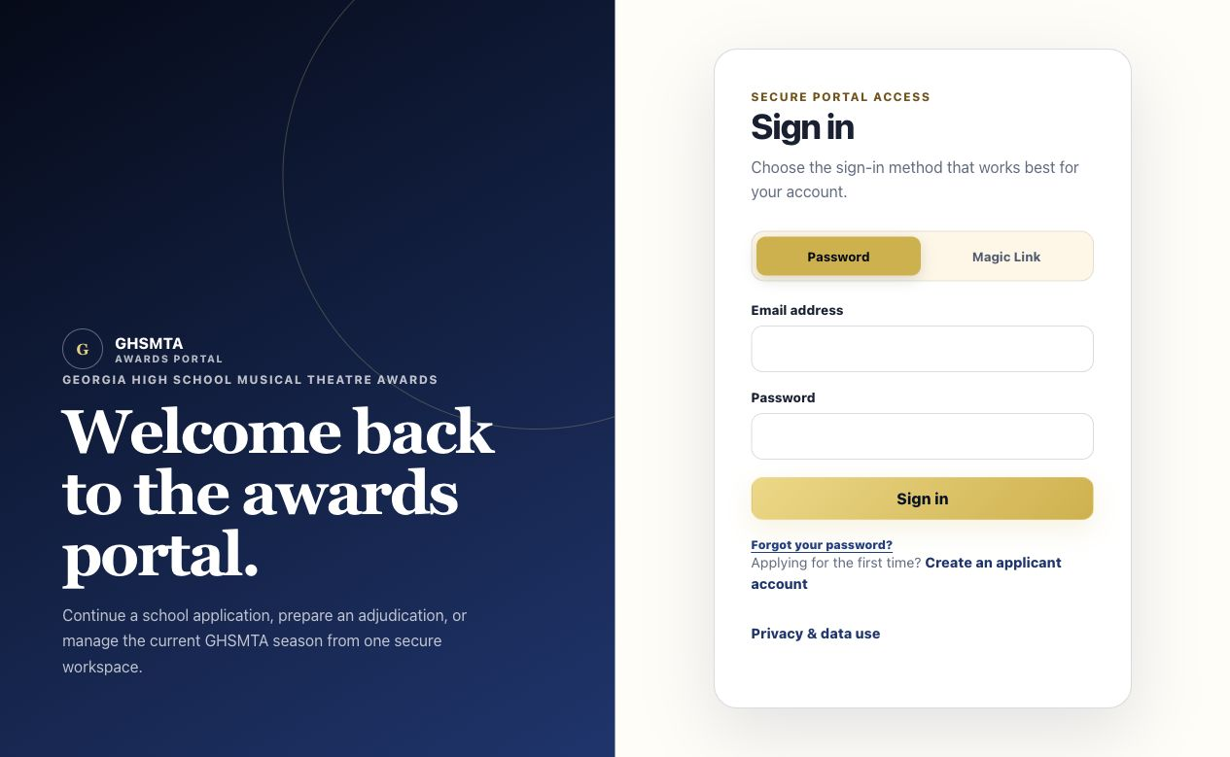
Sign-in screen. Choose Password or Magic Link, then follow the on-screen directions.
Current setting: Text-message verification is temporarily disabled. Follow any additional security prompt if the portal displays one in the future.

PART 2

Start a program application
After signing in, open My Application or select View applications from the dashboard.
- Find Start another application.
- Choose the correct open program and enter school details.
- Application program: select the correct season and track.
- School name: enter the official school name consistently.
- Production title: enter the current production title when applicable.
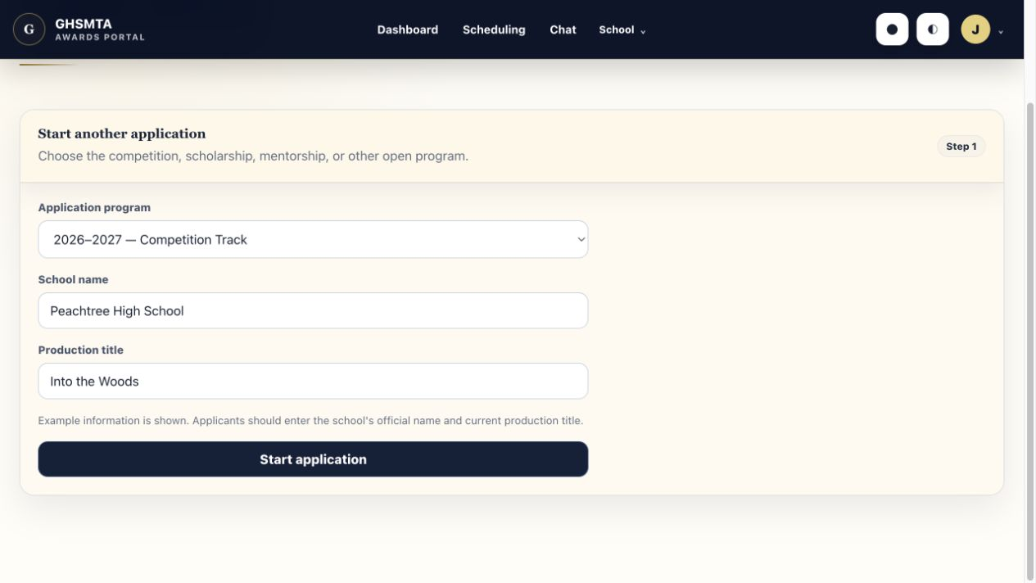
Example start form. Select Start application only after checking the program and school details.
If no program appears: The program may not be open yet, may have closed, or may already have an application under this account. Contact the GHSMTA team before creating a second account.

PART 3

Complete and submit each stage
The active stage is the one currently available for editing.
- Use the stage tabs to track progress.
Completed stages show their status. The current stage is highlighted and contains the editable questions.
- Answer every required question, then review your work.
Fields labeled Required must be completed before the stage can be submitted.
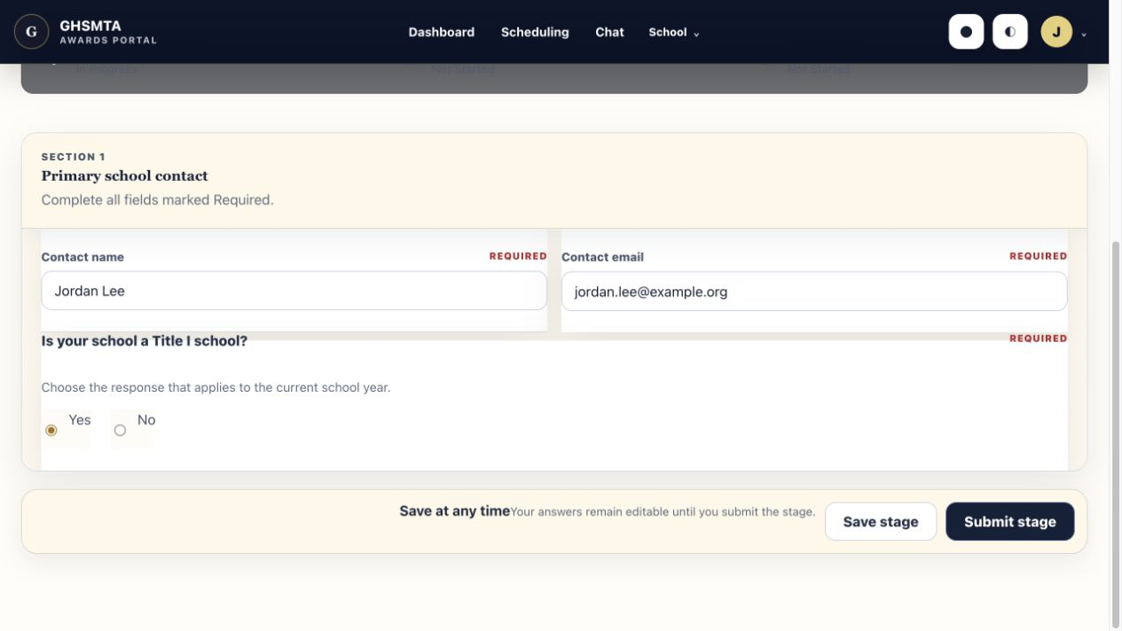
Example stage. Required labels identify the responses that must be completed.
SAVE STAGE | SUBMIT STAGE
Stores the answers entered so far. The current stage remains editable. | Checks required fields, completes the stage, locks it, and opens the next stage.
Before submitting: Review the entire current stage. After Submit stage, an applicant cannot edit that stage unless an Owner reopens the application.

PART 4

Submit the completed application
- Repeat the save-and-submit process for every stage.
Submitting a stage opens the next applicant-visible stage automatically.
- Submit the final stage.
When the last required stage is submitted, the application status changes from Draft to Submitted.
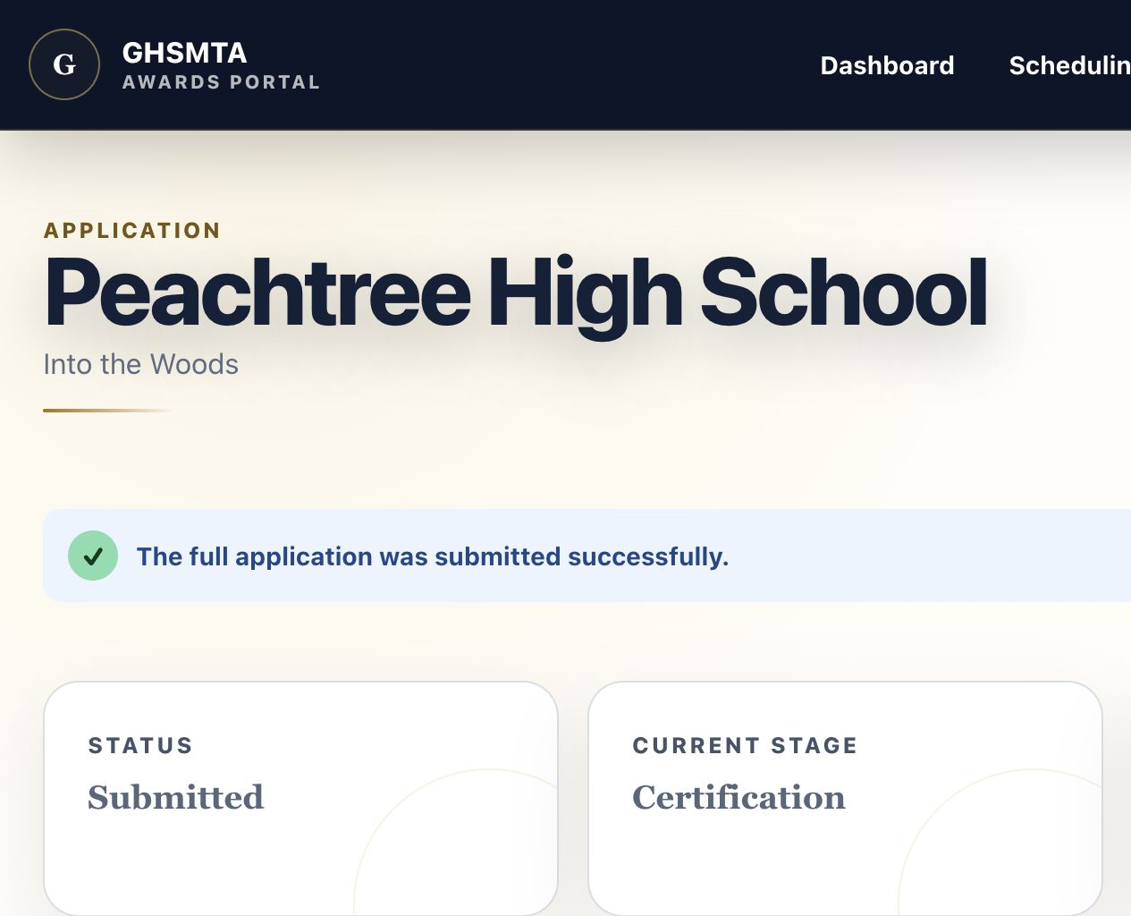
Successful final submission. Confirm both the success message and Submitted status.
Submission is final: The application becomes read-only. If a correction is necessary, ask a GHSMTA Owner to reopen it before the deadline.

AFTER SUBMISSION

Watch the portal for next steps
Keep the account email address and School Messaging available throughout the season.

What may happen next
- Invoice and payment notices may arrive by email, in-app notification, and private School Messaging.
- Scheduling options and reminders will appear in Scheduling.
- Supporting materials can be uploaded through School files when requested.
- GHSMTA updates for your school will appear in School Messaging—not the adjudicator Panel Channel.

Troubleshooting
IF THIS HAPPENS | TRY THIS
No confirmation email | Check spam/junk, verify the email address, and wait a few minutes before trying again.
Cannot sign in | Use Magic Link or Forgot your password? from the sign-in screen.
Program is not listed | Confirm that it is open and that no application already exists for that program.
Required-field warning | Return to the current stage and complete every field labeled Required.
Need to correct submitted work | Contact the GHSMTA team through School Messaging and request that an Owner reopen it.
Report a portal issue: After signing in, use the ? control in the menu bar to submit a bug report or feature request. Include the page, what happened, and a screenshot when possible.

