**AH – Martin Slough**

6/7/2021

* Looking north form Martin Rd where proposed updated culvert project
* Holding a fair amount of water in several vegetated pools
* Several juvenile Chinook fold in isolated pool where tree hangs over water last summer (August 2020)

6/9/2021

* Started survey at culvert and moved downstream to mouth
* Culvert under Martin Rd looks completely filled with vegetation and debris
* There are two consecutive beaver dams with a couple of inches flowing over them so currently connected but would create several isolated pools at low flows
* WPT 93 – this location is a likely pinch point, sedge wall on beaver dam passable at survey date but likely not at low flow
* Another large beaver dam with sedge wall between WPT 96 and 98

* Actual pinch point is beaver dam with about 3-5 ft drop where timelapse camera installed WPT 101 (48.481845, -121.58763) just to the right of where Ian standing in picture ~5 ft upstream of the beaver dam (third beaver dam) in middle of channel. Also location where survey ended.

* Solinst level logger (#002-2136259) and HOBO temperature logger (#21063853) located 10 ft upstream from second beaver dam and 15 ft from RBK under mature overhanging alder tree branch at WPT 100 (48.481607, -121.587726)
* Level logger gauge depth 0.90 m
* Temperature logger inside level logger housing because forgot wire to attach to level logger t-post

* DO logger secured to sturdy underwater branch ~15 ft DNS of second mature alder on LBK ~10 ft from LBK at WPT 102 (48.480938, -121.587882)

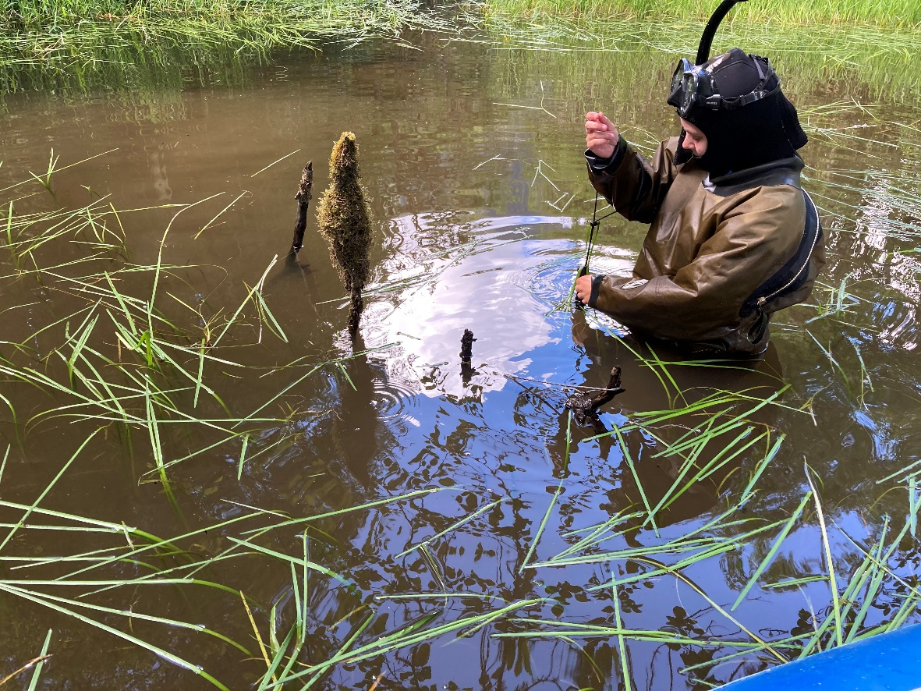

9/20/2021

* Conducted snorkel survey started at Martin Rd bridge but saw no fish (visibility 0.5 m)

* Still steep impassable beaver dam at timelapse camera causing disconnection point
* WPT 268 – first beaver dam (not fish passable)
* WPT 270 – second beaver dam (not fish passable)

9/21/2021

* Checked Martin Slough to see if could e-fish but not within the temperature and DO limitation (didn’t record actual conditions)

10/12/2021

* Logger retrieval
* Retrieved level logger 9:54 am, submerged, gage height 0.7 m
* Retrieved temperature logger 9:54 am, submerged
* Water dark and tanic, no fish observed
* Site is disconnected with ~2 ft drop at beaver dam where timelapse camera installed
* Retrieved timelapse camera, camera didn’t turn on, no sign of being submerged or tampered with – possibly battery issue, SD card has corrosion on it