**D – West of Stevens Creek**

6/10/2021

* Boat reconnaissance
* No description of connectivity
* Timelapse camera placed 25-35 yds up from marked D1 channel at farthest downstream beaver dam/beaver dam remains (has flow underneath), just upstream of (40 ft) from location of subsurface flow at WPT 114 (48.488206, -122.16057)

* HOBO temp logger (#21053124) and level logger (#002-2136258) on same t-post ~15 ft from camera to east, just over grass berm at WPT 115 (48.488237, -122.160581)
* Level logger gauge height 0.825 m

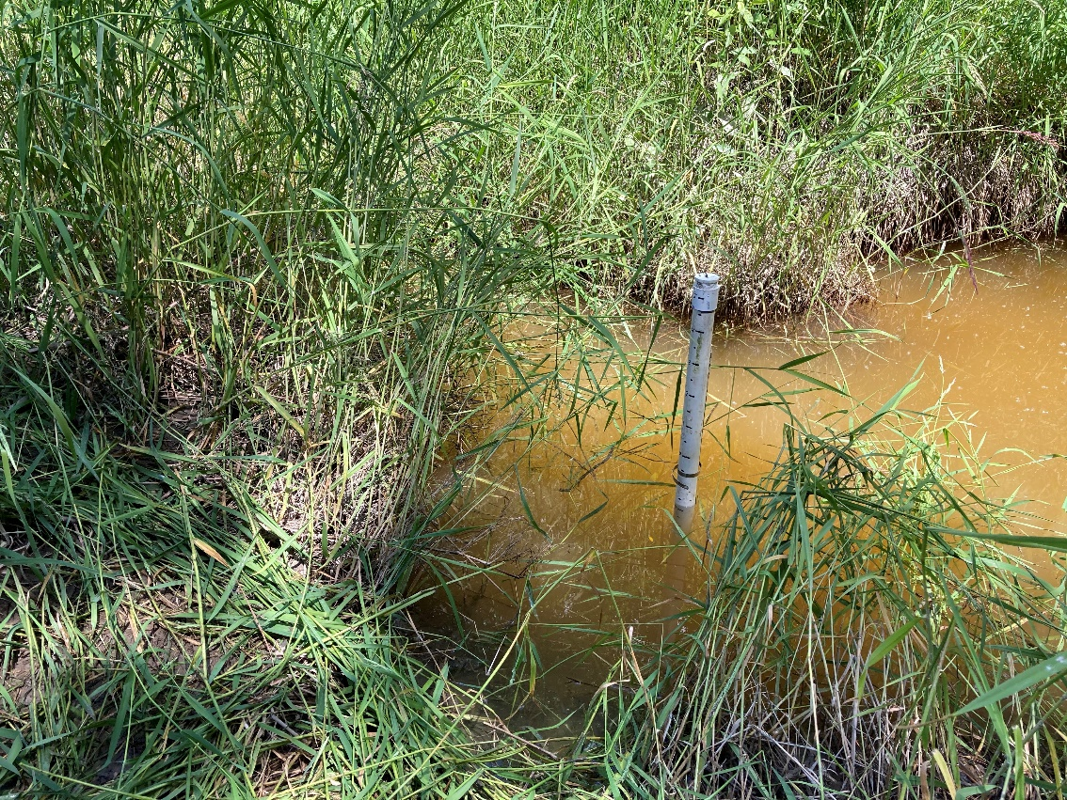

9/22/2021

* Boat reconnaissance
* Site disconnected at large vegetated berm/beaver dam where the timelapse camera is installed
* Large hole in berm/beaver dam with dry channel running through it

* Level logger should maybe go further into site if chosen for next year because this year in outlet channel instead of large pond
* Visibility bad, can’t snorkel (saw one fish surface)
* WPT 295 – at downstream end of pond took habitat measurement
  + Temp: 13.0°C / DO: 1.43 mg/L
* WPT 296 – closer to the upstream end of the pond took another habitat measurement
  + Temp: 13.1°C / DO: 3.67 mg/L / Depth: 0.54 m

* Another channel coming off from timelapse camera to the NE but looks like it would lead to an area that doesn’t hold substantial water according to REM

10/11/2021

* Logger retrieval
* Retrieved level logger 2:36 pm, submerged, gage height 0.6 m
* Retrieved temperature logger, submerged
* Slough appears disconnected, no water flowing through beaver dam
* Water turbid and reasonably cold, no fish observed