**West of Stevens Creek Slough (Site D)**

Seasonally Disconnected Floodplain Habitat Project: Year 1 (2021) Reconnaissance Report

Maddie Hicks, Jonathan Armstrong (Oregon State University)

Catherine Austin (Skagit River System Cooperative)

Site Map

* D1 – site outlet
* WPT 295 – habitat measurements taken at downstream end of slough 9/22/2021
* WPT 296 – habitat measurements taken closer to the upstream end of slough 9/22/2021
* Level logger – placed at upstream end of outlet channel 6/10/2021 – 10/11/2021
* Temperature logger – placed at upstream end of outlet channel 6/10/2021 – 10/11/2021
* Timelapse camera – placed upstream from D1 at vegetated berm/beaver dam 6/10/2021 – 10/11/2021

Figure 1: Map of Site D with Relative Elevation Model (REM) showing elevation (ft) relative to the mainstem at base flows. REM developed by NSD from USGS 2016 LiDAR and provided by SRSC.

Temperature, Water Level, and Connectivity Trends

Figure 2. Changes in water level (m) and temperature (°C) in West of Stevens Creek Slough relative to Skagit discharge (cfs). The gray vertical bar shows when the temperature logger was out of the water. The gray horizontal bar shows estimated site disconnection ranging between a Skagit discharge of 7,500 – 9,000 cfs (USGS Marblemount, WA)

* Estimated Connectivity Threshold: 7,500 – 9,000 cfs (USGS Marblemount, WA)
* Given the low relative elevation of the site to the Skagit mainstem, site connectivity is likely heavily influenced by mainstem discharge
* As Skagit flows recede the water level in the site appears to decline rapidly
* Figure 2 water level shows that site completely dried up but logger not in the very deepest spot so could have held water
* 6/10/2021 – 10/11/2021
  + Minimum Temperature: 9.9°C
  + Maximum Tempreature: 19.0°C
  + Average Tempereature: 14.2°C

6/10/2021

* Boat reconnaissance
* Site potentially disconnected with small amount of water flowing under vegetated berm/beaver dam that may not be fish passable (Figure 3)
* Subsurface flow coming out of ground just downstream of timelapse camera location
* Turbid water just upstream of vegetated berm/beaver dam so not able to snorkel (Figure 4)
* No fish observed likely because of poor visibility

Figure 3. Small trickle flowing under vegetated berm into outlet channel

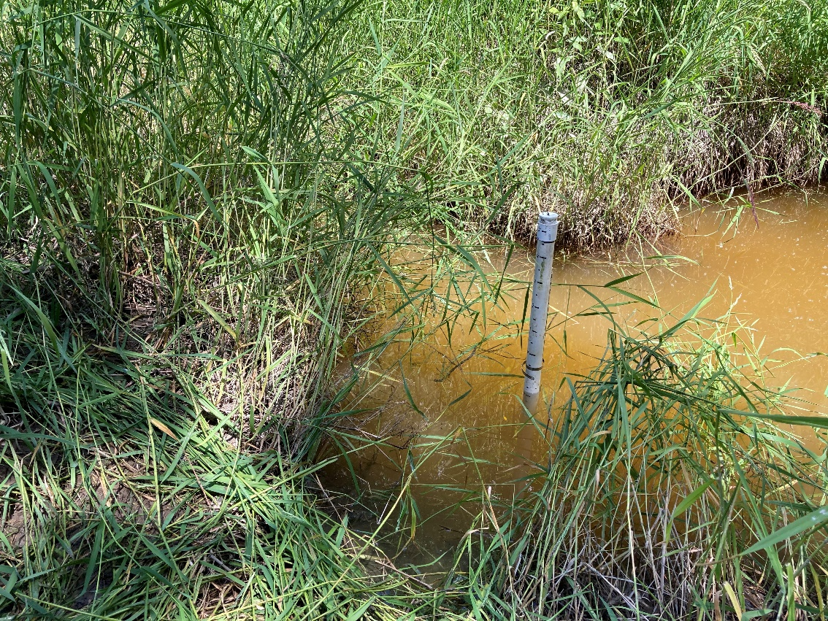

Figure 4. Level logger just upstream of vegetated berm in turbid slough

9/22/2021

* Boat reconnaissance
* Site disconnected at large vegetated berm/beaver dam at timelapse camera location with no water flowing underneath (Figure 5)
* Outlet channel just downstream of vegetated berm/beaver dam dry for 10-15 ft

Figure 5. Site disconnected at vegetated berm with no flow underneath and downstream outlet channel partially dry

* Moderate turbidity in slough (Figure 6)
* A couple of juvenile salmonids observed surfacing
* WPT 295 – took temperature and DO measurements at downstream end of slough
  + Temperature: 13.0°C
  + DO: 1.43 mg/L
* WPT 296 – took temperature and DO measurements closer to the upstream end of slough
  + Temperature: 13.1°C
  + DO: 3.67 mg/L
  + Depth: 0.54 m

Figure 6. Looking upstream at slough from vegetated berm

10/11/2021

* Boat reconnaissance
* Site disconnected at large vegetated berm/beaver dam at timelapse camera location with no water flowing underneath
* Water turbid and cold
* No fish observed