# How to build 2D app in Hololens

## Introduction

This sample demonstrates how to build 2D app in Hololens, which is a hello world application. In this sample, you can click a button for several times so that the application will show the click count that you have clicked.

While you are developing UWP app for Hololens, the limitations you need to know is that, some feature of UWP is not supported in Hololens, for details you can visit this page: [Current limitations for app using APIs from the shell](https://developer.microsoft.com/en-us/windows/holographic/current_limitations_for_apps_using_apis_from_the_shell).

## Sample prerequisites

To open and run this sample, ensure that the following requisites have been met:

* Microsoft Windows 10(10.0.14393) or above.
* Microsoft Visual Studio 2015 Update3 or later version(s).
* Microsoft Visual Studio installed UWP develop component.
* The Hololens emulator is installed.
  + [download address: <https://developer.microsoft.com/en-us/windows/holographic/install_the_tools> ]

## Building the sample

* Open the sample solution “**CS2DHololensApp.sln**” using Visual Studio.
* Press **F6 Key** or select **Build -> Build Solution** from the menu to build the sample.

## Running the sample

* Open the sample solution using Visual Studio.
* Select debug environment as Hololens emulator.

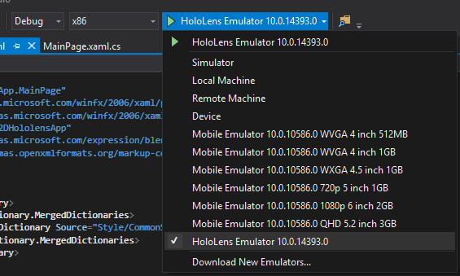

* Press **F5 Key** or select **Debug -> Start Debugging** from the menu.
* After the app has been deployed in emulator and is running, you can see this in Hololens emulator:

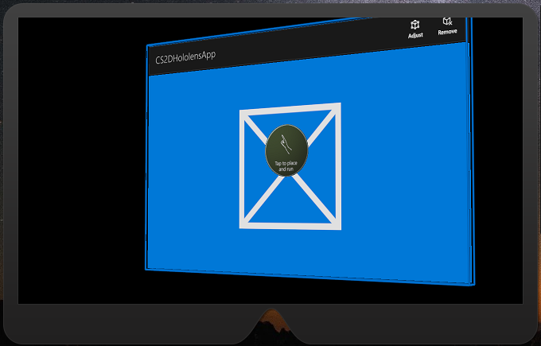

* Press **Right** button of mouse and Drag up to run this app in Hololens emulator, and then you will see that.

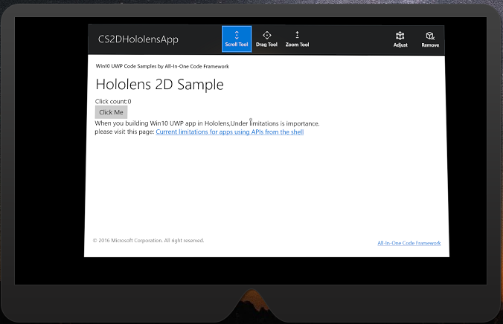

* Notice the point in the screen center and use **W,A,S,D Key** and **Up,Down,Left,Right** Key to move the point to the button in this app.

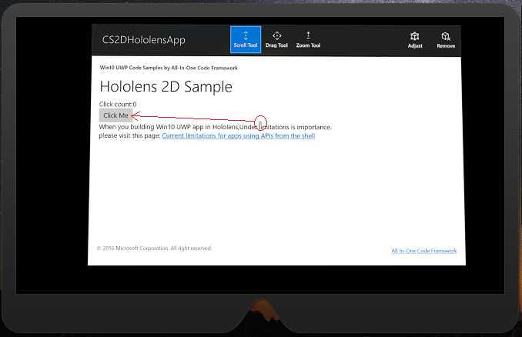

* When the point is on the button, you can press space key to simulate the click action. After that, the click count will be changed.

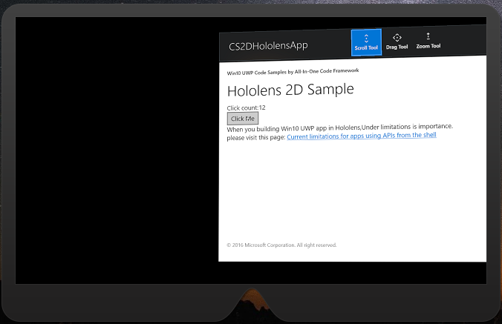

## Using the code

CS code is:

public sealed partial class MainPage : Page

{

public MainPageViewModel ViewModel = new MainPageViewModel();

public MainPage()

{

this.InitializeComponent();

this.DataContext = ViewModel;

}

private void Button_Click(object sender, RoutedEventArgs e)

{

ViewModel.ClickCount++;

}

}

public class MainPageViewModel : BindableBase

{

private int _clickCount;

public int ClickCount

{

get { return _clickCount; }

set { SetProperty(ref _clickCount, value); }

}

}

Xaml is:

<StackPanel Grid.Row="3">

<StackPanel Orientation="Horizontal">

<TextBlock Text="Click count:" />

<TextBlock Text="{Binding ClickCount}" />

</StackPanel>

<Button Click="Button_Click">Click Me</Button>

<RichTextBlock>

<Paragraph>

<Span>When you building Win10 UWP app in Hololens,Under limitations is importance.</Span>

<LineBreak />

<Span>please visit this page:</Span>

<Hyperlink NavigateUri="https://developer.microsoft.com/en-us/windows/holographic/current_limitations_for_apps_using_apis_from_the_shell">Current limitations for apps using APIs from the shell</Hyperlink>

</Paragraph>

</RichTextBlock>

</StackPanel>

## More information

Building 2D apps:

<https://developer.microsoft.com/en-us/windows/holographic/building_2d_apps>

Current limitations for apps using APIs from the shell:

<https://developer.microsoft.com/en-us/windows/holographic/current_limitations_for_apps_using_apis_from_the_shell>