Bull Run

Maddie Comtois

Version 1.0

Game Description

Bull Run is a Spanish running of the bulls themed running game where the player tries to make it to the end of the course before being run over by a bull. The player, or torero, jumps on top of platforms to avoid the bull running behind him. If the bull runs into the player three times, the game is over and the player loses. A score continues to increase while the player is running and stops when the player reaches the end of the course (bull ring) or loses all lives. The object of the game is to get to the end of the course as quickly as possible without losing all three lives, and to have the lowest score.

If the player makes it to the end of the game without losing all three lives, they are directed to the winning screen. If the score for the most recent run is lower than that of a previous game, the overall top score is replaced with the new lower one. The player can then chose to play again or exit the game. If the player looses all three lives before reaching the end of the course, they are directed to the game over screen. Their score is displayed, but it is not taken into account when calculating the overall top score, since the player did not actually win the game (reach the bull ring). The player can then chose to play again or exit the game.

UI Design

The player moves the character left and right by using the corresponding left and right arrow keys, or by pressing the keys ‘a’ and ‘d’. The player can jump by pressing the up arrow, space bar, or ‘w’ key. The player will not move if no key is pressed. If the player runs into the bull character while running, or if the bull runs into the player while the player is standing still, the player will lose a life. At the end of the game, the player can press any key to play again or the escape key to quit the game.

Flow Chart

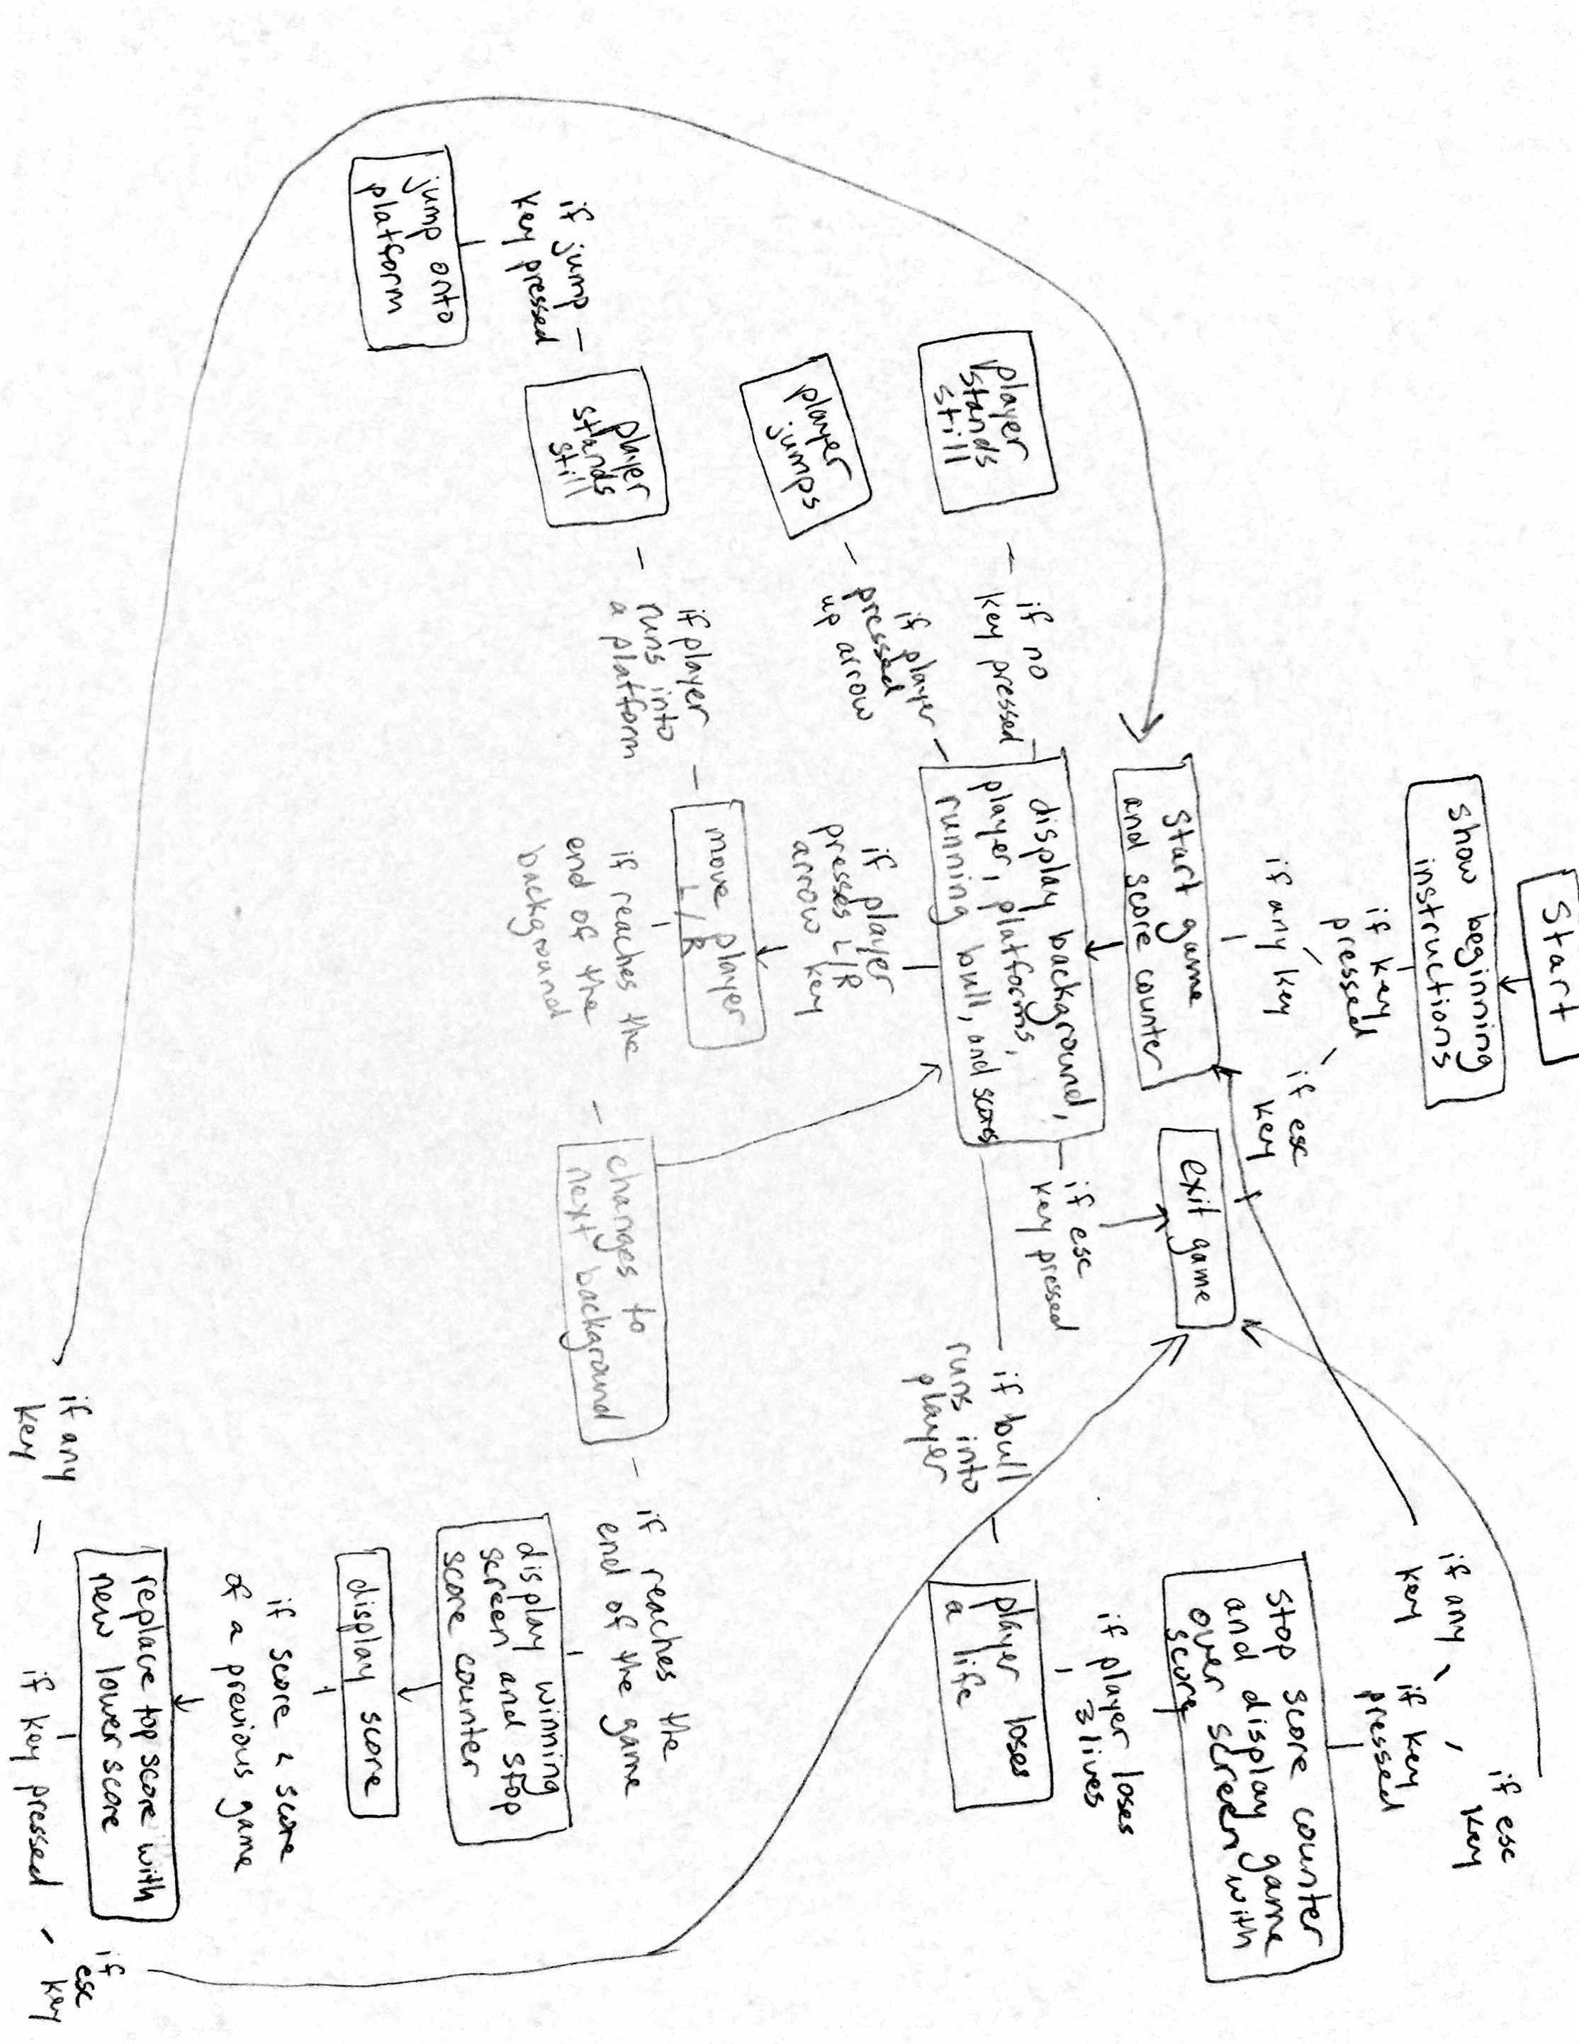

Sprite List

Torero

Bull

Platforms

Object List

Background1

Background2

Background3

Background4

Background5

Background6

Background7

Background7copy

Speed Score

Top Speed Score

Max Lives

Test Plan

Purposefully lose all lives in each different background:

Each time the game turned to the game over screen.

Go to the win screen if the player finishes the last background:

The game would quit and display an error that the background list was out of range, even when the numbers were changed to compensate for the length. Created a copy of the last background to pass through the list that would direct the game to the winning screen.

Win with different amounts of lives left:

Each time the game went to the win screen.

Run into the bull “backwards”:

The player did not lose a life. Changed the code to lose a life no matter which part of the bull the player runs into.

Let the player stand still out of the bull’s reach for 30 min:

The score counter continued to increase the score, nothing unexpected happened.

Win and beat the top score:

The top score would only be replaced if the run took longer than a previous successful run. Changed the code to only accept a new top score if the score was less than the previous one.

Win without beating the top score:

The top score remained the previous top score and was not replaced by the new one.

“Win” the game and lose last life at the same time.

The computer would restart the game without going to a win or lose screen. Changed the code to only go to the win screen if it had more than 0 lives.

See if game would restart when pressing any key except for the escape key:

The game would restart every time.

See if the game would quit if the escape key were pressed during the game:

The game would quit at any point.

Credits

These references were helpful for when I was not sure how to code a certain aspect of the game.

Craven, Paul. "Program Arcade Games With Python And Pygame." *Program Arcade Games*

*With Python And Pygame*. Simpson College, 2015. Web. 20 July 2016. <http://programarcadegames.com/index.php?lang=en>

Pygame documentation

Sweigart, Al. *Invent Your Own Computer Games with Python 3rd Edition*. N.p.: Albert Sweigart,

2008-2015. Print.