***The Fine Arts are a Necessity in Public Grade Schools, and Here’s Why***

*How the arts benefit students in all aspects of their lives.*

By Madelyn Beck / October 23, 2022

American public school art budgets have decreased by almost 70%, according to popular art sales and research website, artnet.com [link to the data]. New York arts programs have taken a hit.

2020 not only brought a deadly world pandemic, which came with much uncertainty of when life would go back to normal, but it also led us into the normalization of remote schooling. Because of this, many arts programs took a hit: teachers found it difficult to teach over a computer screen what is meant to be an interactive and hands-on type of instruction.

However, the Syracuse City School District somehow managed to remain almost entirely untouched after coming out of the pandemic, and has even grown greatly because of it.

“The district has about 20,000 students, and every single one of them has access to the fine arts from the day they start Pre-K,” said Rory Edwards, director of fine arts for the Syracuse City School District, and former band and music theory teacher at SCDS’s Henninger High School. “We offer visual art and classroom music, and when students get into upper elementary school they have the opportunity to start instrumental music. In high school our students have the opportunity to participate in drama performances, theater, musicals, plays, and other arts related extracurricular activities.”

This access to the fine arts is not completely uncommon for public school students to have access to from such a young age, but for this many opportunities to be provided is where SCSD stands out from others.

It is not only important for students to have access to the arts in grade school because college makes it a lot more difficult to take art and music classes, but the fine arts allow students a creative outlet during their days that can help relieve stress and express their emotions.

Lisa Teater, an art teacher at Corcoran High School has been teaching art classes ranging from studio art, to advanced portfolio classes in the SCSD for 17 years and describes her experience teaching students as “her happy place.”

“The Syracuse City School District offers IB art classes, or college level classes that can transfer over for college credit once students start to apply to schools. These classes challenge students not only in aspects of skill level, but also in intellectual ways of learning how to annotate their art work, and dig deeper into the meaning behind what they are creating,” said Teater.

Lisa Teater shared her IB art class's current project of turning anatomical hearts into a representation of a personal identity that may not be surface level, or very recognizable at first glance. Students are forced to dig deep into a part of them, and pull in more in depth information on their creative process.

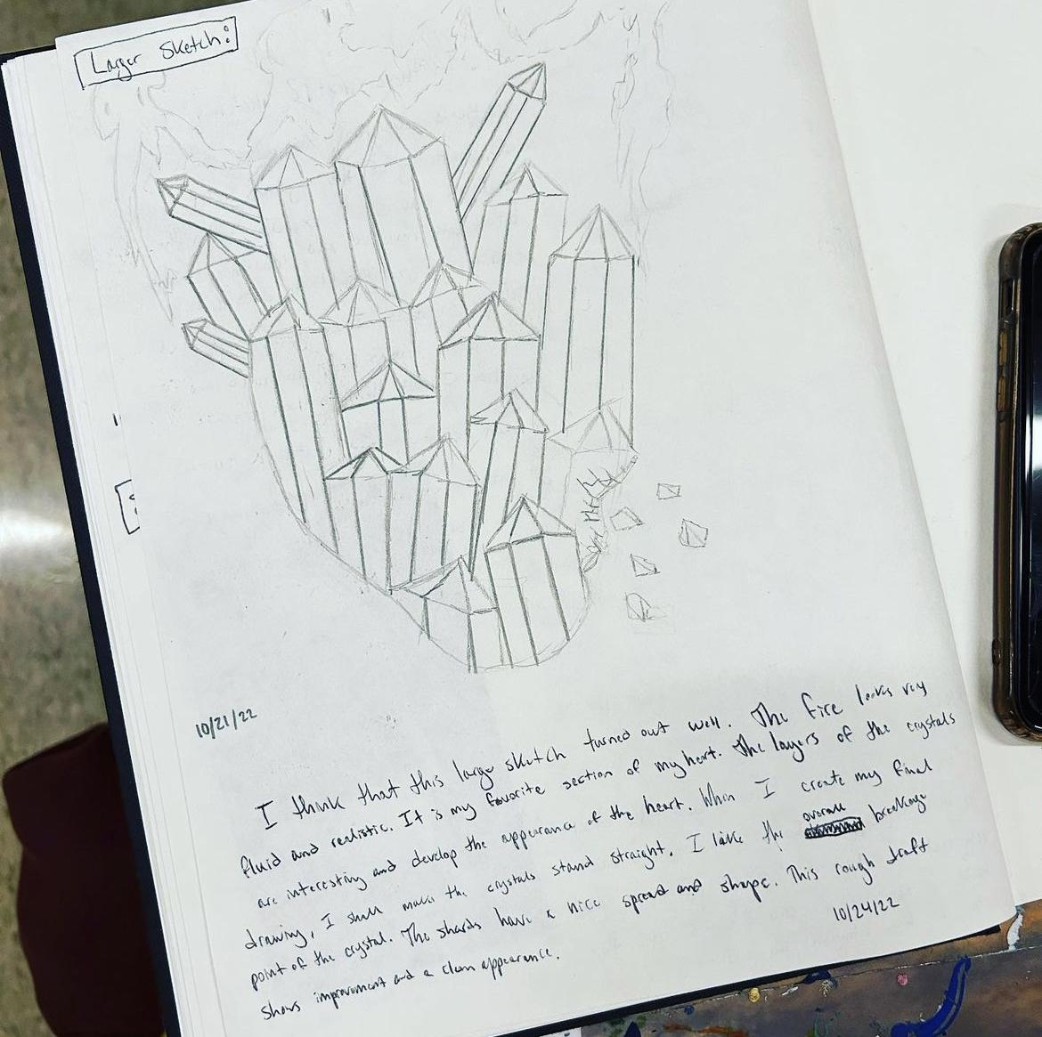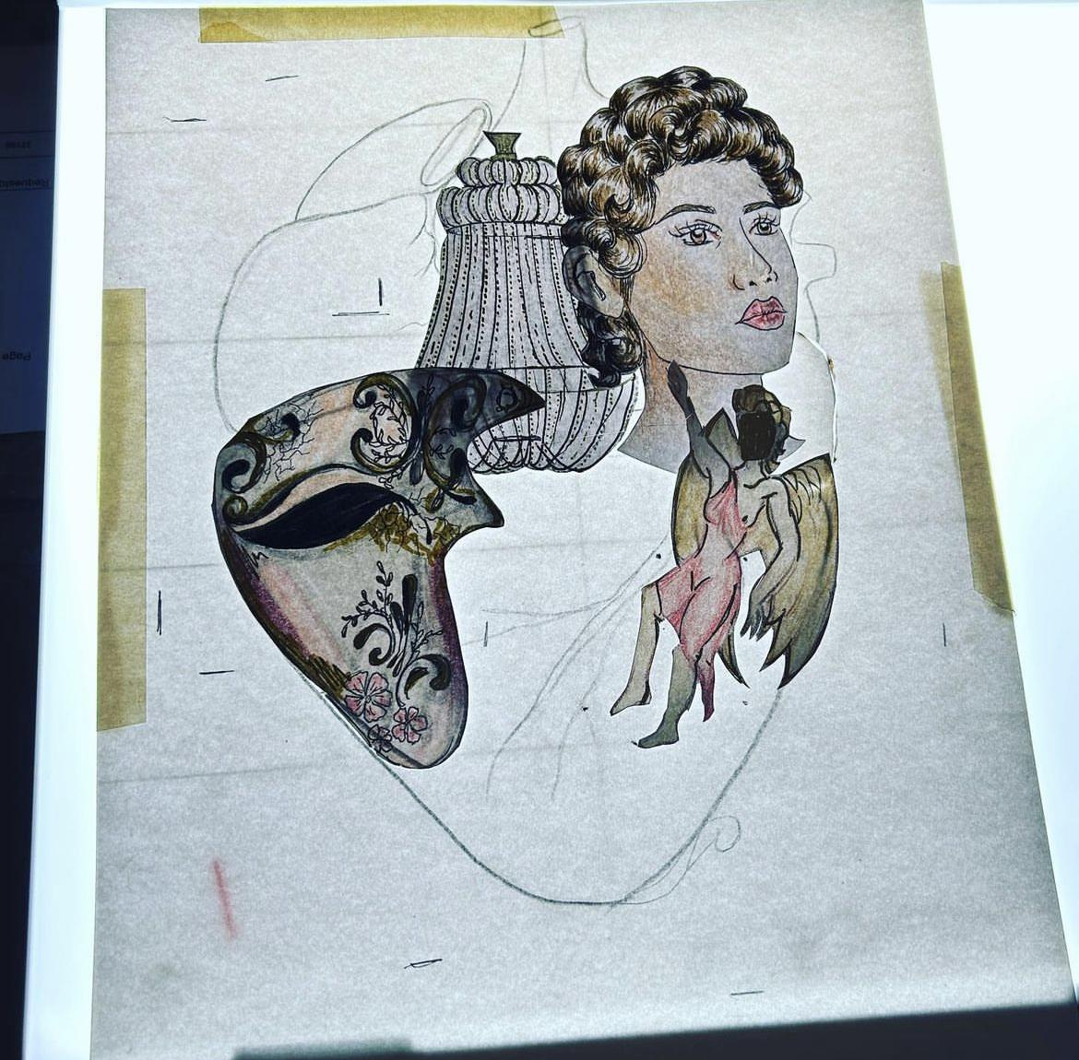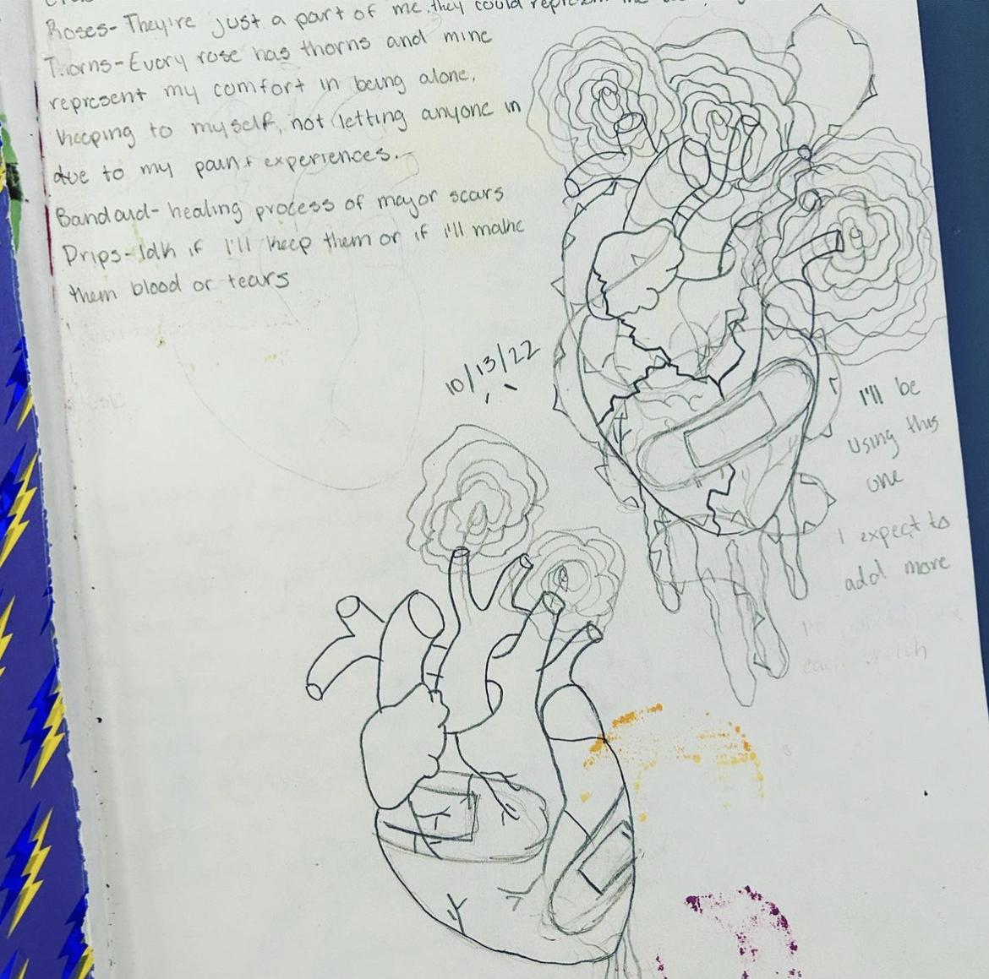

However, these intensive arts programs are not equally accessible all around central New York. Outside of the SCSD, many art and music teachers struggle to maintain a successful program for students due to funding and budget cuts.

“I have friends who are teachers in surrounding districts that have expressed the inequity in regards to some of the funding they get in comparison to us,” said Lisa Teater.

Rory Edwards in particular has made sure to provide as best of an experience for students and teachers as possible, by giving access to all types of programs and experiences throughout the school year. Students throughout the district are able to participate in many arts related activities such as theater performances, music competitions, and so many others.

“I do feel very supported by the community and district, but funding could always be better,” said Lisa Teater. “If we had another art teacher we would have more experiences for students to do.”

After working as an art teacher in this district for so long, Lisa Teater has experienced many moments in which students have been able to find their place in the arts, and have used their creativity to relieve the stress of other classes, and even from their home lives.

The arts not only allow students to learn new skills in different mediums, but it also carries over into other aspects of their lives.

Why art matters:

* It gives a visual representation of the past
* It embellishes the world around us
* Art is therapeutic
* A gateway to expression
* Art communicates in ways words can’t
* It helps us express our dreams
* It helps us understand ourselves
* It tells stories, both real and imaginary
* It provides a creative outlet
* Art helps us understand what is happening in the present day
* It helps us communicate what may be difficult to talk about vocally