**Syracuse Stage premieres the musical of *How to Dance in Ohio***

*Representation of the underrepresented.*

By Madelyn Beck | September 25, 2022

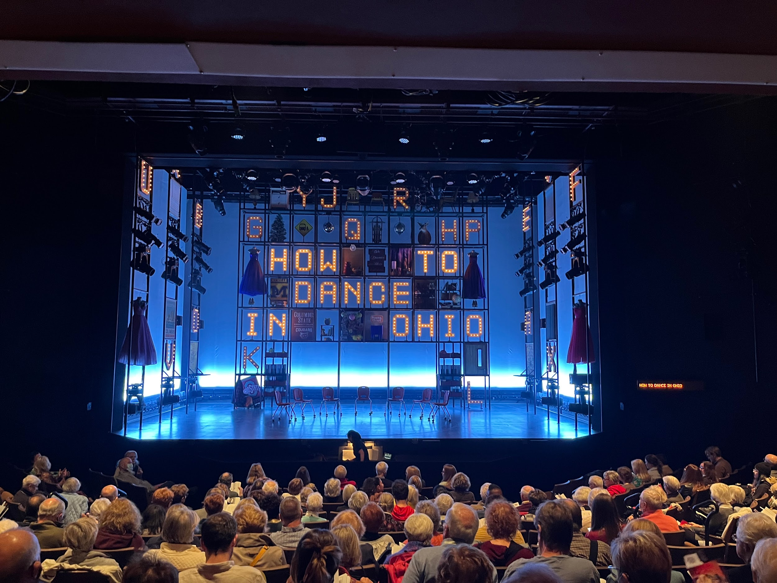

Photo by Madelyn Beck

The Syracuse Stage opened its doors on September 23, to run the first ever full musical production of *How to Dance in Ohio*, based on the 2015 HBO documentary by the same name. Not only featuring Tony Award winning actors, but the Stage also opened up the opportunity for current and previous Syracuse University students to gain equity points for the theater acting union.

*How to Dance in Ohio* follows the story of seven autistic teens and young adults on their coming of age story of navigating their way through the world. However, this is not only a show with representation of autism onstage, but the Ohio team also made sure to create a safe and inclusive environment offstage to ensure the actors could be as successful as possible. This is one of the first shows to cast all characters with actors of the same neuro, ethnic, and other identifying characteristic backgrounds, which is a huge part of why this story is so important to tell.

Sammi Cannold, the director of *How to Dance in Ohio*, said she wanted to make the show as accurate a representation as possible of how autism can appear from person to person, and the best way to do this was to cast people that are actually on the autism spectrum as each of the characters.

“The biggest way, across the board, that allowed us to bring ourselves to our characters was that our director has been very welcoming to the idea of us releasing any stims, or releases of energy that we need to do on stage, because it is pretty common for autistic people. She really wanted us to be authentic to ourselves and to the characters,.” said Liam Pearce, a former student at Pace University, currently playing the role of Drew in *How to Dance in Ohio*. “Not having to mask or suppress any of my stims or quirks helps me connect to the character very easily.”

Pearce was diagnosed with autism at the age of five and was in group therapy, similar to the show, until the age of 9. Throughout his middle school, high school, and college experience, he was not surrounded by many people who could fully understand how much autism affected his life. Being in this show, surrounded by other people that share a similar diagnosis, and by people who are understanding of the accommodations needed was validating,” he said.

“It’s completely different from anything I’ve done before,” said Pearce. “It feels safe.”

In an attempt to ensure rehearsals and the overall experience was as inclusive as possible, the production team sent out a survey to the cast prior to the start of rehearsals where they were able to share any accommodations that would need to be as successful as possible during the process.

“Before we started rehearsals, they sent us a form of accessibility concerns, and I am visually impaired so there was an option for enlarged print in our scripts,.” said Corinne Ferrer, a Syracuse University senior studying acting. “I really felt seen because we are not really surrounded by that attention to accessibility very much.”

Corinne understudies the role of Ashley Amigo, a Cuban American girl with a single father. The casting and production team made sure to cast actors with as similar of a personal identity as possible to the characters to ensure the most accurate representation. Corinne was able to encapsulate the character of Ashley onstage because of her ethnicity, and close connection with her parents that pushed her to strive for her goals.

“It’s a story of so many underrepresented people, and voices you never hear about,” said Corinne.

Autism is extremely underrepresented in the arts, and this show encapsulates the struggles that people with autism deal with from day to day, and how they make decisions and interact with other people in different situations. One example in particular, throughout the show we see the journey of a character by the name of Marideth Bridges who has severe sensory issues. She is seen periodically wearing headphones to block out excess noise, and is uncomfortable with physical touch. By the end of the show though, Marideth is able to overcome her boundaries with physical touch; allowing Drew to hold her hand as they dance together.

*How to Dance in Ohio* is not a show about autism, but instead a show about the lives of people living with autism. It shows the audience that autism appears very differently from person to person.

“It is very important that we have all autistic actors playing the autistic characters because it is not something that we have seen in the media very often. We usually get neurotypical people playing the autistic parts,” said Imri Leshed, a recent Syracuse University graduate, who understudies for three of the autistic male roles in the show. “It is a very great example of the way that theater can be used as an artform to get across an important message.”

The Syracuse Stage will be running *How to Dance in Ohio* from now until October 9. Tickets, and more information can be found at <https://www.syracusestage.org/events>.

Since coverage of this show on September 28, the show had to close early due to a Covid-19 outbreak within the cast and crew.

Sources:

Liam Pearce (actor playing the role of Drew) (980)240-4122

Imri Leshed (Former Syracuse Student, swing for three autistic characters) (607)229-5965

Corinne Ferrer (Syracuse University drama student, understudy for Ashley Amigo) (786)512-4986