Task Definition
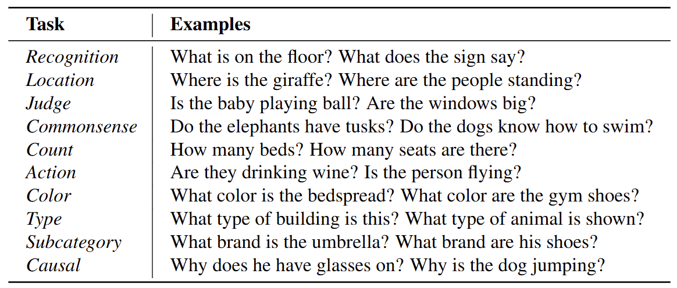

Task1: Recognition
Definition: Determining whether a specific object or category exists in the image.
Examples: “Is there a helmet?” or “Is a bus present?”

Task2: Location (Spatial relation operator)
Definition: Identifying the relative or absolute position of an object or part within the image.
Examples: “Left of the car”(relative), “Behind the person”(relative),“Right side of the image”(absolute)

Task3: Judge (Binary Condition Evaluation)
Definition: Evaluating whether a specific statement or condition is true.
Examples: “Is the motorcycle damaged?”, “Is the person looking at the camera?”

Task4: Commonsense (External Knowledge Integration)
Definition: Applying non-visual knowledge that cannot be inferred from pixels alone.
Examples: “Is this vehicle suitable for carrying cargo?”, “Can a ladder support a person’s weight?”

Task5: Count (Counting and Quantitative Reasoning)
Definition: The Number task concerns the quantitative characterization of a visually defined set. It includes exact counting, comparing quantities, reasoning about order (e.g., “third from the left”), and judging approximate amounts or proportions, as long as the answer fundamentally depends on “how many” in some form.
Examples: [Counting] “How many bikes are in the image?”
[Ording/Ranking]” Which person is the third from the left?”,” What is the position of the red car in the queue?”
[Comparison of quantity/size]” Are there more motorcycles than bicycles?” Does the right shelf have fewer books than the left shelf?
[Range / approximation] “Does the crowd contain at least 20 people?”
[Proportion / ratio]” Do more than half of the people wear hats?”,

Task6: Action (Pose - Motion Inference)
Definition: Identify activity or state change performed by an entity. It includes actions by humans, animals, robots and other devices. Action can be past, present or future actions.
Examples: “Is the dog running?”,” Is the excavator lifting soil?”,

Task7: Color (Visual Attribute of Objects)
Definition: The Color task involves identifying the perceived color of an object or any of its visually distinguishable parts. It can be the primary color of the object, a secondary or minor color, a local region/component’s color(e.g. stripe, handle, label), or colors affected by lighting/shading/reflection.
Examples: “What color is the jacket?”
“Is the iron hot?”
“Is the meat undercooked?”

Task8: Type (Coarse Category Identification)
Definition: Classify the general(super) class of an object
Examples: “Is this a vehicle?”(rather than ask to identify truck/sedan)

Task9: Subcategory (Fine-Grained Category Identification)
Definition: Classify the specific(sub) class of an object.
Examples: “Is this a sedan/pickup?”(rather than ask to identify vehicle)

Task10 Causal (Cause Effect Interpretation)
Definition: Inferring the causal relationship between visual events, states, or configurations observable in the image.
Examples: “Why is the dog runing?”,”What feeling will person A’s action make to person B? “

