Experiment 14 M. Devarajulu
Aim 192212058
To implement the Alpha-Beta Pruning Algorithm using Python
Algorithm
- Define the game tree with leaf node values.
- Initialize alpha = -∞ and beta = +∞.
- If the current node is a maximizing node, update alpha with the maximum value.
- If the current node is a minimizing node, update beta with the minimum value.
- If alpha ≥ beta, prune the remaining branches.
- Continue until the root node is evaluated.
- Display the optimal value.

Program
import tkinter as tk

# Leaf node values
values = [3, 5, 6, 9, 1, 2, 0, -1]

# Alpha-Beta Pruning
def alpha_beta(depth, node, maximizing, alpha, beta):
# If leaf node
if depth == 3:
return values[node]

if maximizing:
best = -1000

for i in range(2):
child_value = alpha_beta(
depth + 1,
node * 2 + i,
False,
alpha,
beta
)

best = max(best, child_value)
alpha = max(alpha, best)

# Beta cut-off
if beta <= alpha:
break

return best

else:
best = 1000

for i in range(2):
child_value = alpha_beta(
depth + 1,
node * 2 + i,
True,
alpha,
beta
)

best = min(best, child_value)
beta = min(beta, best)

# Alpha cut-off
if beta <= alpha:
break

return best

# Calculate optimal value
optimal_value = alpha_beta(0, 0, True, -1000, 1000)

# ---------------- GUI ----------------

window = tk.Tk()
window.title("Alpha-Beta Pruning")
window.geometry("700x450")

canvas = tk.Canvas(
window,
width=700,
height=450,
bg="white"
)
canvas.pack()

# Node positions
positions = {
"A": (350, 50),

"B": (200, 140),
"C": (500, 140),

"D": (130, 230),
"E": (270, 230),
"F": (430, 230),
"G": (570, 230),

"3": (100, 350),
"5": (160, 350),
"6": (240, 350),
"9": (300, 350),

"1": (400, 350),
"2": (460, 350),
"0": (540, 350),
"-1": (600, 350)
}

# Edges
edges = [
("A", "B"),
("A", "C"),

("B", "D"),
("B", "E"),

("C", "F"),
("C", "G"),

("D", "3"),
("D", "5"),

("E", "6"),
("E", "9"),

("F", "1"),
("F", "2"),

("G", "0")
]

# Draw normal edges
for start, end in edges:
x1, y1 = positions[start]
x2, y2 = positions[end]

canvas.create_line(
x1, y1,
x2, y2,
width=2
)

# Pruned branch
x1, y1 = positions["G"]
x2, y2 = positions["-1"]

canvas.create_line(
x1, y1,
x2, y2,
fill="red",
dash=(6, 3),
width=2
)

# Draw nodes
for node, (x, y) in positions.items():

canvas.create_oval(
x - 20,
y - 20,
x + 20,
y + 20,
fill="lightblue",
outline="black"
)

canvas.create_text(
x,
y,
text=node,
font=("Arial", 11, "bold")
)

# Result
canvas.create_text(
350,
410,
text="Optimal Value = " + str(optimal_value),
font=("Arial", 14, "bold")
)

window.mainloop()

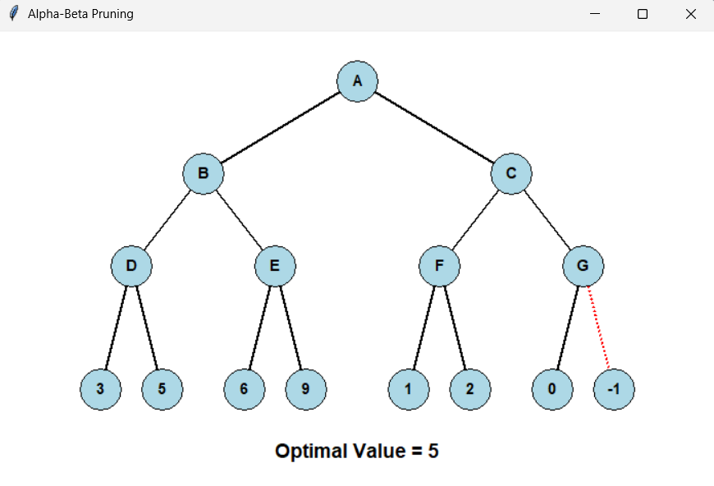
Output:

Result:
The Alpha-Beta Pruning algorithm successfully finds the optimal game value as 6, while reducing unnecessary node evaluations.

