Experiment 12 M. Devarajulu
Aim 192212058
To implement the Tic-Tac-Toe Game using Python

Algorithm
- Create a 3×3 game board initialized with empty spaces.
- Display the board.
- Alternate turns between Player X and Player O.
- Accept the row and column as input from the current player.
- Place the player's symbol if the selected position is empty.
- Check if the player has won by completing a row, column, or diagonal.
- If all cells are filled and there is no winner, declare the game a draw.
- Otherwise, continue until a winner is found.

Program
# Tic-Tac-Toe Game

board = [' ' for i in range(9)]

def print_board():
print()
print(board[0], "|", board[1], "|", board[2])
print("--+---+--")
print(board[3], "|", board[4], "|", board[5])
print("--+---+--")
print(board[6], "|", board[7], "|", board[8])
print()

def check_win(player):
win_positions = [
[0, 1, 2],
[3, 4, 5],
[6, 7, 8],
[0, 3, 6],
[1, 4, 7],
[2, 5, 8],
[0, 4, 8],
[2, 4, 6]
]

for pos in win_positions:
if board[pos[0]] == board[pos[1]] == board[pos[2]] == player:
return True

return False

player = 'X'

for turn in range(9):
print_board()

try:
move = int(input("Player " + player + ", Enter position (1-9): "))

if move < 1 or move > 9:
print("Please enter a position between 1 and 9.")
continue

if board[move - 1] == ' ':
board[move - 1] = player
else:
print("Position already occupied!")
continue

except ValueError:
print("Please enter a valid number.")
continue

if check_win(player):
print_board()
print("Player", player, "Wins!")
break

if player == 'X':
player = 'O'
else:
player = 'X'

else:
print_board()
print("Game Draw!")

Output
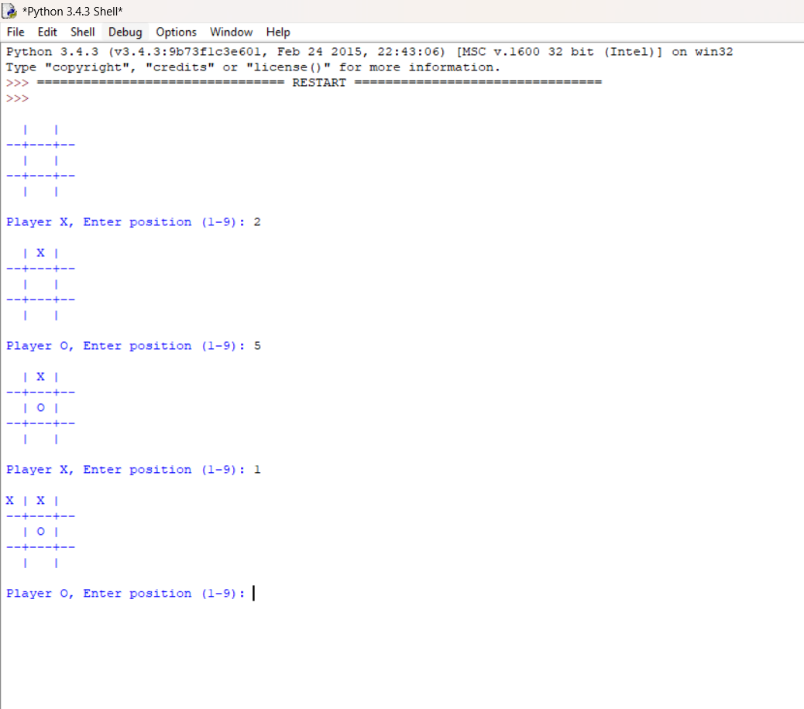

Result
The program successfully implements the Tic-Tac-Toe Game. Two players take turns placing their symbols on the board

