Experiment 13 M. Devarajulu
Aim 192212058
To implement the Minimax Algorithm in Python

Algorithm
- Represent the game as a tree with terminal nodes containing utility values.
- If the current node is a terminal node, return its utility value.
- If it is the maximizing player's turn, choose the maximum value among all child nodes.
- If it is the minimizing player's turn, choose the minimum value among all child nodes.
- Continue recursively until the optimal value is obtained.
- Display the optimal value for the maximizing player.

Program
# Minimax Algorithm

def minimax(depth, isMax):
if depth == 3:
return 0

if isMax:
best = -1000

for i in range(2):
value = minimax(depth + 1, False)

if value > best:
best = value

return best

else:
best = 1000

for i in range(2):
value = minimax(depth + 1, True)

if value < best:
best = value

return best

# Driver Code
print("Best Score:", minimax(0, True))

Output

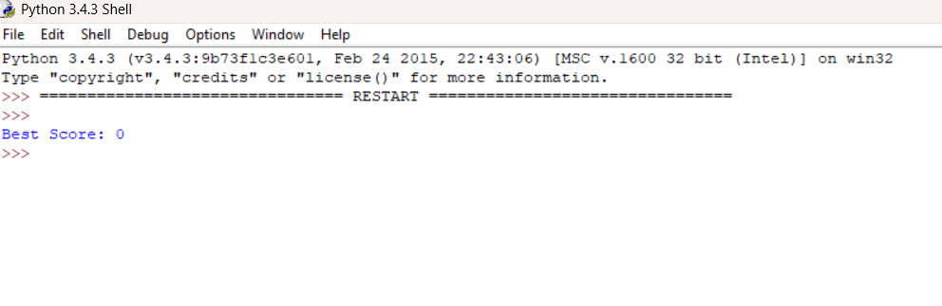

Result
The program successfully implements the Minimax Algorithm.

