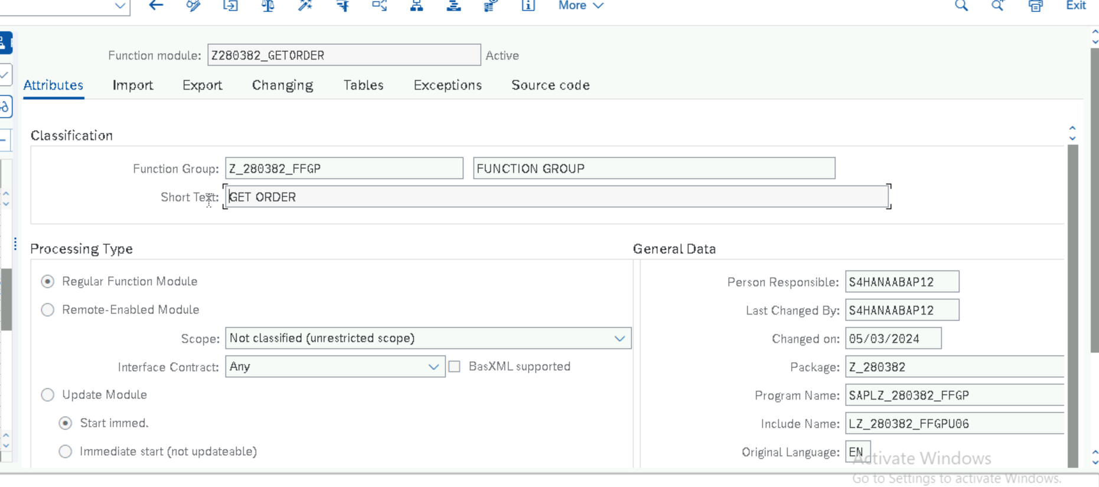

REPORT Z280382_GETORDER NO STANDARD PAGE HEADING.  
DATA : L_TAB TYPE ZLT_GETORDER,  
       LS_TAB TYPE ZGT_GETORDER.  
SELECT-OPTIONS lV_ORNO FOR L_TAB-AUFNR .  
  
CALL FUNCTION 'Z280382_GETORDER'  
  EXPORTING  
    from_order_number       = LV_ORNO-LOW  
    to_order_number         = LV_ORNO-HIGH  
  TABLES  
    gt_tab1                 = LS_TAB.  
          .  
  
 PERFORM WRITE1 .  
  
FORM write1 .  
LOOP AT LS_TAB INTO L_TAB.  
  WRITE : / L_TAB-AUFNR,  
            L_TAB-AUART,  
             L_TAB-AUTYP,  
             L_TAB-WERKS.  
  ENDLOOP.  
  
ENDFORM.