PROJECT: Azure Firewall Centralised Egress Filtering
Submitted by:
Name: R. Akhilesh
Roll No: 2400032599
Branch: CSE-1
University: KL University
Abstract
The Azure Firewall Centralised Egress Filtering project is designed to control and secure outbound network traffic from resources deployed in Microsoft Azure. The main objective is to route all outbound traffic through a central Azure Firewall, allowing the organization to monitor, filter, and control communication between internal workloads and the public Internet.
The project uses Azure Firewall as a centralized security layer for inspecting outbound traffic. User-Defined Routes (UDRs) are configured to direct traffic from private subnets through the firewall before it reaches external destinations. This ensures that outbound communication follows a controlled and monitored network path.
An FQDN allowlist is implemented to restrict outbound access to only approved domain names. This helps prevent workloads from accessing unauthorized or unnecessary external websites and services. Firewall policies and application/network rules are used to define which traffic is permitted or denied.
The project also considers important operational challenges. Incorrect configuration of User-Defined Routes can cause connectivity problems or a complete network outage, so routing must be carefully planned and tested. In addition, Azure Firewall has a significant baseline cost even when traffic volume is low, making cost considerations important when designing the solution.
Overall, the project provides a centralized approach to outbound traffic control, domain-based filtering, network security, monitoring, and controlled Internet access for Azure workloads.

2. Project Architecture Diagram
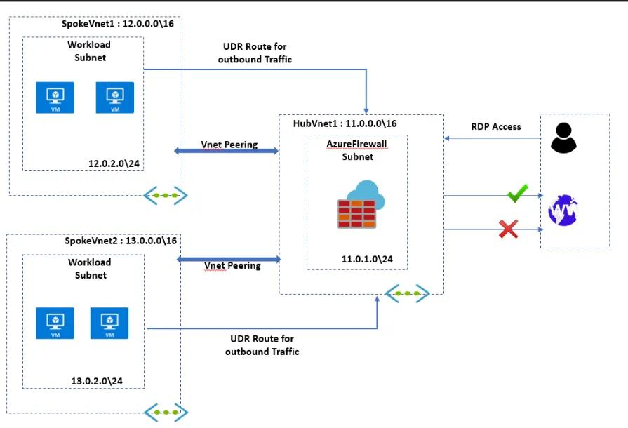
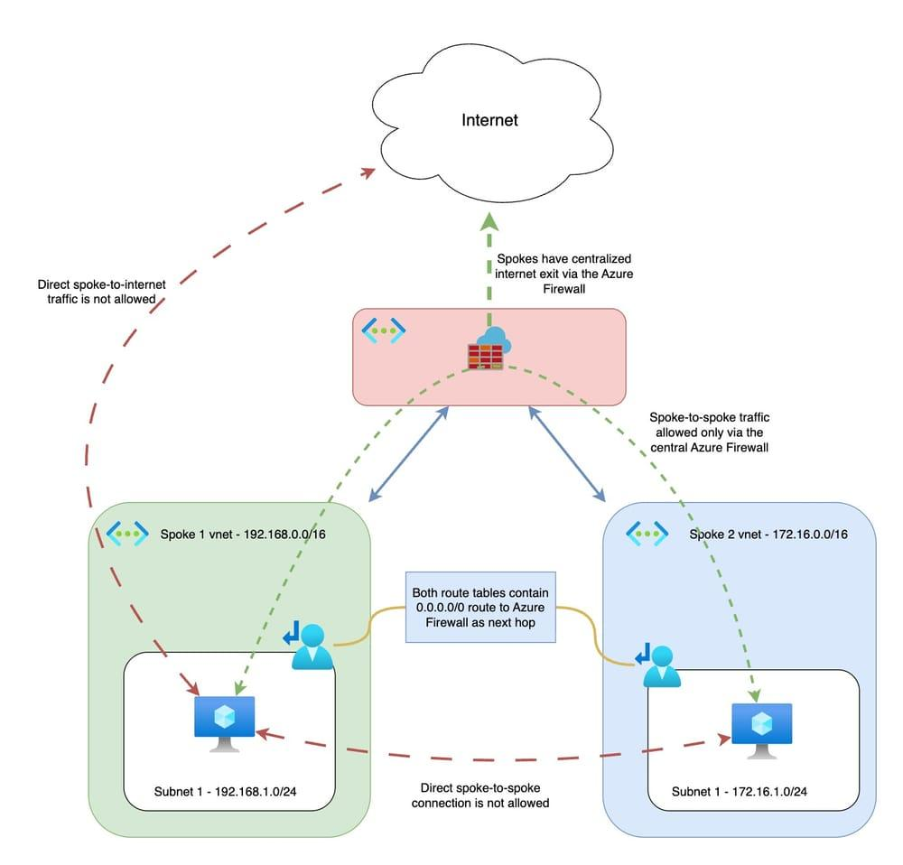
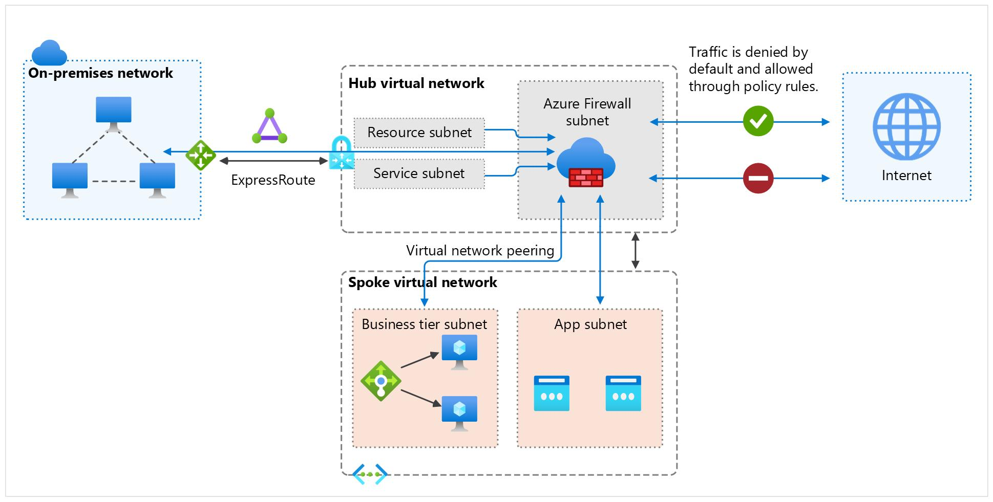
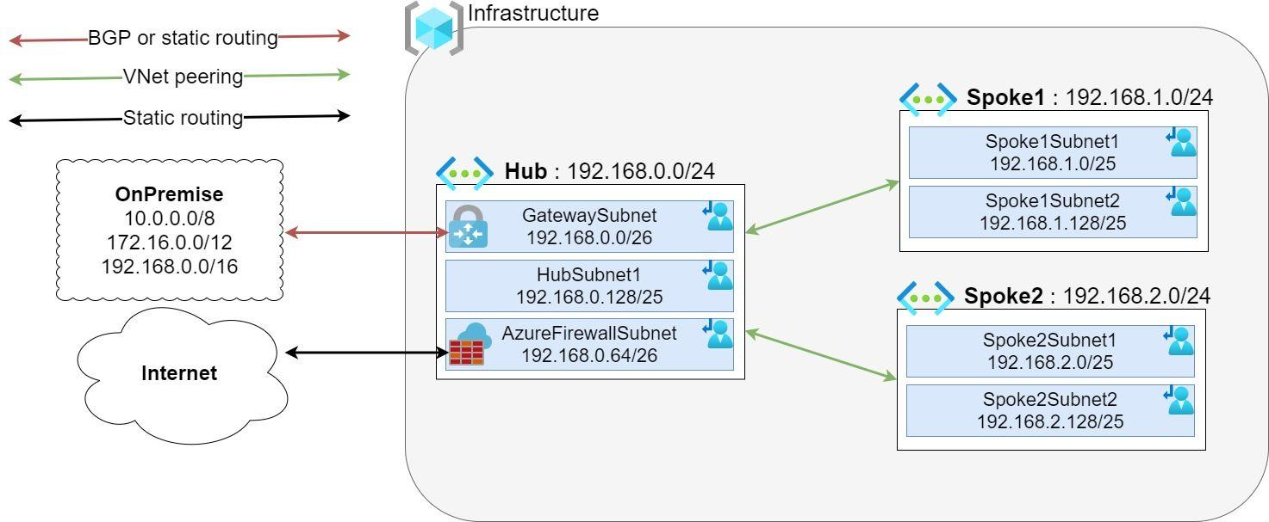
Architecture Explanation
1. Application / Virtual Machines
The application servers and Virtual Machines are deployed inside private Azure subnets. Their outbound Internet traffic needs to be controlled before reaching external destinations.
2. User-Defined Route (UDR)
A User-Defined Route is configured to direct outbound traffic from the private subnet toward the Azure Firewall. This makes the firewall the central path for Internet-bound traffic.
3. Azure Firewall
Azure Firewall acts as the central security component. It examines outbound traffic and applies the configured firewall rules and policies before allowing or blocking the connection.
4. Firewall Policy
Firewall policies define the rules that determine which network and application traffic is permitted or denied.
5. FQDN Allowlist
The FQDN allowlist contains approved domain names that workloads are allowed to access. Requests to destinations outside the allowed list can be blocked according to the configured policy.
6. Internet
Traffic that satisfies the configured firewall rules is allowed to proceed to the Internet. Unauthorized traffic is blocked by the firewall.
7. Monitoring and Logs
Firewall logs can be used to monitor traffic, investigate blocked requests, and understand firewall rule decisions.
8. Cost Consideration
Azure Firewall has a baseline operating cost in addition to traffic-related costs. Therefore, the architecture should consider expected traffic volume and whether the centralized firewall deployment is economically appropriate.

3. Services / Technologies Required
Service / Technology | Purpose
Microsoft Azure | Cloud platform for deploying the network infrastructure
Azure Firewall | Centralized inspection and filtering of outbound traffic
Azure Virtual Network (VNet) | Provides the private network environment
Azure Subnets | Separates workloads and controls network traffic paths
User-Defined Routes (UDR) | Routes outbound traffic through Azure Firewall
Route Tables | Stores and applies custom routing rules
Firewall Policy | Defines network and application traffic rules
FQDN Filtering / Application Rules | Controls access to approved domain names
Network Rules | Controls traffic based on IP addresses, ports, and protocols
Azure Monitor | Provides monitoring and analysis of network activity
Azure Firewall Logs | Records firewall traffic and rule decisions
Log Analytics Workspace | Stores and queries monitoring and firewall logs
Azure Portal | Used to configure and manage Azure resources
Technologies Used
- Cloud Platform: Microsoft Azure
- Network: Azure Virtual Network and Subnets
- Firewall: Azure Firewall
- Routing: User-Defined Routes and Route Tables
- Traffic Filtering: Firewall Policies and FQDN Filtering
- Monitoring: Azure Monitor
- Logging: Log Analytics
- Management: Azure Portal

4. Simple Project Flow
Application/VM → Private Subnet → User-Defined Route → Azure Firewall → Firewall Policy & FQDN Allowlist → Internet
Example
Suppose an application needs to access:
approved-example.com
The traffic leaves the private subnet and is routed through the Azure Firewall. The firewall checks the configured rules and FQDN allowlist. If the destination is approved, the traffic is allowed to reach the Internet.
If the application attempts to access an unauthorized domain, the firewall can block the request according to the configured policy.
Bottlenecks Addressed
UDR Misconfiguration:
Incorrect User-Defined Routes can redirect traffic incorrectly and potentially cause a total connectivity outage. Therefore, routes should be configured carefully and tested before applying them to production workloads.
Firewall Cost:
Azure Firewall introduces a baseline cost even when traffic is low. The project should therefore consider the expected traffic volume and resource requirements when evaluating the deployment.

