AZURE FIREWALL
CENTRALISED EGRESS FILTERING
Project Report

Project Number | P021
Subject / Course Code | 24CC3046 - Network Security
Team Number | T225
Guide | Dr P. Lakshmi

Implementation evidence is based on the supplied Azure Portal screenshots and the completed project setup.

1. Team Details
The project is identified as 24CC3046-P021 under Network Security. The project scenario covers three participating teams (T021, T123 and T225). The implementation described in this report is the T225 deployment and validation setup.
S.No. | Student Name | Student ID | Primary Contribution
1 | Maddukuri Hema | 2400033171 | Azure networking and workload VM setup
2 | Yanamadala Aditya Swaroop | 2400032999 | Azure Firewall and FQDN policy configuration
3 | Rachapudi Akhilesh | 2400032599 | UDR/routing, testing and documentation

2. Project Overview
Azure Firewall Centralised Egress Filtering is a network-security project that controls outbound traffic from Azure workloads. The main design places one Azure Firewall as a central security checkpoint and uses a User Defined Route (UDR) to direct internet-bound traffic to that firewall.

Use Cases
- Route all outbound traffic through one firewall.
- Enforce an FQDN allowlist.

Bottlenecks / Challenges
- User-defined route misconfiguration can cause total outbound connectivity loss.
- Azure Firewall introduces significant cost even when traffic volume is low.
- Subnet, routing and firewall policy settings must work together correctly.

3. Key Concepts
Term | Meaning | Role in this project
Egress | Outgoing network traffic leaving a workload toward an external network or the Internet. | The traffic we want to control.
Azure Firewall | Centralized Azure security service used to inspect and enforce traffic rules. | Acts as the common egress security checkpoint.
VNet | Azure Virtual Network. | Provides the private network containing the firewall and workload subnet.
Subnet | A smaller address range inside a VNet. | Separates firewall and workload resources.
UDR | User Defined Route; a manually defined route. | Sends Internet-bound traffic toward the firewall.
FQDN | Fully Qualified Domain Name, e.g. www.google.com. | Identifies approved Internet destinations.
FQDN Allowlist | A list of approved domain names. | Restricts which external destinations the workload can access.
HTTPS:443 | Secure web traffic on TCP port 443. | Protocol used in the application rule tests.

4. Architecture and Traffic Flow
The working architecture is a centralized egress design. A workload VM is placed in Workload-SN. The subnet is associated with Egress-RouteTable, whose default route points to the Azure Firewall private IP 10.0.0.4. The firewall uses Egress-FW-Policy to evaluate the destination FQDN.
TEAM / WORKLOAD VM
|
v
WORKLOAD-SN (10.0.2.0/24)
|
v
EGRESS-ROUTETABLE
0.0.0.0/0 -> 10.0.0.4
|
v
AZURE FIREWALL (10.0.0.4)
|
v
FQDN APPLICATION RULE
|
+--> APPROVED DOMAIN -> ALLOW -> INTERNET
|
+--> UNAPPROVED DOMAIN -> DENY / HTTPS FAILURE

5. Azure Resources Created
Resource | Configured Value | Purpose
Resource Group | RG-Egress-Filtering | Holds all project resources.
VNet | Egress-VNet - 10.0.0.0/16 | Private Azure network.
Firewall subnet | AzureFirewallSubnet - 10.0.0.0/26 | Hosts the Azure Firewall.
Management subnet | AzureFirewallManagementSubnet - 10.0.1.0/26 | Firewall management network.
Workload subnet | Workload-SN - 10.0.2.0/24 | Hosts the test VM / team workloads.
Azure Firewall | Egress-FW - private IP 10.0.0.4 | Centralized egress inspection point.
Firewall Policy | Egress-FW-Policy | Contains application/FQDN rules.
Route Table | Egress-RouteTable | Contains the default UDR to the firewall.
Test VM | Egress-Test-VM - private IP 10.0.2.4 | Generates outbound test traffic.

6. Implementation Procedure
The following procedure records the implementation sequence used for the T225 project. Values below match the supplied evidence screenshots and the completed Azure setup.

6.1 Create the Resource Group
Create the Azure resource group RG-Egress-Filtering in Central India. All project resources were placed in this resource group.
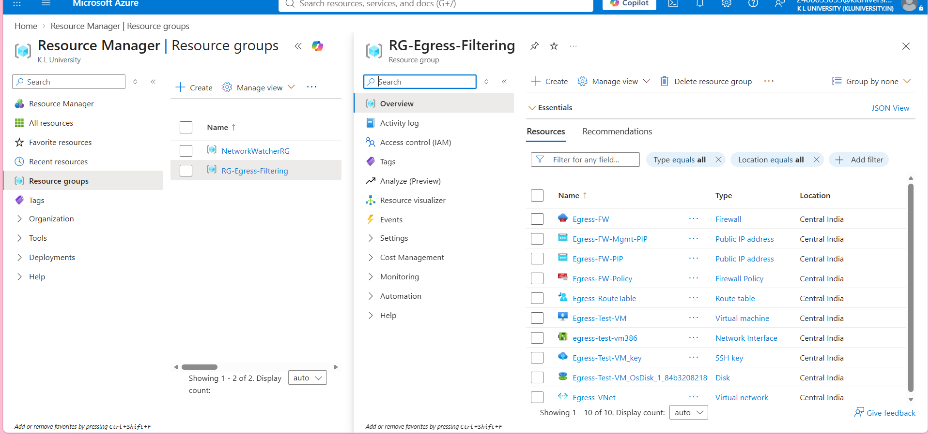
Figure 1. Resource group containing the project resources.

6.2 Create the Virtual Network and Subnets
Create Egress-VNet with address space 10.0.0.0/16. Create the three required subnets: AzureFirewallSubnet, AzureFirewallManagementSubnet and Workload-SN.
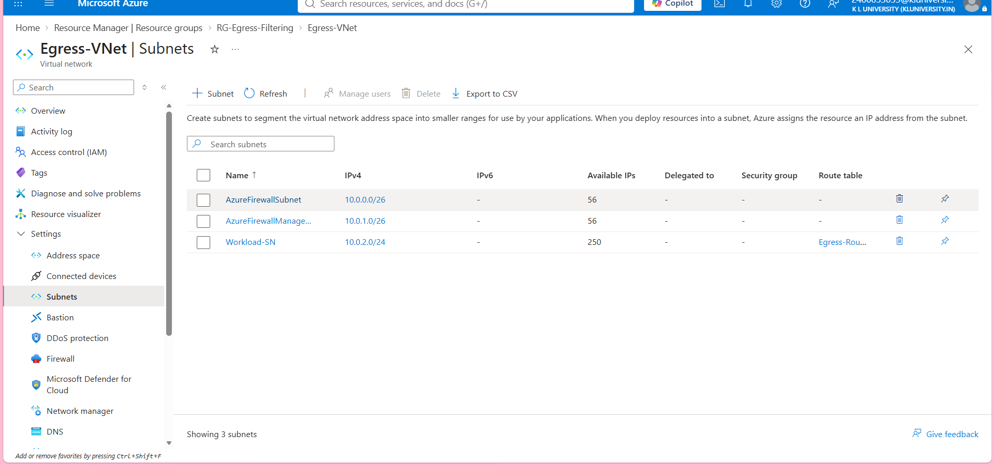
Figure 2. Egress-VNet with the three subnets.
The firewall subnet and management subnet are dedicated to the firewall, while Workload-SN is the subnet used by the test workload.
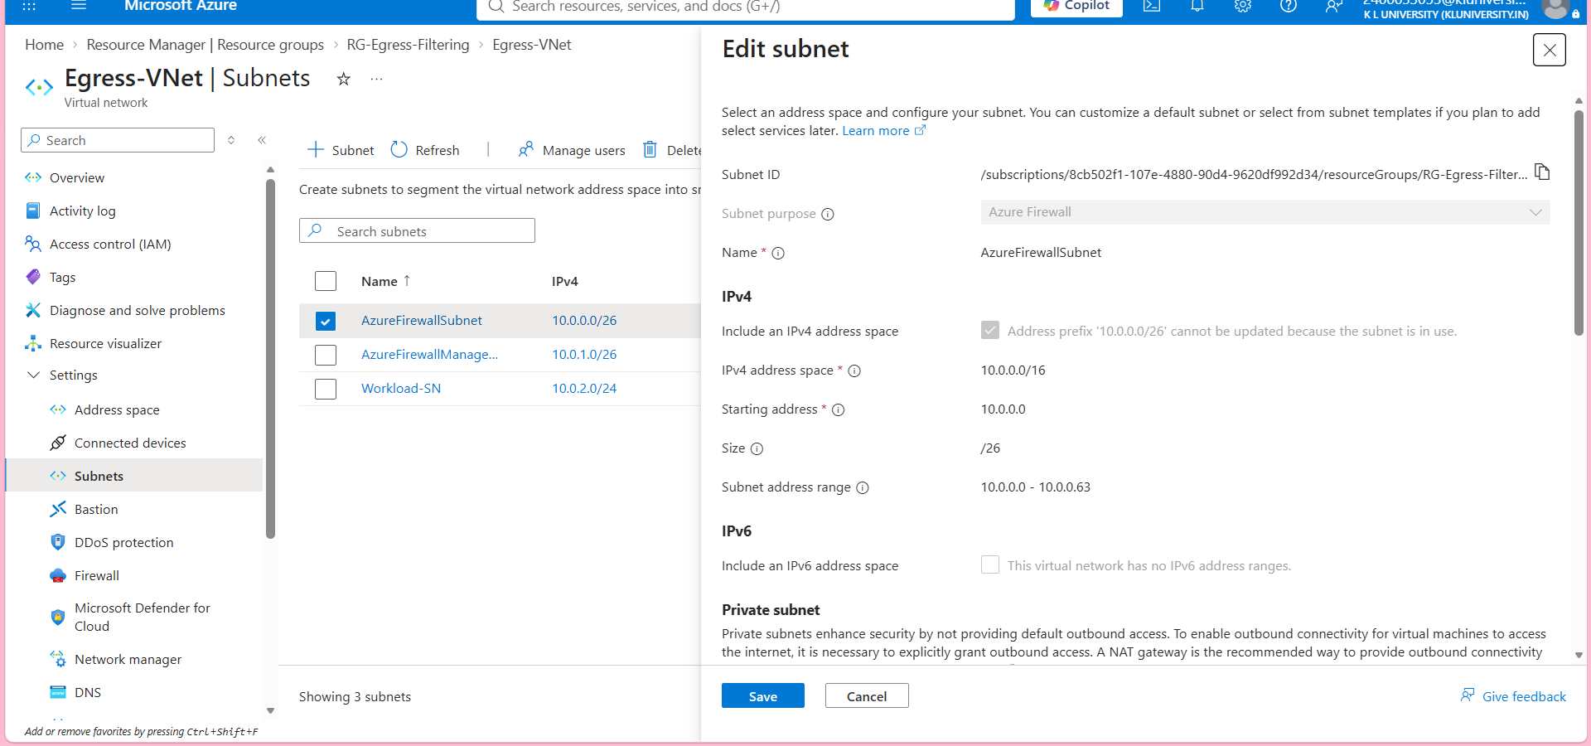
Figure 3. Detailed subnet configuration for the firewall subnet.

6.3 Deploy Azure Firewall
Deploy Egress-FW in Central India using the Basic SKU and attach Egress-FW-Policy. The firewall is placed in AzureFirewallSubnet and receives the private IP 10.0.0.4.
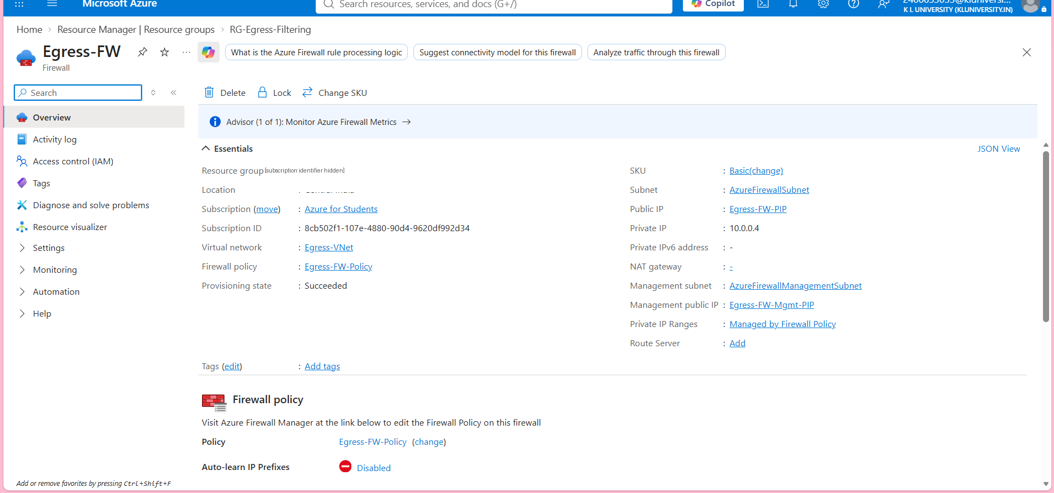
Figure 4. Azure Firewall overview showing the VNet, firewall subnet, policy and private IP.

6.4 Create and Configure the Route Table
Create Egress-RouteTable and add a default route for Internet-bound traffic. The destination is 0.0.0.0/0 and the next hop is the Azure Firewall private IP 10.0.0.4.
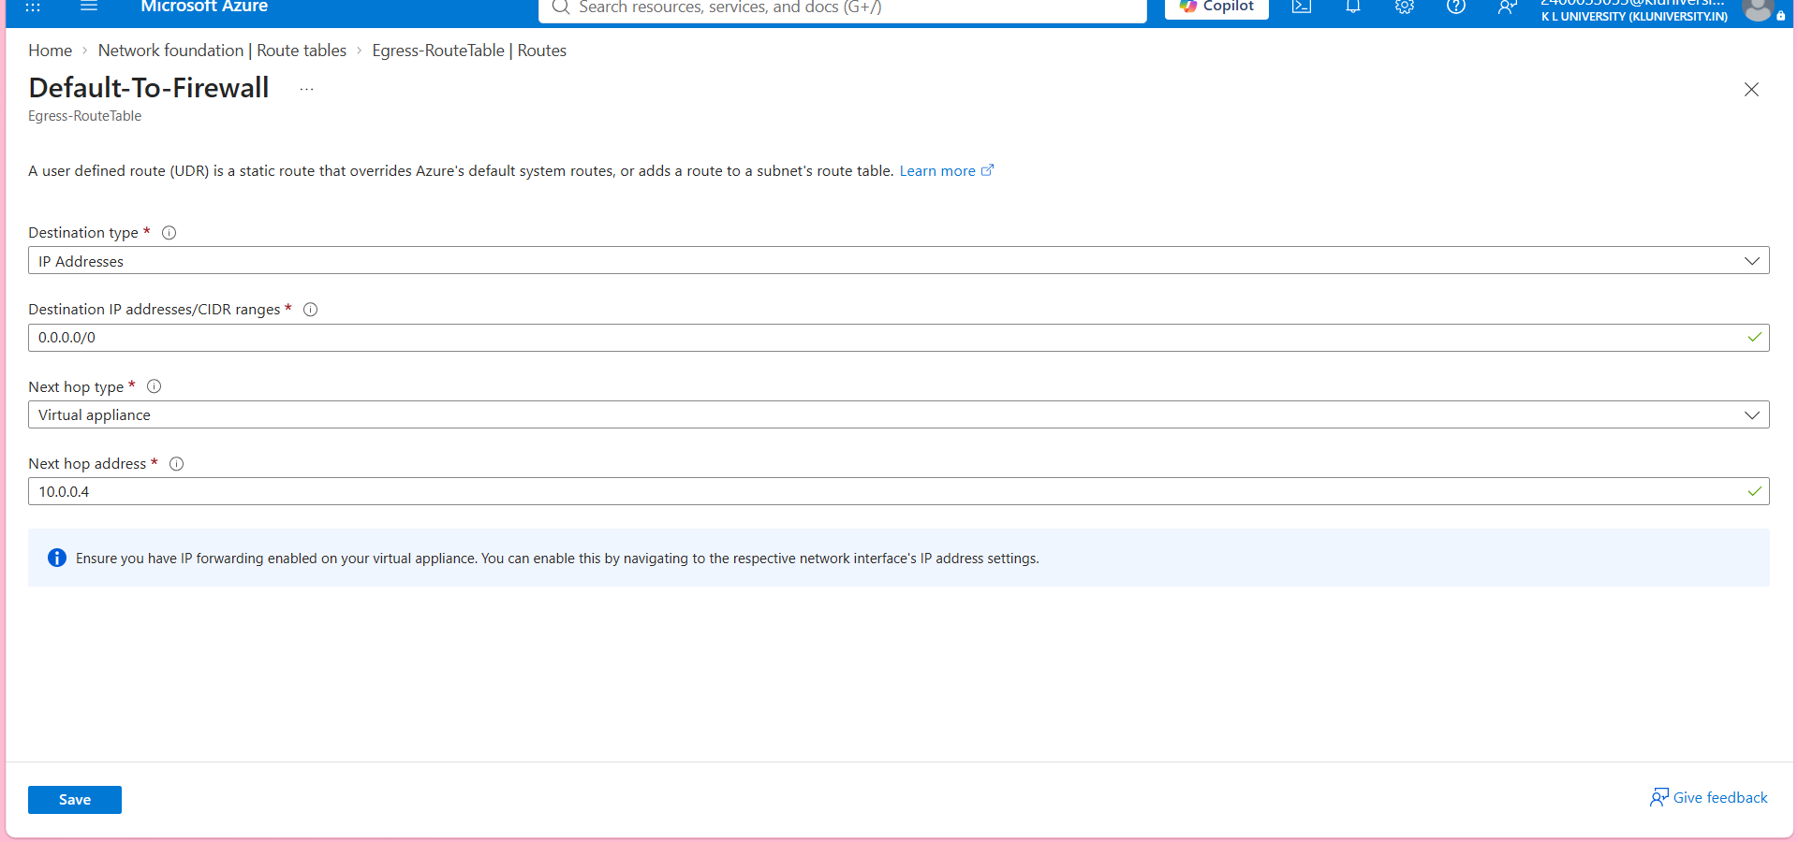
Figure 5. Default route: 0.0.0.0/0 -> Virtual appliance -> 10.0.0.4.

6.5 Associate the Route Table with Workload-SN
Associate Egress-RouteTable with Workload-SN. This is the step that applies the default route to the workload subnet.
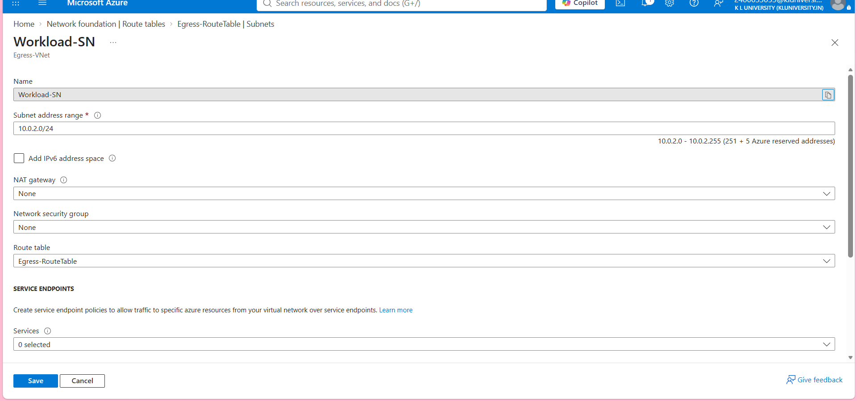
Figure 6. Egress-RouteTable associated with Workload-SN.

6.6 Create the FQDN Allowlist
In Egress-FW-Policy, create an Application rule collection named Allow-Approved-Websites. For the tested workload, the rule uses source 10.0.2.0/24, HTTPS:443 and approved FQDNs. The supplied evidence includes www.google.com and newerp.kluniversity.in as allowed destinations.
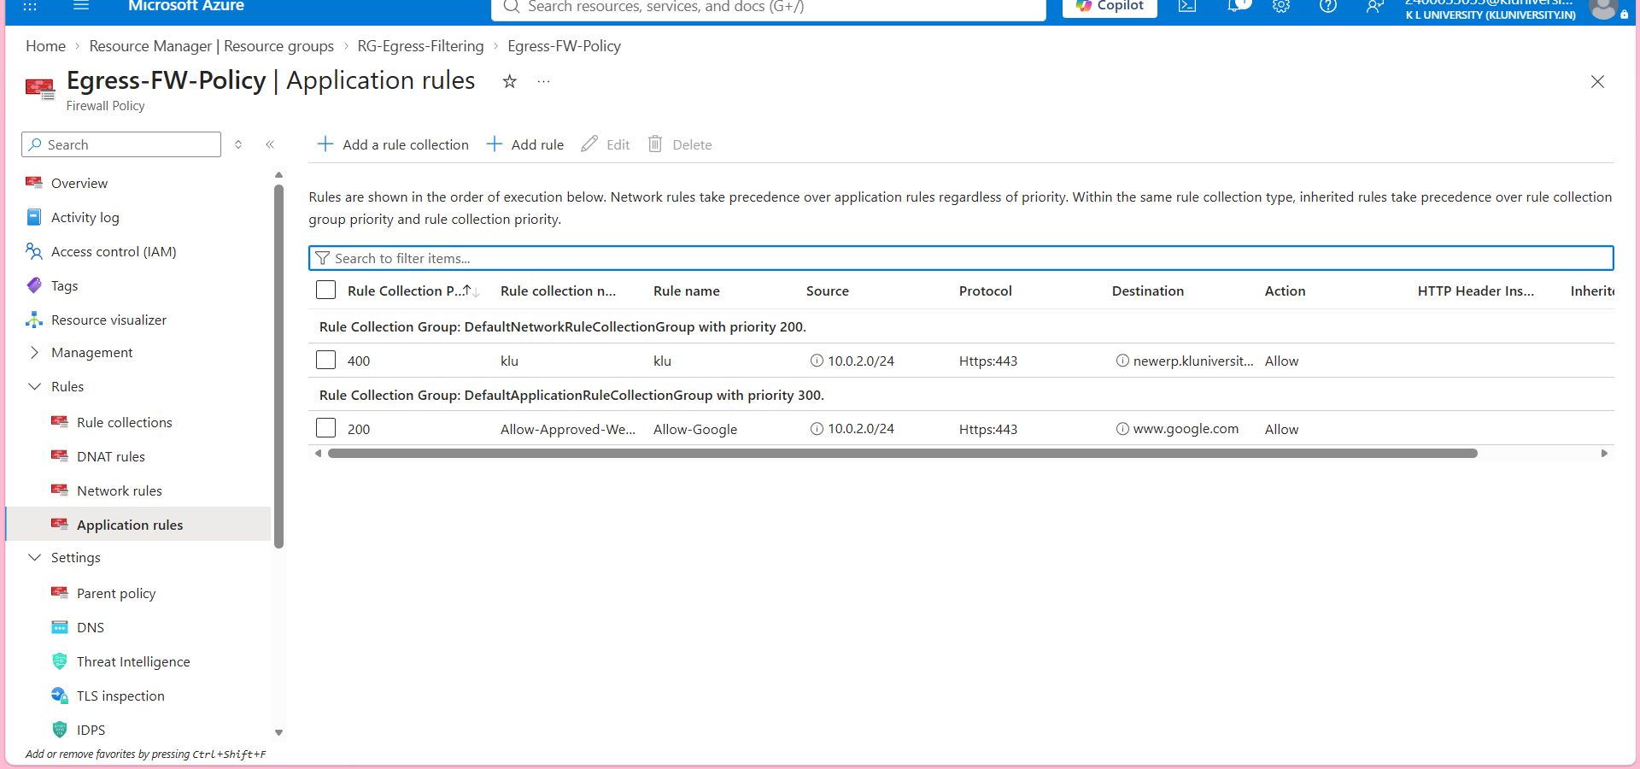
Figure 7. Application rules showing the approved FQDN destinations.

6.7 Create the Test VM
Create Egress-Test-VM in Workload-SN. The validation VM uses private IP 10.0.2.4 and has no public IP. It generates outbound HTTPS traffic for validation.

6.8 Generate and Validate Outbound Traffic
Use Azure Run Command on the VM to execute curl requests. This avoids needing inbound SSH access and directly tests the workload from inside the Azure network.

7. Testing and Validation

7.1 Approved FQDN Test
curl -Iv --max-time 15 https://www.google.com
The supplied output returned HTTP/2 200. This shows that the approved FQDN could be reached successfully from the workload VM.
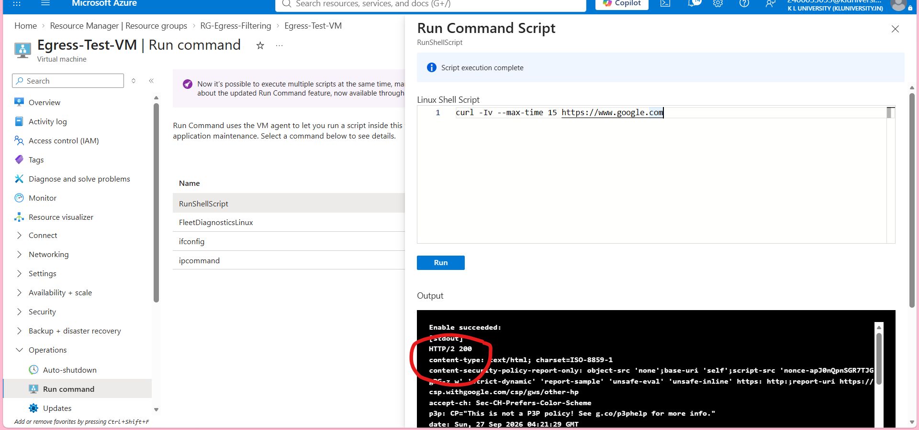
Figure 8. Run Command output for the approved FQDN test showing HTTP/2 200.

7.2 Unapproved FQDN Test
curl -Iv --max-time 15 https://www.microsoft.com
The supplied output shows that www.microsoft.com was resolved and a TCP connection to port 443 was established, but the TLS session failed with SSL_ERROR_SYSCALL and curl error 35. The HTTPS request therefore did not complete successfully.
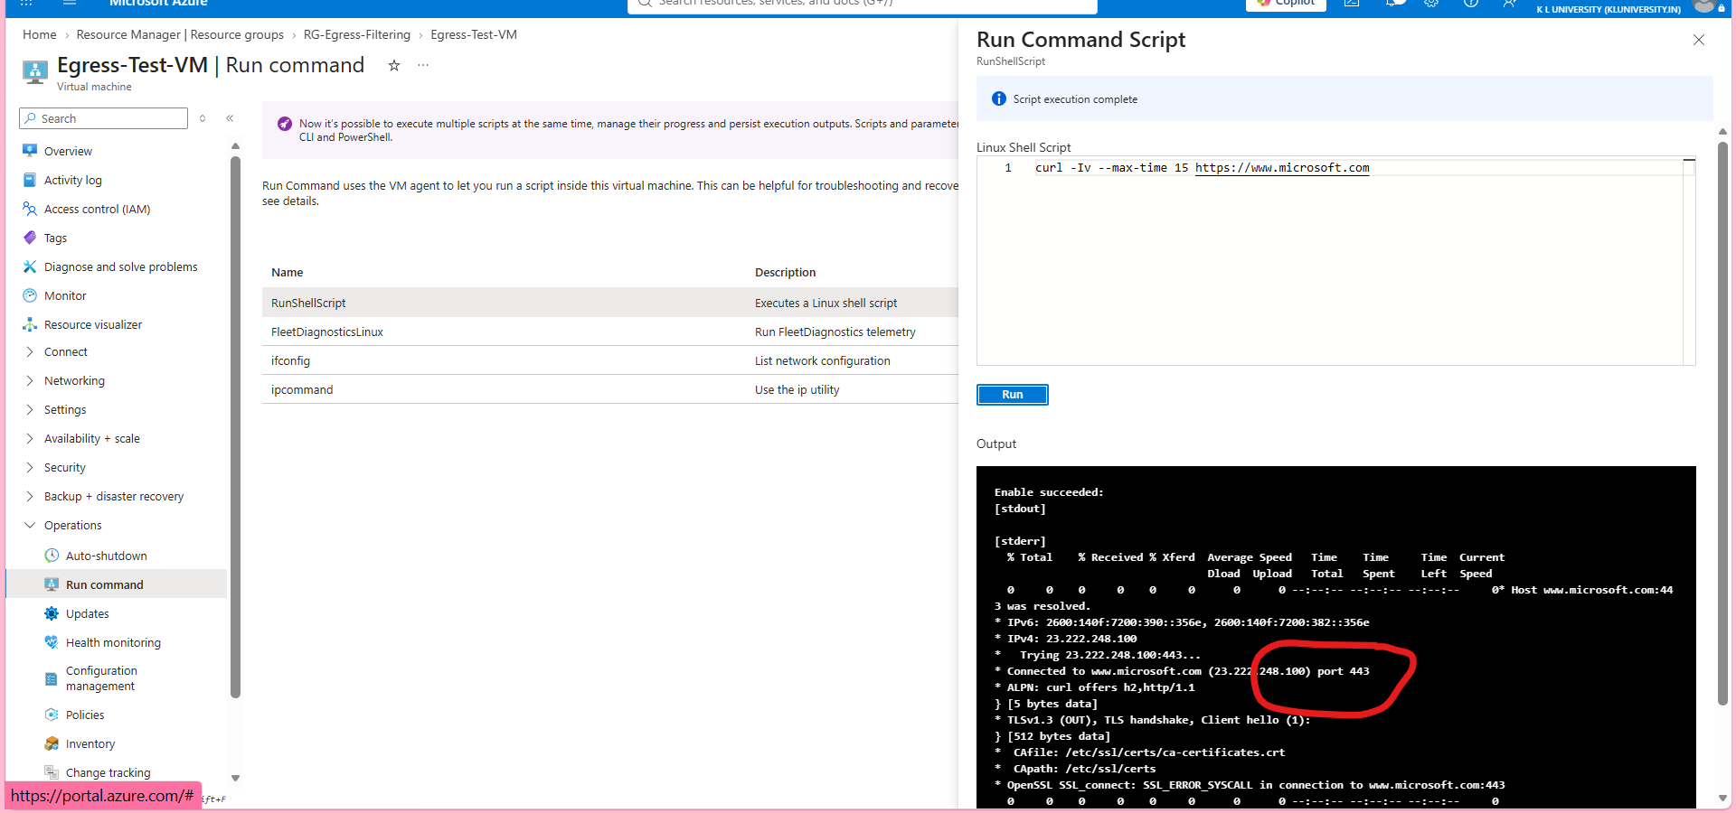
Figure 9. Run Command output for the unapproved FQDN test showing the TLS failure.

7.3 Validation Summary
Test | Configured State | Observed Result | Interpretation
www.google.com | Approved FQDN | HTTP/2 200 | Approved destination is reachable.
www.microsoft.com | Not in allowlist | TLS handshake failed; curl error 35 | Unapproved HTTPS request did not complete successfully.

For a production-grade audit trail, the final evidence can also include Azure Firewall application-rule logs showing the decision. The current report focuses on the requested portal configuration and Run Command evidence.

8. End-to-End Procedure Summary
Step | Action | Outcome
1 | Create RG-Egress-Filtering | Project resource container created.
2 | Create Egress-VNet and three subnets | Network foundation created.
3 | Deploy Egress-FW and Egress-FW-Policy | Central firewall security layer created.
4 | Create Egress-RouteTable | Routing control created.
5 | Add 0.0.0.0/0 -> 10.0.0.4 | Internet traffic directed to firewall.
6 | Associate route table with Workload-SN | UDR applied to workload traffic.
7 | Configure FQDN application rules | Approved destinations defined.
8 | Create Egress-Test-VM | Test workload created.
9 | Run curl tests | Allowed and unapproved behavior validated.

9. Individual Contributions
The team divided the work into three connected areas so that networking, security policy and validation could be implemented and reviewed separately.

Maddukuri Hema - Azure Network and VM Setup
Worked on the Azure foundation: resource group, Virtual Network, firewall-related subnets and the workload VM. This part creates the network and the source of outbound traffic.

Yanamadala Aditya Swaroop - Firewall and FQDN Security
Worked on Azure Firewall deployment, Firewall Policy configuration and application rules. This part defines which external FQDN destinations are approved.

Rachapudi Akhilesh - Routing, Testing and Documentation
Worked on the User Defined Route, route-table association, outbound validation using Run Command, interpretation of test results and documentation of the final implementation.

10. Bottlenecks and Precautions

UDR Misconfiguration
An incorrect destination, next-hop type or next-hop IP can interrupt outbound connectivity. The critical route in this project is 0.0.0.0/0 with the Azure Firewall private IP 10.0.0.4 as the virtual-appliance next hop.

Firewall Cost
Azure Firewall is a billable resource and can create significant cost even at low traffic volumes. For a student demonstration, resources should be used only for the required testing window and then deallocated or removed when no longer needed.

Configuration Dependency
The VNet, subnets, route table, firewall and policy must agree with each other. A change in one part can affect the complete traffic path.

DNS / Connectivity Troubleshooting
The test environment initially experienced DNS-resolution issues when external custom DNS servers were configured on the VM NIC. The final test used the VNet-inherited Azure DNS configuration so the workload could resolve and reach the approved FQDN.

11. Reviewer Demonstration Flow
For a short live demonstration, show the following sequence in Azure Portal:
- Egress-FW overview - confirm the firewall and private IP 10.0.0.4.
- Egress-RouteTable -> Routes - show 0.0.0.0/0 pointing to 10.0.0.4.
- Egress-FW-Policy -> Application rules - show the approved FQDN rule for www.google.com.
- Egress-Test-VM -> Run Command - run the approved and unapproved curl tests.
curl -Iv --max-time 15 https://www.google.com
# Approved destination -> HTTP/2 200
curl -Iv --max-time 15 https://www.microsoft.com
# Unapproved destination -> HTTPS/TLS request does not complete
The explanation to the reviewer can be summarized as: “The workload subnet uses a default route to the centralized Azure Firewall. The Firewall Policy contains an FQDN allowlist. The approved domain returns a successful HTTP response, while the unapproved HTTPS request does not complete.”

12. Conclusion
The T225 implementation demonstrates a centralized egress-security pattern in Azure. Internet-bound traffic from the workload subnet is directed through one Azure Firewall using a User Defined Route, and outbound HTTPS destinations are controlled through FQDN application rules. The supplied validation evidence shows successful access to an approved FQDN and an unsuccessful HTTPS request to an unapproved FQDN.

Appendix A - Evidence File List
File | Evidence
01-resource-group.png | Project resource group and deployed Azure resources.
02-vnet-subnets.png | VNet and three subnet configuration.
02-vnet-subnets-detail.png | Detailed firewall subnet configuration.
03-azure-firewall.png | Azure Firewall overview and private IP 10.0.0.4.
04-route-table.png | Default route 0.0.0.0/0 to 10.0.0.4.
05-route-association.png | Route table association with Workload-SN.
06-fqdn-allowlist.png | FQDN application rules for approved destinations.
07-google-allowed.png | Approved-domain test with HTTP/2 200.
08-microsoft-unapproved.png | Unapproved-domain test showing HTTPS/TLS failure.

