LumiTrack – Museum Exposure Limiter

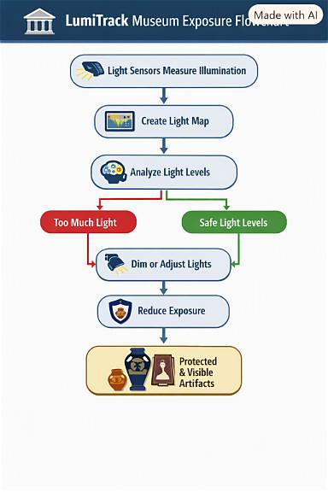

1. Light falls on the LDR sensor
2. STM32 reads the sensor voltage using ADC
3. Servo rotates the sensor to different angles
4. Computer stores readings and creates a light map
5. ML estimates exposure risk and recommends an action
6. System checks safety and reports the result

4. Embedded System Design and IoT syllabus
CO | Simple explanation | Project application
CO-1 | STM32 architecture and programming | Configure and program the controller.
CO-2 | PWM and motor control | Move the servo using PWM signals.
CO-3 | Sensors, ADC and fault detection | Measure light and check sensor readings.
CO-4 | CAN communication | Optional extension for sending commands and sensor data over CAN.
CO-5 | PID and feedback control | Useful if implementing an external closed-loop controller.
CO-6 | Complete servo-control system | Integrate hardware, firmware, communication and feedback.

5. Machine Learning syllabus
Module | Simple explanation | Project application
M1: ML lifecycle | Prepare data and build a model | Collect and organise light readings.
M2: Linear models | Predict using mathematical models | Classify acceptable versus excessive exposure using logistic regression.
M3: Tree models | Make decisions using rules learned from data | Use a decision tree or random forest to estimate exposure risk.
M4: Unsupervised learning | Find patterns in data | Group lighting conditions or identify unusual readings.
M5: Evaluation | Check model performance | Use precision, recall, F1-score and a confusion matrix.
M6: ML engineering | Deploy and monitor a model | Connect the trained model to the Python application.

6. Software and tools
- STM32CubeIDE: Write and debug embedded C code.
- STM32CubeMX: Configure the STM32 peripherals and clocks.
- Python: Process data and run the ML model.
- Pandas: Organise and clean the dataset.
- Scikit-learn: Train and evaluate ML models.
- Matplotlib: Draw graphs of light intensity and exposure.
- USB serial interface: Transfer scan data between the STM32 and computer.

7. How do you evaluate the project?

Test | What it tells you
Sensor test | Is the light reading reliable?
Servo test | Does it reach the correct angle?
Light-map test | Does the scan show light changes correctly?
Exposure test | Does the estimated exposure remain within the specified limit?
ML test | Does the model correctly identify risky conditions?
Safety test | Does the system respond safely to faults?
Final test | Does it work with a new lighting arrangement?

9. Recommended implementation order
- Connect the LDR and read its voltage.
- Control the servo at approved angles.
- Combine sensor readings and servo movement.
- Save readings in a CSV dataset.
- Calculate cumulative exposure using calibrated measurements.
- Build a simple threshold-based baseline.
- Train a logistic regression or decision tree model.
- Compare model results with the baseline.
- Test the complete system under different lighting conditions.
- Prepare graphs, results, a report and a demonstration video.

