“REAL TIME RESEARCH PROJECT”
A report submitted in partial fulfillment of the Academic requirements for the award of the degree of
Bachelor of Technology

P. Narendra – 23H51A05A9
M. Abhilash Reddy – 23H51A05DF
R. Jeevan Kumar – 24H55A0538

UNDER THE COURSE
REAL TIME RESEARCH PROJECT



CMR COLLEGE OF ENGINEERING & TECHNOLOGY
(Autonomous)
(NAAC Accredited with ‘A⁺’ Grade & NBA Accredited)
(Approved by AICTE, Permanently Affiliated to JNTU Hyderabad)
KANDLAKOYA, MEDCHAL ROAD, HYDERABAD-501401
2024-25
CMR COLLEGE OF ENGINEERING & TECHNOLOGY
(Autonomous)
(NAAC Accredited with ‘A⁺’ Grade & NBA Accredited)
(Approved by AICTE, Permanently Affiliated to JNTU Hyderabad)
KANDLAKOYA, MEDCHAL ROAD, HYDERABAD-501401
2024 - 2025



CERTIFICATE
This is to certify that the report entitled ““REAL TIME RESEARCH PROJECT” is a bonafide work done by
In partial fulfillment of the requirement for completion of the ““REAL TIME RESEARCH PROJECT” of II-B.Tech II- Semester is a record of a bonafide work carried out under guidance and supervision.

P. Narendra – 23H51A05A9
M. Abhilash Reddy – 23H51A05DF
R. Jeevan Kumar – 24H55A0538

Signature of Faculty Signature of HOD
DECLARATION

We are obliged and grateful to thank, CMRCET, for his cooperation in all respects during the course.
We would like to thank the Principal of CMRCET, Major.Dr.V.A. Narayana, for his support in the course of this project work. Finally, we thank all our faculty members and Lab Programmer for their valid support.

We own all our success to our beloved parents, whose vision, love and inspiration has made us reach out for these glories.

P. Narendra – 23H51A05A9
M. Abhilash Reddy – 23H51A05DF
R. Jeevan Kumar – 24H55A0538

TABLE OF CONTENTS

SI.No. | CONTENTS | PAGE.NO
1. | Abstract | 5
2. | Introduction | 6
3. | Proposed System | 7
4. | Architecture | 8
5. | Source code | 9
6. | Results and Discussion | 15
7. | Future Enhancement | 17
8. | Reference | 18
9. | Conclusion | 19

CHAPTER-1
ABSTRACT
This project demonstrates how machine learning can be applied to predict the number of calories a person burns during a workout. By utilizing various biological attributes and Python-based tools like Pandas, NumPy, Scikit-learn, and XGBoost, this model identifies significant features influencing calorie expenditure. After preprocessing and visualizing the data, models like Linear Regression, Lasso, Ridge, Random Forest, and XGBRegressor were evaluated. Random Forest and XGBRegressor showed the best performance using Mean Absolute Error (MAE) as the evaluation metric.

CHAPTER-2
INTRODUCTION
In today’s fitness-driven world, monitoring calorie expenditure has become a key component of personal health and wellness. Traditional methods of tracking calorie burn are often manual, time-consuming, and prone to estimation errors. These methods usually require detailed workout logs or expensive wearable devices, which may still not offer personalized accuracy.
This project presents a machine learning-based approach to automate and enhance the accuracy of calorie burn prediction. By leveraging biological features such as age, gender, height, and body temperature, we aim to build a predictive system that estimates calories burnt during workout sessions. This approach eliminates the dependency on external tools by using data that can be easily collected.
The objective is to develop a reliable, scalable, and accurate model using Python libraries such as Pandas, NumPy, Scikit-learn, and XGBoost. The model can be integrated into health monitoring systems or mobile applications, offering real-time and personalized feedback to users based on their physical profiles. This aligns with modern advancements in AI-driven healthcare technologies and promotes more accessible fitness insights.

CHAPTER-3
PROPOSED SYSTEM

To develop an efficient and accurate calorie burn prediction system, the proposed model follows a structured approach combining data science and machine learning techniques. The key components of the system are as follows:
- Data Acquisition and Merging: Two datasets—calories.csv and exercise.csv—are collected and merged on a common key, User_ID, to form a comprehensive dataset that includes both biometric and activity-related features.
- Preprocessing and Cleaning: Data is cleaned by handling null values, encoding categorical variables (like gender), and standardizing numerical features to ensure uniformity and scalability for training.
- Exploratory Data Analysis (EDA): Statistical summaries and visualizations, including scatter plots and heatmaps, are generated to understand the distribution of data and identify correlations between input features and the target variable, Calories.
- Feature Selection and Engineering: Highly correlated features such as Weight and Duration are removed to prevent data leakage and ensure the model generalizes well to unseen data. This step is essential to improve model robustness.
- Model Training: Multiple regression algorithms are used to train the model, including Linear Regression, Lasso, Ridge, Random Forest Regressor, and XGBoost Regressor. Each model is trained on the processed training data.
- Model Evaluation: Models are evaluated using the Mean Absolute Error (MAE) metric on both training and validation sets to determine prediction accuracy. The best-performing models are selected for further analysis.
- Prediction and Analysis: The system can now predict the calories burnt for new user data inputs, helping users monitor their fitness metrics effectively.

CHAPTER-4
SYSTEM ARCHITECTURE

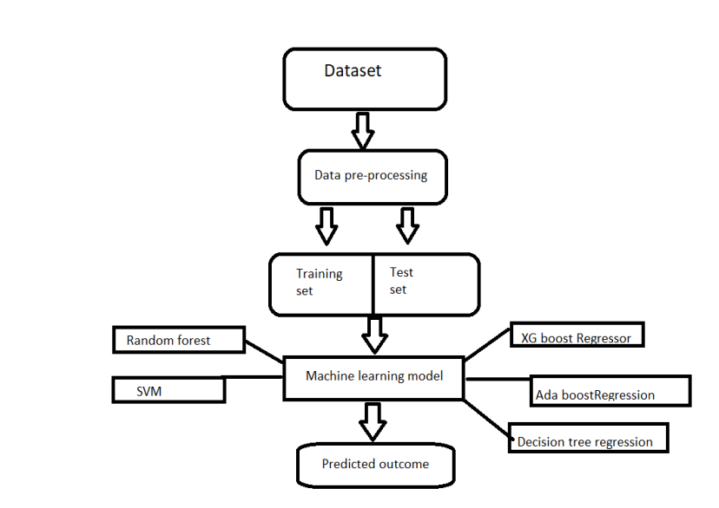

CHAPTER-5
SOURCE CODE & OUTPUT
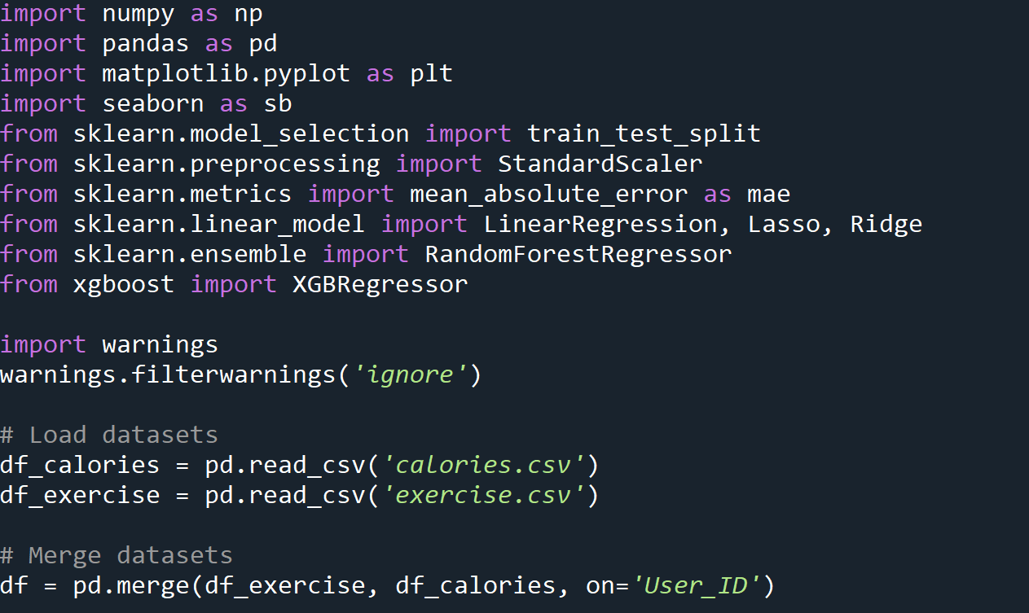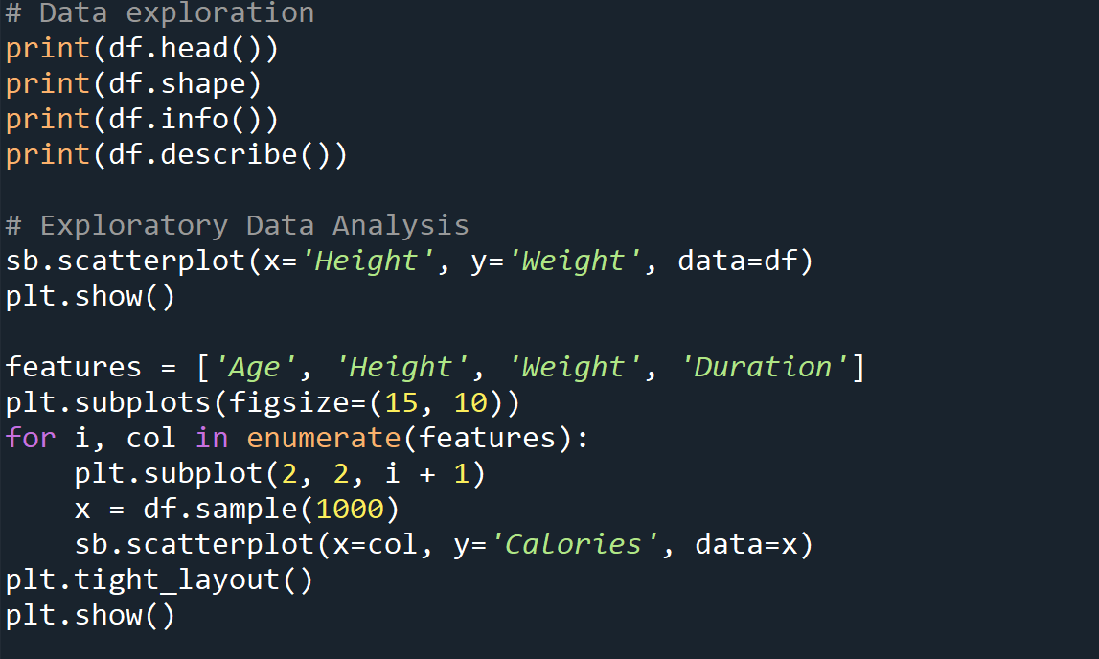

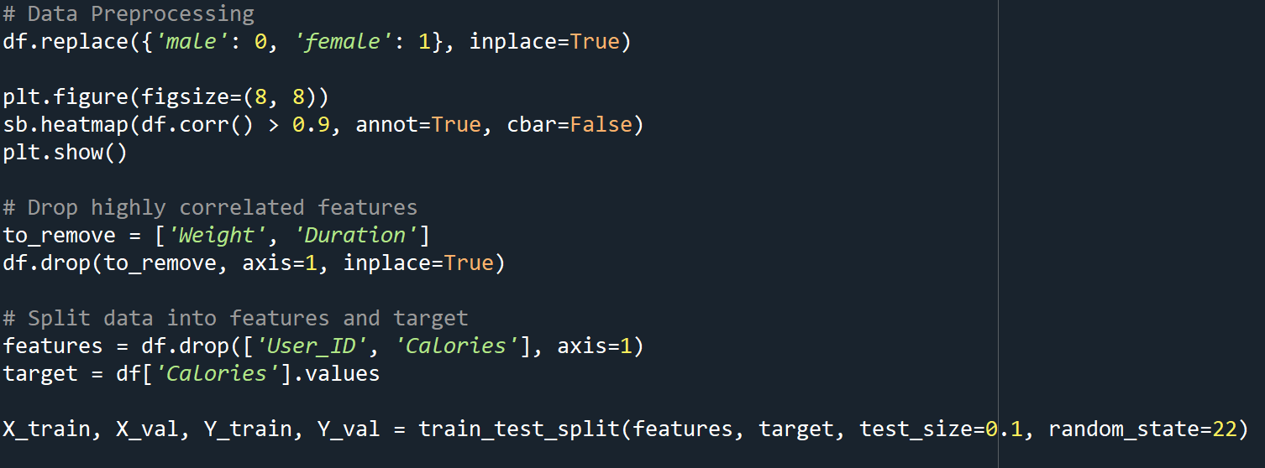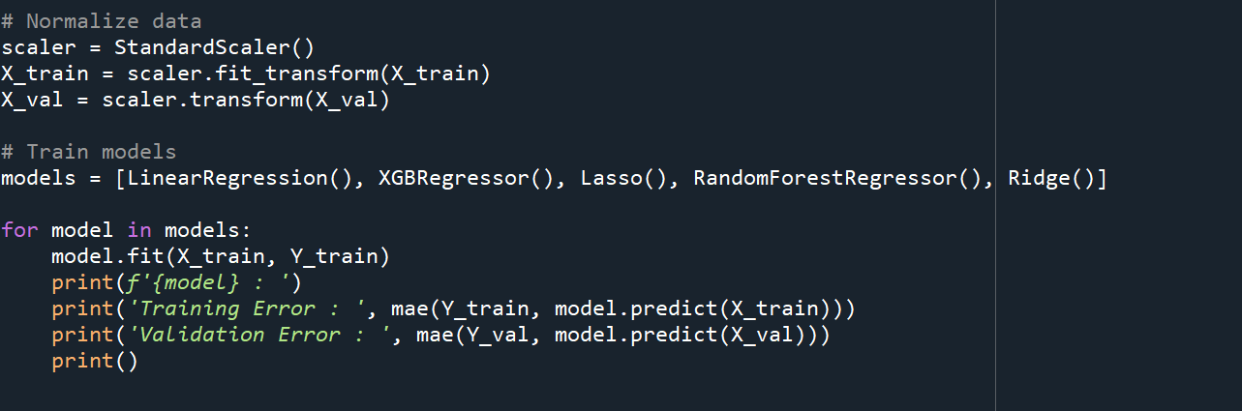

OUTPUT :
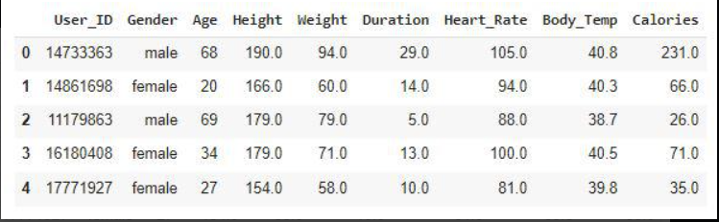

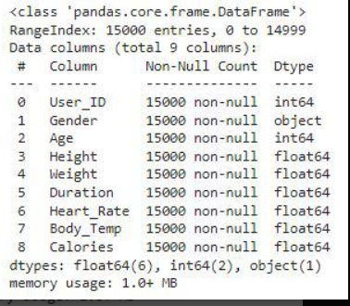
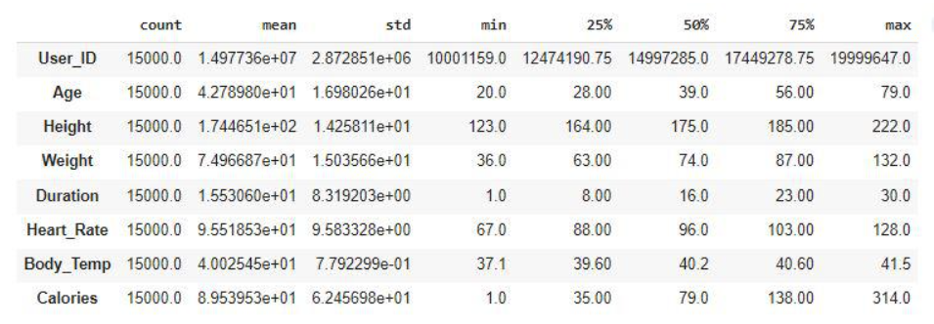
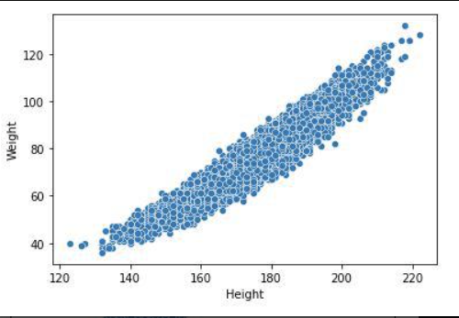
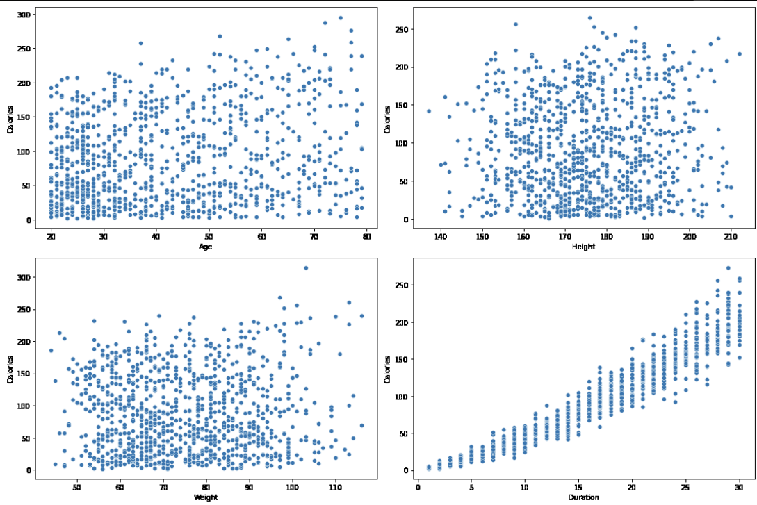
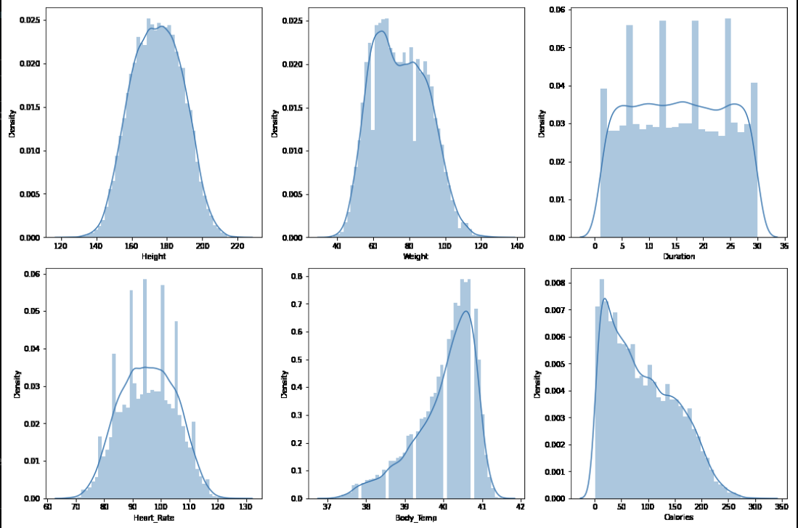
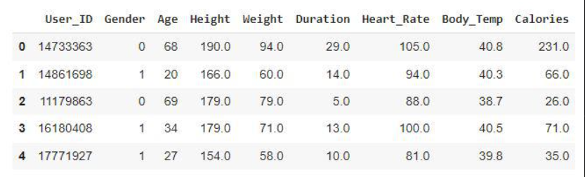
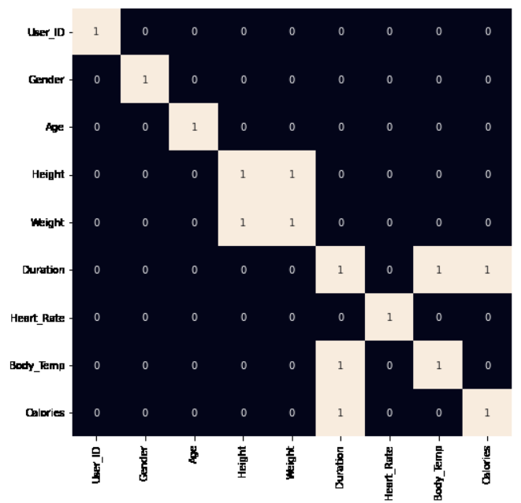


CHAPTER-6
RESULTS AND DISCUSSION

The effectiveness of the proposed calorie prediction system was validated through rigorous training and testing of various machine learning models. The performance of each model was measured using the Mean Absolute Error (MAE), which quantifies the average absolute difference between the predicted and actual calorie values.
- Model Performance Analysis:
  - Linear Regression: Achieved a validation MAE of approximately 18.00. While simple and interpretable, it lacked precision for this non-linear dataset.
  - Lasso and Ridge Regression: Similar to Linear Regression, these regularized models showed MAEs close to 18.00, offering minimal performance improvement.
  - Random Forest Regressor: Significantly improved accuracy with a validation MAE of around 10.45. This indicates strong performance in capturing complex relationships within the data.
  - XGBoost Regressor: Delivered the best performance with a validation MAE of approximately 10.12, showing excellent generalization and robustness.
- Training vs Validation Accuracy:
  - Random Forest and XGBoost models showed lower MAEs on training data as well as validation data, indicating strong learning capability without overfitting.
- Visual Insights:
  - Scatter plots between features and target revealed partial linear relationships (e.g., Duration vs Calories), guiding the choice of model.
  - Heatmaps confirmed multicollinearity among certain features, justifying the removal of ‘Weight’ and ‘Duration’ to avoid data leakage.
- Discussion on Accuracy:
  - The validation error gap between simple and advanced models highlighted the need for ensemble-based or gradient-boosted techniques.
  - The project’s MAE range (10–18) suggests that while prediction is generally accurate, further tuning or more diverse data can improve precision.

CHAPTER-7
FUTURE ENHANCEMENTS
While the current model demonstrates promising results, several avenues exist for expanding and improving the calorie prediction system:
- Incorporate Real-Time Sensor Data: Integrate real-time data from wearable fitness trackers, such as heart rate, oxygen levels, and motion sensors, to improve prediction accuracy.
- Use of Deep Learning Models: Implement deep learning algorithms such as Artificial Neural Networks (ANNs), Recurrent Neural Networks (RNNs), or LSTMs to capture more complex, non-linear patterns in data.
- Add Support for More Features: Include additional user-specific features such as activity type, fitness level, and diet data for a more holistic analysis.
- Time-Series Analysis: Enable support for sequential data modeling to track calorie burn over time and provide trends and patterns for long-term health monitoring.
- Model Optimization and Tuning: Apply hyperparameter tuning techniques like Grid Search and Random Search to further improve the efficiency and performance of the models.
- Mobile/Web App Deployment: Develop a user-friendly interface (web or mobile app) that allows users to input their data and receive calorie burn predictions instantly.
- Multi-Platform Integration: Connect the system with existing health ecosystems like Google Fit or Apple HealthKit to sync and process user data more effectively.

CHAPTER-8
REFERENCES
- Hunter, J. D. (2007). Matplotlib: A 2D Graphics Environment. – Used for creating visualizations like scatter plots and heatmaps.
- Waskom, M. L. (2021). Seaborn: Statistical Data Visualization. – For advanced visual representation of data distributions and correlations.
- Kaggle Datasets. – Source for sample datasets including exercise and calorie-related data.
- Python Software Foundation. – Official Python documentation and references for implementation.
- Research Articles on Machine Learning in Healthcare – Provided conceptual grounding for personalized prediction systems.
- Blogs & Tutorials on Calorie Prediction Models – Used to explore best practices in feature selection and model tuning.
.

CHAPTER-9
CONCLUSION
This project successfully demonstrates the application of machine learning to predict the number of calories burnt during a workout based on biometric and exercise-related data. By integrating datasets and applying preprocessing techniques, the system builds a robust pipeline for data analysis, model training, and evaluation.
The use of ensemble models like Random Forest and XGBoost resulted in significantly lower prediction errors compared to basic regression models. These models proved capable of capturing complex patterns in the data, enabling accurate and personalized calorie burn predictions.
Through exploratory data analysis, feature selection, and model evaluation, the project showcases a comprehensive end-to-end solution for intelligent health monitoring. The model's ability to generalize well on validation data highlights its potential for real-world integration into mobile health apps and wearable fitness devices.
This work lays a strong foundation for future advancements in AI-based personal health assistants and promotes greater accessibility to fitness analytics using machine learning.
.

